Interview notes with Ralitsa
ENERGY
The Big Questions

All images credit Ralitsa Hiteva

I conducted interviews with people in these locations so far:
Sofia (Bulgaria)
Varna (Bulgaria)
Plovdiv (Bulgaria)
Veliko Turnovo (Bulgaria)
Sevlievo (Bulgaria)
Gabrovo (Bulgaria)
Pleven (Bulgaria)
Ruse (Bulgaria)
Dobrich (Bulgaria)
London (UK)
Newcastle (UK)
Brussels (Belgium)
Geneva (Switzerland)
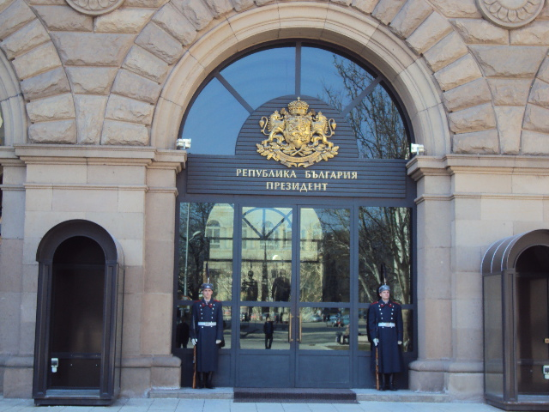
I met officials in Government buildings in several locations around Bulgaria

I’m exploring how energy security & low carbon energy are compatible and complimentary...
The EU has a 2020 strategy for energy. There are 3 main targets in the strategy, which involve reducing the use of non-renewables.
The energy history of Bulgaria is interesting.
It was a country that was behind the “iron curtain” for over 60 years
Energy was always cheap

Until 2004 it was self-sufficient country for energy.

Bulgaria traditionally has a broad mix of different energy sources.

There are solar installations, and various gas refineries.
Grants were available for the development of other types.

Bulgaria is a good location for renewable energy, but this was potentially more than the capacity of the grid...

A seismic zone runs through the country, which provides some extra problems when siting nuclear power plants

Interviews – information flowing...
Asked some key questions:
- What is the material change in energy that is taking place right now ?
- What energy is being produced – how different to before ?

EU membership has changed a lot of things, because it means that there are targets to meet by 2020.
Transition to low carbon – different rules
Competition has been introduced – always have to change system so that costs are driven lower
Green energy is more expensive than nuclear.

We also have external pressures such as ‘peak oil’...
The infrastructure is not as up to date as it could be in all parts of the country
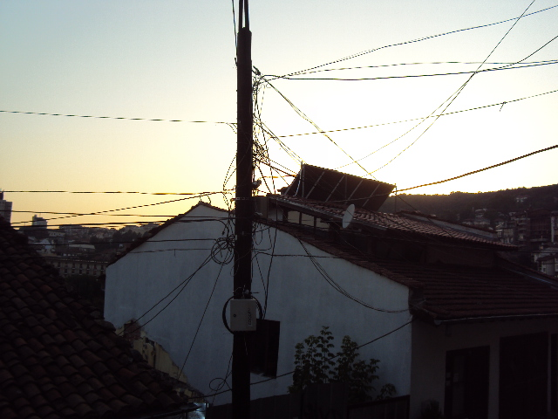

In Jan 2009, the pipelines were shut down and there were 24 days with no gas. As a transit fuel – better than oil
When gas stops, oil is burned, but that doesn’t help with the targets for carbon emissions

The pipeline being built is the Bourgas-Alexandripolis and it is still in construction. Years behind schedule are also two other pipelines : Nabucco and South Stream. The one gas pipeline which is currently in operation in Bulgaria (and has been for some time) is owned by a Bulgarian state owned company: Bulgargaz. The gas flows from Romania through Bulgaria towards Turkey and Greece. Nabucco and South Stream will connect the Caspian region with central Europe (up to Germany).

