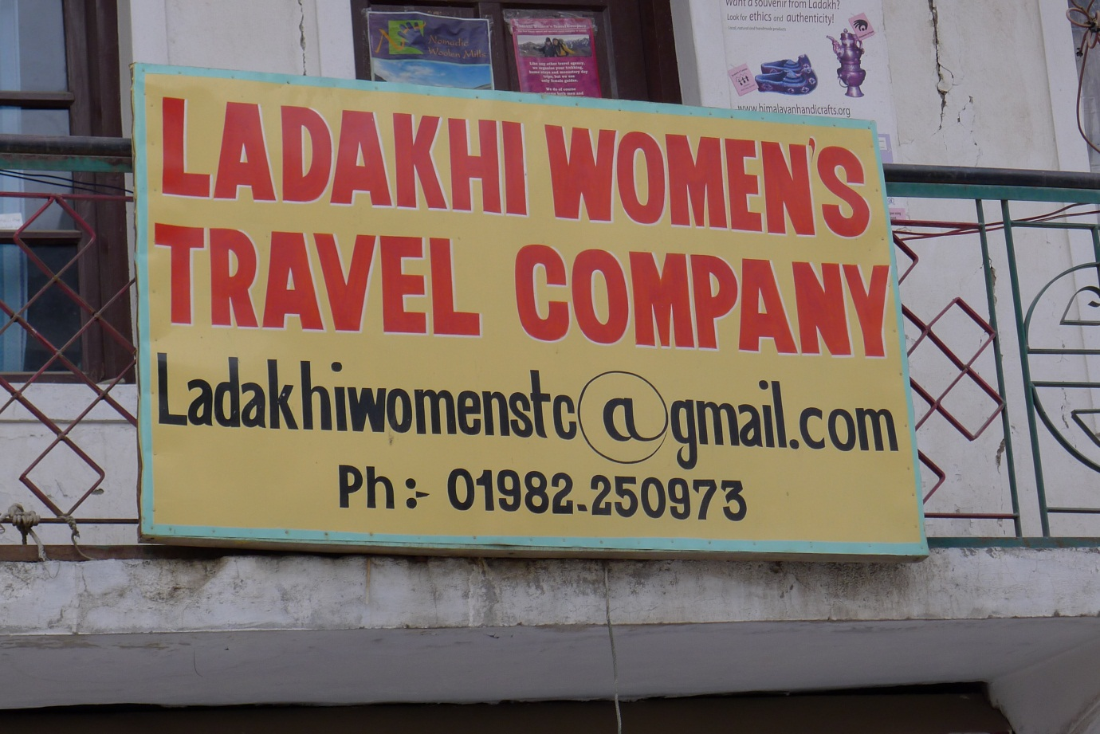**Photo Analysis**

Use of email illustrates some communications infrastructure is available to stimulate tourism growth

“Women’s Travel Company” suggests a certain amount of women’s empowerment is coming out of tourism as a positive effect

“Travel company” illustrates that tourism is present in this area

