Everyday Drone Stories
KS5.4 Categories and restrictions

Specification
AQA 3.2.1.2 Global systems. Unequal flows of people, money, ideas and technology within global systems can sometimes act to promote stability, growth and development but can also cause inequalities, conflicts and injustices for people and places.

Edexcel Topic 7: Superpowers. TNCs are dominant economic forces in the global economy and economic and cultural globalisation in terms of technology (patents) and trade patterns.

OCR Topic 2.1 – Changing Spaces; Making Places. How shifting flows of people, resources, money and investment and ideas have helped shape the demographic, socio-economic and cultural profile of places over time.

WJEC Changing Places. External forces and factors influencing economic restructuring including changing technology and lifestyles, government strategy and globalisation.

How are drones regulated in the UK?
There are various rules and regulations in place that cover and apply to drone use in the UK. The UK’s airspace is regulated by the Civil Aviation Authority, known as the CAA.
The CAA’s drone rules are based on the potential risk of the flight and provide information on where you can fly and the proximity to other people, depending on the size and weight of your drone.
The CAA’s drone regulations are based around three categories: the open category, the specific category, and the certified category.

- The Open Category is ‘intended for low-risk drone flights’ and covers drones weighing under 250 grams, and drones weighing 250g up to 25 kilograms. Flights in the open category must not exceed 120 metres / 400 feet, must adhere to all applicable airspace restrictions, and drones must be kept within the operator’s visual line of sight. Flights in the open category are also subject to further distinctions around the proximity to uninvolved persons and distance from residential, commercial, industrial or recreational areas, depending on the drone’s weight and whether the drone has a camera onboard.

- See guidance document CAP2012 for summary table of all open category requirements.

- The Drone and Model Aircraft Code advises drone users that if their drone weighs over 250 grams they will need to obtain a flyer ID - showing they have passed an online flying test and indicating that they are responsible for ‘flying safely and legally’, and if their drone weighs below 250 grams and has a camera, or weighs over 250 grams, they need to obtain an operator ID – which must be labelled on their drone and indicates that they are ‘responsible for the drone or model aircraft, and who they allow to fly it’.

- The Specific Category is intended for ‘higher risk flights’ and/or those that fall outside the open category. Specific Category flights require the operator to hold an operational authorisation, issued by the Civil Aviation Authority. This authorisation is based upon the CAA’s evaluation of a safety risk assessment.

- The Certified Category is for large drones which have to meet specific safety certifications akin to manned aircraft and aviation. Drone flights in this category are subject to the same regulatory regime as manned aviation, and this is under development and not yet published.

You can find current information about drone regulation on the Civil Aviation Authority’s website (https://www.caa.co.uk/drones/ ), and detailed in the Drone and Model Aircraft Code (https://register-drones.caa.co.uk/drone-code/the_drone_code.pdf).

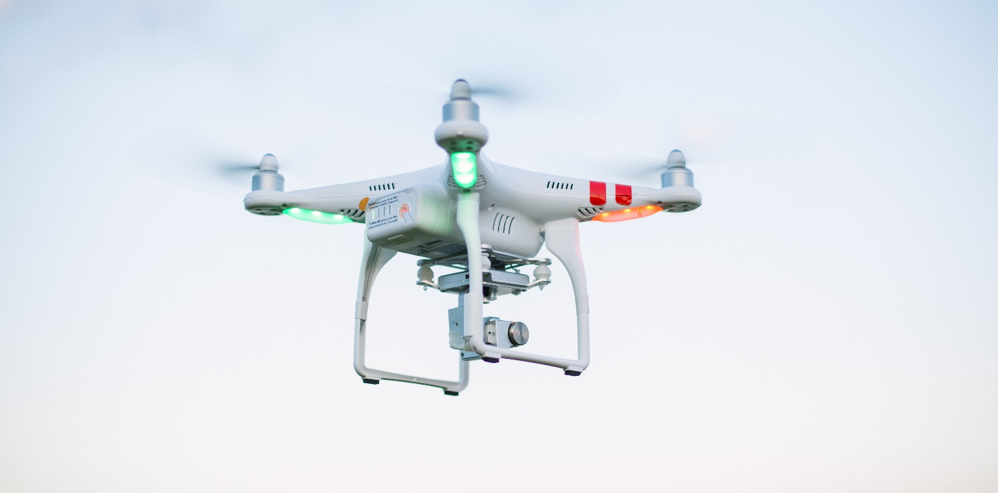
Figure 1 © David Grandmougin

Off the shelf drones and the open category
Many UK drone users and pilots buy what are known as consumer or off the shelf drones, meaning they are available to purchase by citizens like us (e.g., on the high street, or online).

Perhaps you or a family member has one? Consumer drones like one in the picture above are also used by a number of businesses for applications such as roof inspection and infrastructure monitoring, as well as by emergency services (e.g., police, fire, search and rescue).

In this activity, we are going to think about flying and living with these kinds of consumer drones.

These kinds of drones are typically associated with flight in the Open Category (see above), and their pilots are required to adhere to the Drone and Model Aircraft Code.

The Drone and Model Aircraft Code details key restrictions on drone flying in the open category ¹:

- Fly below 120 metres (400 ft).

- Do not fly closer to people than 50 metres.

- Never fly over people who are crowded together.

- Keep at least 150 metres away from residential, commercial and industrial areas.

- Stay well away from airports, airfields, spaceports and aircraft.

- Check your surroundings and local maps to follow any flying restrictions ².

¹ This is not an exhaustive list.
² Flying restrictions might include sites such as prisons, military ranges, royal palaces, and government buildings, and restrictions may also apply in terms of local byelaws, tall buildings, Sites of Special Scientific Interest. There might also be restrictions around temporary political conferences, emergency incidents, air shows or festivals.

Activity: Flying drones safely
- Study Figure 2. Based on the list above:

- Where do you think you can fly drones?
- Where do you think you cannot fly drones?
- Are there any locations where it might be legal to fly a drone, but where drone flight could cause anxiety or offence?

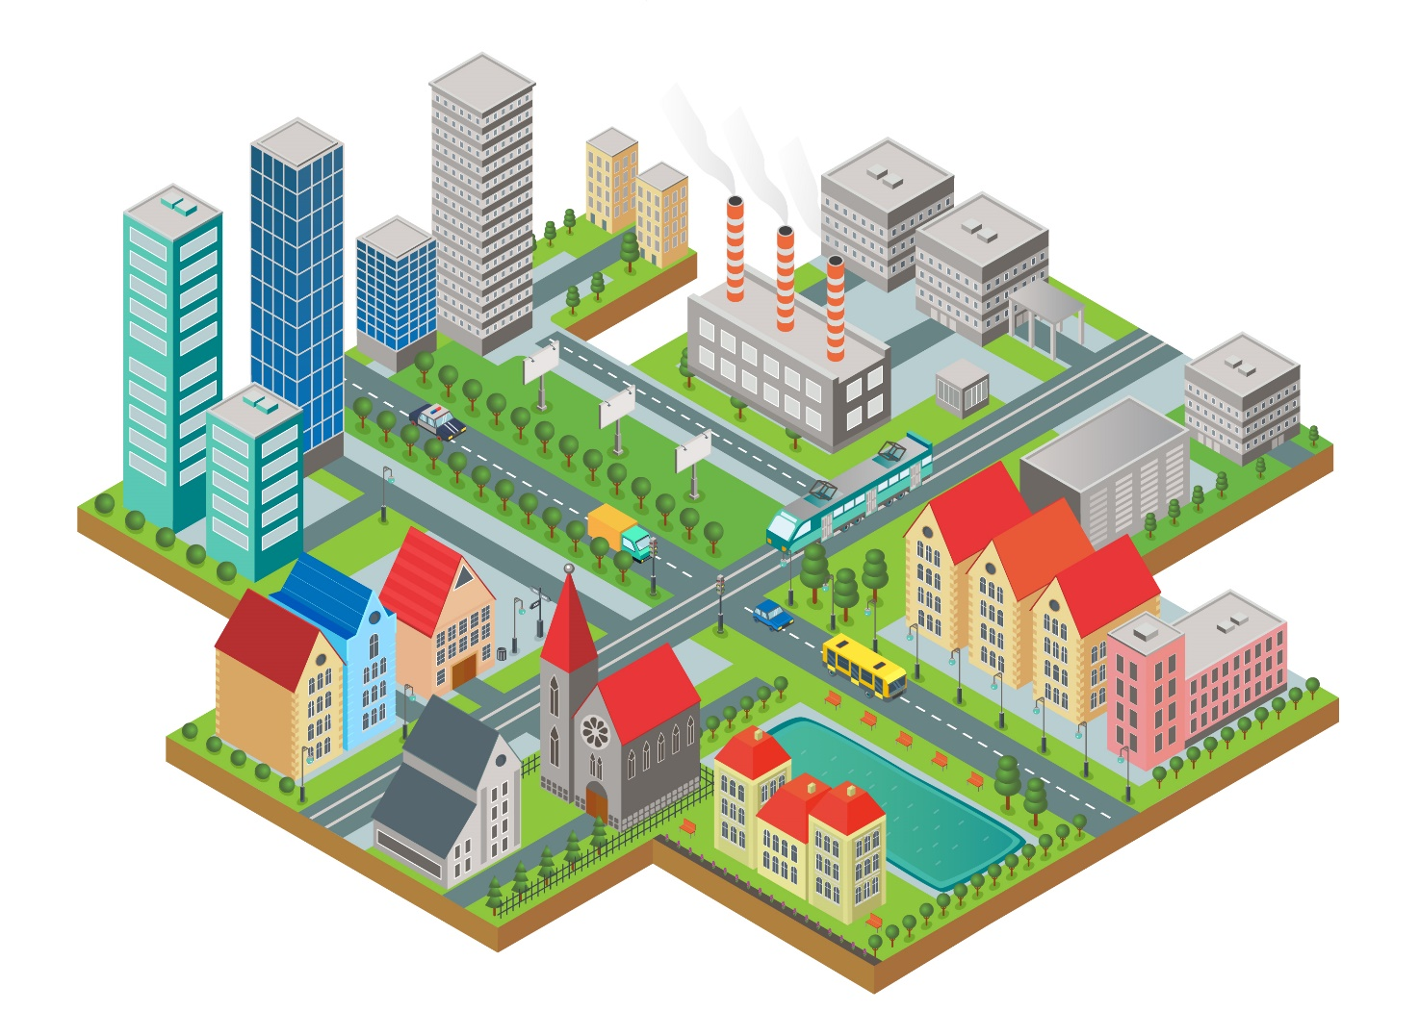
Figure 2 Small map of a city © RGS-IBG

- As is shown in Figure 3 below, the Drone and Model Aircraft code states that you should not fly your drone closer to people than 50 metres. Why do you think this distance is important?
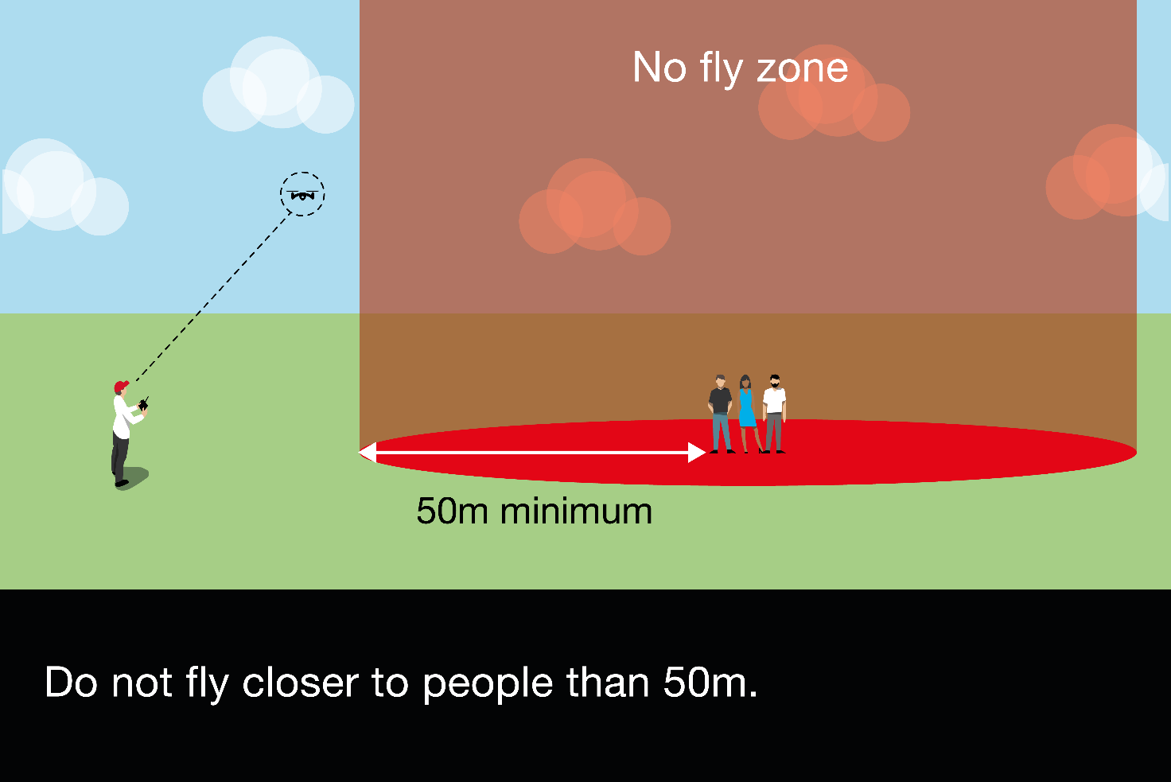
Figure 3 Where to fly your drone. The CAA Drone and Model Aircraft Code

- Many drones are fitted with cameras and can capture images and video. The Drone and Model Aircraft Code requires drone pilots to ‘respect people and their privacy’, adding that if you collect images or video in places ‘where people can expect privacy, such as inside their home or garden, you’re likely to be breaking data protection laws’. If you were a drone pilot, what might you do to ensure you respect people’s privacy? Pages 32 – 33 of the Drone and Model Aircraft Code include some clues.

Answers
- Where do you think you can fly drones? This depends on the scale of the map and the size (weight) of the drone. If operating in the open category, you need to keep your down below 120 metres (400 ft), not fly closer to people than 50 metres (which may flying in many of the diagrams areas difficult, if they are busy or congested), never fly over people who are crowded together (which may be the case at events or in busy town centres), and importantly – keep at least 150 metres away from residential, commercial and industrial areas. Where do you think you cannot fly drones? There are restrictions around drone flight near tall buildings. Critical infrastructure, such as energy power plants and key arterial roads, are also restricted areas. Some of the buildings might be government buildings (with additional restrictions) and the pilot needs to ensure they remain at least 150 metres away from commercial areas/ properties. Are there any locations where it might be legal to fly a drone, but where drone flight could cause anxiety or offence? In this scenario, the drone pilot should think carefully about what their drone’s camera might be able to see, e.g. flying near private gardens or near places of worship.

- The Drone and Model Aircraft code states that you should not fly your drone closer to people than 50 metres. Why do you think this distance is important? The distance is important primarily because of maintain the safety of ‘uninvolved persons’ (i.e. people not involved in your drone flight), in case of loss of control or an accident (e.g. drone crash) which could cause injury or harm. Maintaining a good distance also gives the pilot a longer reaction time / window in case of factors such as changing weather or loss of control.

- If you were a drone pilot, what might you do to ensure you respect people’s privacy? The Drone and Model Aircraft Code advises: know what your drone camera can do and what kinds of images or videos it can take (e.g. zoom, whether you can stop / start recording when you are flying); making yourself visible when you’re flying (e.g. wearing high vis) so people can see who is flying the drone; letting people know before you start taking pictures; think before you share photos and videos online (e.g. on social media); keep photos and videos secure (e.g. delete what you don’t need, store images / video safely and securely).

Further reading
- Civil Aviation Authority The Drone and Model Aircraft Code

- Sikora I, Gabriel T (2015) Complaints, peeping toms and airplane near misses show drone regulations are needed now. The Conversation https://theconversation.com/complaints-peeping-toms-and-airplane-near-misses-show-drone-regulations-are-needed-now-47134 (note - this article was written in 2015 – how has current regulation responded?)

- Rice S, Milner M (2019) Don’t shoot! That drone overhead probably isn’t invading your privacy. The Conversation https://theconversation.com/dont-shoot-that-drone-overhead-probably-isnt-invading-your-privacy-114701

