|  |
| --- |
| The Russian Arctic: climate change activity sheet 2 |

This is a worksheet for Key Stage 3 geography. It is designed to complement a wider scheme of work either on climate change or on Russia specifically.

**Curriculum relevance**

Russia is an important stakeholder in the Arctic because:

* Roughly 20% of Russia is within the Arctic Circle
* Russia is investing heavily in the Arctic, specifically on the Yamal Peninsula
* It has symbolic and nationalistic value — many Arctic nations want a ‘presence’ there

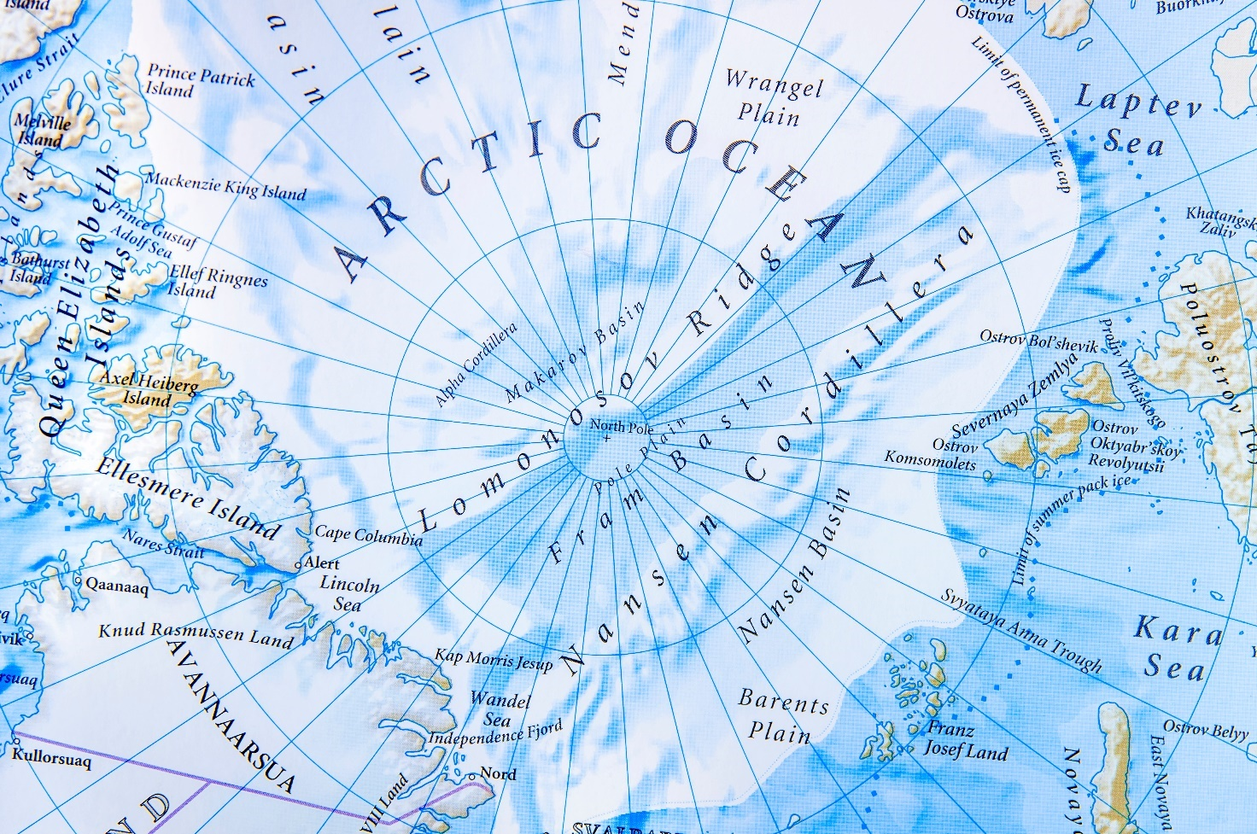

Figure 1 the Arctic Ocean © Bennian Pond5

**Where is the Arctic?**

The Arctic has different boundaries but the simplest way to define it is the area within the Arctic circle, 66°N. With this definition the area constitutes around 20 million square kilometers (8 million square miles), of which about 70% is ocean. The Arctic Ocean image below illustrates how much of the high-latitudes is open water — there is very little land in the Arctic.

There are 8 countries which have land and a share of Arctic: Norway, Sweden, Finland, Russia, USA (Alaska), Denmark (Greenland), Canada and Iceland. Across these 8 countries indigenous people make up about 10% of the 4 million people that live there. Out of these 4 million inhabitants in the Arctic, 2 million are Russian

1. Research and identify the 8 countries with land in the Arctic and label them onto Figure 2. Next add the Laptev Sea and the Kara Sea, as shown in Figure 1.

The USGS (United States Geological Survey) estimates that 87% (360 billion barrels oil equivalent) of Arctic oil and natural gas is found in only 7 Arctic Ocean basins: the **Amerasian Basin, East Barents Basin, East Greenland Rift Basin, Arctic Alaska Basin, West Greenland-East Canada Basin, West Siberian Basin, and the Yenisey-Khatanga Basin.**

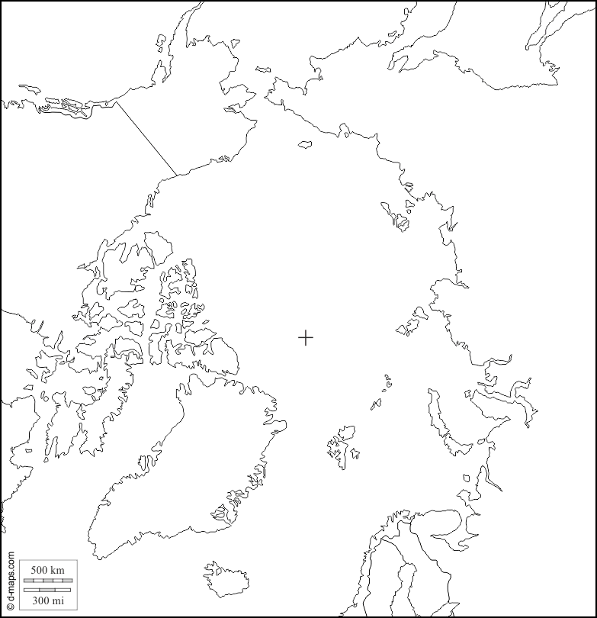Figure 2 the 8 Arctic countries © [www.d-maps.com/carte.php?num_car=3193&lang=en](http://www.d-maps.com/carte.php?num_car=3193&lang=en)

**Climate change and Permafrost**

The Arctic climate is changing between 2 and 4 times faster than the rest of the world, making the region the leading edge of global climate change and a hugely influential area.

The high-latitudes are seeing rapid temperature increases in the twenty-first century, with warmer and warmer climate records being set. This will have a huge effect regionally on the landscape and wildlife but also worldwide as global warming spirals out of control.

1. Annotate the following labels onto Figure 3: albedo of the Arctic Ocean, the continent of Asia, incoming solar radiation, the Arctic Ocean and the main 3 greenhouse gases CO₂ CH₄ N₂O
2. Why do you think one arrow appears to break the pattern — being reflected back into space? Watch this video from Professor Iain Stewart to help you answer [www.bbc.co.uk/bitesize/clips/zhmb4wx](http://www.bbc.co.uk/bitesize/clips/zhmb4wx)

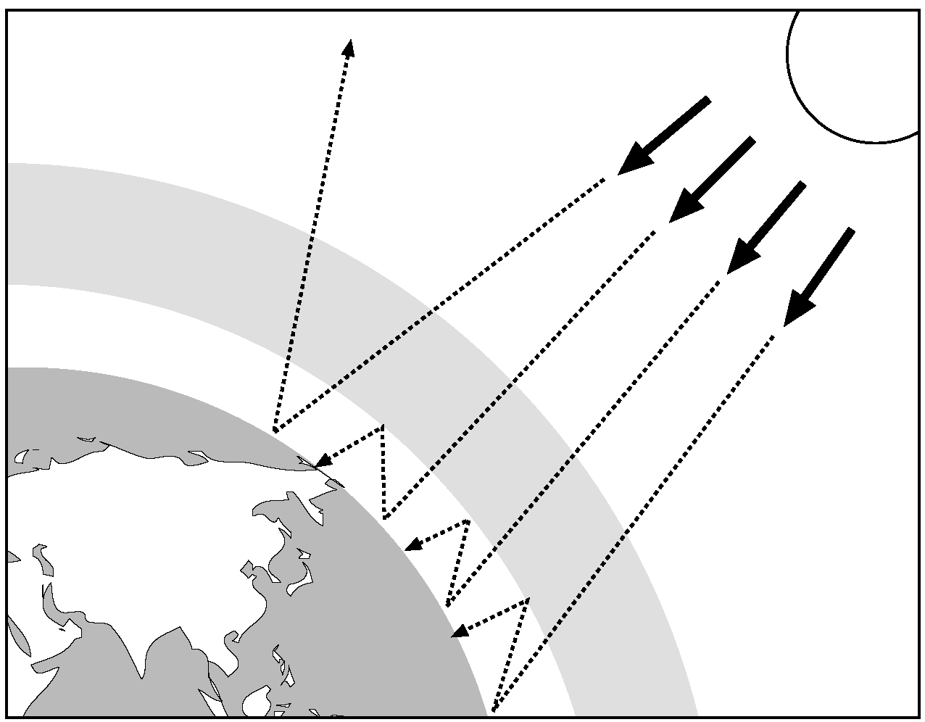

Figure 3 climate change: the greenhouse effect and global warming **©** [www.edu.rsc.org/download?ac=12267](http://www.edu.rsc.org/download?ac=12267)

There have been dramatic changes in the Arctic from climate change:

* Summer sea ice extent in the Arctic Ocean has continued to shrink (with a smaller change in winter extent)
* Glaciers and the Greenland ice sheet are losing land ice — which is accelerating global sea level rise
* Wildfires have increased dramatically (with an expansion of them into the Arctic tundra)
* Atmospheric and oceanic circulation patterns have changed from a shrinking mid-latitude high-latitude temperature difference and the thawing (melting) of Arctic permafrost

Permafrost is a permanently frozen layer beneath the Earth’s surface, consisting of soil, rock or sediment. In the Arctic permafrost is thawing at a considerable rate leading to the decomposition of previously frozen organic matter. This is worrisome as it is estimated that permafrost soils have around 2.5 times more carbon than the entireglobal atmosphere — which will be potentially released, adding further to global warming.

1. In Figure 4 below are 2 columns of earth, both are a cross-sectional view. One is a photograph of permafrost soil, the other is a blank soil horizon profile. Add the notes onto the correct part of the diagram.

The permafrost layer exists beneath the active layer. It is this part of the soil horizon which is permanently frozen. Permafrost thickness can range from 1 metre to more than 1000 metres in depth

A layer of soil on top of permafrost does not stay frozen all year. The active layer freezes in the winter and thaws in the summer. In colder regions where the ground rarely thaws, the active layer is very thin — only 10 to 15 centimetres

The talik layer is the bottom layer under permafrost. It is year-round unfrozen ground which is often found under thermokarst lakes (as they don’t freeze, the soil doesn’t either)

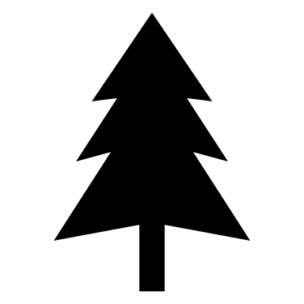

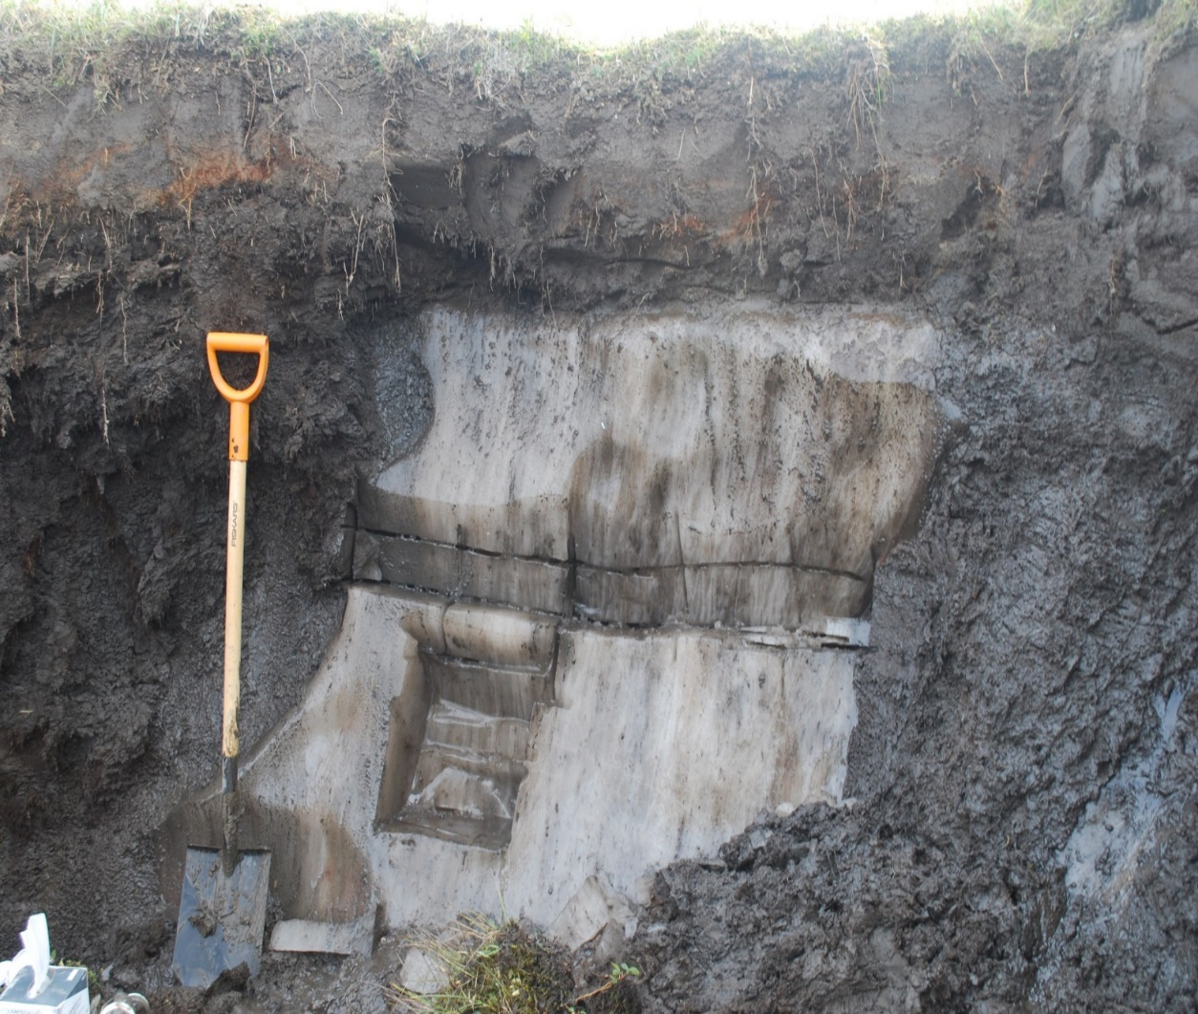 

Figure 4 © Thomas Opel

**Further information**

* Disappearing Arctic Sea Ice: [the Global Climate Impacts infographic](https://e360.yale.edu/assets/site/_1500x1500_fit_center-center_80/WarmingArctic.jpg)
* Find out where [the last ice area is](http://www.arcticwwf.org/places/last-ice-area/)
* National Geographic [Tundra explained](http://www.nationalgeographic.com/environment/habitats/tundra-biome/)
* NSIDC [Climate Change in the Arctic](https://nsidc.org/cryosphere/arctic-meteorology/climate_change.html)
* The Arctic Council [The Arctic in a Changing Climate](https://arctic-council.org/explore/topics/climate/)
* The Guardian ‘[Drastic’ rise in high Arctic lightning has scientists worried](https://www.theguardian.com/environment/2022/jan/07/lightning-high-arctic-rise-scientists-worried)
* Carbon Brief [The irreversible emissions of a permafrost ‘tipping point’](https://www.carbonbrief.org/guest-post-the-irreversible-emissions-of-a-permafrost-tipping-point)

Thank you to Dr Caroline Coch, Polar specialist at WWF-UK, for helping with the production of this resource