**Historic Cities**

[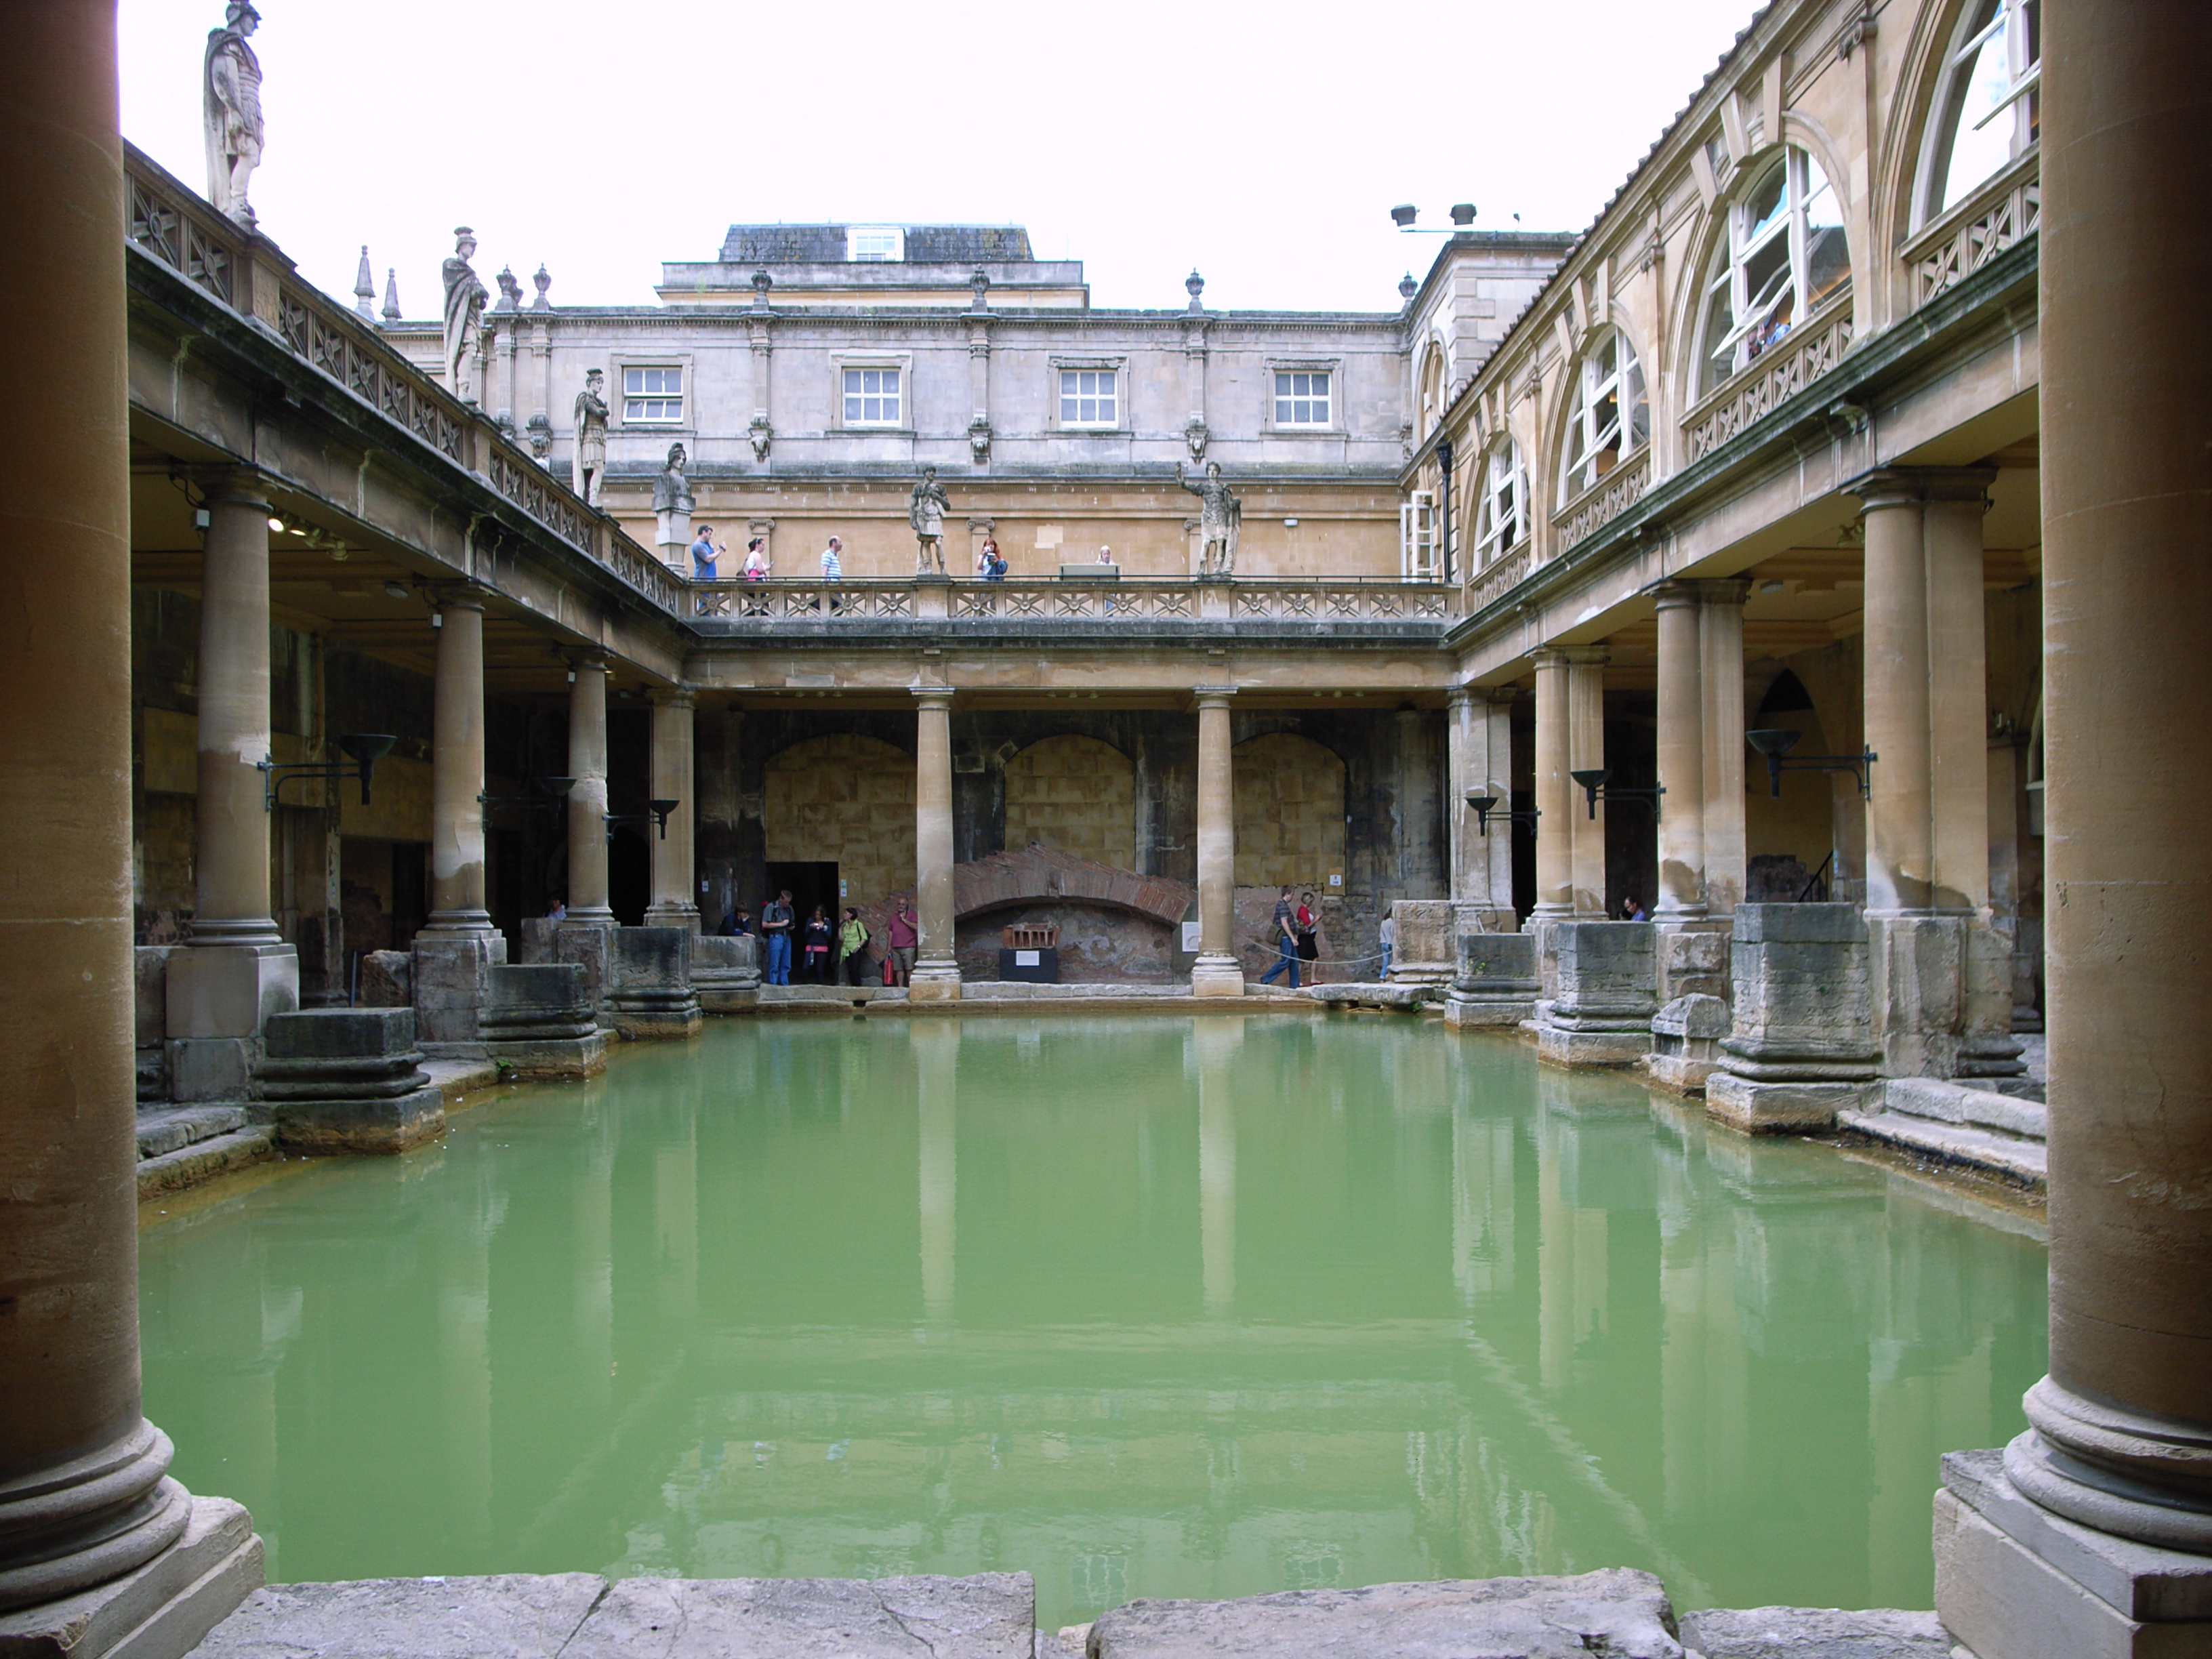](https://www.google.co.uk/url?sa=i&rct=j&q=&esrc=s&frm=1&source=images&cd=&cad=rja&uact=8&ved=0CAcQjRxqFQoTCL7WoOeQjccCFcm9FAodgkgHzg&url=https://commons.wikimedia.org/wiki/File:The_Great_Bath_in_Bath_(UK).jpg&ei=rXu_Vf7LDsn7UoKRnfAM&bvm=bv.99261572,d.eXY&psig=AFQjCNEdLAUMxiCjZF7kZ-lP-b2BQ5LSBw&ust=1438698779463401)[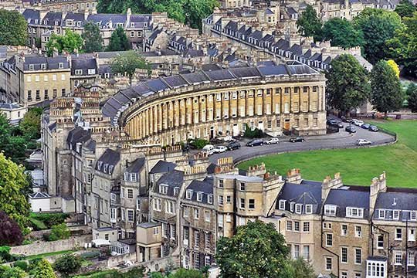](http://www.google.co.uk/url?sa=i&rct=j&q=&esrc=s&frm=1&source=images&cd=&cad=rja&uact=8&ved=0CAcQjRxqFQoTCLzju9WQjccCFUVvFAodfH8AGA&url=http://studentcities.co.uk/bath.html&ei=h3u_VfyDOcXeUfz-gcAB&bvm=bv.99261572,d.eXY&psig=AFQjCNFexSjNZXA1VTY0smWAcHY3SuXKHQ&ust=1438698743641727)

**Bath**

**Historic Cities**

[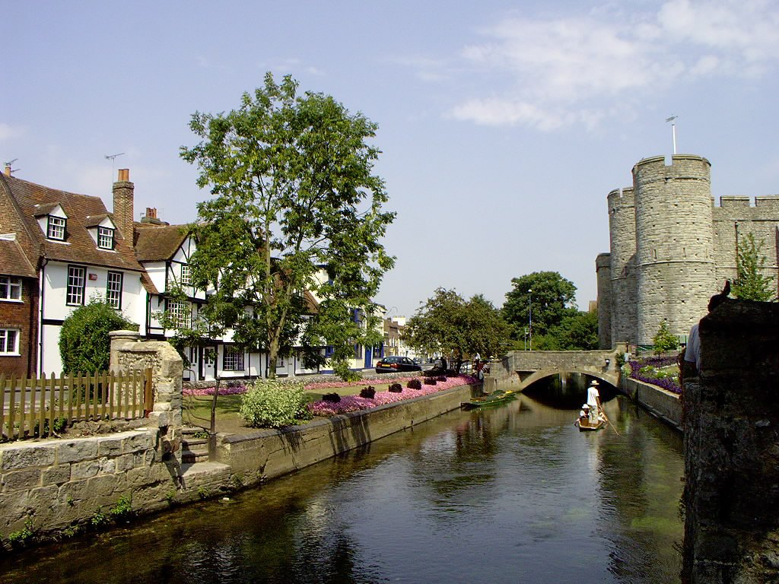](https://www.google.co.uk/url?sa=i&rct=j&q=&esrc=s&frm=1&source=images&cd=&cad=rja&uact=8&ved=0CAcQjRxqFQoTCIus1I2TjccCFci6FAodlUoDww&url=https://en.wikipedia.org/wiki/River_Stour,_Kent&ei=Fn6_VYvJJ8j1UpWVjZgM&bvm=bv.99261572,d.eXY&psig=AFQjCNHATG6N5jl9WNFK0FFIxp6kD3Ig3Q&ust=1438699412678711)[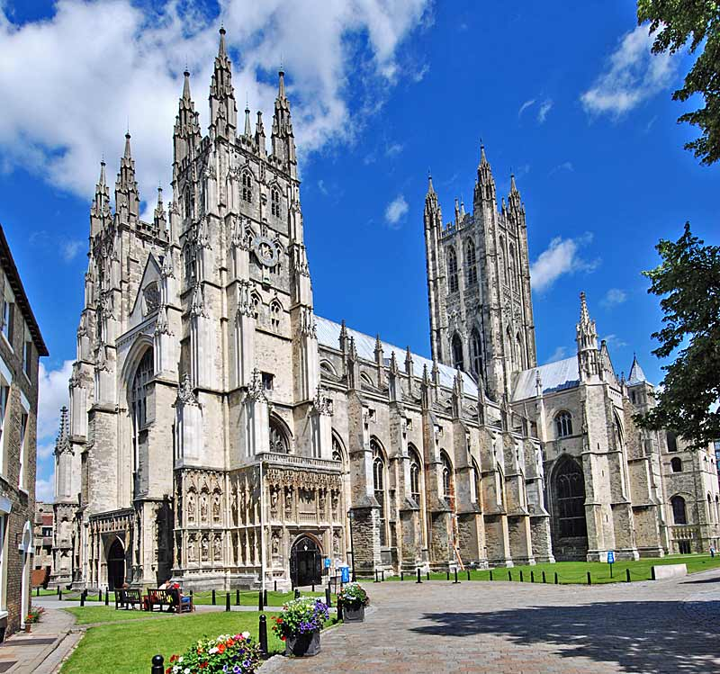](http://www.google.co.uk/url?sa=i&rct=j&q=&esrc=s&frm=1&source=images&cd=&cad=rja&uact=8&ved=0CAcQjRxqFQoTCJygzYKTjccCFYztFAodkBAPvQ&url=http://www.paradoxplace.com/Photo%20Pages/UK/Britain_South_and_West/Canterbury_Cathedral/Canterbury_External/Canterbury_External.htm&ei=_32_VdykHIzbU5ChvOgL&bvm=bv.99261572,d.eXY&psig=AFQjCNHBYK4X7cViKtlo5Rxwd7prFBpanA&ust=1438699362081258)

**Canterbury**

**Historic Cities**

[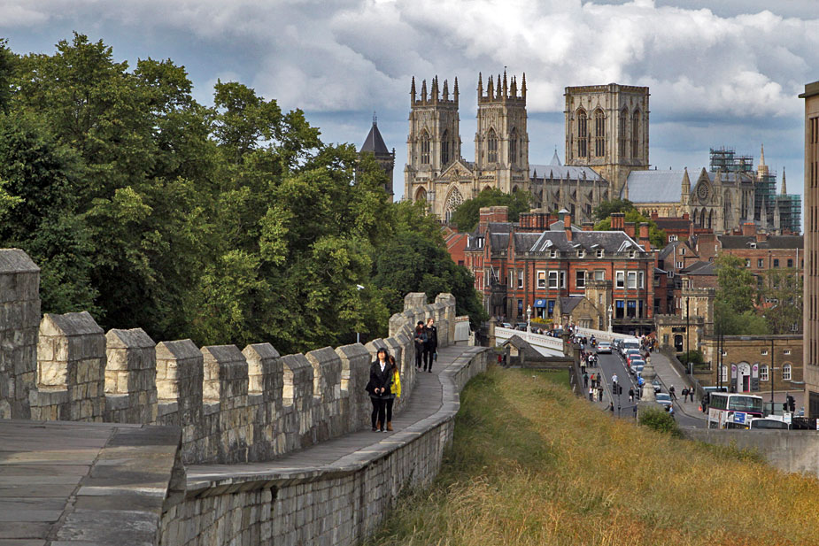](http://www.google.co.uk/url?sa=i&rct=j&q=&esrc=s&frm=1&source=images&cd=&cad=rja&uact=8&ved=0CAcQjRxqFQoTCNuhxu-RjccCFUeyFAod0PsAAA&url=http://angelstravelandtours.com/day-tours/york-excursion/&ei=y3y_VZuQBMfkUtD3Aw&bvm=bv.99261572,d.eXY&psig=AFQjCNEuF2RXP0HMdMVfXlRnrBoNSVGqwA&ust=1438699070156011)[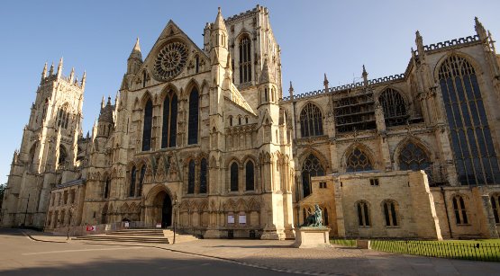](http://www.google.co.uk/url?sa=i&rct=j&q=&esrc=s&frm=1&source=images&cd=&cad=rja&uact=8&ved=0CAcQjRxqFQoTCPru0cKRjccCFQJXFAodFZwDgw&url=http://www.insideyork.co.uk/&ei=bHy_VfqINoKuUZW4jpgI&bvm=bv.99261572,d.cWw&psig=AFQjCNEAypIa1X6V9ciCE2nFb1L4NfIqKg&ust=1438698980151767)

**York**

**Historic Cities**

[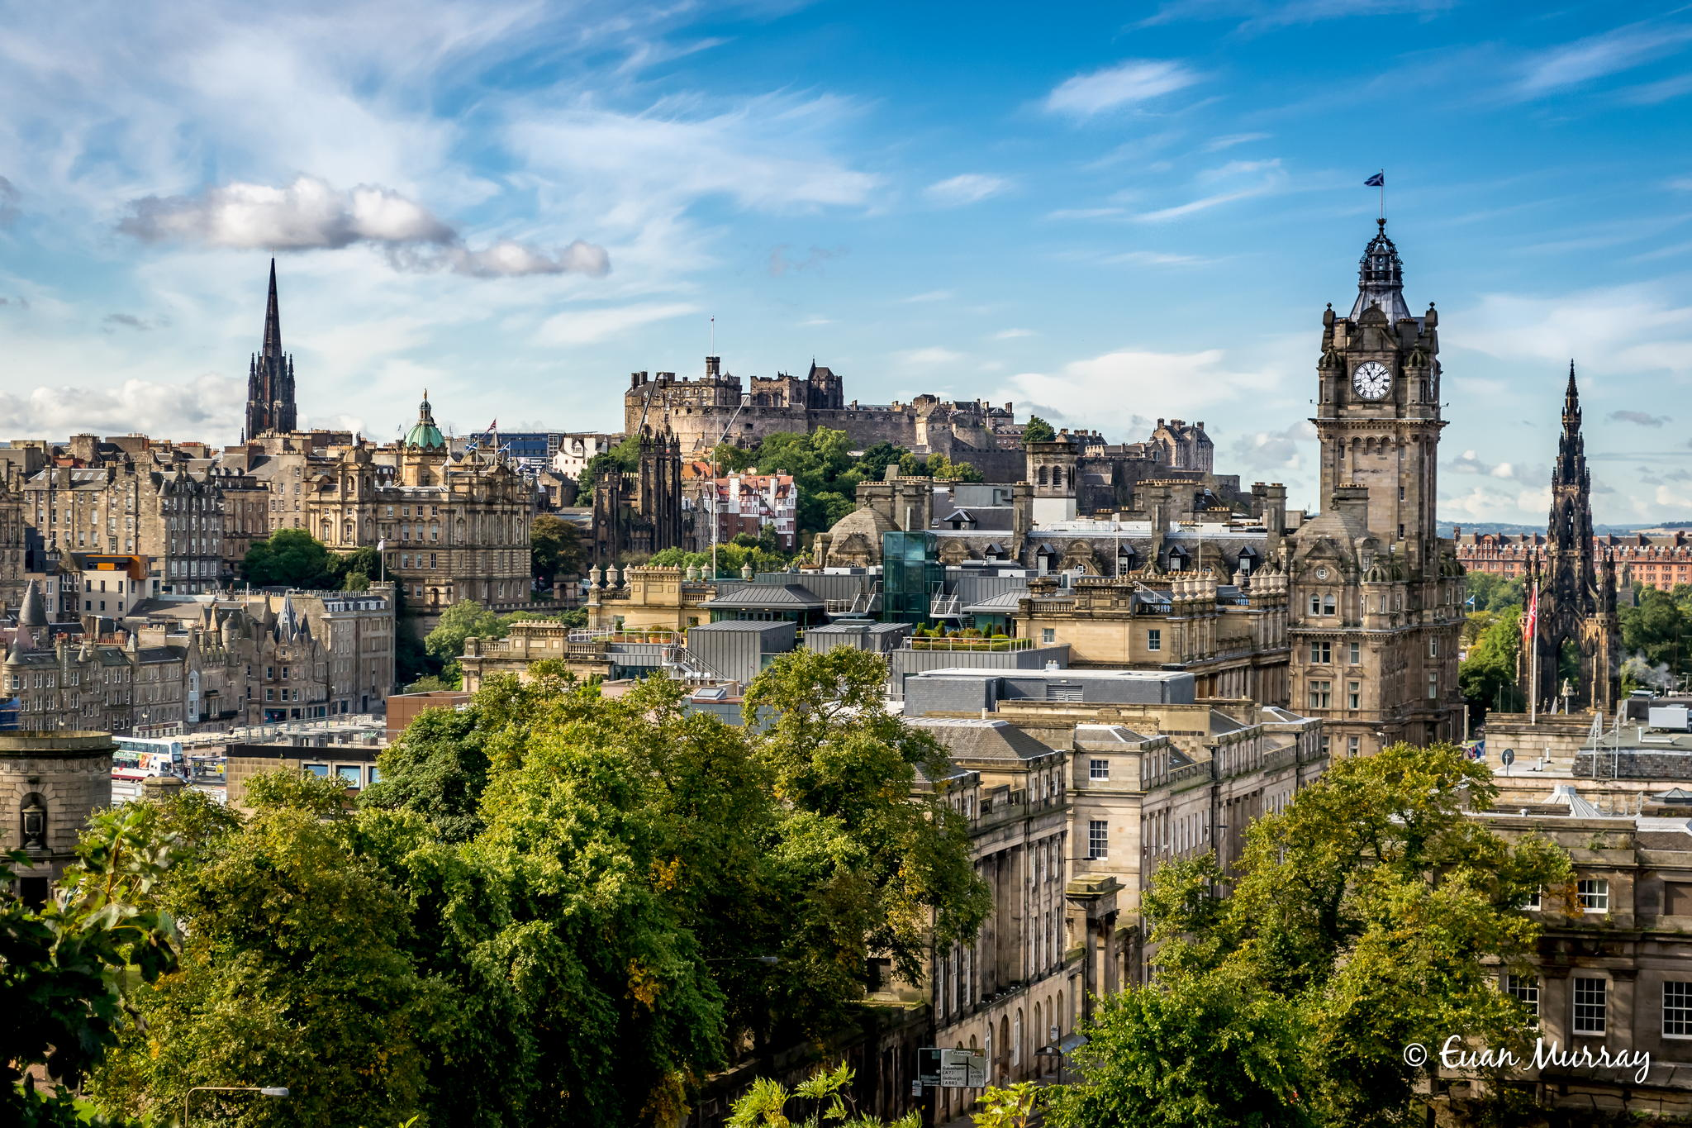](http://www.google.co.uk/url?sa=i&rct=j&q=&esrc=s&frm=1&source=images&cd=&cad=rja&uact=8&ved=0CAcQjRxqFQoTCJ7Lqp2QjccCFYuzFAodAt0H_g&url=http://www.thousandwonders.net/Edinburgh&ei=Enu_VZ76DIvnUoK6n_AP&bvm=bv.99261572,d.cWw&psig=AFQjCNEhZmObXEuB0J2LGegCpY9Ewgjyiw&ust=1438698532421594)[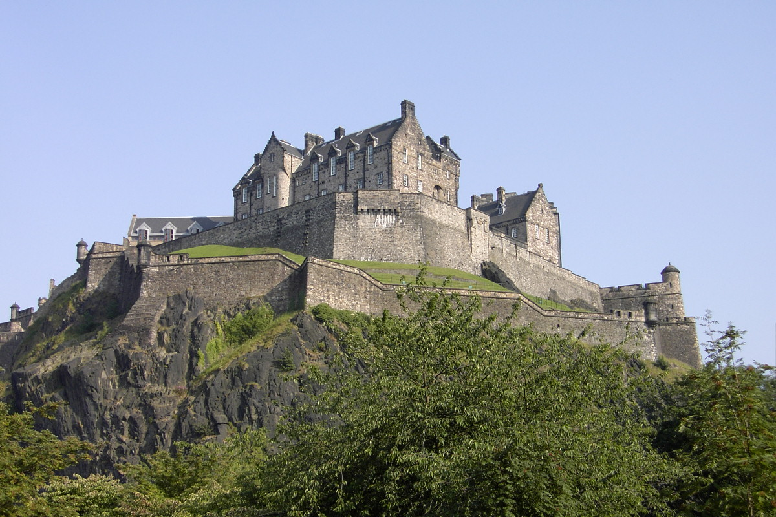](http://www.google.co.uk/url?sa=i&rct=j&q=&esrc=s&frm=1&source=images&cd=&cad=rja&uact=8&ved=0CAcQjRxqFQoTCL6VuIyQjccCFcXAFAod1LoAFQ&url=http://intoedinburgh.com/listing/edinburgh-castle-things/&ei=7nq_Vb7mL8WBU9T1gqgB&bvm=bv.99261572,d.cWw&psig=AFQjCNEe010oSQYMm1ky-gqPWwoaUfH0xA&ust=1438698578048312)

**Edinburgh**