Graphical skills activity sheet Tree maps

Tree maps
Tree maps are diagrams which represent data in nested rectangles. Each rectangle size corresponds to its numerical value. The data is hierarchical – a tree structure – and determines how the rectangles are sized and ordered within the total sum area.

The simple idea behind tree maps is to facilitate comparison of quantities and to reveal patterns of hierarchical structures. This is done by breaking the data into its constitutional parts, allowing comparison of large and small components within the dataset.

Instructions
The dataset below is extracted from the article Enhancing the Climate Infrastructure of Africa’s Infrastructure by Huber et al., from chapter 4, Table 4.2.

The focus is on climate change in Africa and the regional response, which has been to enhance infrastructure, particularly for water and power sectors. This investment is crucial to sustain Africa’s growth and accelerate the eradication of extreme poverty. The research covers the seven major river basins and all four of Africa’s electric power pools.

Basin | Existing hydropower capacity MW | Future additional hydropower capacity MW | Existing irrigation capacity ha | Future additional irrigation capacity ha
Congo | 1,858 | 44,402 | 20282
Niger | 1,994 | 4,667 | 738011 | 1791457
Nile | 2,542 | 21,392 | 6220270 | 772350
Orange | 680 | 48 | 66530
Sénégal | 200 | 877 | 75460 | 255327
Volta | 1,673 | 484 | 27909 | 177389
Zambezi | 4,827 | 8,204 | 244542 | 668542
Total | 13,774 | 80,074 | 7765688 | 4854870
Table 1 a summary of existing and planned hydropower and irrigation capacity

Follow the steps below to create a tree map for the data on existing and planned hydropower and irrigation.

- To create a tree map, open an excel spreadsheet and select the tree map under the Insert tab.

- You only need Branch 1 and Branch 2 in the first column. Delete any excess branches.

- Change all the Branch 1 cells to read “Future capacity”.

- Change the Leaf column to the country names i.e., Congo, Niger, Nile etc.

- Populate the data for Future additional hydropower capacity into the spreadsheet.

- You now need to repeat this process for Branch 2.

- Change all the Branch 2 cells to read “Existing hydropower capacity”.

- Again, you must input the country names, this time to replace all the Leaf cells in Branch 2.

- Populate the data for Existing hydropower capacity.

- Create a second tree map for Existing and future irrigation capacity.

Questions
- Analyse the graphic on existing and planned irrigation in Africa.

- Study Figure 1. Explain what the climate models suggest for the sale of hydroelectricity for the driest and wettest scenarios.

- Analyse the graphic on Existing and future irrigation capacity in Africa.

- Now explain what the climate models suggest for the revenue from irrigation for the driest and wettest scenarios.

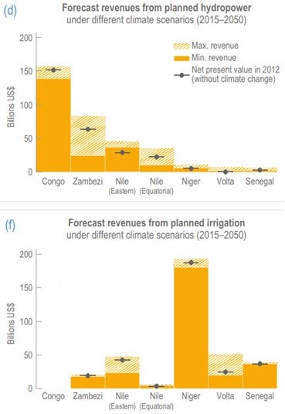
Figure 1 extracted from the IPCC report Impacts, Adaptation and Vulnerability chapter 9

Answers
  - The tree map is drawn below. If the full text isn’t visible you can hover over a sector for further details or click for a larger version.

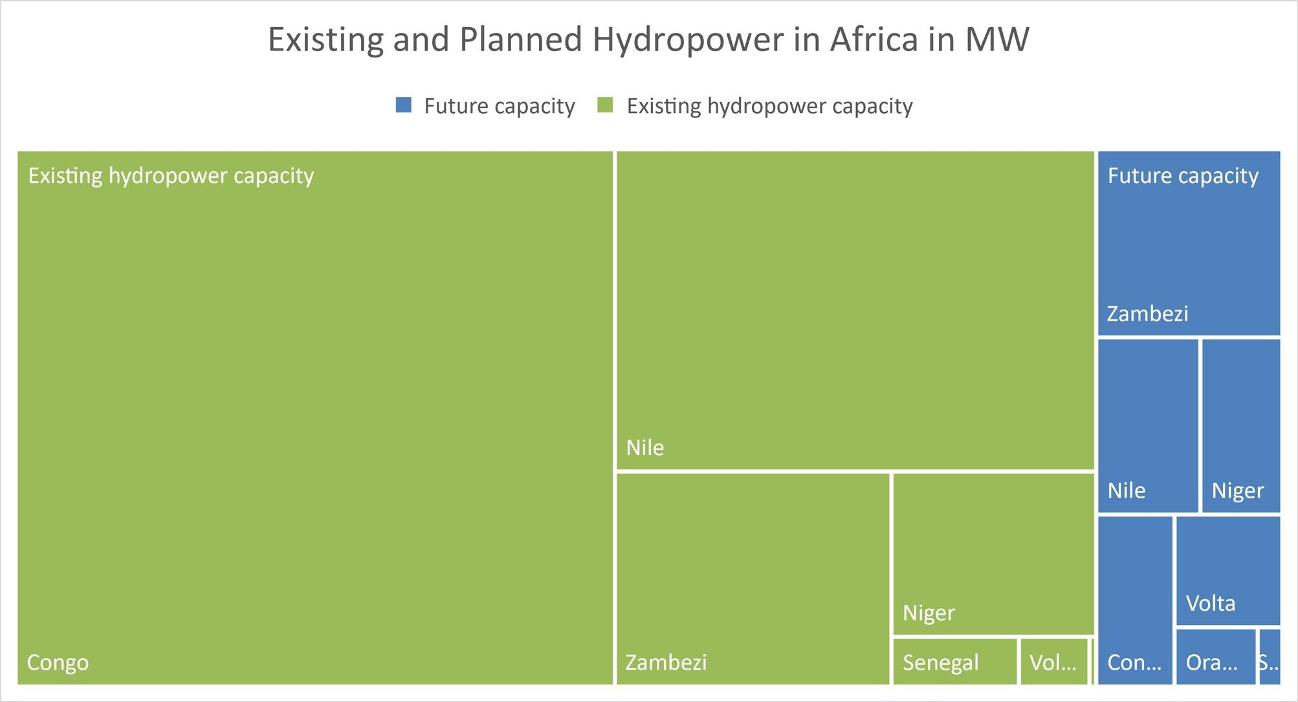
Figure 2

j. The tree map for Existing and Future irrigation capacity is below.

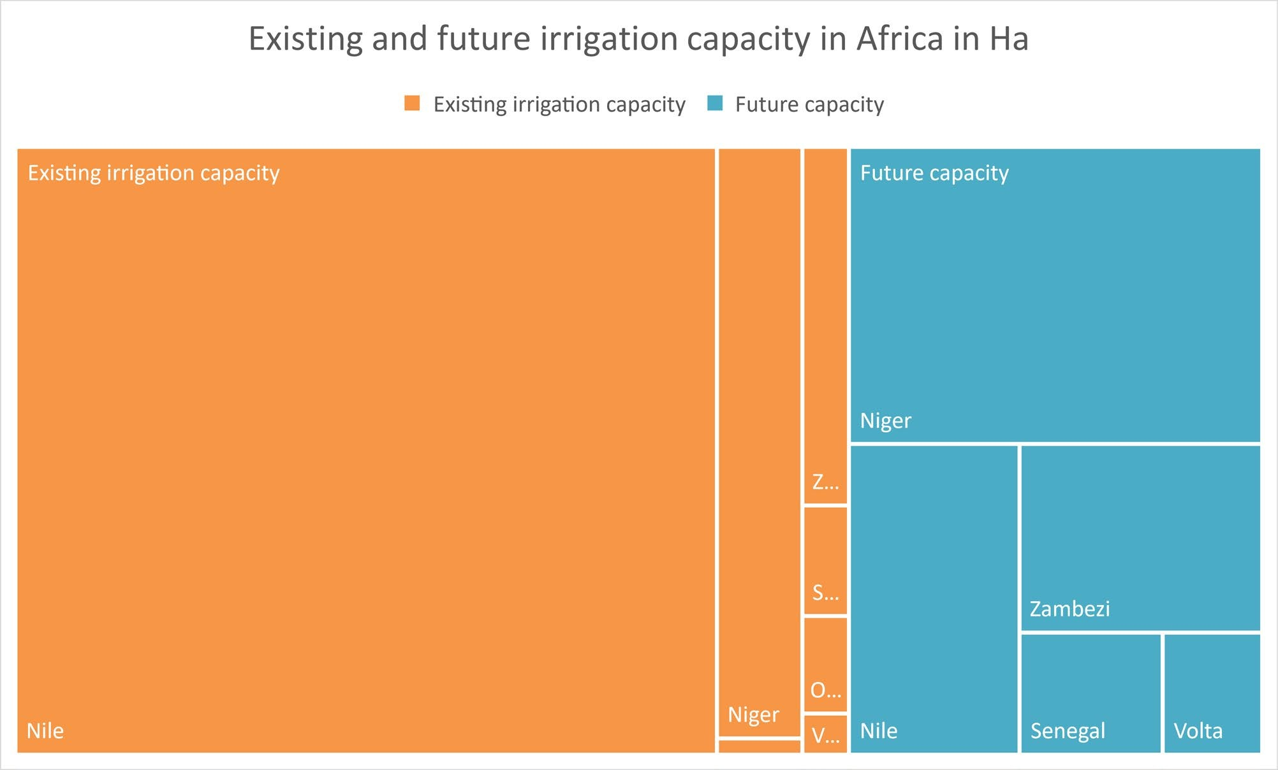

Figure 3
- The Congo River Basin is the largest in Africa. The Congo river is the continent’s largest by volume and is its most powerful. Figure 2 clearly shows that the Congo has the highest amount of existing hydropower capacity with 44,402 MW. This amount is double that of the next river – the River Nile – which has only 21,392 MW. However, the River Nile has more future potential for development. Future hydropower capacity for the River Nile has been estimated at an additional 2,542 MW. The smallest amount of hydropower capacity is currently the Orange River (48 MW), whilst the smallest future capacity is the Sénégal River (200 MW).

- The sale of hydroelectricity will have an impact in Sub Saharan Africa, particularly on the Congo and Zambezi rivers. The highest risk to hydropower output is in the Zambezi, where the driest scenarios would see a 58% reduction in revenues relative to a scenario without climate change. The next largest drop between net present value (without climate change) and minimum forecast revenues is for the River Nile.

- Future irrigation capacity is identified around the Niger River (1,791,457 Ha), the River Nile (772,350 Ha), and Zambezi River (668,542 Ha) in Africa. This directly correlates with existing capacity as the Nile, Niger and Zambezi currently have the highest level of irrigation. This is likely due to the water holding capacity of the soil and drainage conditions, irrigation infrastructure, and the amount of available water. These rivers have the top 10 largest discharges (m³/s) in Africa.

- The River Nile will lose the most revenue from planned irrigation due to climate change. The highest risk to production of irrigated crops is in the Eastern Nile, where irrigation revenue could be 34% lower in the driest scenario than the baseline scenario. After the River Nile the Niger River will be the second most affected. However, the Niger will retain a very high minimum revenue in spite of different climate scenarios.

