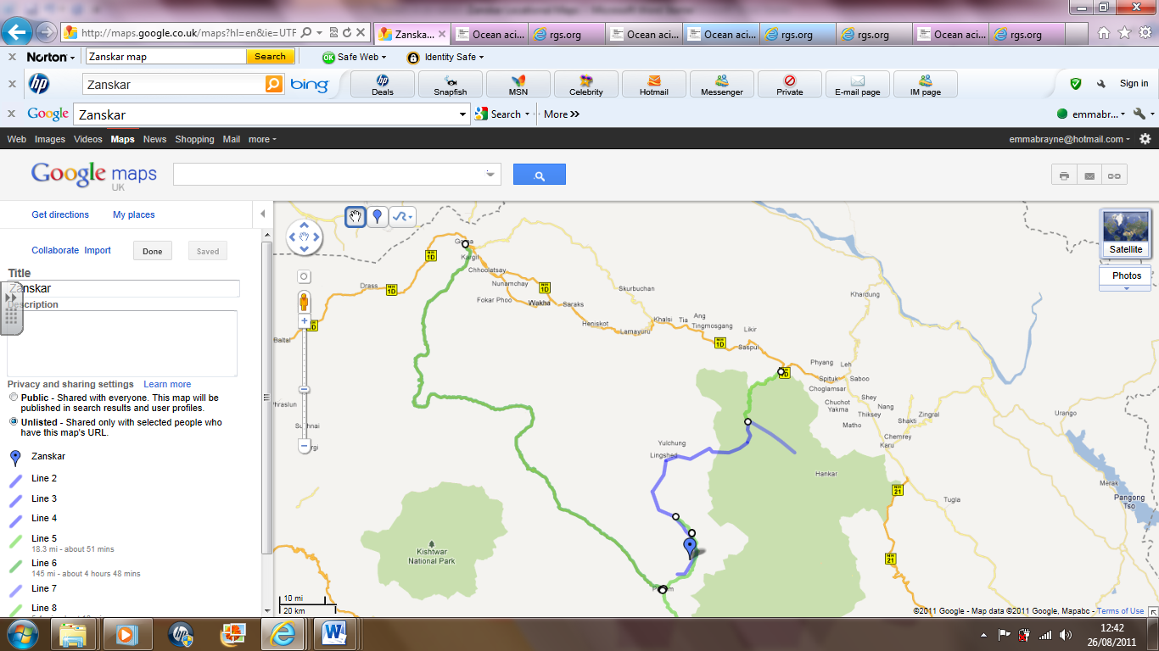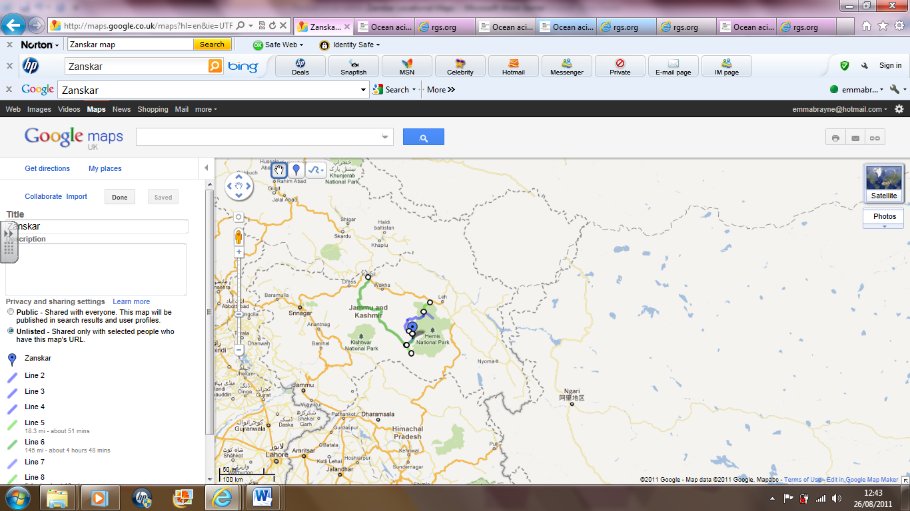

**1.**

**2.**

Small track road – only accessible in summer

The Chadar– a frozen river, tributary of the Indus River

**ZANSKAR**

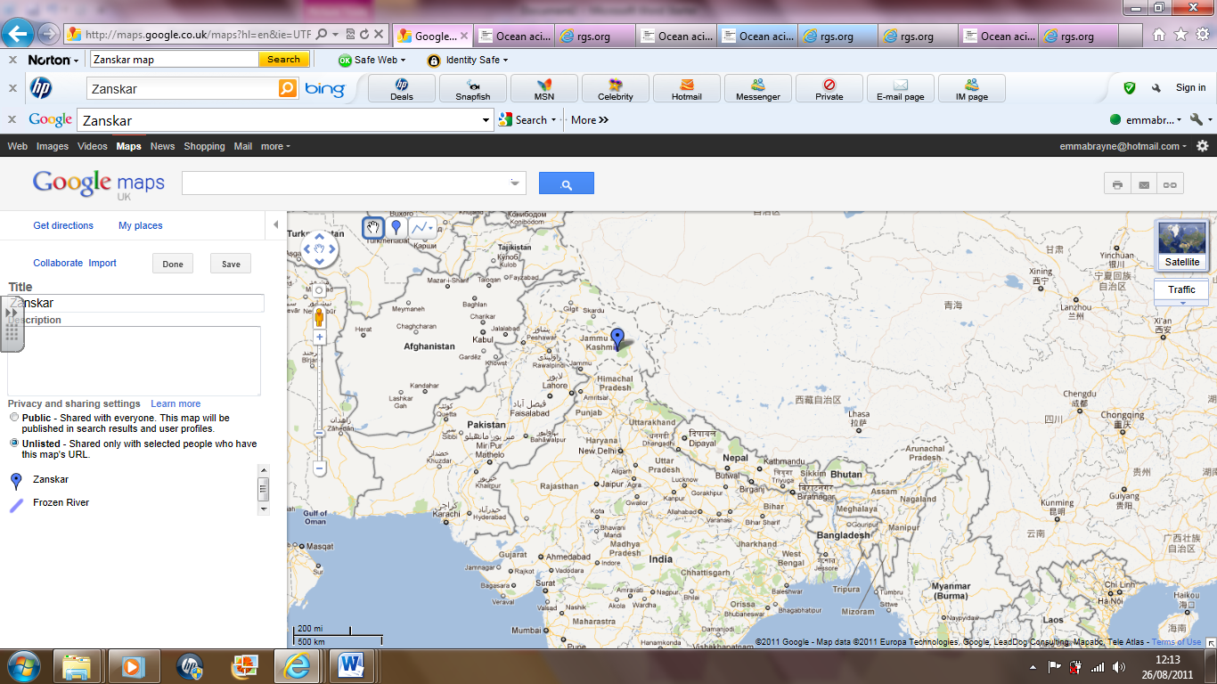

**3.**