FT for schools: Ghost Town to Growth Town activity sheet 15

This resource was written by author and geography consultant Stephen Schwab.

Introduction
The town council for Stevenage, led by Richard Henry, recently announced plans to ‘look beyond shopping’ to breathe life into the tired town centre. The council hope to create healthy high streets for the twenty-first century, with a new holistic approach based on building flats and creating jobs.

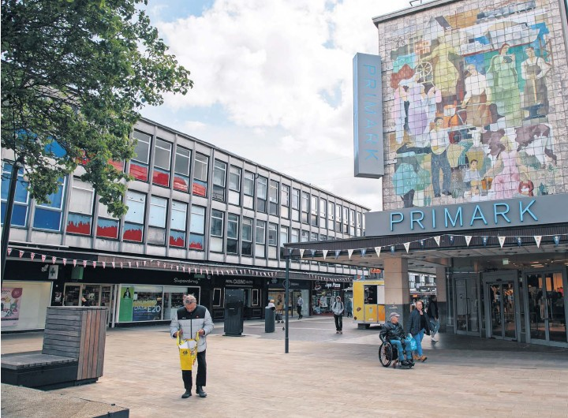
Figure 1 © Louis Delbarre, Hans Lucas/FT

The article
Access the article at www.ft.com/content/4bd1997b-6f2f-4787-a514-d12d34b0451c to learn about the postwar utopia of Stevenage.

After decades of attempted regeneration, based on retail and being a satellite town close to London, Stevenage now plans to be more than a commuter town. In the past workers have simply used the town to come and go from the capital. It is now hoped that the town can reimage itself to create a place that investors aspire to come to.

Due to the rise of megastores, delivery services, online shopping, and out-ot-town shopping centres high streets are increasingly under threat. Comparing year-on-year trends, high street footfall declined by 7.7% from pre-pandemic levels versus 2023, reports the BRC. The overall retail picture is equally gloomy, with the total footfall for high streets, shopping centres and retail parks 8.8% lower than pre-2019.
Specification links
AQA A level 3.2.3 Contemporary urban environments.

Edexcel A level 4A Regenerating Places.

OCR A Level Topic 2.1 Changing Spaces; Making Places.

WJEC A level Section A: Changing Places.

The Stevenage Vision Statement
In the early 1960s Stevenage town centre was brand new—bright, modern, and described as ‘cutting edge’. It summed up the twentieth century ethos of the new town. The Stevenage vision is to reinvigorate the town centre so that it once again serves people. It will be a ‘destination town centre’ with a mixed profile of retail, leisure and residential that will meet the needs of the local population whilst also attracting visitors for many years to come.

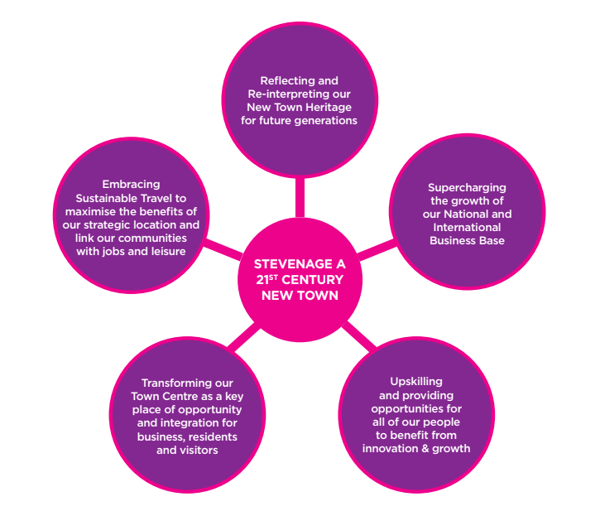

Figure 2 the Stevenage new town plan © Stevenage Even Better investment plan

Activity
- Read about the Soho area in London in Soho? It’s so yesterday, darling and London’s West End gets first purpose-built theatre in 50 years. Do you think that Stevenage can create a successful 21st Century Town Centre?

- Explain where you would rather visit and why.

- What social, economic and environmental problems will the regeneration need to overcome to convince the sceptics to choose Stevenage?

Further work
- Financial Times ‘New town’ offers vision of how to breathe life back into ailing UK high streets

- BBC News Stevenage: The town that aimed for Utopia

- YouTube Stevenage Regeneration - BBC Look East

- Hertfordshire Mercury Inside the £1bn redevelopment plan that will completely transform Stevenage town centre

