**National Flags**

[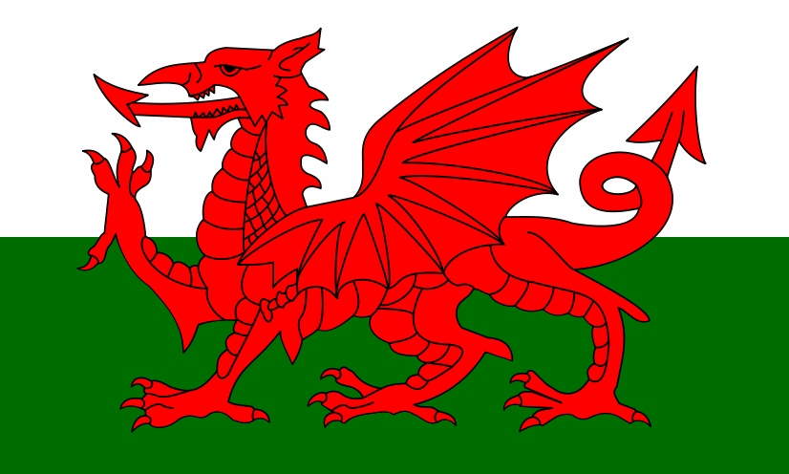](http://www.google.co.uk/url?sa=i&rct=j&q=&esrc=s&frm=1&source=images&cd=&cad=rja&uact=8&ved=0CAcQjRxqFQoTCM3h5vKXjccCFQpZFAodZoANGA&url=http://liberapedia.wikia.com/wiki/File:Welsh_flag.jpg&ei=HIO_Vc3jHoqyUeaAtsAB&bvm=bv.99261572,d.eXY&psig=AFQjCNEdOGQgkHgwVTDFY2t2PhB0uK9UBA&ust=1438700697442683)

**Wales:**

**Red Dragon**

**National Flags**

[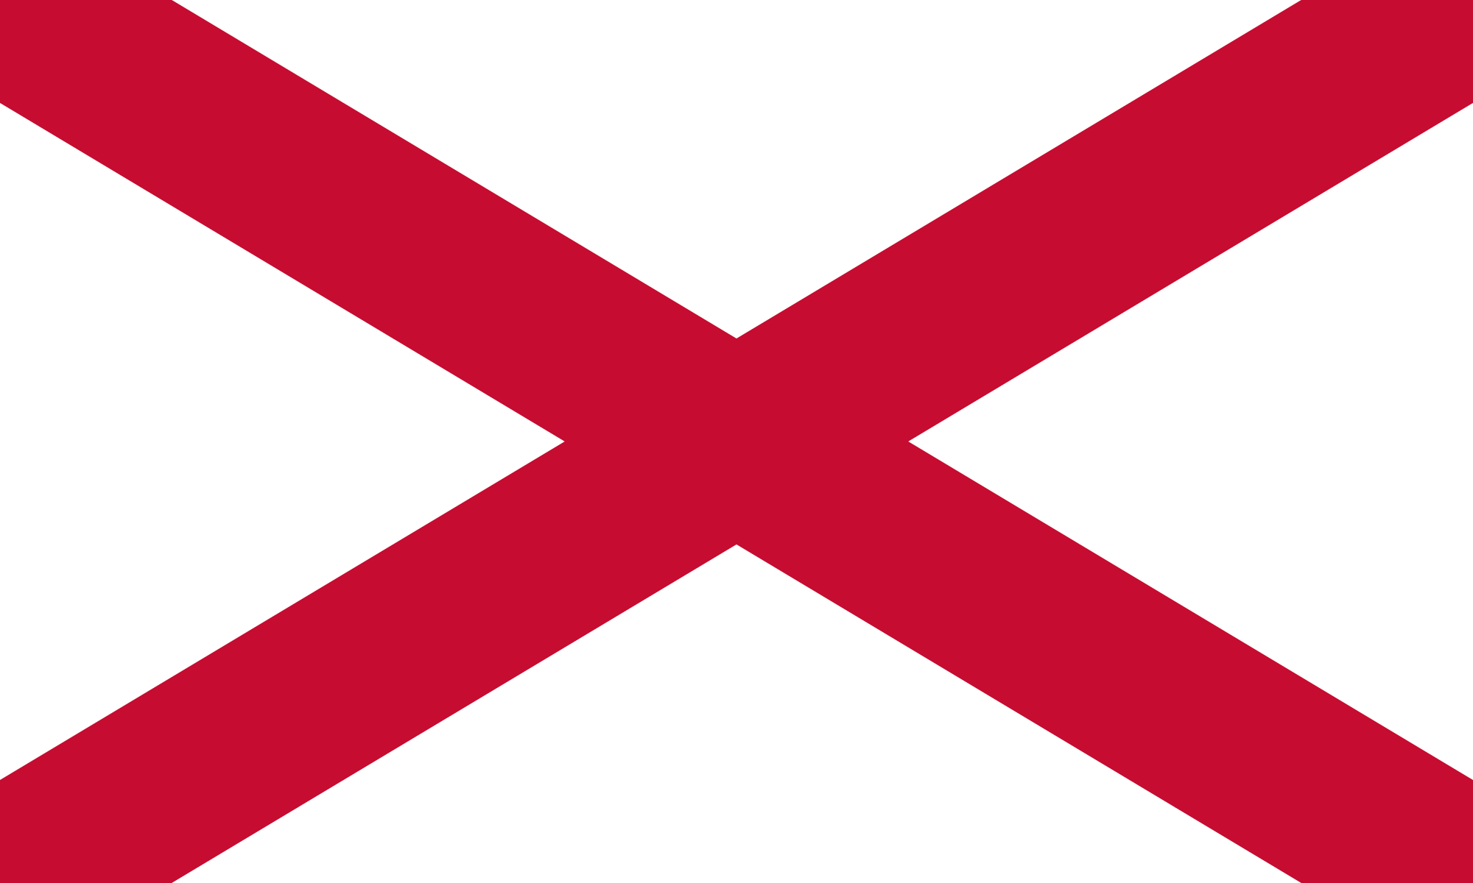](https://www.google.co.uk/url?sa=i&rct=j&q=&esrc=s&frm=1&source=images&cd=&cad=rja&uact=8&ved=0CAcQjRxqFQoTCMqaksmYjccCFUZZFAod6rcN1A&url=https://en.wikipedia.org/wiki/Flag_of_Northern_Ireland&ei=0YO_VYruIsayUervtqAN&bvm=bv.99261572,d.eXY&psig=AFQjCNGmUpmc3lVwBs-WZcxUgkCa3C7Kfw&ust=1438700860720453)

**Northern Ireland:**

**St. Patrick’s Saltire**

**National Flags**

[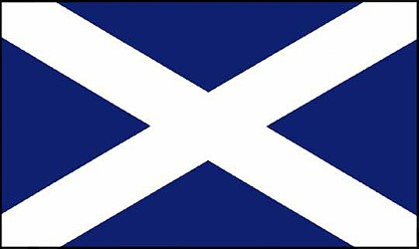](http://www.google.co.uk/url?sa=i&rct=j&q=&esrc=s&frm=1&source=images&cd=&cad=rja&uact=8&ved=0CAcQjRxqFQoTCK3d852YjccCFQFVFAodtQgCwQ&url=http://www.woodlands-junior.kent.sch.uk/geography/unionjack3.html&ei=doO_Va3KNoGqUbWRiIgM&bvm=bv.99261572,d.eXY&psig=AFQjCNGRtybwI8wQgWQBFrAE50N4vP5NGQ&ust=1438700787536251)

**Scotland:**

**St Andrew’s Cross**

**National Flags**

[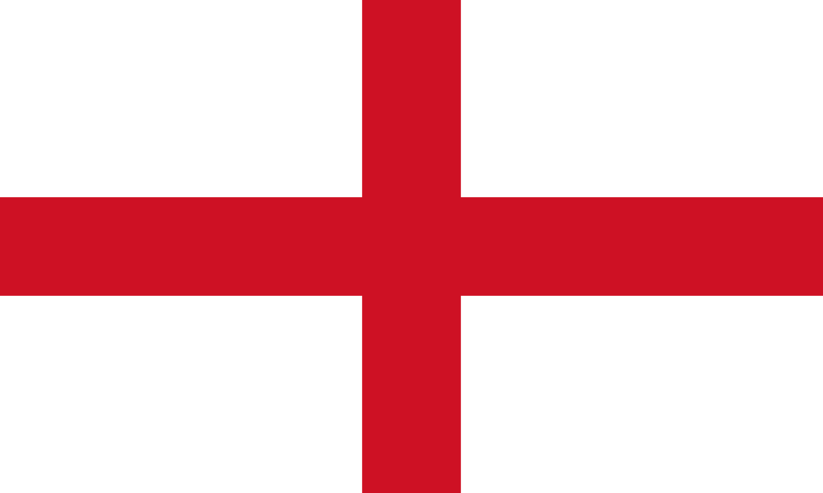](https://www.google.co.uk/url?sa=i&rct=j&q=&esrc=s&frm=1&source=images&cd=&cad=rja&uact=8&ved=0CAcQjRxqFQoTCJ-9gceXjccCFQfDFAodty4I0A&url=https://en.wikipedia.org/wiki/Flag_of_England&ei=wIK_VZ_dKIeGU7fdoIAN&bvm=bv.99261572,d.eXY&psig=AFQjCNHKCNpneLidi3jui4zNquiKDHtuLA&ust=1438700599866175)

**England:**

**St. George’s Cross**