FT for schools: COVID-19 activity sheet 2

This resource was written by Stephen Schwab, author, and consultant.

The article
www.ft.com/content/d48d3fe5-d152-4bcb-8f93-a96084543f48 Glasgow climate talks on hold over coronavirus 1 April 2020.

Specification links
Questions have been constructed considering the OCR A Level Specification Topic 3.1 Climate Change, but other exam boards include climate change e.g., Edexcel, Topic 7.

OCR A Level Geography scheme of work Topic 3.1. Climate Change. 3. Why is there a debate over Climate Change? 4. In what ways can humans respond to Climate Change? 5. Can an international response to Climate Change ever work?

Activity
Read the Financial Times article: Glasgow climate talks on hold over coronavirus 1 April 2020.

- Suggest why COP26 2020 was to be such an important event and explain the implications of its hoped outcome.

- Give one positive and one negative consequence of the postponement.

- The article has had several responses. Read the letter from Connor McCoole in response to the postponement. Summarise the key points of his letter.

Read the comments from readers after the news reporting, from C3PM, Richard, and John 9913.

C3PM wrote: ‘We don’t know yet if policy makers are overreacting to Climate Change. Imagine if trillions of dollars was spent thoughtfully to reduce carbon emissions 20 years ago’.

Richard replied: ‘People need jobs first before they start worrying about Climate Change’.

John 9913 replied: ‘Dead people don’t need jobs. There is a hierarchy of needs, a viable environment is a precondition for a functioning economy’.

- What are the common arguments expressed by the two readers C3PM & John 9913?

- Do you believe Richard makes a valid point? Give reasons for your opinion.

Further work
- France 24 Future pandemics likely to be deadlier and more frequent, warns UN panel

- The Washington Post Amid pandemic, U.N. cancels global climate conference

UN Climate Change Executive Secretary Patricia Espinosa said that climate change remains ‘the biggest threat facing humanity over the long term’ and that restarting economies would be ‘a chance for nations to recover better, to include the most vulnerable in those plans, and a chance to shape the 21st century economy in ways that are clean, green, healthy, just, and more resilient.’

European Commission vice-president Frans Timmermans said ‘we will not slow down our work domestically or internationally to prepare for an ambitious COP26, when it takes place’, indicating European Union commitment to climate neutrality by 2050 and intent to formally pledge more aggressive future emissions cuts, adding ‘we will also continue to work intensively through all available channels with our partners around the world to share our plans and to encourage them to raise ambition, too’.

Laurence Tubiana, chief executive of the European Climate Foundation, a key player in the 2015 Paris agreement noted the postponement understandable but she hopes it will increase resolve among countries to work together in the future. ‘Public health and safety must come first now. This crisis has shown that international cooperation and solidarity are essential to protect global well-being and peace. COP26 next year should become a centrepiece of revitalized global cooperation.’

- Write a detailed paragraph showing how the three officials suggest the COVID-19 pandemic could positively affect tackling Climate Change.

- COP26 was considered urgent in the battle against Climate Change. Read the rest of the Washington Post Article (or any other sources you may wish to research) and list at least 5 pressing problems/impacts of current temperature conditions and forecasts.

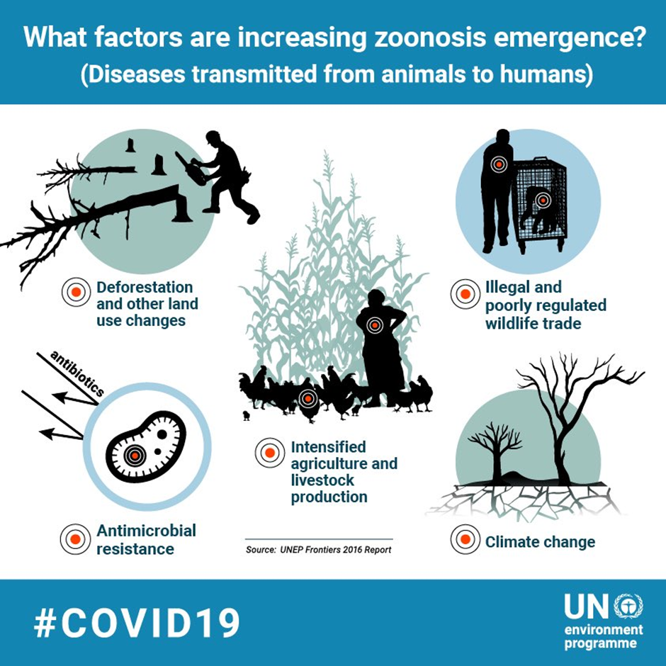
Figure 1 © UN Six nature facts related to coronaviruses

- What does the poster show about the connections between Climate Change and COVID-19?

Read the Financial Times Opinion: Coronavirus has exposed our arrogant relationship with nature 9 April 2020 by Johannes Vogel, director – general of the Museum of Natural History in Berlin, the Leibnitz Institute for Evolution and Biodiversity Research and a professor at the Humboldt University www.ft.com/content/902310ea-7996-11ea-bd25-7fd923850377. The writer’s opinion is that ‘the threats we face are interrelated’.

- Suggest a minimum of three problems the writer highlights about world approaches to the interrelated problems of nature and climate.

- He claims that the world already has the technology to tackle climate change, but lacks the will to act collectively.

Research Mitigation and Adaptation strategies to reduce the risks of Climate Change. Assess how effective responses to Climate Change have been at differing levels of political and social cooperation and differing geographic scales (global, national, local).

- Nature Why deforestation and extinctions make pandemics more likely

- BBC News Coronavirus: This is not the last pandemic

