Coastal processes mix and match sheet
Draw a line from the key term to the definition then add a letter in the table of the image which best represents the process. Use different colours for each process to help you see the connections more clearly.

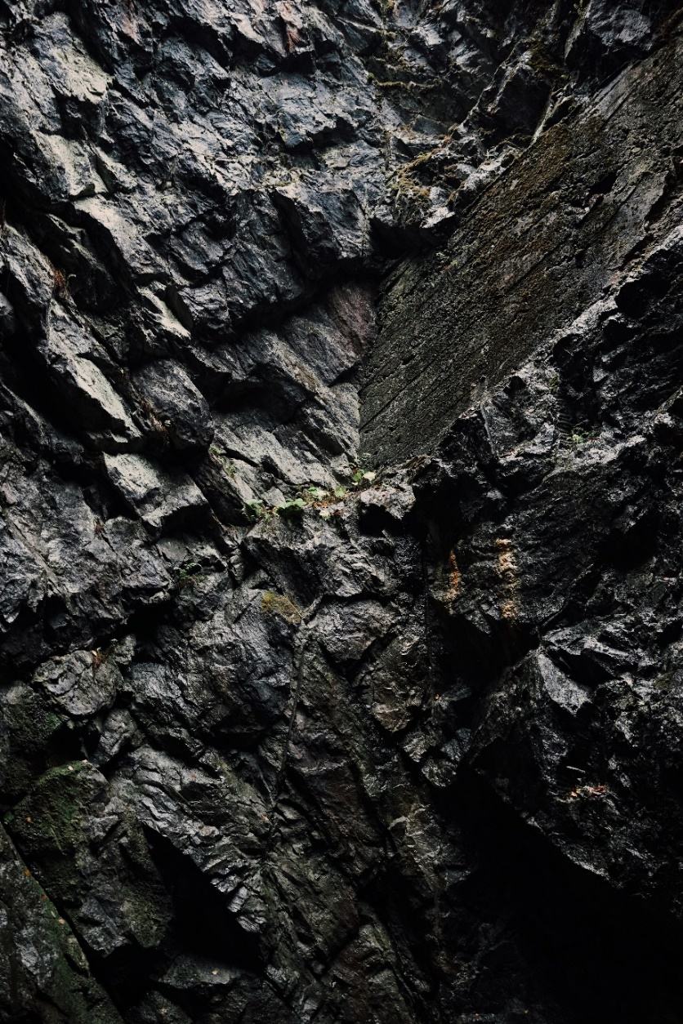
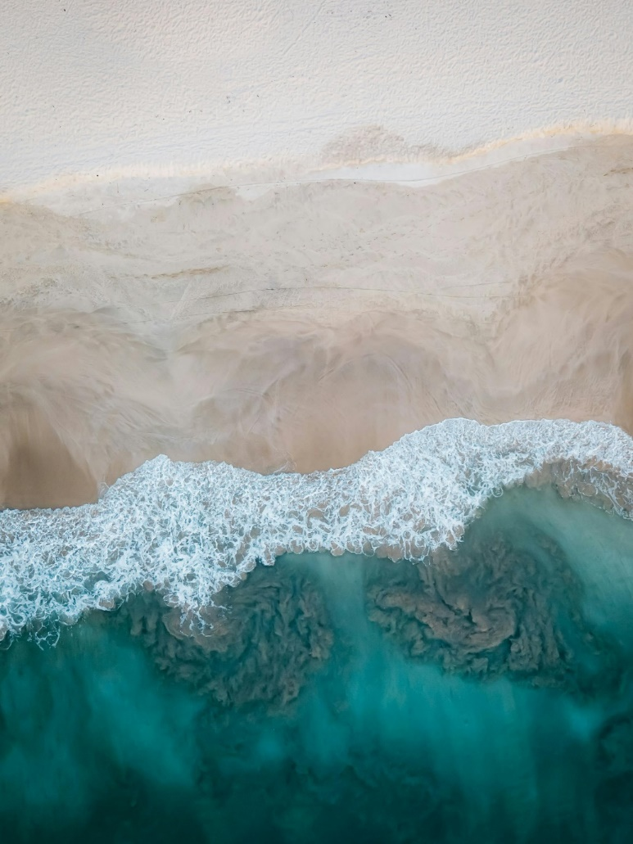

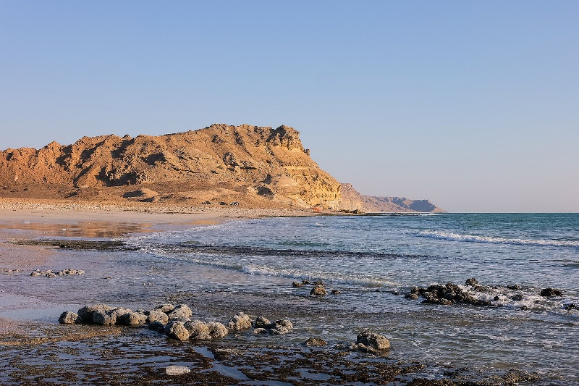
E
D
C
B
A

Key term |  | Definition |  | Image Letter
Weathering |  | The downhill movement of material under the force of gravity.
Mass movement |  | The wearing away of the coast by the sea.
Deposition |  | The movement of material within the sea.
Transportation |  | The breaking down of rocks in situ (in original place) by the elements such as wind and rain.
Erosion |  | What is left behind when waves lose their energy.

Answers

Key term |  | Definition |  | Image
Weathering |  | The downhill movement of material under the force of gravity. |  | 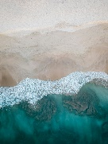E
Mass movement |  | The wearing away of the coast by the sea. |  | D
Deposition |  | The movement of material within the sea. |  | 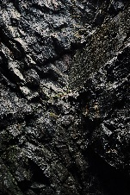B
Transportation |  | The breaking down of rocks in situ (in original place) by the elements such as wind and rain. |  | 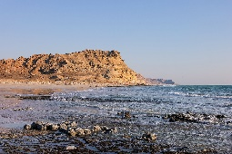C
Erosion |  | What is left behind when waves lose their energy. |  | A

