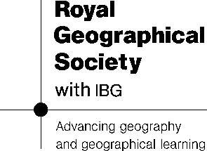
Station 1: Ruppell’s Fox
Tasks
1. Match the sentence starters and ends together on the station. Don’t forget to mix the statements back up again once you have finished.
2. Use the descriptions to annotate around the image of the Ruppell’s Fox below to show how it adapts to the desert. Make sure you draw arrows to the place where you are describing the fox.

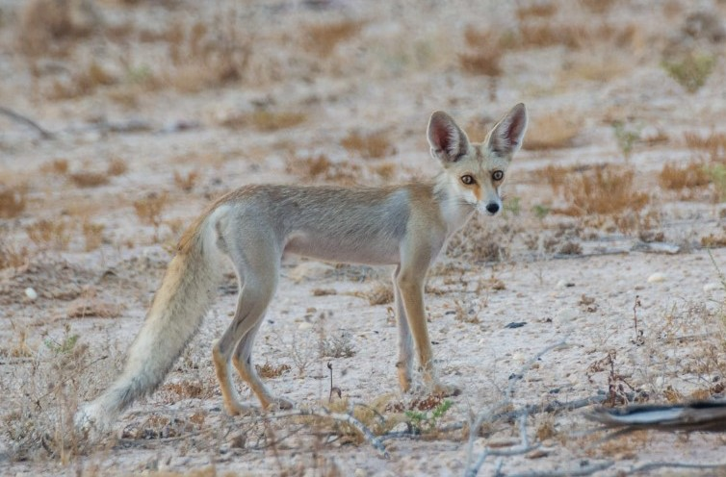
Source: Jude Vincy CC-BY-2.0

Station 2: The Date Palm Tree
Task: Read the following facts and complete the missing parts of the sentence using the word bank. NOTE: the word will only be used once.
Text summarised from: Date palm: The cornerstone of civilisation in the Middle East and North Africa. By Tammana Begum, NHM, 22 March 2023
The Date Palm has adapted to thrive in most of the Arabian Peninsula as well as other arid environments around the world. It is thought that wild Date Palm trees were growing in Oman over 6,000 years ago. Date Palms can grow up to 23 metres tall and can live up to 100 years. They are Keystone Species meaning that they help define a whole ecosystem – without them, the ecosystem would be hugely different or not exist at all.
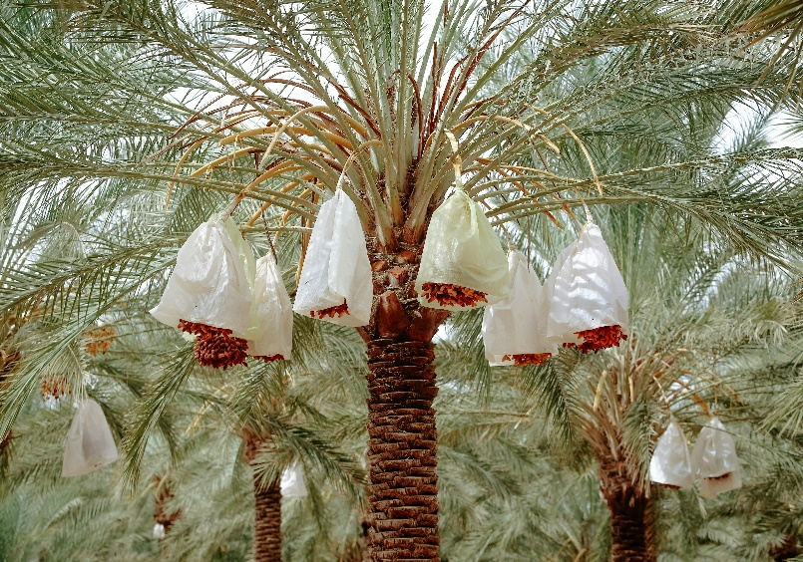
- Deep Roots: Its long, deep root __________ allows it to access underground ________ sources, such as hidden rivers, ensuring survival despite low rainfall.

- Heat Resistance: The tree requires high temperatures (above ____°C) to bear fruit but can also withstand brief cold spells below _______°C.
Image Credit: Radwan Menzer, Pexels
- Microclimate Creation: Its tall, robust trunk and canopy provide _______, reducing wind _________ and enabling other __________ to grow around it.

- Drought & Salinity Tolerance: The date palm can survive in dry, ______ soils, making it well-suited to desert environments.

- Pollination Strategy: It is mainly wind-__________ but can also be pollinated by __________. In modern agriculture, selective pollination increases fruit production.

- Sustainable Food Source: The fruit is ___________, non-perishable, and easily _______________, making it a crucial food supply in arid regions.


Station 3: Wahiba Bedouin People
Task: Read the diary entry of a Bedouin and summarise how they have adapted below using one of the following formats: mind map, table, bullet points.
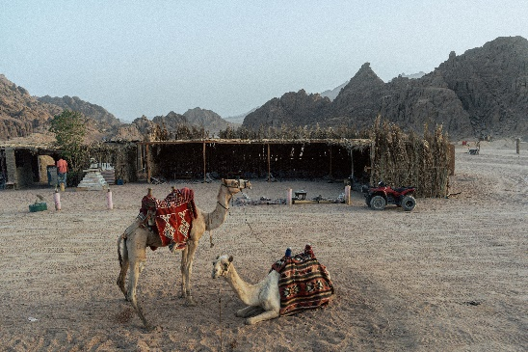

Image Credit: Irem Turkkan, Pexels

