Ocean Acidification

Lesson 1: Case Study

Key question: What is ocean acidification, how is it linked to climate change and why is it so significant in the Arctic region?

Aim: To produce an A-level case study on the topic of ocean acidification in the Arctic Ocean, to include:
- an overview of key processes
- facts and figures
- sketch maps and diagrams
- location-specific information

Starter
Watch the audio slideshow “The Science”. This gives an introduction to the process of ocean acidification, which you will be studying over the next three lessons.

Before you start, get into groups of four. Each person in the group should be allocated a question from the list below, and should concentrate on answering this question while they watch the video clip. After you’ve finished watching, share your answers with the rest of the group and the class.

Tip: You’ll have to watch the whole clip to fully answer each question – don’t stop listening once you think yours has been covered or you might miss something!
Questions:
- Write a summary of the main physical and biological processes that result in carbon being exchanged between the atmosphere and the ocean.
- What are the two reasons why the Arctic Ocean is so vulnerable to ocean acidification?
- How is human activity contributing to ocean acidification?
- What impact does ocean acidification have on organisms living in the Arctic Ocean?

Now read Dr Helen Findlay’s blog entries from her 2010 ocean acidification research trip to the Arctic Ocean, where she spent 45 days monitoring levels of carbon dioxide in the atmosphere and ocean, and taking water samples for analysis back in the laboratory.

- Visit www.catlinarcticsurvey2010.com
- Click on the Blog tab at the top of the page
- Look through the blog for entries made by the Scientific Team

As well as giving you some more information about ocean acidification and the research project you’re studying, this will also give you an idea of how an academic blog might be written, as this is what you’ll be doing for the remainder of the lesson.
Main
Now it’s your turn!
Your task is to write three blog entries as if you were an ocean acidification scientist in the Arctic Ocean. These will form a case study of ocean acidification research in the Arctic Ocean. Your blog entries should include facts and figures, sketch maps and diagrams drawn by you and if necessary scanned into your blog), and specific location relating to the location and aims of the project. Each entry should be approximately 350 words long (but no longer!).

The three entries should cover the following aspects of the project:

- What is ocean acidification?
An introduction to the issue of ocean acidification including:
- A definition of the term ‘ocean acidification’
- Facts and figures about the process and how it affects organisms living in the ocean
- A diagram to show the process of ocean acidification

- What was the project in the Arctic Ocean all about?
Specific information about Dr Helen Findlay’s research project in the Arctic Ocean, including:
- A location map
- The aims of her research
- The techniques that she used

- What does the future hold for the Arctic Ocean?
- An explanation of why the Arctic Ocean is particularly vulnerable to ocean acidification, and threats to the ecosystems in this region
- A summary of key findings from Dr Helen Findlay’s research
- Information on how ocean acidification can be prevented

There are many sources of information that you can use to help you write your blog. The Ocean Acidification Reference List document provided is a good place to start. You might also find Dr Helen Findlay’s own summary of her research findings useful, although this is an academic document so the content is quite complex.

Plenary
What have you learnt so far?
Without looking back at your notes, write down three new facts about ocean acidification during the course of this lesson. Share your ideas with your group or with the rest of the class. You could do this by contributing to a shared document and/or displaying them on the Interactive White Board.

To help you to decide which information to consult first, each source has been given between one and three stars according to their importance to your work:

*** Vital, you must read / watch this
** Useful for finding out that extra detail
* In-depth information for the topics you’re really interested in

Documents

Ocean Acidification – The Facts ***
A special introductory guide for policy advisers and decision makers.
EPOCA (European Project on Ocean Acidification) 2009
www.epoca-project.eu/index.php/what-do-we-do/outreach/rug/oa-the-facts.html
A great starting point with a fact file and some general information about ocean acidification including a summary of recent research into the problem.

Ocean Acidification – Questions Answered **
A fresh look at the global problem of ocean acidification for those people who want to know a little more.
EPOCA (European Project on Ocean Acidification) 2010
www.epoca-project.eu/index.php/what-do-we-do/outreach/rug/oa-questions-answered.html
A more detailed document that specific information about the processes and chemical reactions involved in ocean acidification, and the implications for oceans and species.

The Guardian, 10 December 2009 **
Ocean acidification rates pose disaster for marine life, major study shows.
www.guardian.co.uk/environment/2009/dec/10/ocean-acidification-epoca
This article outlines the threat that ocean acidification poses to marine organisms and highlights the difficulty of preventing the process from occurring with current rates of CO₂ emissions.

Additional documents can be found on the EPOCA education website **/*
These include information posters, fact sheets and articles. See links within the text and also at the bottom of the page.
www.epoca-project.eu/index.php/what-do-we-do/education/classroom.html

Video clips

The Other CO₂ Problem ***
www.youtube.com/watch?v=55D8TGRsl4k
An animation explaining the issue of ocean acidification produced by students at a school in Plymouth.

Plymouth Marine Laboratory ***
www.youtube.com/user/PMLAdministrator?feature=mhee
Ocean acidification: connecting science, industry, policy and public. An excellent video clip which covers all aspects of ocean acidification: the process, implications and potential solutions.

Catlin Arctic Survey 2010: The Story So Far ***
www.youtube.com/watch?v=IXAdxSSfYE0&feature=related
An overview of the 2010 Catlin Arctic Survey in photos and facts. This slide show explains ocean acidification and outlines the aims of the survey.

Catlin Arctic Survey Science Video Gallery ***
www.catlinarcticsurvey.com/tag/science/
A selection of video clips from research scientists describing their work and experiences collecting data at the Arctic Sea Ice Station. The 2010 survey focused on ocean acidification, so it is the 2010 video clips that you are particularly interested in.

Dr Helen Findlay of the Catlin Arctic Survey Ice Base **
www.youtube.com/watch?v=lxZVq096USg&feature=player_embedded
In this video clip, Dr Helen Findlay explains the difficulty of collecting data in the extreme cold environment of the Arctic.

Audio

Ocean Acidification Lecture by Professor Nicholas Owens **
www.geographyinthenews.rgs.org/interviews/article/default.aspx?id=1234
Professor Nicholas Owens is the Director of the British Antarctic Survey. In 2009, he gave a lecture on ocean acidification at the Royal Geographical Society (with IBG). If your school has membership of the RGS, you can listen to his lecture by logging onto the Geography in the News website and clicking the link on this page.

Websites

Catlin Arctic Survey 2010 ***
www.catlinarcticsurvey2010.com/Science.aspx
The Catlin Arctic Survey is a collaboration between scientists and explorers to undertake research in the Arctic. In 2010, the survey focused on ocean acidification, and Helen Findlay was part of the ‘Ice Team’ of academic researchers. On this website you can find information, photos and blogs about her experiences and findings. There is also some useful background information about ocean acidification (under ‘About’), detail of the equipment she used (under ‘Equipment’), and information about the wider aims of the survey (under ‘Research’). Finally, you can see a map of where her research was carried out by clicking on the Google Earth icon at the top right of the site.

Catlin Arctic Survey Science ***
www.catlinarcticsurvey.com/science/ocean-acidification-2010/
This website includes a very useful diagram summarising the process of ocean acidification.

The Independent blogs ***
http://blogs.independent.co.uk/author/catlinarctic/
Dr Helen Findlay wrote three blog entries for The Independent whilst carrying out her research into ocean acidification in the Arctic. They are the first three blog entries on this website: “’You know it’s been great when the farewell is hard’”, “Over half way in the high arctic” and “In video: Dr Helen Findlay at the Catlin Arctic Survey Ice Base”.

Geography in the News website ***
www.geographyinthenews.rgs.org/interviews/article/default.aspx?id=1234
Professor Nicholas Owens, the Director of the British Antarctic Survey, answers questions on ocean acidification.

BBC News Website ***
http://news.bbc.co.uk/1/hi/sci/tech/7933589.stm
Ocean acidification is explained here as one of the key effects of climate change. The potential impacts of the process on coral, plankton and invertebrates are outlined and there are some useful diagrams.

Catlin Arctic Survey **
www.catlinarcticsurvey.com
The general Catlin Arctic Survey website has yet more on the research carried out during the 2010 survey, plus information about the 2009 project, which focused on Sea Ice Loss, and the 2011 project, which focused on Thermohaline Circulation.

EPOCA Ocean Acidification Blog *
http://oceanacidification.wordpress.com/
An information outlet on ocean acidification provided by EPOCA, the European Project on Ocean Acidification, which reports on research developments and media coverage of the issue.

Ocean Acidification in the Arctic: A summary from current observations.
Helen Findlay, Plymouth Marine Laboratory

Ocean acidification is normally discussed in terms of global average responses – the global surface ocean pH has decreased by 0.1 unit since the industrial revolution; the global surface ocean pH is expected to continue to decrease by a further 0.3 units by the end of the 21st Century (Feely et al. 2004). However, just like temperature and global warming, we know that ocean pH differs regionally (Fig. 1), and in many locations there is also a seasonal cycle. For example, in the temperate and sub-polar regions of the North Atlantic and North Pacific, there are long-term records that the pH varies on a seasonal cycle (Bellerby et al. 2005; Wootton et al. 2008; Olafsson et al. 2009) because of changes in physical ocean properties, such as temperature and salinity, but also because of the biological processes. Microscopic plants (phytoplankton) photosynthesis in the spring and summer and take up CO2 from the ocean thereby causing a slight increase in pH, but in winter when few plants grow, respiring organisms have a more significant effect on the pH by releasing CO2 back into the ocean (Fig. 2; Findlay et al. 2008; Litt et al. 2010). Ocean pH change is buffered by the ions that are present in seawater (collectively known as alkalinity). A particularly important ion is carbonate ion. Carbonate ion can join with hydrogen ions to form bicarbonate ions, and in this way, over long periods of time, these ions regulate ocean pH. However when CO2 is added to the ocean very rapidly, as is happening now, the concentration of carbonate ions is not able to keep up and so is also reduced.

The carbonate ion concentration is important for determining the saturation states of calcium carbonate (CaCO3) minerals such as calcite and aragonite. These minerals are important for contributing to the carbon cycle but are also important components of many marine organisms’ shells and skeletons. When there is a lower concentration of carbonate ions then the CaCO3 saturations state is also going to be relatively lower. If the CaCO3 saturation state falls below 1 (becomes undersaturated) then the minerals are more likely to dissolve. In the Arctic Ocean the alkalinity level is already lower than many other oceans. So the Arctic is unlikely to be able to buffer as much change in pH as other regions might.

To date most data and information about the carbon cycle and ocean acidification in the Arctic
Ocean has come from fieldwork carried out in the late spring, summer or early autumn months.
There are very few datasets of the wintertime pH conditions and particularly few studies have looked at how the biological processes influence the carbon cycle in late winter and early spring when light levels increase enough to stimulate phytoplankton growth. The Arctic Ocean is further complicated by sea ice, which may act to slow or stop gas exchange between the atmosphere and the ocean; sea ice also affects ocean mixing, temperature and salinity regimes, as well as the marine organisms that are present in the ocean.

Observations of the spring and summertime carbon system, including measurements of pH and the important CaCO3 saturation states, have shown that the Arctic Ocean already appears to have quite low levels of both pH and CaCO3 saturation states, compared to the global averages (Fig. 3). Because much of this data has come from summer research cruises (using research ships) the areas studied tend to be where there is less ice cover and where phytoplankton have already started to consume CO2 and increase the pH level.
Our research, with the Catlin Arctic Survey in 2010 and 2011, has involved measuring the carbon system in the seawater under the sea ice in the Arctic Ocean during the late winter and early spring period. Although we are still finalising the data, we found levels of pH and carbonate ions are low in the seawater underneath the ice, but can be significantly influenced by both biological and physical processes. The sea ice itself had a pH of about 7.3 at this time of year, which is unsurprising because brine (salt) will have drained out of the sea ice when the sea ice was forming and this process will have removed much of the dissolved inorganic carbon and the alkalinity from the sea ice. Micro-organisms that live in the sea ice are continually respiring and releasing CO2 as well, so there is a build-up of CO2 gas in the sea ice which lowers the pH.

We were also looking at how different pH levels might affect a type of zooplankton (microscopic animals) called Copepods. Copepods are quite hardy creatures as they are able to thrive in many different environmental conditions. They are able to migrate hundreds of meters vertically through the water column every day. We found that they were not significantly impacted by the changes in pH that we exposed them to in terms of their ability to survive, grow and develop.

This is perhaps not surprising as the pH levels that we measured through the water column ranged from about 7.7 at 200 m to 8.0 at the surface. These natural pH levels are equivalent to what are considered the global average conditions for now (pH 8.1); and are predicted for the future (pH 7.7); and are the levels that we exposed the Copepods to. Additionally we must remember that there is a seasonal variability in pH. Therefore not only will the pH conditions change depending on where the organisms are living but it will also change depending on the time of year.

Marine organisms that live in these naturally variable environments will only be exposed to these low pH conditions for certain periods of their lives. They are likely to have adaptive mechanisms in their behaviour or physiology that allow them to survive these relatively short periods of stress. Understanding what these mechanisms are will allow us to understand how and why some organisms may be more vulnerable than other organisms. So we are still looking deeper into the physiology of these copepods in order to understand if there are subtle changes in their energy budgets and life-history. Another important point to remember is that ocean acidification is acting to shift the range of these naturally variable systems. For example, a seasonal cycle of pH in surface waters could have a pH range from 7.7 to 8.3 (giving an average of pH 8.0). This whole range will shift as the oceans become more acidic. These surface waters in the future might therefore experience pH levels from 7.4 to 8.0 (average 7.70). The marine organisms living in these conditions are therefore experiencing periods when the pH level is 7.4.

In the Arctic Ocean it is likely that the loss of sea ice due to global warming will also alter how the carbon cycle works, and how the ocean acidifies. More open water will potentially allow more CO2 to be added to the Arctic Ocean because the waters are cold and can hold more CO2.
Also, the open waters will expose the phytoplankton to more light; giving them longer periods to photosynthesis and increasing the drawdown of CO2 from the atmosphere as the phytoplankton use up CO2 in the surface waters to make organic matter. What’s more, changes in water density from the melting sea ice could also affect how carbon is cycled in the ocean; by changing the rate at which carbon is removed from the surface waters.

References:

Bates NR, Mathis JT, Cooper LW (2009) Ocean acidification and biologically induced seasonality of carbonate saturation states in the western Arctic ocean. J. Geophys. Res. 114:
C11007.

Bellerby RGJ, Olsen A, Furevik T, Anderson LA (2005) Response of the surface ocean CO₂ system in the Nordic Seas and North Atlantic to climate change. In: Drange H, Dokken TM,
Furevik T, Gerdes R, Berger W (Eds.) Climate Variability in the Nordic Seas: Geophysical
Monograph Series, AGU, pp. 189–198.

Feely RA et al. (2004) Impact of anthropogenic CO2 on the CaCO3 system in the oceans.
Science, 305: 362-366.

Findlay HS, Tyrrell T, Bellerby RGJ, Merico A, Skjelvan I (2008) Carbon and nutrient mixed layer dynamics in the Norwegian Sea. Biogeosci., 5: 1395-1410.

Litt EJ, Hardman-Mountford NJ, Blackford JC, Mitchelson-Jacob G, Goodman A, Moore GF,
Communigs DG, Butenschon M (2010) Biological control of pCO2 at station L4 in the Western
English Channel over 3 years. J. Plank. Res.

Olafsson J, Olfsdottir SR, Benoit-Cattin A, Danielsen M, Arnarson TS, Takahashi T (2009) Rate of Iceland Sea acidification from time series measurements. Biogeosci. Discuss., 6: 5251-5270.

Turley C, Eby M, Ridgwell AJ, Schmidt DN, Findlay HS, Brownless C, Riebesell U, Fabry VJ,
Feely RA, Gattuso J-P (2010) The societal challenge of ocean acidification. Mar. Poll. Bull. 60: 787-792.

Wootton TJ, Pfister CA, Forester JD (2008) Dynamic patterns and ecological impacts of declining ocean pH in a high-resolution multi-year dataset. Proc. Nat. Acad. Sci. USA, 105: 18848-18853.

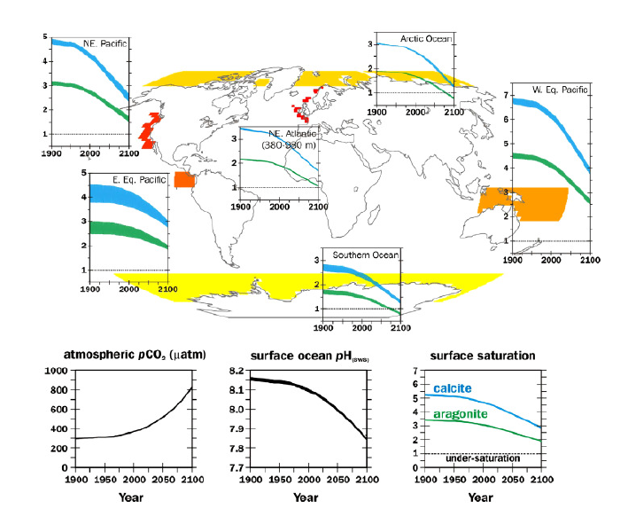

Figure 1: Projected regional changes in ocean chemistry compared to global-scale surface ocean changes. The transient simulation of climate and carbonate chemistry was performed with the UVic Earth System Climate Model using observed historical boundary conditions to 2006 and the SRES A2 scenario to 2100 (Eby et al., 2009). For each of the six illustrative high risk marine ecosystems (Arctic Ocean, Southern Ocean, NE Pacific margin intermediate depth NE Atlantic (500–1500 m), western equatorial Pacific, eastern equatorial Pacific), the blue shaded band indicates the annual range in ocean saturation state with respect to aragonite, while the green shaded band indicates the range for calcite saturation. Area average surface ocean conditions are calculated for all regions with the exception of the NE Atlantic where area average benthic conditions between 380 and 980 m have been used. The thickness of the line indicates the seasonal range, with the threshold of undersaturated environmental conditions marked as a horizontal dash line. The varying evolution in the magnitude of the seasonal range between different regions is due to the complex interplay between changes in stratification, ocean circulation, and sea-ice extent, and distorted due to the non-linear nature of the saturation scale. The corresponding regions from which the annual ranges are calculated are shown shaded. Global ocean surface averages (bottom three panels) are shown, from left to right: CO2 partial pressure, pH (SWS) and calcite and aragonite saturation state (Figure taken from Turley et al. 2010).

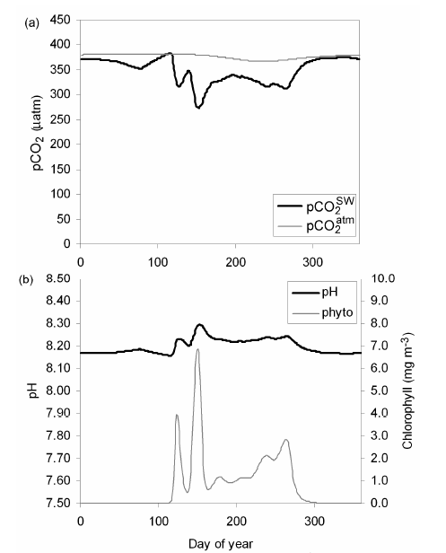

Figure 2: A modelled seasonal cycle of (a) pCO2 in the atmosphere (pCO2 atm) and in the surface ocean (pCO2
SW) and (b) pH and chlorophyll (a proxy for phytoplankton) parameterised and validated using observational data from Ocean Weather Station Mike in the Norwegian Sea (66 ºN, 02 ºE) (see Findlay et al. 2008).

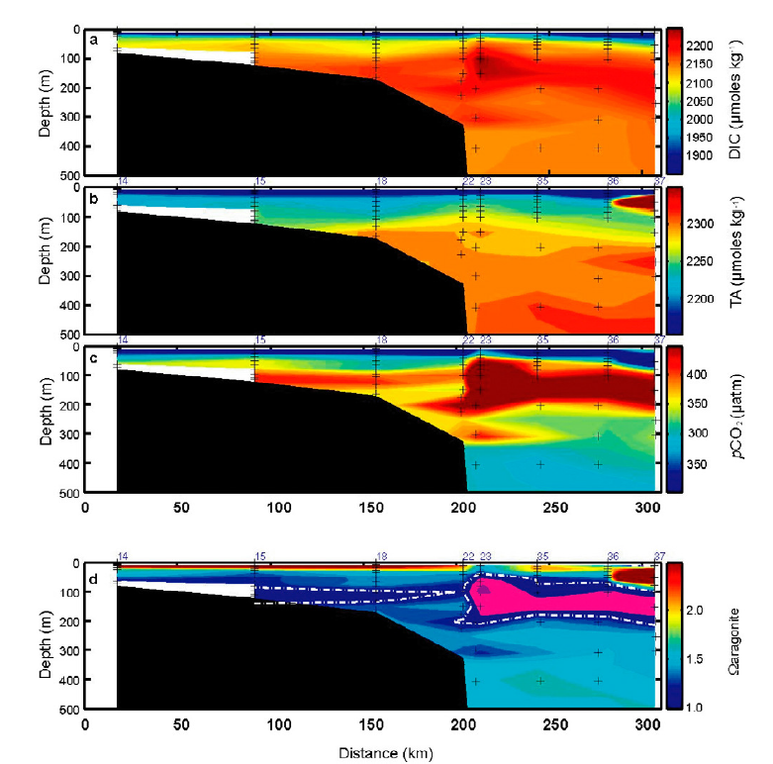

Figure 3: Representative section of (a) DIC, (b) TA, (c) pCO2, and (d) Ω aragonite across the Chukchi Sea shelf into the deep Canada Basin of the Arctic Ocean at Barrow Canyon for summer 2002. Note that the pink color represents regions of aragonite under saturation (Figure taken from Bates et al. 2009).

