Year 11 Independent Field work Investigation
What will we investigate?
You need to complete three field work activities, one from each section. These will help develop your understanding of collecting data in the field and will provide us with results we can use to better understand how to present our data in geography.

Will this be assessed in the exam?
This year, you will not have to remember your field work results or what you did in the exam. However, there will be questions which ask you to understand how to present and analyse data which other people have collected. Also, if you are planning to study geography to A level you will have the opportunity to complete an independent field work investigation, so knowledge of how we complete field work in geography is important.

How should I submit my work?
All your data needs to be recorded in this booklet. For your Section A investigation you will also need to submit a photograph or short video to your teacher to show you completing the field work and the site which you investigated.

Section A - In the field!
Select one of the two tasks below and record your results in the space provided
Option 1. River Investigation
To complete this option you will need to be able to visit a local river. You will need to be able to measure out 5 metres at the side of the river in two contrasting locations.

Sampling

Base your sampling on areas where you might expect significant changes in river velocity (choose two sites). By choosing sampling sites immediately downstream of confluences you may be able to identify the significant changes in velocity and consider the impact of stream order. This is called stratified sampling.

TASK: In the space below, briefly explain why you chose your two contrasting sites:

I chose my sites because…______________________________________________________ ____________________________________________________________________________________________________________________________________________________________________________________________________________________________________________________________________________________________________________

Hypothesis

Your hypothesis is a prediction of what you expect to find in your field work investigation. We are studying velocity so your hypothesis should predict which site is likely to have a higher velocity:

Velocity will be increase / decrease with distance downstream. Therefore, velocity will be highest at site ________________.

Equipment

For this investigation you will need:
- A tape measure
- Stopwatch (you can use your phone, just don’t drop it in the river!)
- Dog biscuits / small float e.g. stick / orange
- Something to mark out the start and end of your transect (e.g. you could use a stone at either end).

What to do

You will need to choose a stream that is either shallow enough for you to stand in (no deeper than your wellies). Some suggested locations include: Mill Brook near South Morton / Wallingford; The River Windrush near Bourton on the Water.
To measure velocity you will need a float such as dog biscuits. These make good floats as they are not too easily moved by wind and break down in the water if swept away.

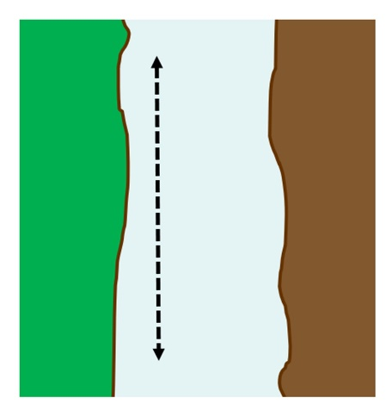
- Measure out 5 metres downstream – you could do this on the bank of the river if it is deep, or in the middle of the river with help from a partner if it is shallow enough to not rise above your wellies!
- Place the float in the water at the upstream end in the middle of the river channel – do this by either dropping your biscuit from a bridge, or standing in the middle of the river if it is safe.
- Start timing when you let go of the float
- When it reaches the end of your measured stretch stop timing
- Repeat five times and calculate a mean time

Do this at each site you have chosen to study and record your results in the table below.

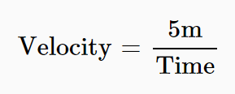

 | Site 1 (upstream) |  | Site 2 (downstream)
Sample | Time taken (in seconds) | Velocity (see calculation above) | Time taken (in seconds) | Velocity (see calculation above)
1
2
3
4
5
Mean velocity (m/s): |  |  | Mean velocity (m/s):

Risk assessment

Potential risk | Likelihood (5 = very likely, 1 = very unlikely) | Severity (5 = very severe, 1 = not severe) | Management

Evaluation

Problems with my data collection techniques included…

If I were to repeat this investigation again, I would improve it by…

Option 2. Sustainable Urban Transport
To complete this option you will need to be able to visit a local town or urban area. You will need to be able to visit two contrasting locations, potentially one with lots of sustainable transport access (e.g. bus lane, cycle lane etc.) and one without.

Sampling

Base your sampling on areas where you might expect significant changes in urban transport (choose two sites). By choosing sampling sites with increasing distance from a city centre you may be able to identify significant changes in the amount of public transport and consider the impact of urban transport design. This is called stratified sampling.

TASK: In the space below, briefly explain why you chose your two contrasting sites:

I chose my sites because…______________________________________________________ ____________________________________________________________________________________________________________________________________________________________________________________________________________________________________________________________________________________________________________

Hypothesis

Your hypothesis is a prediction of what you expect to find in your field work investigation. We are studying the amount of sustainable transport:

The amount and use of sustainable transport will be significantly higher at site_____________ compared to site______________________.

Equipment

For this investigation you will need:
- Stopwatch (you can use your phone)

What to do

You will need to choose one site in the centre of the town / city and one towards the edge to show contrasting use of sustainable transport options.

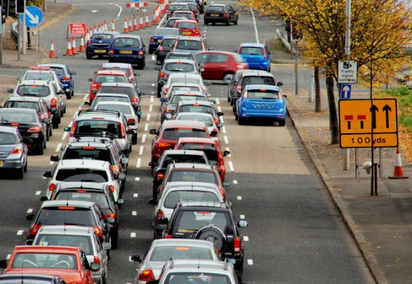
- In your chosen location, choose a place to stand on the pavement where you can see the full flow of traffic in both directions. It may help to have someone else with you to help count the traffic.
- Start timing for 5 minutes and record all the types of vehicles that pass you in that time using a tally chart.
- Repeat this three times at each site to get a mean number of each type of vehicle.

Do this at each site you have chosen to study and record your results in the table below.

Site 1 | 5 minutes | 5 minutes | 5 minutes | Mean number
Lorries
Motorbikes / mopeds
Cars
Buses
Bicycles
Pedestrians
Total number of vehicles (do not include pedestrians)

Site 2 | 5 minutes | 5 minutes | 5 minutes | Mean number
Lorries
Motorbikes / mopeds
Cars
Buses
Bicycles
Pedestrians
Total number of vehicles (do not include pedestrians)

Risk assessment

Potential risk | Likelihood (5 = very likely, 1 = very unlikely) | Severity (5 = very severe, 1 = not severe) | Management

Evaluation

Problems with my data collection techniques included…

If I were to repeat this investigation again, I would improve it by…

Section B - In the field or remote
Select one of the two tasks below and record your results in the space provided
Option 1: Changes in Land Use
To complete this option you can either visit a local city, or explore a city online using Google Earth street view.

Sampling

We are going to use systematic sampling for this study. This means that we take 10 measurements at equal distances, in this case along a road. If you are visiting the city on foot, you will need to think carefully about how you can measure equal distances between your 10 sites (perhaps you could measure using your feet or a tape measure?).

TASK: In the space below, briefly explain how you will sample along a road in your city (i.e. how will you divide your road into 10 sites? What distance will you use between each site?)

I will sample along the road by dividing the sites into …______________________________ ____________________________________________________________________________________________________________________________________________________________________________________________________________________________________________________________________________________________________________

Hypothesis

Your hypothesis is a prediction of what you expect to find in your field work investigation. We are studying the changes in land use in a city centre. Complete the statement below with the words residential and commercial.

With increasing distance from the city centre, land use will become more __________________ and less _____________________

What to do

Select a street in your city either using Google Earth or by visiting in person. At 10 equal distances along your transect record the land use in that area by referring to the RICEPOTS key below. If you are using Google Earth, you will need to click on street view.

Site | Residential | Industrial | Commercial | Entertainment | Public building | Open space | Transport | Services
1 (Closest to city centre)
2

3

4

5

6

7

8

9

10 (Furthest from city centre)

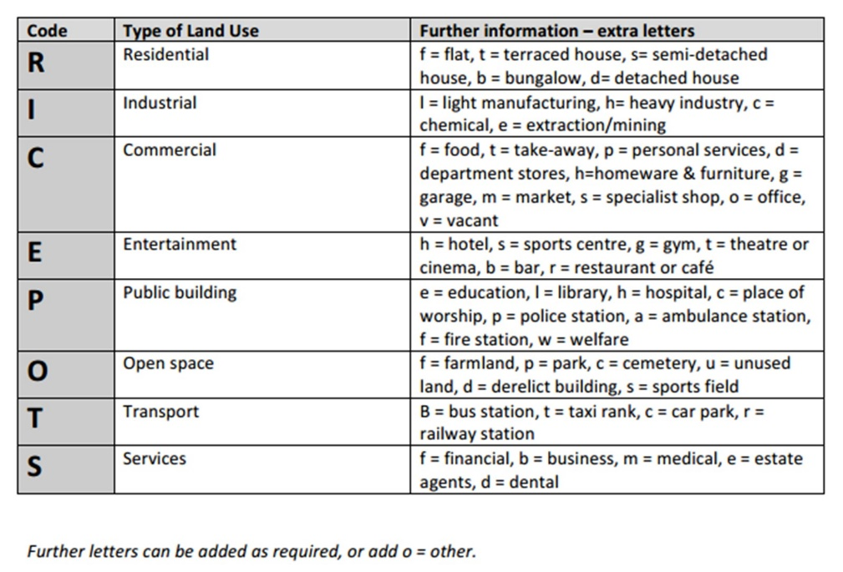
Evaluation & Conclusion

What are some of the problems with your results? (Think about how accurate and reliable they were.)

Are you able to accept or reject your hypothesis?

What are the main reasons why you have reached this conclusion?

Challenge question: How valid is your conclusion? (Would someone else reach the same conclusion as you? Why / why not?)
Option 2: Environmental Quality in Urban Areas
To complete this option you can either visit a local city, or explore a city online using Google Earth street view.

Sampling

We are going to use systematic sampling for this study. This means that we take 10 measurements at equal distances, in this case along a road. If you are visiting the city on foot, you will need to think carefully about how you can measure equal distances between your 10 sites (perhaps you could measure using your feet or a tape measure?).

TASK: In the space below, briefly explain how you will sample along a road in your city (i.e. how will you divide your road into 10 sites? What distance will you use between each site?)

I will sample along the road by dividing the sites into …______________________________ ____________________________________________________________________________________________________________________________________________________________________________________________________________________________________________________________________________________________________________

Hypothesis

Your hypothesis is a prediction of what you expect to find in your field work investigation. We are studying the changes in environmental quality in a city centre. Complete the statement below using either decline or improve.

With increasing distance from the city centre, environmental quality will ____________________.

What to do

Select a street in your city either using Google Earth or by visiting in person. At 10 equal distances along your transect record the environmental quality in that area by filling in the bi-polar survey. If you are using Google Earth, you will need to click on street view.

Site 1 (Closest to city centre) | 1 | 2 | 3 | 4 | 5
Buildings show evidence of vandalism / graffiti |  |  |  |  |  | No vandalism / graffiti evident on buildings
No greenery visible |  |  |  |  |  | Trees / shrubs / greenery visible
Paths poorly maintained / broken paving |  |  |  |  |  | Paths well maintained
No garden / open space – doors open into street |  |  |  |  |  | Large gardens or open space outside houses
Parking is difficult – many vehicles parked on the road |  |  |  |  |  | Parking in garages or driveways
Site 2 | 1 | 2 | 3 | 4 | 5
Buildings show evidence of vandalism / graffiti |  |  |  |  |  | No vandalism / graffiti evident on buildings
No greenery visible |  |  |  |  |  | Trees / shrubs / greenery visible
Paths poorly maintained / broken paving |  |  |  |  |  | Paths well maintained
No garden / open space – doors open into street |  |  |  |  |  | Large gardens or open space outside houses
Parking is difficult – many vehicles parked on the road |  |  |  |  |  | Parking in garages or driveways

Site 3 | 1 | 2 | 3 | 4 | 5
Buildings show evidence of vandalism / graffiti |  |  |  |  |  | No vandalism / graffiti evident on buildings
No greenery visible |  |  |  |  |  | Trees / shrubs / greenery visible
Paths poorly maintained / broken paving |  |  |  |  |  | Paths well maintained
No garden / open space – doors open into street |  |  |  |  |  | Large gardens or open space outside houses
Parking is difficult – many vehicles parked on the road |  |  |  |  |  | Parking in garages or driveways

Site 4 | 1 | 2 | 3 | 4 | 5
Buildings show evidence of vandalism / graffiti |  |  |  |  |  | No vandalism / graffiti evident on buildings
No greenery visible |  |  |  |  |  | Trees / shrubs / greenery visible
Paths poorly maintained / broken paving |  |  |  |  |  | Paths well maintained
No garden / open space – doors open into street |  |  |  |  |  | Large gardens or open space outside houses
Parking is difficult – many vehicles parked on the road |  |  |  |  |  | Parking in garages or driveways

Site 5 | 1 | 2 | 3 | 4 | 5
Buildings show evidence of vandalism / graffiti |  |  |  |  |  | No vandalism / graffiti evident on buildings
No greenery visible |  |  |  |  |  | Trees / shrubs / greenery visible
Paths poorly maintained / broken paving |  |  |  |  |  | Paths well maintained
No garden / open space – doors open into street |  |  |  |  |  | Large gardens or open space outside houses
Parking is difficult – many vehicles parked on the road |  |  |  |  |  | Parking in garages or driveways

Site 6 | 1 | 2 | 3 | 4 | 5
Buildings show evidence of vandalism / graffiti |  |  |  |  |  | No vandalism / graffiti evident on buildings
No greenery visible |  |  |  |  |  | Trees / shrubs / greenery visible
Paths poorly maintained / broken paving |  |  |  |  |  | Paths well maintained
No garden / open space – doors open into street |  |  |  |  |  | Large gardens or open space outside houses
Parking is difficult – many vehicles parked on the road |  |  |  |  |  | Parking in garages or driveways

Site 7 | 1 | 2 | 3 | 4 | 5
Buildings show evidence of vandalism / graffiti |  |  |  |  |  | No vandalism / graffiti evident on buildings
No greenery visible |  |  |  |  |  | Trees / shrubs / greenery visible
Paths poorly maintained / broken paving |  |  |  |  |  | Paths well maintained
No garden / open space – doors open into street |  |  |  |  |  | Large gardens or open space outside houses
Parking is difficult – many vehicles parked on the road |  |  |  |  |  | Parking in garages or driveways

Site 8 | 1 | 2 | 3 | 4 | 5
Buildings show evidence of vandalism / graffiti |  |  |  |  |  | No vandalism / graffiti evident on buildings
No greenery visible |  |  |  |  |  | Trees / shrubs / greenery visible
Paths poorly maintained / broken paving |  |  |  |  |  | Paths well maintained
No garden / open space – doors open into street |  |  |  |  |  | Large gardens or open space outside houses
Parking is difficult – many vehicles parked on the road |  |  |  |  |  | Parking in garages or driveways

Site 9 | 1 | 2 | 3 | 4 | 5
Buildings show evidence of vandalism / graffiti |  |  |  |  |  | No vandalism / graffiti evident on buildings
No greenery visible |  |  |  |  |  | Trees / shrubs / greenery visible
Paths poorly maintained / broken paving |  |  |  |  |  | Paths well maintained
No garden / open space – doors open into street |  |  |  |  |  | Large gardens or open space outside houses
Parking is difficult – many vehicles parked on the road |  |  |  |  |  | Parking in garages or driveways

Site 10 (Furthest from city centre) | 1 | 2 | 3 | 4 | 5
Buildings show evidence of vandalism / graffiti |  |  |  |  |  | No vandalism / graffiti evident on buildings
No greenery visible |  |  |  |  |  | Trees / shrubs / greenery visible
Paths poorly maintained / broken paving |  |  |  |  |  | Paths well maintained
No garden / open space – doors open into street |  |  |  |  |  | Large gardens or open space outside houses
Parking is difficult – many vehicles parked on the road |  |  |  |  |  | Parking in garages or driveways

Evaluation & Conclusion

What are some of the problems with your results? (Think about how accurate and reliable they were.)

Are you able to accept or reject your hypothesis?

What are the main reasons why you have reached this conclusion?

Challenge question: How valid is your conclusion? (Would someone else reach the same conclusion as you? Why / why not?)

Section C- Remote
Select one of the two tasks below and record your results in the space provided
Option 1: Sustainable Water Use
To complete this option you are going to design a questionnaire to ask people about their sustainable water use and consider whether use of sustainable water strategies increases or decreases with age.

Sampling

It would be good to ensure you have a range of age groups answering your questionnaire. Which type of sampling would help us achieve that? Delete as appropriate in the following statement: We are going to use random / systematic / stratified sampling for this study.

TASK: In the space below, briefly explain how you will select participants for your questionnaire.

I will sample people for my questionnaire by …_____________________________________ ____________________________________________________________________________________________________________________________________________________________________________________________________________________________________________________________________________________________________________

Hypothesis

Your hypothesis is a prediction of what you expect to find in your field work investigation. We are studying whether there is a correlation between age and sustainable water use. Complete the statement below:

With increasing average age of the household, the range of sustainable water use strategies in homes will increase / decrease.

What to do

You need to design your own questionnaire with 5 questions which ensure that you are able to reach a conclusion about the hypothesis above. This questionnaire will be asked to at least 10 different people.

Describing your results

Describe 5 key findings from your questionnaire – remember to use GCSE!

Explaining your results

Give 3 reasons why you think you found these results

Option 2: Climate Change
To complete this option you are going to design a questionnaire to ask people about their actions in mitigating climate change (e.g. recycling, using public transport) and consider whether use of these mitigating strategies increase or decrease with age.

Sampling

It would be good to ensure you have a range of age groups answering your questionnaire. Which type of sampling would help us achieve that? Delete as appropriate in the following statement: We are going to use random / systematic / stratified sampling for this study.

TASK: In the space below, briefly explain how you will select participants for your questionnaire.

I will sample people for my questionnaire by …_____________________________________ ____________________________________________________________________________________________________________________________________________________________________________________________________________________________________________________________________________________________________________

Hypothesis

Your hypothesis is a prediction of what you expect to find in your field work investigation. We are studying whether there is a correlation between age and climate change mitigation strategies. Complete the statement below:

With increasing average age, the range of climate change mitigation strategies used will increase / decrease.

What to do

You need to design your own questionnaire with 5 questions which ensure that you are able to reach a conclusion about the hypothesis above. This questionnaire will be asked to at least 10 different people.

Describing your results

Describe 5 key findings from your questionnaire – remember to use GCSE!

Explaining your results

Give 3 reasons why you think you found these results

