Tackling Food Insecurity
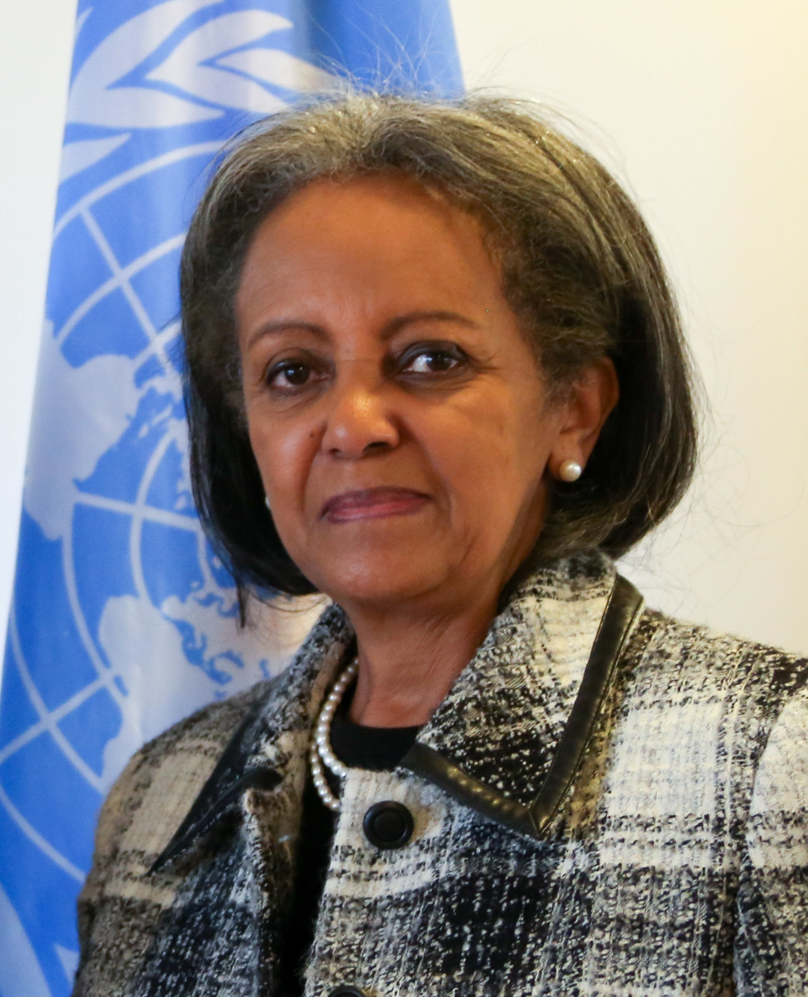
Imagine you are Sahle-Work Zewde, the President of Ethiopia. You have been given $10 million by the World Food Programme to address food insecurity in your country. They have presented you with some options of how to spend your money. Choose what you will spend your money on and justify your choices - how will each of these help to reduce food insecurity? Some independent research may be helpful to guide your answers.

- Purchase new agricultural equipment  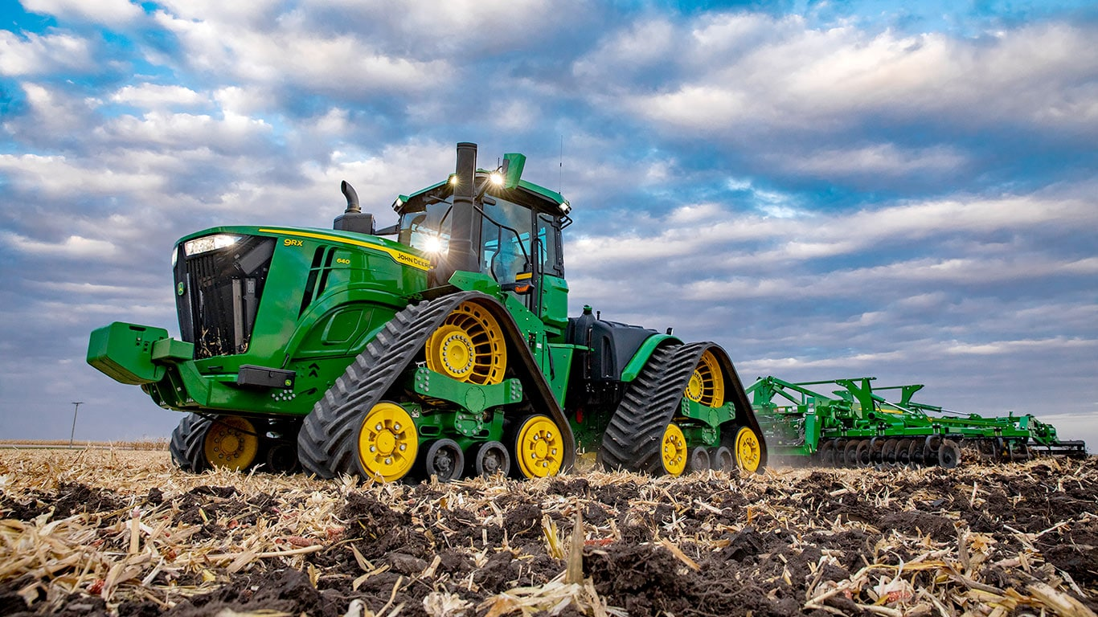  Cost: $10,000 per tractor | - Purchase irrigation systems for farms  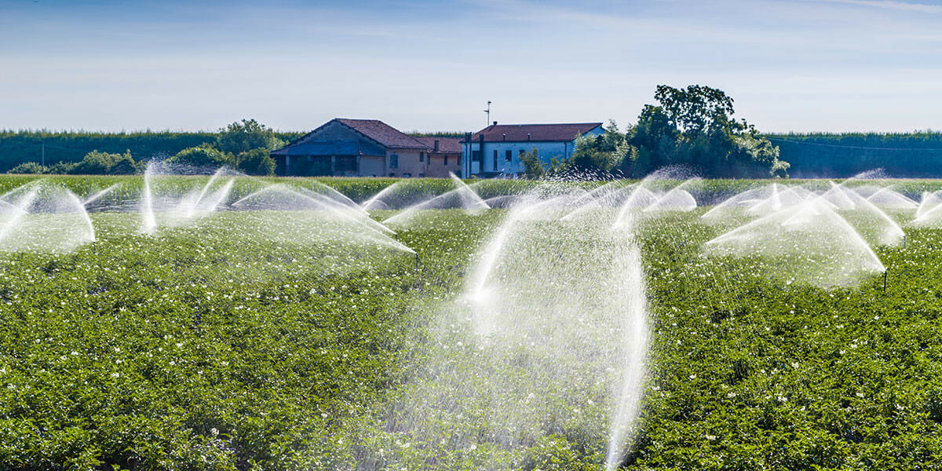  Cost: $100,000 per system for a farm | - Send food aid to 25 areas in need  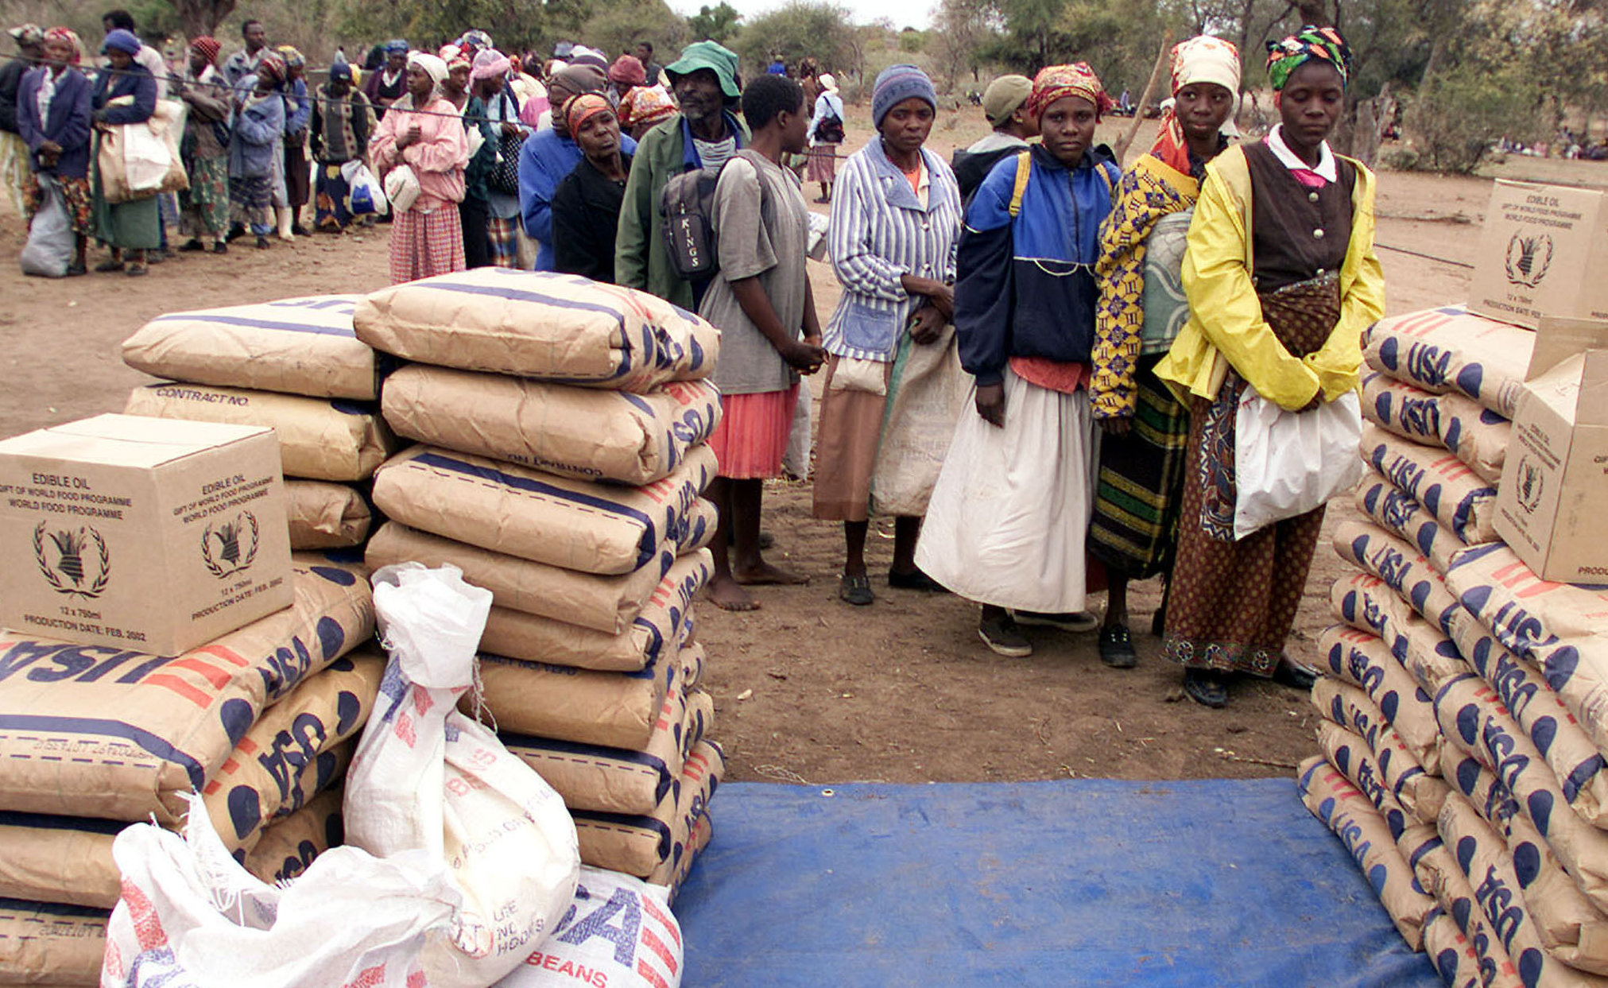  Cost: $500,000
- Cash transfers to individual families in need  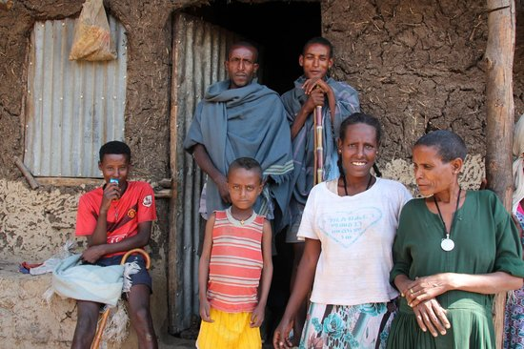  Cost: $100 per family for a month | - Build a dam that will help 5 million people  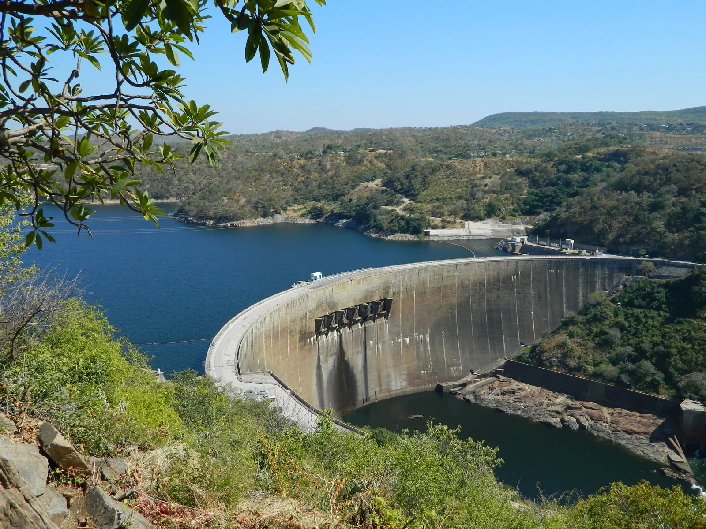  Cost: $1 million | - Create a community garden in one village  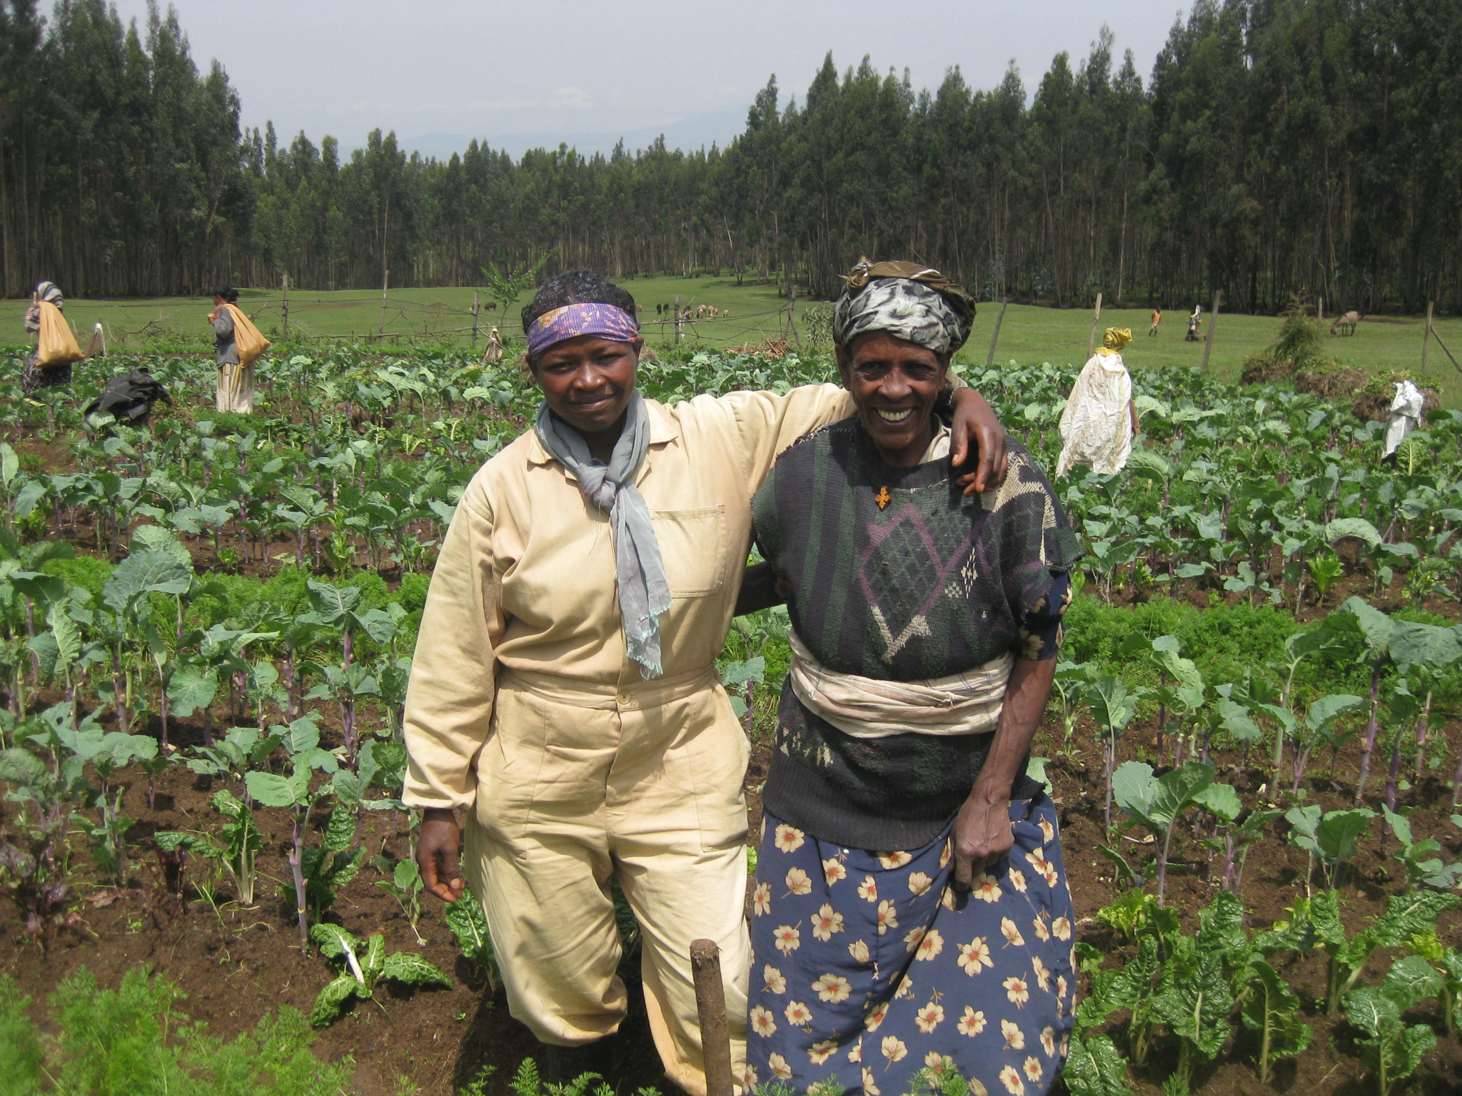  Cost: $500
- Build a main road connecting 100 villages to a city  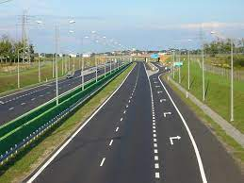  Cost: $1 million | - Invest in agricultural research and development (for more productive seeds and farming practices)  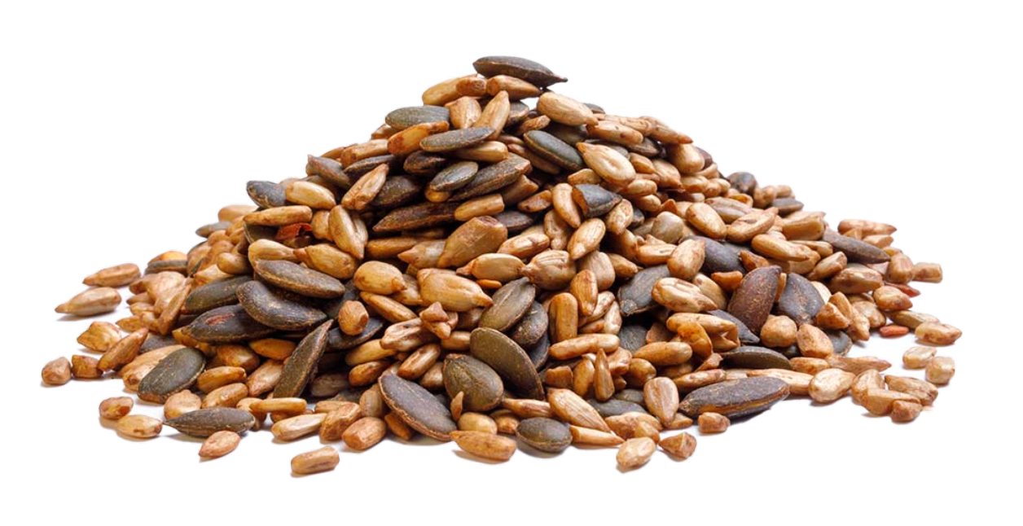  Cost: $300,000 | - Establish agricultural training centres  (1 centre will train 50 people)  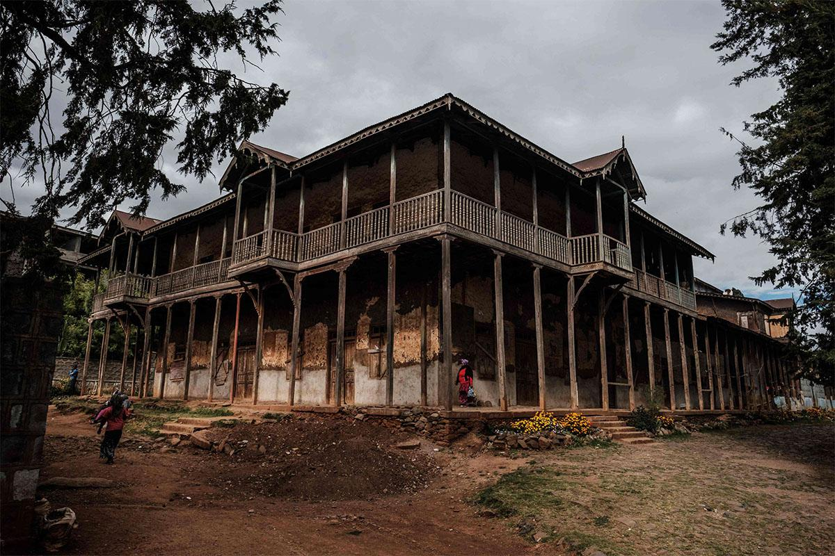  Cost: $5,000 per centre

Tackling Food Insecurity
Imagine you work for the Non-Governmental Organisation (NGO) Oxfam. You have been given $50,000 in donations to address food insecurity in a village in Ethiopia. They have presented you with some options of how to spend your money. Choose what you will spend your money on and justify your choices - how will each of these help to reduce food insecurity? Some independent research may be helpful to guide your answers.
- Purchase new agricultural equipment  Cost: $10,000 per tractor | - Purchase irrigation systems for farms  Cost: $100,000 per system for a farm | - Send food aid to 25 areas in need  Cost: $500,000
- Cash transfers to individual families in need  Cost: $100 per family for a month | - Build a dam that will help 5 million people  Cost: $1 million | - Create a community garden in one village  Cost: $500
- Build a main road connecting 100 villages to a city  Cost: $1 million | - Invest in agricultural research and development (for more productive seeds and farming practices)  Cost: $300,000 | - Establish agricultural training centres  (1 centre will train 50 people)  Cost: $5,000 per centre

