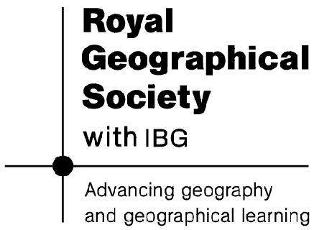
Treasure Hunt-Answers

Follow the clues to find the treasure in the form of a slogan.
- Start at 303794.
- Head North for 1km. Take the first letter of the station you have arrived at. Take care-there are 2 stations close together! E (Embankment)
- Go East for 2km. You will find yourself at a building. What type of building is it? Take the first letter. Clue: The Natural History and Science are types of these. M (Museum)
- From here head to 320811. Take the first letter from the name of the holy person found here. P (St. Paul’s Cathedral)
- Head North North West. For ¾ of a kilometre. You will find yourself at an arts centre. Take the second letter from the name of this centre. A (Barbican)
- Go to 322806. Have a look at letter you can see here. It looks like a V. What letter is it in fact? Clue: think about Roman London. U
- Head South West for 1km. You will find yourself at a station. Take the first letter of the name of this station. S (Southwark)
- Head to 304789. You will find yourself in the middle of a bridge. Take the first letter of the name of the bridge. L (Lambeth)
- Now go North until you come to 304807. Write the third letter of the name you see. R (Strand)
- You now have all of the clues. Rearrange the letters to make a slogan. MAPS RULE
Bonus: The name you found at 9 is the name of a street. There was a song about this street. Can you find the name of the fruit mentioned in this song? Banana

