Everyday Drone Stories
KS3.3 What are drones?

Specification
The KS3 National Curriculum in England
As a student progresses, their growing knowledge about the world helps them to deepen their understanding of the interaction between physical and human processes, and of the formation and use of landscapes and environments.

Students interpret a range of sources of geographical information, including maps, diagrams, globes, aerial photographs, and Geographical Information Systems (GIS).

The KS3 National Curriculum of Wales
Progression in Locating places, environments, and patterns. Students construct and use plans and maps and apply map skills accurately to obtain information. They identify and explain geographical patterns and how places and patterns are interconnected.

Students use geographical information systems (GIS), satellite imagery and software for mapping technology to analyse data and study patterns.

What are drones?
Drones, like the example pictured below, are small aircraft without a pilot on board. Drones can also be called Unmanned Aerial Vehicles (UAVs) or Remotely Piloted Aircraft Systems (RPAS).

Drones can be operated by a pilot on the ground or can be pre-programmed to independently follow a set flight path or route. Drones are a growing feature of UK skies. Drones have lots of different users and uses. Drones can be flown:

- As a hobby or for fun (perhaps a family member or friend has a drone).

- By researchers to capture images of places and environments from the air.

- By civil actors such as emergency services (police, fire, search and rescue) to help locate missing people or identify the spread of fires.

- By commercial actors such as businesses to inspect buildings from the air or to deliver items.
Drones come in different shapes and sizes. Some drones have cameras and sensors attached to them so they can take photographs, capture videos and collect different types of data from the air. Other drones are used to carry, transport and deliver things – like medicine or small parcels.

While drones allow us to do a lot of things and offer a range of benefits (e.g., increasing safety and reducing costs and emissions), they also introduce different risks and challenges into our airspace.

These include issues such as: safety (what if a drone crashes or collides with someone or something), security (how might drones be misused to cause disruption or harm to people or places), privacy (what can drones see, what data do they capture and record), and noise (how might the noise from drones disturb people or animals).
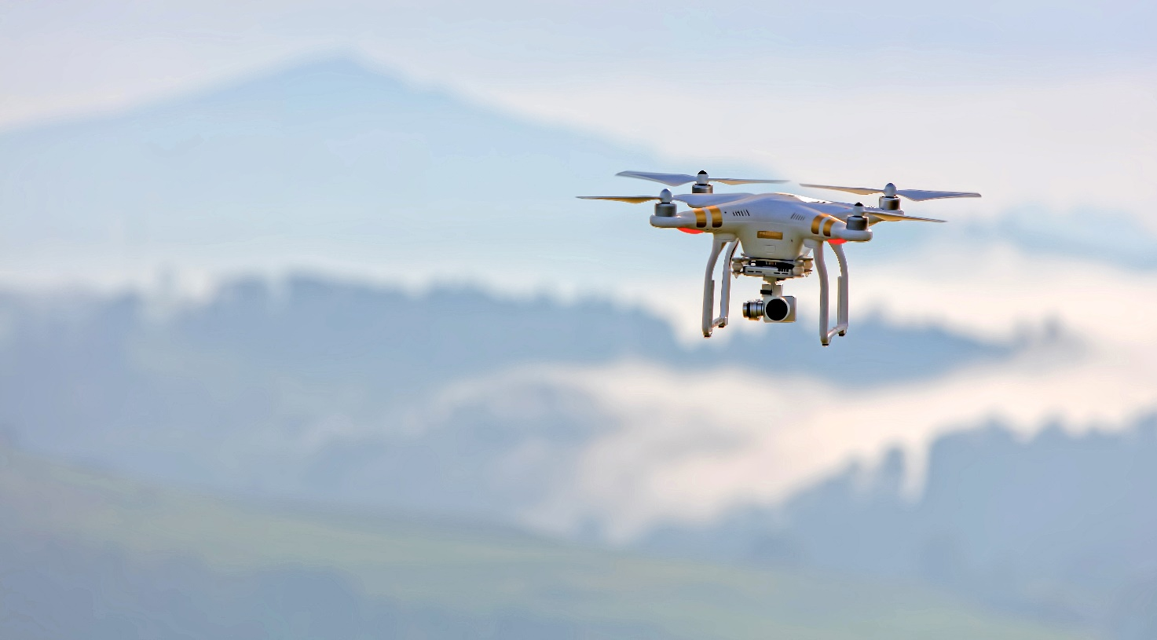
Figure 1 A drone in flight © Ricardo Gomez Angel

Activity
In this worksheet we’re going to learn more about what drones can do and reflect on some of the positives and negatives of using, living with, and sharing our skies with drones.

We’ve selected two drone applications – delivery drones and drones to support wildlife conservation – as examples.

We’re going to think about who and what these applications involve and impact, and their benefits and risks.

Example 1: Delivery drones
From parcels to medicines, drones are being developed, trialled and deployed to deliver different goods and matter in and across the UK.

To learn more about how delivery drones, read these two short articles:

- BBC News (2022) Royal Mail wants fleet of 500 drones to carry mail to remote UK communities https://www.bbc.co.uk/news/technology-61409558

- Paine G (2019) Drones to deliver incessant buzzing noise, and packages. The Conversation https://theconversation.com/drones-to-deliver-incessant-buzzing-noise-and-packages-116257

- As you read these articles, consider the following questions:

- Who or what do these delivery drone operations involve and impact?
- What are the potential benefits of delivery drones?
- What are the potential challenges and risks of delivery drones?

Example 2: Drones to support wildlife conservation
Drones are increasingly being used in global conservation efforts. As tools praised for their comparative accessibility, affordability and data-capturing capabilities, drones are being deployed by diverse users in a range of applications. From wildlife monitoring and vegetation mapping, to the detection of poachers and the (counter-)mapping of territories and land, drones have emerged as a key part of the toolkit for many conservation practitioners and researchers.

To learn more about how and why drones are used in conservation efforts around the world, read these two short articles:

- Young RJ (2014) Conservation drones – here comes the animals’ air force. The Conversation https://theconversation.com/conservation-drones-here-comes-the-animals-air-force-35220

- Mulero Pazmany M (2018) Viral bear video shows how drones threaten wildlife – and what to do about it. The Conversation https://theconversation.com/viral-bear-video-shows-how-drones-threaten-wildlife-and-what-to-do-about-it-106903

- As you read these articles, consider the following questions:

- Who or what do these conservation drone operations involve and impact?
- What are the potential benefits of conservation drones?
- What are the potential challenges and risks of conservation drones?

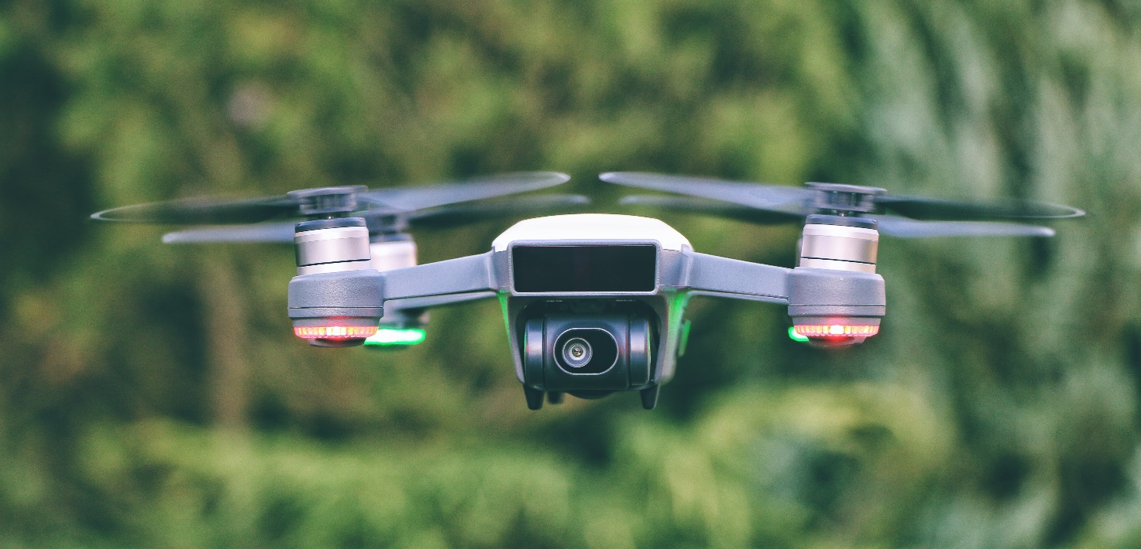
Figure 2 Drone in flight © Petr Sevcovic

Answers
- Delivery drones: The article introduces delivery drone applications, including a Royal Mail fleet of postal drones to deliver letters to remote communities around the UK, such as isolated islands including Scilly, Shetlands Islands, Orkney Islands and the Hebrides. The articles introduce different actors involved and potentially impacted, including local people and communities, and the postal service and workers. What are the benefits of delivery drones? The articles present the benefits of delivery drones in terms of connection and access (particularly in disconnected places), economic gains, and in terms of convenience. What are the potential challenges and risks of delivery drones? The articles present a range of potential challenges and risks, including around noise (reflecting on operating hours, annoyance), visual pollution, as well as challenges of operating safely in the airspace (e.g., how to integrate drones with other aircraft and airspace users – such as manned aircraft, parachutists, military aircraft etc). One thing that can be pointed out to link to the next exercise is the potential impact of delivery drones on not just humans, but wildlife too (e.g., pets, birds). In addition, environmental claims that drones reduce the ‘last-mile delivery emissions’ can also be further unpacked, as we need to consider of pollution from drone production, supply chains, additional packaging that may be required to protect the items in transport, powering the drones and the infrastructure supporting them (e.g., communications).

- Conservation drones: Who or what might conservation drone operations involve and impact? The articles involve a range of actors, including researchers and conservation organisations, and different wildlife (i.e., humans and non-humans). They demonstrate that while drones can be used in conservation efforts designed to monitor and protect different wildlife, they can also be disruptive to the wildlife they target and wildlife more widely that are in the vicinity. What are the potential benefits of conservation drones? The articles highlight that drones can be very useful conservation tools that allow the capturing of important visual data on animals, their habitats, behaviours and movements. What are the potential challenges and risks of conservation drones? While drones are often used to collect data that informs effective conservation efforts, their use can also disturb wildlife, including both animal species being monitored and non-target species. Drones can prompt a range of anti-predatory responses in wildlife (including curiosity, vigilance, alert, alarm, fleeing responses and aggressive behaviour), as well as non-visible responses (such as an increased heart rate). While varying by animal characteristics (such as species), operators can consider and adapt drone attributes and flight timings and patterns to minimise potential disruption and exhibit care to non-humans with whom we share the (air)space.

Further reading
- BBC News (2022) UK set to have world’s biggest automated drone superhighway https://www.bbc.co.uk/news/technology-62177614

- Cureton P (2022) Drone superhighways and airports are coming – let’s make sure they don’t make life miserable. The Conversation https://theconversation.com/drone-superhighways-and-airports-are-coming-lets-make-sure-they-dont-make-life-miserable-187304

- Aublin JA (2023) Drones gather new and useful data for marine research, but they can disturb whales and dolphins. The Conversation https://theconversation.com/drones-gather-new-and-useful-data-for-marine-research-but-they-can-disturb-whales-and-dolphins-198985

- Responsible drone use in biodiversity conservation: Guidelines for environmental and conservation organisations who use drones. CIFOR ICRAF https://www.cifor-icraf.org/knowledge/publication/8851/

- Jackman A, Millner N (2023) From data to disturbance: Fostering responsible and considerate conservation drone use. Geography Directions https://blog.geographydirections.com/2023/06/29/from-data-to-disturbance-fostering-responsible-and-considerate-conservation-drone-use/

