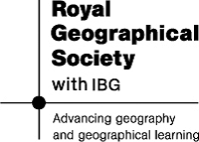

General Skills | Geographical Skills
Being a good communicator with strong presentation skills | Scientific and lab skills
Being competent with ICT | Producing and interpreting maps
Being able to carry out research | Fieldwork techniques
Being able to manage your time by juggling commitments, meeting deadlines and managing stress | Debate and enquiry, being able to see arguments form the perspectives of others
Being good at combining information from a variety of different sources | Being able to represent data using GIS models
Being able to work effectively as part of a team | Environmental and social awareness.
Being able to take charge in a situation if necessary | Being able to tackle global issues like climate change in a meaningful way.
Being able to effectively present and report information in a clear manner | Being able to collect and interpret multiple sources of data.

