Lesson seven: Assessment - UK Knowledge Quiz

- Which continent is Britain part of?
Europe

- Name the countries which make up the United Kingdom
England, Wales, Scotland and Northern Ireland

- What is the name of the climate in the UK?
Temperate maritime

- Which UK country has the largest population?
England

- Which city is the capital of Wales?
Cardiff

- Which is the longest river in the UK?
River Severn

- Name the highest mountain in Scotland
Ben Nevis

- List three English counties and name, for each, a famous food product that originates from there.
Country | Product
Lincolnshire | Lincolnshire sausage
Yorkshire | Yorkshire pudding
Cornwall | Cornish pasty

- Choose one football team. What is the club’s nickname? How does it explain the history of industry in the town/city?
Any of those provided in lesson four: Famous Football Cities
- For either Birmingham or Blackpool, describe how the settlement has grown and developed over time. Make sure you mention physical and human factors – you may wish to make a list of these before you start your answer.
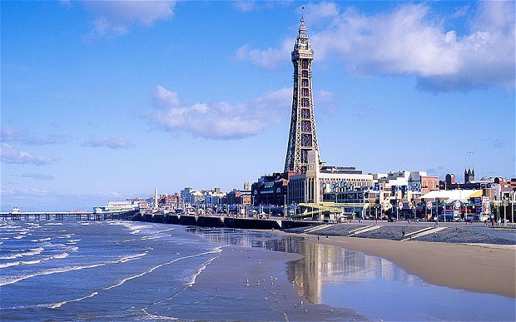
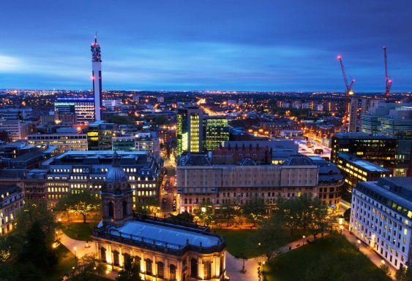

Pupils include at least three key facts about the development of either settlement from lesson five: B&B Cities of Contrast.

