Geographical skills audit

Geographical skills – taken from real job adverts

Flood Risk Officer – Environmental Agency - Flood Risk Officer - 23489 - Environment Agency Jobs (tal.net)

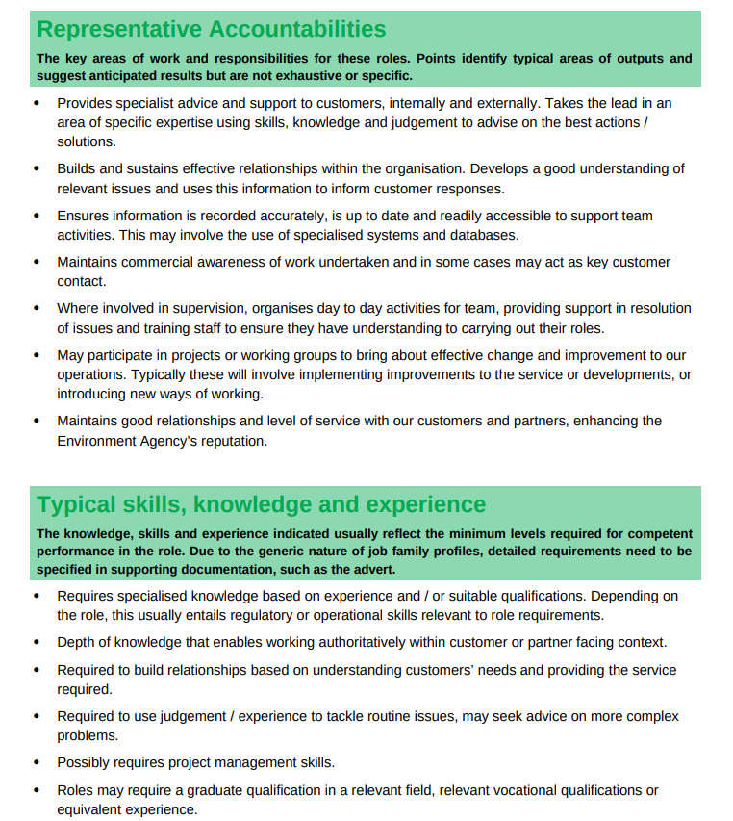

Environmental Consultant – Skills and Job description (Prospects – Environmental consultant job profile | Prospects.ac.uk)

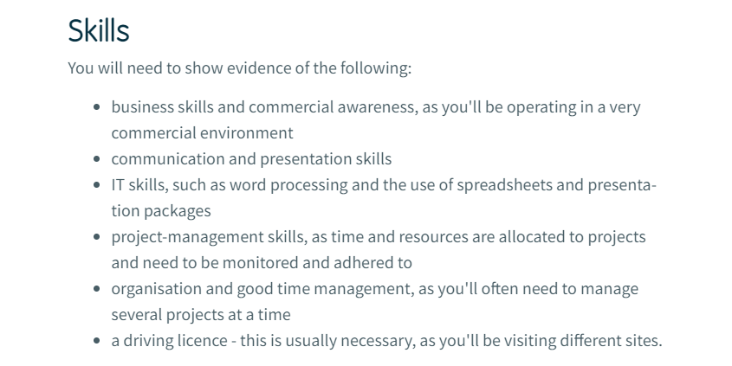
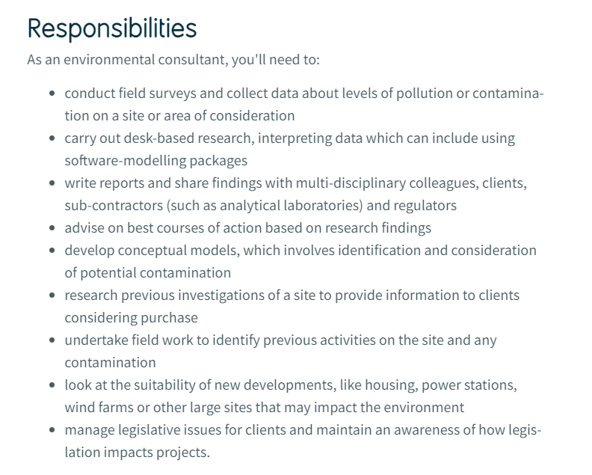

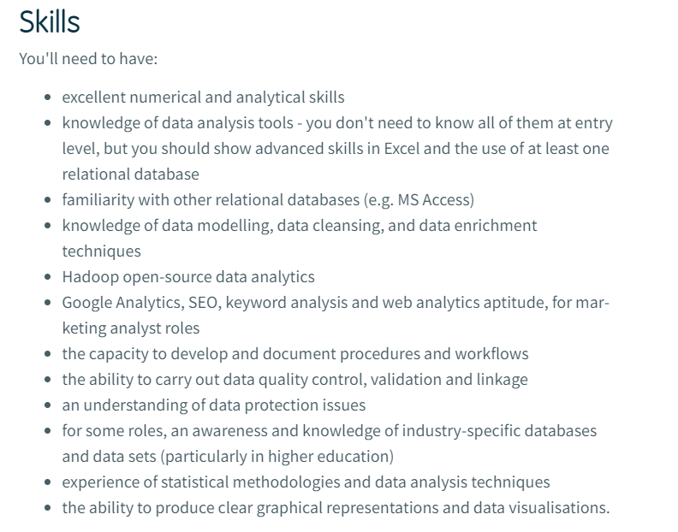
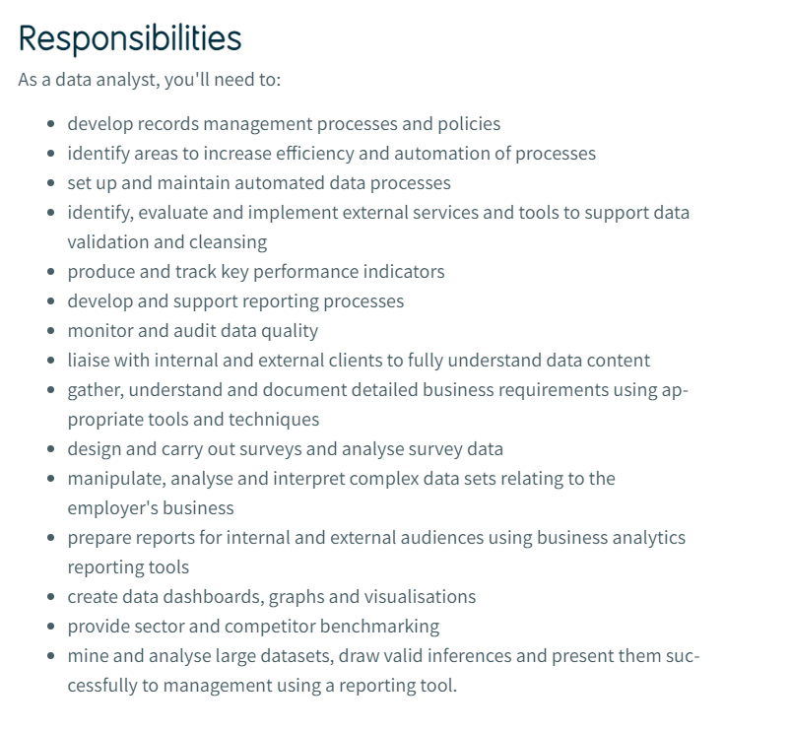
Data Analyst – Prospects – Data analyst job profile | Prospects.ac.uk

