FT for schools: Costa Rica activity sheet 10

This resource was written by authors Stephen Schwab and Susan Schwab.

The context
Costa Rica is a Central American, Spanish speaking republic, bordered by Nicaragua to the north and Panama to the south. The focus is on the west coast of the country, facing the Pacific Ocean, on a peninsula called the Nicoya Peninsula. It is divided into two provinces: the northern Guanacaste Province, and the southern Puntarenas Province.

The article
Access the article at www.ft.com/content/fc58e8ee-0f87-4285-91bc-2d46e1052d61 to learn about the ‘eco-paradise’.

This article looks at the issues of sustainability and ecosystems under pressure due to economic development, particularly with relationship to housing development, USA, and European expatriate and second home purchase, and the tourist industry.

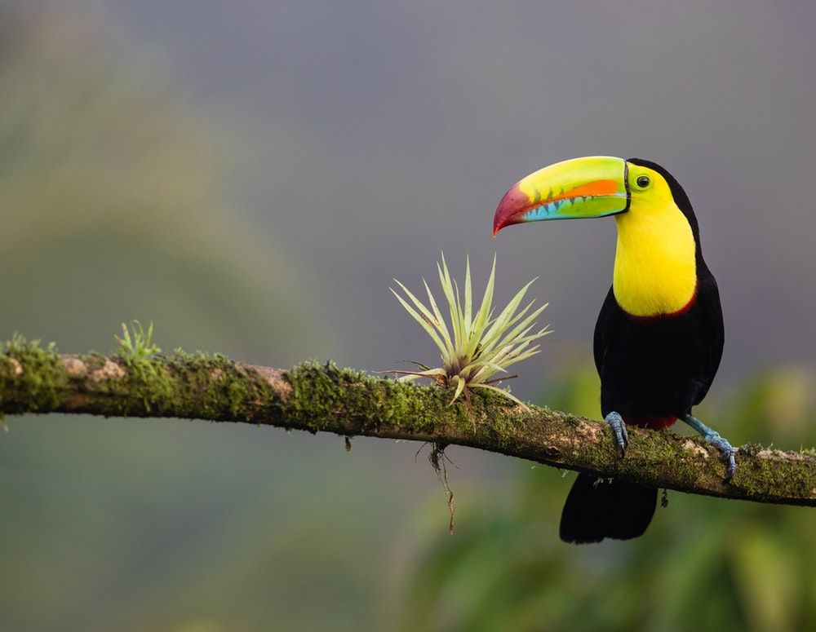
Figure 1 Costa Rica © Zdeněk Macháček Unsplash

Specification links
AQA A level 3.1.6 Ecosystems under stress. Study of the impact of population growth and economic development on ecosystems at various scales.
Edexcel A level Topic 6: 6.7 Biological carbon and the water cycle are threatened by human activity.

OCR Topic 1.2 – Earth’s Life Support Systems. Case study of a tropical rainforest.

WJEC A level 4.2: Ecosystems. 4.2.3 Biodiversity under threat.

Activity
- Briefly summarise the picture the author paints of the Guanacaste in the first 3 paragraphs. Answer in terms of place and the people attracted this area of Costa Rica. Also include a description of the houses for sale at the end of the article.

- Study Figure 2 below. What other activities are there for foreigners and city-living Costa Ricans on the Nicoya Peninsula?

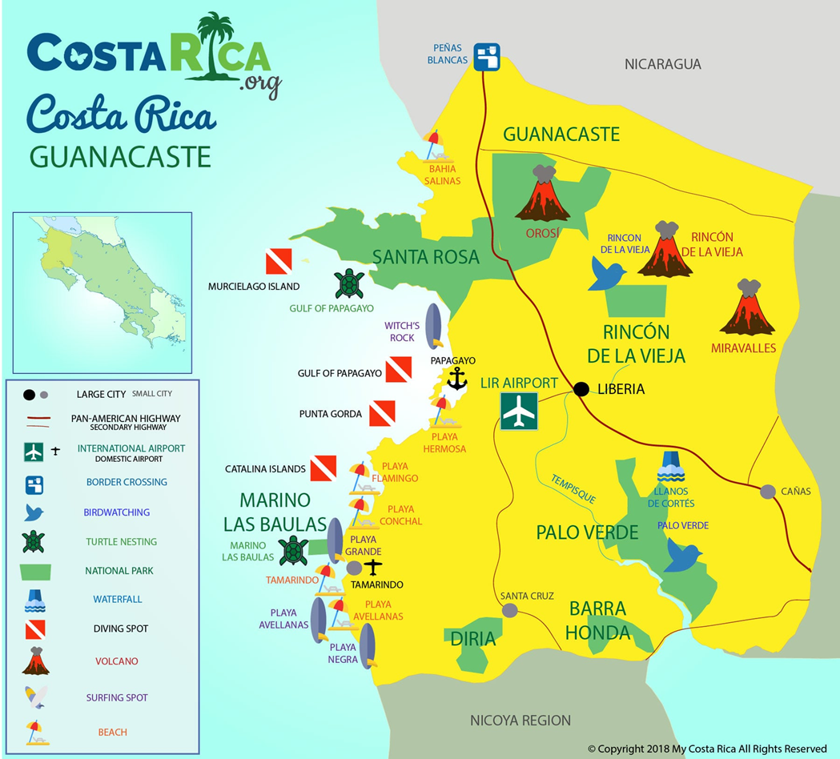
Figure 2 the attractions of Guanacaste, Nicoya Peninsula

- Costa Rica has a rich ecology and is seeking economic development whilst protecting its diverse habitats. Create a poster emphasising these ‘green credentials’ to attract foreign buyers.
- Using the extract below create a 4-column table of problems resulting from Costa Rica’s ‘construction boom’. Use the headings Environmental, Social, and Economic in the first 3 columns.

The Banks family own and run the eco-hotel Libelula Lounge and Lodgings, which they bought and extended for around $800,000. “We’re committed to sustainability” says Banks, but she increasingly feels like “a small oasis in a developing area”, she says. “More often than not, people are stripping plots of all their trees to clear spaces for their homes, and there are issues with the destruction of wildlife habitats, especially monkeys.”

- Read the next 3 paragraphs after the extract in article. Add another heading titled Political and extend your table.

- The following quotes are extracted from the UNEP report.

Costa Rica has long punched above its weight as a global green pioneer with a strong social conscience, but now the Central American nation is preparing to cross the ultimate environmental frontier with a detailed plan to decarbonize its economy by 2050.

Many countries have promised to do the same—reducing emissions is a key commitment of signatories to the Paris Climate Agreement—but Costa Rica is one of the first to turn pledges into solid policies and to frame the shift in terms of economic and social benefit.

The decarbonization plan consists of maintaining an upward curve in terms of economic growth and at the same time generating a downward curve in the use of fossil fuels, in order to stop polluting, said President Carlos Alvarado Quesada.

Costa Rica is keen to show the world that clean and green development is possible and profitable. What are the elements of the bold plan?

Could the Costa Rican template for a ‘living Eden’ cleaner, greener and carbon free]be applied to other countries such as a present-day UK?

- Below is a data table on renewable electricity energy (not total energy) for Costa Rica.

Costa Rica % of renewable electricity in 2018
Hydro electricity | 79
Wind power | 12
Geothermal | 8
Solar | 1
Table 1 Costa Rica. Source: USA International Trade Administration 2021 Energy Resource Guide

Investigate the potential and benefits of exploiting renewable energy resources for Costa Rica as well as the limitations and ecological problems that exist.

Some names which may help in your research: the Miravalles Geothermal field, the Valle Escondido solar project, the Reventazón Dam project, the cancelled El Diquís Hydroelectric Project and the Los Santos Wind Farm.

Further work
- UNEP Costa Rica: the ‘living Eden’ designing a template for a cleaner, carbon-free world

- UNEP Champion of the Earth 2019: Costa Rica YouTube video

- i travel Inside the biodiversity of Costa Rica’s national parks, from spotting sloths to hiking through the cloud forest

- National Geographic Meet the eco-warrior championing regenerative tourism in Costa Rica

- New York Times House Hunting in Costa Rica: Pools, Ponds and a Glassy Heart Near San José

- The Tico Times Tourism and Poverty have an Ocean View in Costa Rica

