|  |
| --- |
|  |

This teacher support pack supplements the Royal Geographical Society’s ‘The geographers behind the map’ resource.   
  
This teacher support park contains the following:   
  
1. Aim of student resource

2. Links to GCSE and A Level specification

3. Answers to the activities in the student resource

4. Links to further support

1. **Aim of student resource**

The aim of the ‘Geographers behind the map’ resource is to show students the role that geographers play in preparing and responding to natural hazards. The resource has a map-skills focus to highlight the importance of geospatial data and GIS in humanitarian response to natural hazards. The geographical careers mentioned in this resource are all based on real life geographers working and living in the UK.

The resource includes a series of student activities, a separate resource (a map of road status following the Myanmar earthquake 2025) and a document containing the job descriptions informing the student activity.

The map has been created by Map Action, and is available here: [Myanmar, Earthquake, March 2025 - MapAction](https://maps.mapaction.org/event/2025-mmr-001). Map Action have a wealth of maps from over 140 events, and you may wish to adapt this resource with alternative maps from their database.   
  
The resource supports teachers in providing careers provision under *Gatsby Benchmark 4: Linking curriculum learning to careers*. For more information on the Gatsby Benchmarks, visit: [Gatsby benchmarks of good career guidance](https://www.rgs.org/schools/careers-and-progression/gatsby-benchmarks-of-good-career-guidance)

1. **Links to specification**

**GCSE links:**   
  
Edexcel B: Component 1: Global Geographical Issues, 1.9 ‘Tectonic hazards affect people and are managed differently at contrasting locations’

AQA: Living with the physical environment, Section A: The challenge of natural hazards, specifically 3.1.1.2

OCR B: Our Natural World, 1.2c ‘How does technology have the potential to save lives in hazard zones?’  
  
WJEC: Key idea 3.2 Vulnerability and hazard reduction, specifically 3.2.2 ‘How might the risks associated with tectonic hazards be reduced?’

**A Level links:**   
  
AQA: 3.1.5 Hazards, specifically 3.1.5.4 ‘Seismic hazards; spatial distribution and risk management designed to reduce the impacts of a hazard through preparedness, mitigation, prevention and adaptation; ‘human responses as evidenced by a recent seismic event’   
  
OCR: Topic 3.5 Hazardous Earth: 5. ‘What measures are available to help people cope with living in tectonically active locations?’, specifically 5.a to 5.c

WJEC: Section A, 4.1: Tectonic Hazards, specifically 4.1.6 ‘Responses to earthquakes …’

1. **Answers to student activities**

**Activity 1 - Using Map Action’s passable road map (resource booklet), answer the questions:**   
  
1. What is the National capital of Myanmar? Name the state the National capital is located in   
Naypyidaw, Nay Pyi Taw state

2. Name three countries that border Myanmar  
Thailand, Laos, Bangladesh, India and China

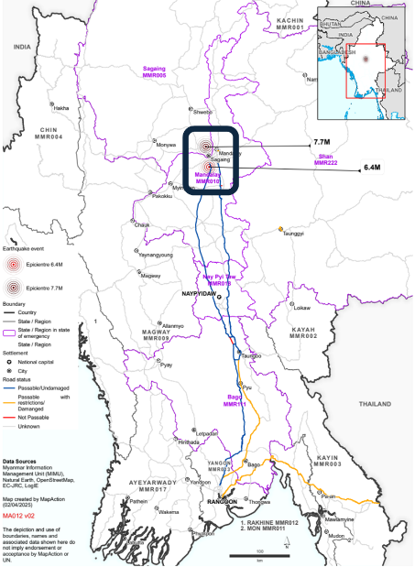3. On your map, circle the epicentre of the earthquakes

4. What is the name of the state of the 7.7 magnitude earthquake? Sagaing

5. What is the name of the closest city to the epicentre of the 6.4 magnitude earthquake? Mandalay

6. What is the correct definition of epicentre? C

a. The point where the earthquake starts, below Earth’s surface   
b. The point where the earthquake starts, above Earth’s surface

c. The point directly above the focus, where the tremors are strongest

d. The point directly above the focus, where the tremors are weakest

7. What is the *as the crow flies* distance of the passable route from Thailand to Rangoon?

Map scale: 100 km = 2.5cm   
Answer = 250km (based on real life distance of 5.5cm)

8. What is the *as the crow flies* distance between Rangoon and epicentre of the 6.4M earthquake?

Map scale: 100 km = 2.5cm   
Answer = 600km (based on real life distance of 15cm)

**Activity 2 – Read the profiles of each of the *geographers behind the map***

**Select the correct person for each of the actions listed below and decide whether these actions occur before, during or after a natural hazard**

1. 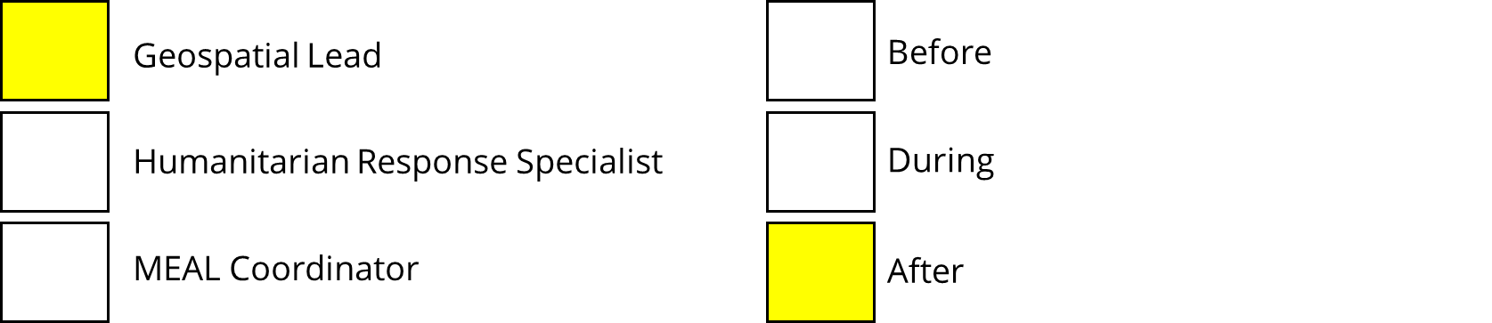Mapping out transport routes that volunteers can use to distribute food aid to local people affected by an earthquake

Challenge – Why might transport routes been inaccessible following an earthquake?   
  
Answers may include – secondary hazards (e.g. lahars or avalanches), liquefaction, fallen trees, debris, damage to infrastructure

1. Delivering workshops to volunteers who will be deployed to the hazard zone to equip them with the skills and knowledge they need to respond effectively

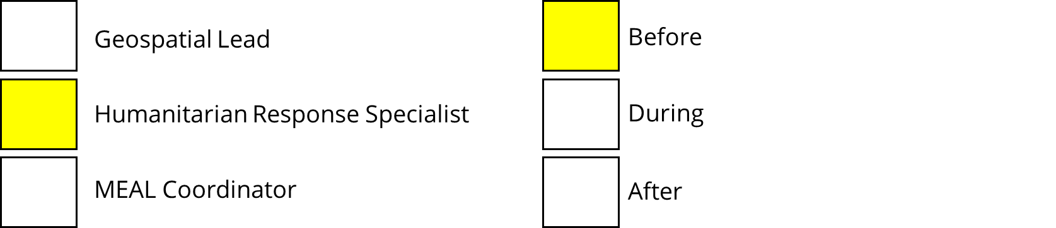

1. Conducting research to evaluate how effective the response is to an earthquake. This may include speaking to local people and local governments.

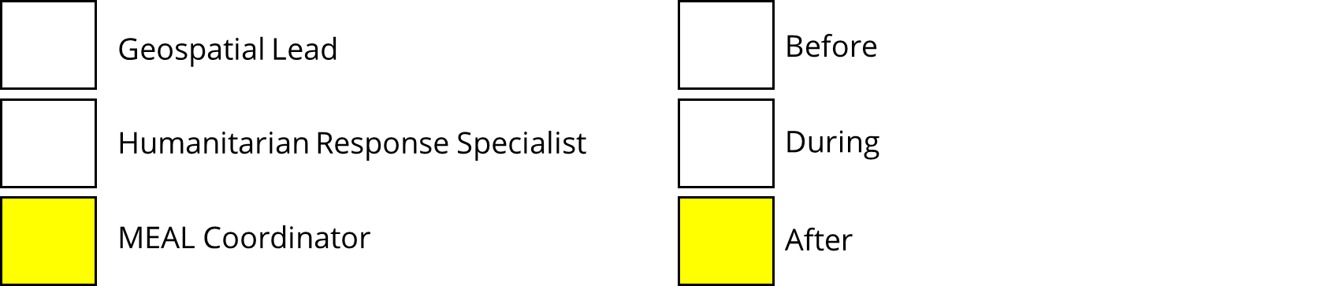

1. Evaluating an emergency response to measure how sustainable it was, and make suggestions for improvements



1. 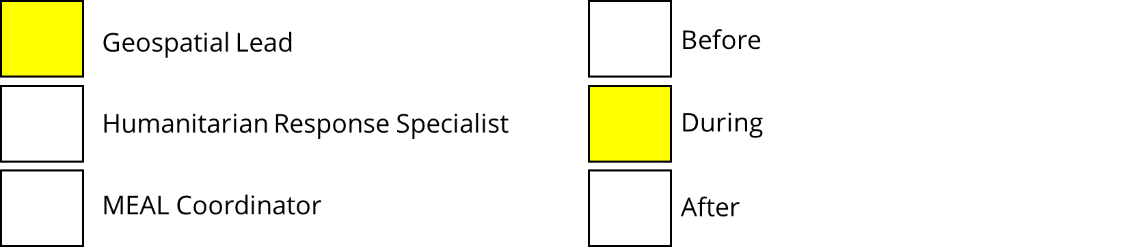Creating a map showing the storm track of a cyclone, typhoon or hurricane

Challenge – What’s the difference between a hurricane, cyclone and typhoon?  
  
Answer – The location. Hurricanes occur in the North Atlantic and Northeast Pacific Ocean, cyclones occur in the South Pacific and Indian Ocean and typhoons occur in the Northwest Pacific Ocean

**b. Complete the sentences below to decide whether the activity described is an example of mitigation or adaptation. An example has been completed for you.**

**Key definitions**

**Mitigation** – Taking action to reduce the impact of a hazard

**Adaptation** – Helping improve the ability of a community or government to cope with a hazard

**Example:** Running workshops for volunteers to ensure they respond effectively to an earthquake is an example of mitigation / adaptation. This is because the workshops take place prior to the hazard to help inform volunteers how to reduce the impact of the earthquake.

1. Conducting a survey after the earthquake to assess how effective the response has been in order to reduce damage in a future scenario is an example of mitigation / adaptation. This is because the survey will help inform how a community copes with a hazard
2. Creating a map showing evacuation routes for local people to take prior to an earthquake is an example of mitigation / adaptation. This is because an evacuation route will allow people to leave the area to reach safety, therefore reducing number of fatalities and injuries
3. Creating education programmes to inform locals of how they can best prepare for an earthquake, therefore reducing the number of people affected is an example of mitigation / adaptation. This is because local communities and responders will be aware of what to do should a hazard occur, therefore helping reducing fatalities and injuries

**Activity 3 – Below is a list of skills that each job requires. Sort the skills into the job that they most align with**The answers below are based on the information contained in the job profiles in the student resource, but they are not binary. Students may be able to justify alternative responses.

**Extension - Explain why each of these roles is important in response to a natural hazard**

* The role of the Geospatial Coordinator is important because …

Responses may include: it’s important to have an understanding of the physical/human geography of a place prior to planning an emergency; helps with understanding natural and human barriers that may affect the effectiveness of the hazard response so responders can adapt accordingly; helps responders prioritise where to help; able to present live and visual information to emergency responders

* The role of the MEAL Coordinator is important because ….

Responses may include: it’s important to be well-informed of community needs and understand the impact of a response on a local communities/governments, it’s important for improving emergency response to help reduce impact of future hazards, it’s important for adaptation

* The role of the Humanitarian Training Specialist is important because

Responses may include: it’s critical that responders are well informed of what to do in emergency scenarios so that they can act effectively; contributes to hazard mitigation, helping reduce the impact of a hazard

**Links to further support**

* Royal Geographical Society’s career pages: [Choose a career with geography - RGS](https://www.rgs.org/choose-geography/choose-a-career-with-geography)
* Teacher CPD: [Teacher events - RGS](https://www.rgs.org/schools/teacher-events)
* I am a geographer: [I am a geographer - RGS](https://www.rgs.org/choose-geography/i-am-a-geographer)
* Statutory careers guidance for schools: [Careers guidance and access for education and training providers - GOV.UK](https://www.gov.uk/government/publications/careers-guidance-provision-for-young-people-in-schools)