The Nitrogen cycle activity sheet 1

Specification links
AQA 3.1.6.2 Ecosystems and processes. Mineral nutrient cycling: Nature of terrestrial ecosystems and the inter-connections between climate, vegetation, soil, and topography which produce them. Ecosystem responses to changes in one or more of their components or environmental controls.

OCR Topic 3.4 – Future of Food. 1.b. Food is a precious resource and global food production can be viewed as an interconnected system: The physical conditions required for growing food including, air, climate, soil, and water.

The Nitrogen cycle
In a similar vein to the carbon and water cycles, Nitrogen is also recycled through the biosphere and atmosphere. Nitrogen is a gas (N₂) which makes up 78% of the Earth’s atmosphere – it is fundamental to many aspects of physical geography with inputs, outputs, stores, and flows.

Nitrogen in the atmosphere falls to the Earth as precipitation, such as rain or snow. Once in the soil it interacts with bacteria on the roots of plants to combine with hydrogen. This process is called Nitrogen fixation and producers ammonium (NH₄⁺). Additional bacteria next add oxygen to the ammonium, in a process called nitrification, creating nitrite (NO₂−). A final bacterium eventually converts this again, into nitrates (NO₃-). Plants absorb this to stimulate growth. When this type of Nitrogen is not within organisms, and is in the soil, it is called ‘loose Nitrogen’.

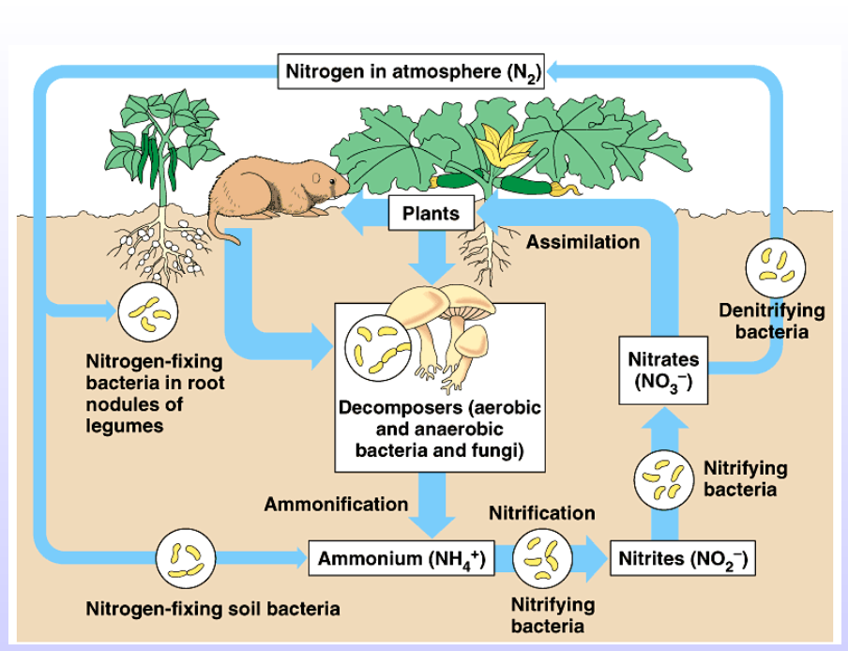
Figure 1 the Nitrogen cycle © fickleandfreckled Flickr

Once Nitrogen has been used by a plant, the dissolved Nitrogen is vaporised back into the atmosphere, and the cycle begins again.

Other pathways out from the soil are described as lost Nitrogen. Nitrogen can be lost by leeching – when Nitrogen is lost as water drains away into water courses from the soil profile or, alternatively, it could be removed by denitrification – as nitrate or nitrite are reduced back into a gaseous form. Denitrification is a bacterial process which often occurs in low-aerated, water-logged soils.

Natural Nitrogen-fixing
Nitrogen fixation is when Nitrogen is taken from its molecular form in the atmosphere (N₂) and turned into various Nitrogen compounds. It is the only way for it to enter the soil and be utilised by plants or crops naturally. The process involves microorganisms (soil bacteria) fixing Nitrogen in a symbiotic relationship with a partnering host plant, such as peas, beans, and clover in the UK. The plant provides sugars from photosynthesis that are consumed by the microbes, and in return the microorganisms fix Nitrogen into ammonium (NH₄+), nitrite (NO₂-), or nitrate (NO₃-) for the plant to absorb as an important nutrient from the soil.

Symbiotic partnering is an important element of Nitrogen fixation around the world. Legumes (beans, peas, lentils) are the most important plants in naturally fixing Nitrogen. For example, the bacteria Rhizobium tropici colonise the root system of the bean plant, causing nodules to form. These nodules house the bacteria which, in return, fix Nitrogen for the plant (and sustains the bacteria). Ultimately, this symbiosis creates leaves fortified with Nitrogen which can then also be recycled (as dead plant material is a source of Nitrogen as well).

Every year many farmers grow cover crops to replenish soils with nutrients, such as Nitrogen. An example crop is red clover which is described as ‘a vigorous plant’ as it is so efficient at fixing nitrogen into the soil.

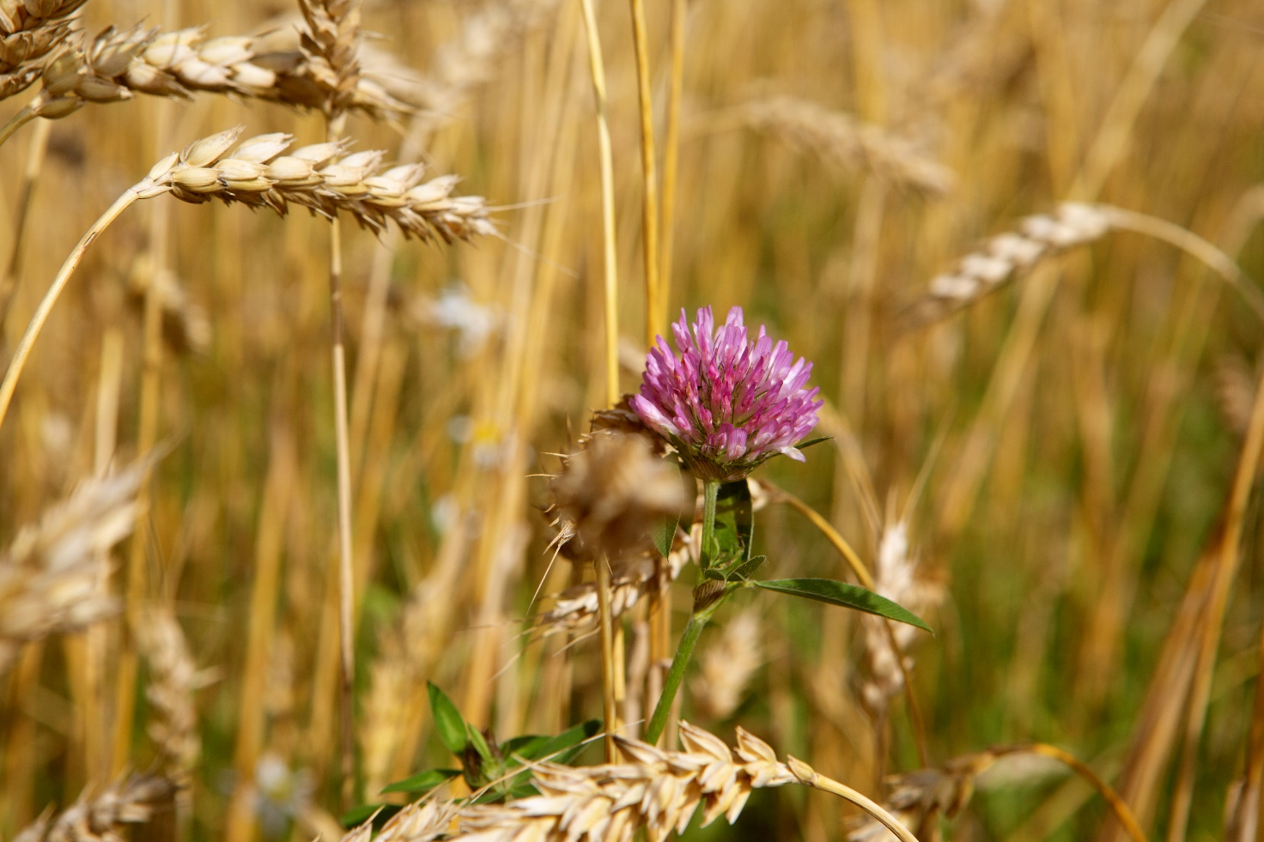
Figure 2 red clover is a cover crop which is often grown over winter build soil fertility naturally © IvanovDenis
Red and white clover are two of the most important forage (fodder) legumes (pea family plants; peas, beans, lentils) in the UK. Farmers plant red clover because it is capable of fixing as much as 250kg per hectare of Nitrogen per hectare in its first year of being sown (the commonly grown white clover only fixes 180kg). For many farmers, red clover is a natural alternative to inorganic Nitrogen fertiliser.

When inorganic Nitrogen fertiliser is used it is called nutrient loading. Nutrient loading is the intentional release, through human activities, of Nitrogen and phosphorus onto farmland. If overloading occurs it can be damaging to the environment however it is also important that there is not a shortage of nutrients as this would limit productivity of agricultural soils.

Losses of nutrients to the environment can impact air quality by ammonia emissions, water quality through nitrate and phosphate levels rising in rivers, and by contributing to climate change with nitrous oxide emissions. Balancing nutrient levels is crucial. A Nitrogen soil balance estimate is therefore an indicator of environmental risk. Due to the declining rates of soil fertility around the world it is very important to maintain nutrient levels in order to meet the demand for food.

Activity
- Use Figure 1 and undertake online research to complete Figure 3 in Appendix A.

- Different regions of the UK have different levels of Nitrogen and phosphorus. Analysis of Nitrogen and phosphorus in managed agricultural soils across the country can identify which areas are experiencing nutrient loading.

Table 1 below shows provisional estimates for the balance of soil Nitrogen throughout England.

Use Table 2 and Figure 4 in Appendix B to create choropleth map of the regional Nitrogen balance for England in 2020. Create a legend using:

- ≤ 25
- ≤ 75
- ≤ 100
- ≤ 125

Region | Kg of nutrient (Nitrogen) per hectare across England
Northeast | 24.3
Northwest | 74.8
Yorkshire & The Humber | 93.3
East Midlands | 107.2
West Midlands | 116.5
East of England | 100.1
Southeast & London | 63.6
Southwest | 93.0
ENGLAND | 88.1
Table 1 soil nutrient balances © DEFRA 2020 for managed agricultural soils per region across England

- A dataset such as Table 1 can be misleading. Looking at the overall balance of Nitrogen in England does not give an accurate picture of input. In Table 2 the dataset is split between input and output.

Analyse the data and identify which regions show nutrient loading (more inputs than outputs).
Region | Inputs kg per ha | Outputs kg per ha | Balance (in - output)
Northeast | 116.8 | 92.6 | 24.3
Northwest | 160.5 | 85.8 | 74.8
Yorkshire & Humber | 189.2 | 95.9 | 93.3
East Midlands | 205.0 | 97.9 | 107.2
West Midlands | 205.3 | 88.8 | 116.5
East of England | 208.9 | 108.8 | 100.1
Southeast & London | 158.9 | 95.3 | 63.6
Southwest | 180.4 | 87.4 | 93.0
ENGLAND | 182.5 | 94.3 | 88.1
Table 2 Nitrogen in England ©DEFRA DEFRA 2020 based on regional data published for aggregate farm accounts

Appendix A

Figure 3

Appendix B

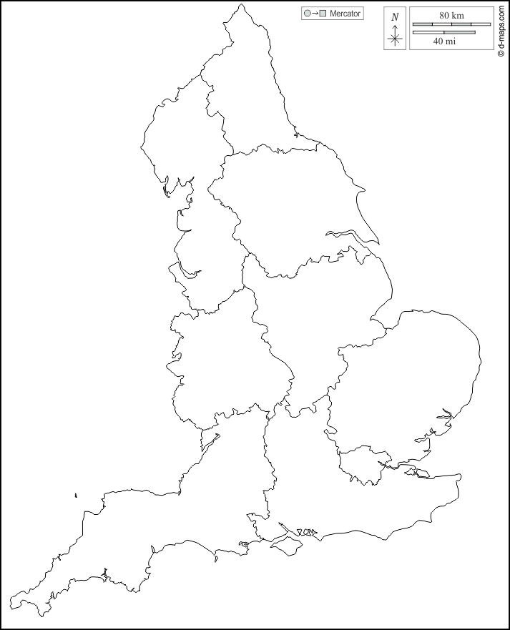
Figure 4 England – regions © d-maps

Answers
- The answers are all correctly labelled in Figure 1 on page 1.

- The choropleth map showing Nitrogen balance for England regions in 2020 is below.

Figure 5 the Nitrogen balance for England

- All regions in England have higher inputs of Nitrogen than outputs. Excessive nutrient loading is evident in East Midlands, West Midlands, and the East of England – where fields are flatter, larger, and more open. In the east the weather is drier resulting in a concentration of arable farming. East Anglia is renowned as having the most productive soils in the UK.

