Task answers

Task 1
Read Sources A, C and D, then answer the following questions:
Source A
- There was concern that large-scale development on the oil industry could threaten the natural features of the islands.
- Estimates by both the Forestry Commission and the annual Agricultural Census of the Ministry of Agriculture, Fisheries and Food (MAFF – a forerunner of Defra) closely agreed with land use estimates across the then 32 land classes of the Countryside Survey.
- The video is meant for the general public. It is both explaining the complexity of the survey, but also how the countryside is a managed landscape that is undergoing significant change. It explores the ambiguities of fieldwork, and the interaction of research, management and policy, doing a pretty good job of explaining the complex interactions between different stakeholders, and the human and physical aspects of our landscape.
- Hedgerow extent had fallen 20%, and there was species loss of 20-30%. Both were in the public consciousness as evidenced by policy outcomes (such as the Hedgerows Regulations 1997). The 2000 Survey found that there had been no further significant loss of hedgerows, though habitat quality had continued to decline. There was now a clear link between the loss of species diversity, the decline of bird and buttery species, and the intensification of agriculture.
Source B
- The accuracy of the new classification scheme compared to the existing scheme was only 62%. This was considered sufficient as even when squares did not match exactly, they fell into neighbouring land classes and the average characteristics of the class remained unchanged. This change makes comparing subsequent surveys to those in 1990 and previously more complex.
- Both the number of land classes and the number of squares surveyed increased to allow reporting of Wales and Scotland separate to the UK as a whole. This corresponded to the process of devolution that devolved some governance to the national assemblies of Wales and Scotland.

Source C
- Merlewood. Other research stations are Banchory, Edinburgh, Bangor, Monks Wood, Furzebrook.
- Upland areas contain significant carbon sinks (e.g. peat bogs). Changing agricultural practices will affect peat bog formation and deterioration, vegetation, fauna and soils. The survey provides the data to monitor change, model ecosystems and understand the behaviour of the carbon sink.
- Lowland Heath. Difficult to find any on the map at all! Most has been turned into farmland.
- Robert G.H.Bunce. (Estonian University of Life Sciences, Kreuzwaldi 5, 51014 Tartu, Estonia)

Source D
- Choose (Citizen science) two apps that would be appropriate for use with young children (7-10-year-olds) and justify your choices. Choose two that would be useful for A-level students and justify your choices.
- What is SWEET, and what are the benefits of using it?
- What are the benefits of ArcGIS tools for data collection? What do you think is the most significant, and why?
- What problems might field surveyors encounter using GIS?
- Who is the NERC, and why are they involved?

Task 2
- The bog habitat mapped – the land classes than contain the highest 32% of the habitat – are predominantly in upland areas of England and Scotland, the Peak District and Pennines, Lake District, Western Scottish Lowlands, and Scottish Highlands (including inner and Outer Hebrides)
- These areas are all at elevations of approx. 400m+, with high rainfall, though mixed geology. This would suggest that bog habitat forms in areas with these physical characteristics. Its distribution suggests it persists in areas remote from dense human populations with little agricultural value.
- Those areas closest to large human populations are most likely to be directly affected. For example, in the Peak District between Manchester and Sheffield, or the Highlands near to Glasgow. The impact of human pollution will have significantly greater range.
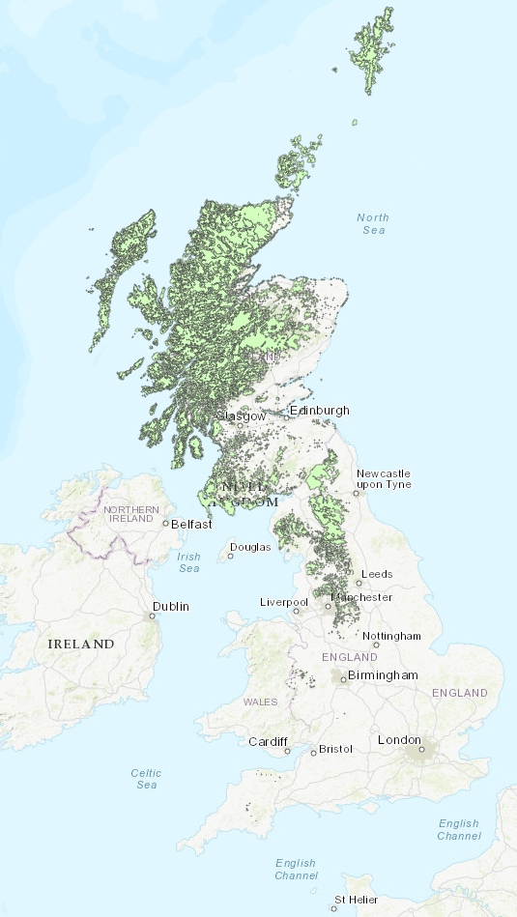

Task 3
Part A
- Road transport
- Largely located in central Wales and the North of the UK. In particular, upland areas, coastlines, small pockets of rural areas, National Parks (e.g. Dartmoor, Snowdonia, North York Moors), Forested areas (e.g. Thetford, Scottish Borders), Scottish Highlands,
- Areas remote from significant human populations and sources of fossil fuel combustion.
- Yes – the Bog habitat as mapped occurs predominantly where there is very low concentration of NO_{x}.
- Possibly – it most likely reflects that the Bog habitat is most common in upland areas that are remote from significant sources of NO_{x}. NO_{x} will be detrimental to the Bog habitat as it inhibits growth and weakens vegetation however it is likely that other factors have a much greater effect tan NO_{x}, for instance urbanisation, and farming.
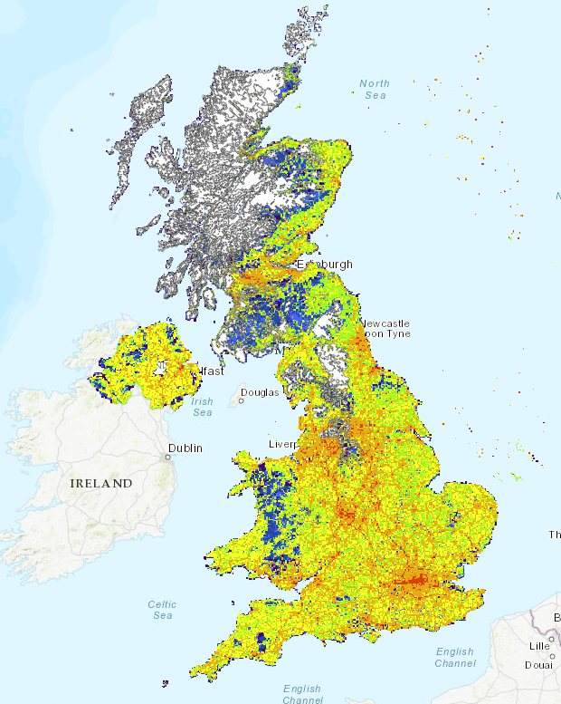
Part B
- Although concentrations follow the road network and are highest in urban areas like NOx, concentrations fall quickly away from sources, and as such much more of the country has low levels of SO₂. This is because SO₂ reacts readily with water vapour (forming sulphuric acid) and is removed from the atmosphere.
- Airports. Jet A (jet engine fuel/Kerosene) contains more sulphur than petrol or diesel and is used in large amounts as planes take off.
- Yes – levels are SO₂ are generally very low where there is Bog, although looking closely around some areas, e.g. Manchester, you can see that higher levels of SO₂ are also found in areas of Bog habitat.
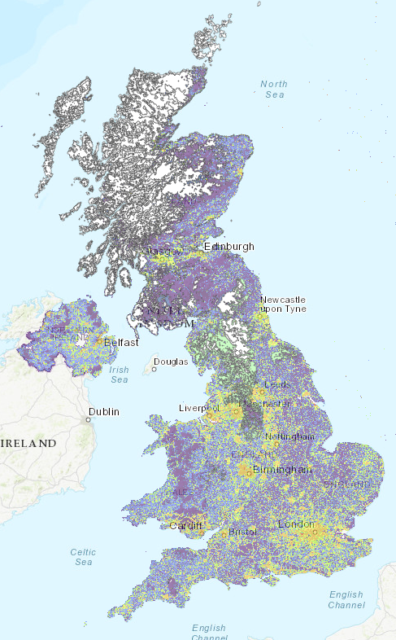
- It is likely that the dominant reason for the pattern is that the bog habitat is common in upland areas remote from human populations and sources of SO₂ (principally from the burning of fossil fuels). SO₂ does acidify rain, however, which would in turn acidify the bog habitat and could be detrimental to it’s growth and/or health by altering the pH of the habitat or increasing the leeching of nutrients. Emissions of SO₂ have fallen as vehicle emissions standards have improved (vehicle fuels now have much lower sulphur content than they did), and as coal-fired power stations have been decommissioned, so the effect of SO₂ on the bog habitat is probably declining.

Task 4
Part 1
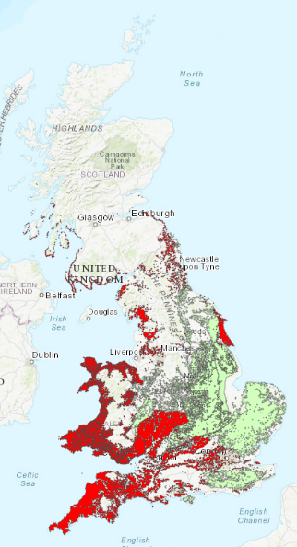
- The highest concentration of improved grassland is in the South-West, West of the Cotswolds, and around the lower land surrounding the Welsh Mountains. The highest concentration of arable land is in East Anglia, around the South Downs, and the Lincolnshire wolds.

- Arable land seems to be most common on flatter land; improved grassland (pasture) in areas which are more undulating.

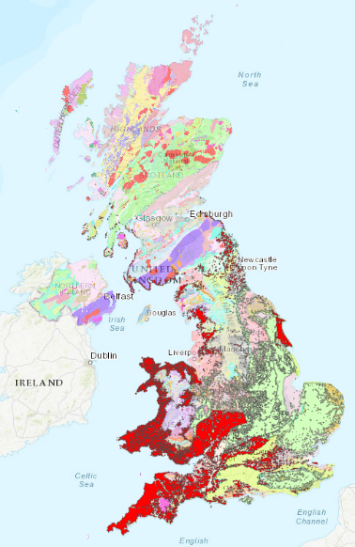
- It does for arable land, which seems more prevalent in areas with bedrock geology consisting of gravel, sand, silt, sandstone or limestone (which as parent material of the soils in the regions will strongly influence the soils suitability for cereal crops). The geology will also affect the topography of the land, these areas have a flatter landscape. There is no corresponding simple pattern for improved grassland which lies over extremely varied geology, which suggests that the topological influence of Geology is the more relevant for pasture (as heavy farm machinery cannot operate on sloping ground).

Task 5
- Broadly dispersed across the UK, though very little in the South-West, East Anglia, the North-West, and the highest upland areas.
- Tree cover in and adjacent to upland areas is most likely commercial plantations as this is agriculturally marginal land. In lowland areas, tree cover is greater in areas that have pastoral farming (as it would reduce the productivity of arable land). The dense cover in Wiltshire and Dorset could relate to areas of land used by the Army and/or consisting of smaller fields (therefore with more boundaries containing more trees) which reflect less intensive agriculture.
- The densest coniferous land cover is in the Scottish borders. These ‘lowlands’ are extensive areas of relatively large hills and are covered in coniferous plantations as they are unsuitable for other agricultural use due to their steep relief and nutrient-poor soils. The densest area of deciduous land cover is across Southern England, around the New Forest and Salisbury Plain. These represent significant areas of land that are protected – either as a National Park or as Army training areas. Deciduous trees are also more likely to thrive at lower latitudes and altitudes.
- Scotland and the North-West. There is either existing tree cover that could be increased or marginal land that could be planted. Other areas are heavily used as pastoral or arable farmland.
- Coniferous trees, as they are the fastest growing. Scotland has the greatest potential as it has the largest land area that could be planted.
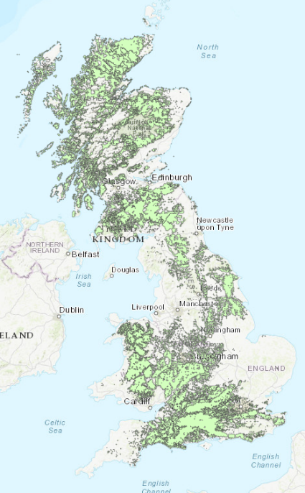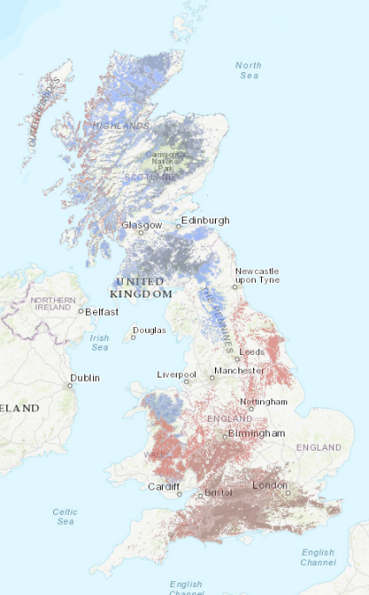

Task 6
- Upland areas in the North of England. Predominantly in National Parks (eg. Peak District, Yorkshire Dales, Lake District, North York Moors, Northumberland), and AONBs, e.g. Forest of Bowland.
- Marginal upland hill farming. Stone walls up to several hundred years old – the distribution has both a historical aspect and also reflects the dominant land use of these areas of agricultural land in the present day.
- Walls reflect human modification of natural habitats. Given the significant investment of time and effort this reflects, there must be an underlying economic imperative, which suggests activities such as farming, or mining. It is unlikely the walls are to keep people out of land given their upland locations. The physical properties of these areas – high rainfall, poor soils, steep relief – describe marginal land capable of minimal agricultural output. This suggests, in turn, that the walls that remain do so because landowners have neither a reason nor the money to remove the walls. As the majority of walls are in protected landscapes it could also be the case that the remain because their removal is prohibited.
