|  |
| --- |
| The geographers behind the map |

On the 29 March 2025, a 7.7 magnitude earthquake struck Myanmar, affecting 18 million people. In response to the earthquake, Map Action (a charity that specialises in creating digital maps to support humanitarian response to natural hazards) have created maps and datasets that will help volunteers access the affected area and help the local community. The maps they have created in response to the Myanmar earthquake include a map of shake intensity by region, a map of what roads can be used following the quake, and a map showing state boundaries in Myanmar. These maps will help volunteers and organisations respond to the earthquake.

**Activity 1 - Using Map Action’s road status map (resource booklet), answer the questions:**   
  
1. What is the National capital of Myanmar? Name the state the National capital is located in

………………………………………………………………………………………………………………………………………….

2. Name three countries that border Myanmar

………………………………………………………………………………………………………………………………………….

3. On your map, circle the epicentres of the earthquakes

………………………………………………………………………………………………………………………………………….

4. What is the name of the state of the 7.7 magnitude earthquake?

………………………………………………………………………………………………………………………………………….

5. What is the name of the closest city to the epicentre of the 6.4 magnitude earthquake?

………………………………………………………………………………………………………………………………………….

6. What is the correct definition of epicentre?

a. The point where the earthquake starts, below Earth’s surface   
b. The point where the earthquake starts, above Earth’s surface

c. The point directly above the focus, where the tremors are strongest

d. The point directly above the focus, where the tremors are weakest

7. What is the *as the crow flies* distance of the passable route from Thailand to Rangoon?

………………………………………………………………………………………………………………………………………….

8. What is the *as the crow flies* distance between Rangoon and epicentre of the 6.4M earthquake?

………………………………………………………………………………………………………………………………………….

**The geographers behind the map**

The jobs below are all based in the **charity** sector, which means that the main goal is to help others rather than make a profit. The charity sector is funded by donations and fundraising. People who work in the charity sector are often very passionate and driven. They want to make a positive change and help tackle global challenges.

|  |  |  |
| --- | --- | --- |
| **Job Title** | **Job description** | **Key skills** |
| **Geospatial Coordinator**  **Map with pin with solid fill** | **Geospatial coordinators** are highly skilled in using Geographical Information Systems (GIS). They design and create maps to aid disaster relief operations. For example, they create digital maps that show affected communities and shelter locations following a hurricane; maps that show transportation routes following an earthquake to help people deliver aid to affected communications; and maps that show the storm track of a tropical storm. They ensure that needs maps are kept up to date to help volunteers who have to respond to an emergency situation, like a hurricane.  A **Geospatial Coordinator** earns between £34,048 and £44,000 per year year | * Excellent GIS skills * Confident working with large sets of data * Excellent analytical skills * Works well in a team and under-pressure * Willing to travel internationally to affected areas for several weeks, multiple times a year |
| **Humanitarian Training Specialist**  **Teacher with solid fill** | A **Humanitarian Training Specialist** designs and delivers training to help improve the GIS skills of volunteers. This includes helping volunteers understand how to respond to a disaster scenario. They help ensure volunteers are well prepared for an emergency situation and that the volunteers can deliver mapping services effectively under challenging conditions. A Humanitarian Training Specialist also train people who work in other non-governmental organisations (charities) and international organisations like the UN. They are very skilled in GIS.  A **Humanitarian Training Specialist** earns between £30,017 and £42,000 per year | * A good understanding of GIS and geospatial data * Excellent communication skills and able to explain things clearly * Creative and able to design effective, engaging activities * Works well in a team and under-pressure |
| **MEAL Coordinator**  **Group with solid fill** | A **Monitoring, Evaluation, Accountability, and Learning (MEAL) Coordinator** helps to measure how successful a response has been to an emergency situation. They will collect data following a disaster to evaluate how successful the response was. This data collection may include speaking to local communities, local governments and other charities. They try and ensure that responses to an emergency situation are sustainable, and make suggestions for improved based on their research. They have excellent knowledge of the risks associated with hazards.  A **MEAL Coordinator** earns between £35,750 and £45,000 per year | * Able to meet deadlines in a fast paced working environment * Willing to travel internationally to affected areas for several weeks, multiple times a year * Excellent communication and teamwork skills |

**Activity 2 – Read the profiles of each of the *geographers behind the map***

**Select the correct person for each of the actions listed below and decide whether these actions occur before, during or after a natural disaster**

1. A black background with a black square

   AI-generated content may be incorrect.Mapping out transport routes that volunteers can use to distribute food aid to local people affected by an earthquake

Challenge – Why might transport routes been inaccessible following an earthquake?

1. Delivering workshops to volunteers who will be deployed to the hazard zone to equip them with the skills and knowledge they need to respond effectively

1. Conducting research to evaluate how effective the response is to an earthquake. This may include speaking to local people and local governments.

1. Evaluating an emergency response to measure how sustainable it was, and make suggestions for improvements

1. A black background with a black square

   AI-generated content may be incorrect.Creating a map showing the storm track of a cyclone, typhoon or hurricane

Challenge – What’s the difference between a hurricane, cyclone and typhoon?

**b. Complete the sentences below to decide whether the activity described is an example of mitigation or adaptation. An example has been completed for you.**

**Key definitions**

**Mitigation** – Taking action to reduce the impact of a hazard

**Adaptation** – Helping improve the ability of a community or government to cope with a hazard

**Example:** Running workshops for volunteers to ensure they respond effectively to an earthquake is an example of mitigation / adaptation. This is because the workshops take place prior to the hazard to help inform volunteers how to reduce the impact of the earthquake.

1. Conducting a survey after the earthquake to assess how effective the response has been in order to reduce damage in a future scenario is an example of mitigation / adaptation. This is because …
2. Creating a map showing evacuation routes for local people to take prior to an earthquake is an example of mitigation / adaptation. This is because …
3. Creating education programmes to inform locals of how they can best prepare for an earthquake, therefore reducing the number of people affected is an example of mitigation / adaptation. This is because …

**Activity 3 – Below is a list of skills that each job requires. Sort the skills into the job that they most align with**

Geospatial Coordinator

Humanitarian Training Specialist

MEAL Coordinator

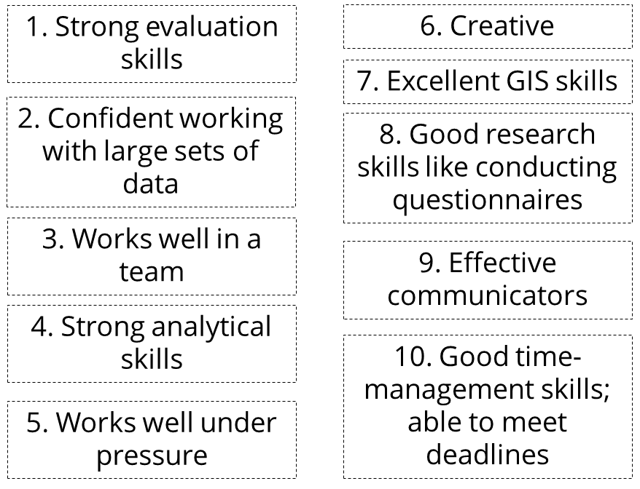

**Extension - Explain why each of these roles is important in response to a natural hazard**

* The role of the Geospatial Coordinator is important because …

……………………………………………………………………………………………………………………………………………………………………………………………………………………………………………………………………………………………………

* The role of the MEAL Coordinator is important because ….

……………………………………………………………………………………………………………………………………………………………………………………………………………………………………………………………………………………………………

* The role of the Humanitarian Training Specialist is important because …

……………………………………………………………………………………………………………………………………………………………………………………………………………………………………………………………………………………………………