Map Skills End of Unit Assessment Answers

- Place the correct directions on each compass point.
North, North East, East, South East, South, South West, West, North West.

- Name three different types of map.
Atlas, Street Map, OS map, Tube map, bus map, etc.
- Look at the map extract. Write the four-figure grid reference for the London Eye.
3079
- Write the four-figure grid reference for the Globe Theatre. 3280
- What direction is St. James’s Palace from St. Paul’s Cathedral?
Southwest
- Look at the contours below. Draw what the landscape would look like.

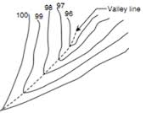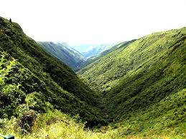

- How else is height recorded on an OS map?
___Spot heights________________ & _______Triangulation Pillars__
- Write the six-figure grid reference for the Aquarium. 305798
- Write the six-figure grid reference for Waterloo Station.
310799
- How far is it from the Tower of London to the Globe Theatre as the crow flies (i.e. a straight line)? Give your answer to the nearest ½ km. __1.5km

