Indian diaspora
Activity sheet 4

Indian migration patterns
India has a large, multi-layered and diversified diaspora. British indentured labour schemes which came into effect following the end of slavery recruited Indian labourers to work across European colonies in Africa and the Caribbean. India was founded as an independent state in 1947, after partition from what is now Pakistan and Bangladesh, leading to massive displacement of Muslims towards Pakistan from India, and of Hindus and Sikhs from Pakistan to India. The discovery of oil in the Gulf region paved the way for significant recruitment of Indian workers. Today, around half of Indian-born international migrants are in the Gulf states, mostly on a temporary basis, working predominantly in low-skilled occupations, particularly construction. Beyond this, there is significant movement of people to take up better-paid skilled work opportunities around the world, particularly North America and Europe. International migration has at different times both allowed people to escape social repression, as well as reinforced inequalities around religion, caste and gender.

By 2020, 18 million people from India were living outside of their country of birth – the largest number of emigrants in the world, and roughly double the numbers in 2000. In an effort to engage with its diaspora, without extending dual citizenship, the Indian government now recognise 32 million people are Overseas Citizens of Indians (OCIs) of different statuses, authorising greater freedom of movement for visits to India and certain other rights.

The Indian diaspora in the UK

Under British colonial control, Indian elites travelled to the UK for education and training and men were recruited as soldiers and seamen during the second World War. After Indian independence in 1947, post-war labour shortages drew people to work in key industries in the UK, particularly transportation and textiles, as well as in the new National Health Service. Later, Indian origin families who had predominantly moved under indentured labour schemes to East Africa, fled the impacts of Africanisation policies in the 1960s and 1970s, to the UK. As low-skilled migration opportunities progressively contracted, migration tended to involve family members, students, entrepreneurs and the highly educated.

According to the 2021 Census, some 920,000 people residing in England and Wales were born in India, making India the most common foreign country of birth, and accounting for 1.5% of the overall population. Some 1.9 million people (3.1% of the England and Wales population) identify as Indian in terms of their ethnicity (this can include people born in the UK with Indian family heritage). Figure 2 shows the geographical distribution of people who identify as Indian.

Figure 1. Population identifying as ethnically Indian by Local Authority District in England and Wales
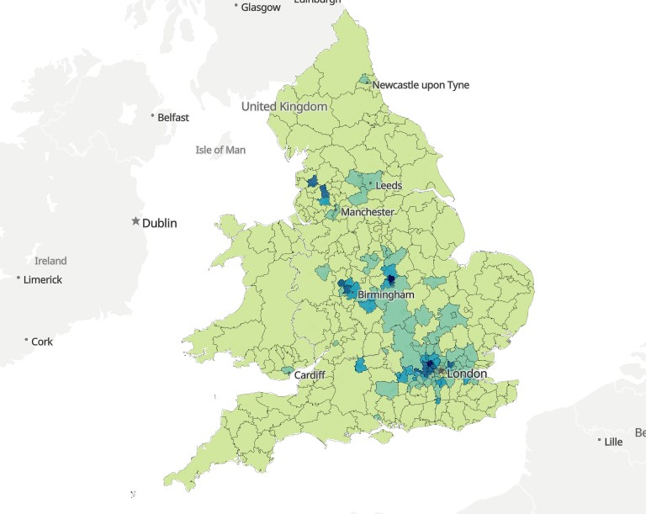

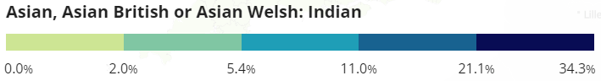
Source: Census Maps 2021, https://www.ons.gov.uk/census/maps/choropleth/identity/ethnic-group/ethnic-group-tb-20b/asian-asian-british-or-asian-welsh-indian

This is a large and diverse ‘community’: as one research workshop participant put it there are ‘many small Indias within India’, and Indians in the UK are of various religions, regional origins and languages, including multi-generational families and new arrivals, and working in varied occupations. On average, people born in India are somewhat better off economically than many other migrant groups. In the 2019 Annual Population Survey, 45% of workers born in India were in high-skilled jobs, especially as IT and communications specialists (compared with 30% of foreign-born and 29% of UK-born workers), and employment rates are similar to the population as a whole (although more gender-biased). India-born full-time employees had among the highest median earnings at £36,200 per year, compared to £28,600 of the UK-born. However, the pandemic also made more visible deprivation that exists in the Indian community, with the low-paid, those with more precarious immigration status, elders and international students being the most vulnerable.

Transnationalism and remittances
People in the UK who identify as Indian and maintain connections with India play an important role in fostering linkages between the two countries. People of Indian origin/ heritage play important roles in business, science, medicine and politics in the UK and Indian food and culture have become popular. Meanwhile, the diaspora is a source of influence in India, engaging in political debate and professional networking. Some people in the UK and elsewhere buy property or start businesses on their own account in India, and some send money to family members.

With its large diaspora, it is not surprising that India receives the largest inflows of remittances of any country worldwide, at US$111 billion in 2022. While this represents only 3.3% of this large country’s GDP, it can be very significant in particular high-emigration regions such as Kerala. Apart from a very slight dip in 2020, remittances to India from other countries have continued to grow, with a startling 24% increase in 2022. The UK is a key source of remittances to India, ranking 6th in 2021 estimates of bilateral flows, after the United Arab Emirates, the United States and other major destinations in the Middle East. India is by far the main destination of remittances from the UK to other countries, at an estimated $4.5 billion in 2021.

Connecting During Covid project findings
After early pandemic restrictions and abrupt and massive layoffs in 2020, the situation in India deteriorated dramatically with the surge in the delta variant in May/June 2021. Particularly during the second wave of the pandemic in India, which occurred at a time of opening up of restrictions in the UK, there appears to have been a surge of charitable/community donations. Social media was awash with appeals for information on how people could help and appeals for help from families and organisations in India. British Indian celebrities sponsored major fund-raising. There were some spectacular results: the Times of India reported that the UK Indian diaspora raised £100,000 for relief in just a few hours. Medical equipment was sent as well as finance, and members of the British Association of Physicians of Indian Origin conducted ‘virtual ward rounds’ with colleagues in Indian hospitals.
However, many of those in most dire need – insecure informal workers and the rural poor and their families – do not have personal family connections abroad. To migrate to the Middle East requires money to pay travel and visa and often employment brokers. To migrate to the UK requires all of this at greater cost, and often also family connections or a certain skill level. People of Indian origin/heritage in the UK do not tend, therefore, to come from the poorest segments of Indian society.
Still, some 30% of the 103 people we surveyed remitted money to friends and family in 2019 and 2020. For instance, a restaurant worker interviewed emphasised the strong cultural sense of responsibility towards parents in India: ‘our parents need our support always. They are not going to the old age home or something, no, never. They are living with us… everyone looking after each other… At the moment I am away from them… so I have to at least help through financially because I cannot look after them personally.’ People also talked about being called by contacts who had never asked for help before, as the situation deteriorated, particularly to try to secure medical help and oxygen as the delta variant of Covid-19 wreaked havoc across India.
Some could relatively easily afford to help out. As seen above, average incomes of Indian migrant employees are relatively strong. Early analysis suggested that 47% percent of Indian migrants were in key worker occupations (two thirds of these in highly skilled jobs) so likely to have maintained employment through the pandemic (compared with 33% of UK-born). An estimated 33% of India-born workers were able to work from home (compared with 30% of UK-born). Some others with relatively stable employment arrangements were able to access furlough or self-employment income supports.
Others were enduring more difficult circumstances, with insecure immigration status and/or in precarious work, and were not able to send or send much, often needing to turn to food banks and community handouts themselves. One interviewee commented those were ‘very sad times and we felt drastically helpless... at the back of my mind, I know that they need money. I don't know how I have survived with all those thoughts in my mind.’ Another explained ‘I just buried it all in my mind and didn’t share this with my family…. It was easier to send money by borrowing rather than telling them about the tough living conditions in the UK for undocumented people.’
However, others did not feel that their relatives needed their help, and still others did not have friends or family abroad. As one interviewee put it, ‘all my family is in East London and I'm more worried about people starving in Manor Park than in India because I don't keep that in touch.’
Further reading
- Animation: Connecting During Covid - PositiveNegatives
- Datta, Kavita, Saliha Majeed-Hajaj and Laura Hamond (2021) ‘Shifting contours of care: How UK Indian diasporas give and receive care in the time of COVID-19’ People Move Blog. Washington DC: World Bank. https://blogs.worldbank.org/peoplemove/shifting-contours-care-how-uk-indian-diasporas-give-and-receive-care-time-covid-19
- Fernández-Reino, Maria and Deniz Kierans (2020) Locking out the keys? Migrant key workers and post-Brexit immigration policies. Migration Observatory Briefing. Oxford: University of Oxford. https://migrationobservatory.ox.ac.uk/resources/reports/locking-out-the-keys-migrant-key-workers-and-post-brexit-immigration-policies/
- Fernández-Reino, Maria and Rob McNeil (2020) Migrants’ labour market profile and the health and economic impacts of the COVID-19 pandemic. Migration Observatory. Oxford: University of Oxford. https://migrationobservatory.ox.ac.uk/resources/reports/migrants-labour-market-profile-and-the-health-and-economic-impacts-of-the-covid-19-pandemic/
- Lindley, Anna, Kavita Datta, Elaine Chase, Laura Hammond, Kaltun Fadal, Iris Lim, Gabriela Loureiro and Saliha Majeed-Hajaj (2023) 'Remitting Through Crisis: Experiences of Migrant and Diaspora Communities in the UK.' Connecting During Covid-19 Research Briefing No. 2. London: Queen Mary University of London. https://www.qmul.ac.uk/geog/media/geography/docs/332_23-Remittances-Crisis-Report-v3.pdf
- Sonwalkar, Prasun (2021) Diaspora turns Covid warriors for Indians back home, Khaleej Times, 13 May https://www.khaleejtimes.com/long-reads/diaspora-turns-covid-warriors-for-indians-back-home

Questions
- How did colonialism affect Indian migration and diaspora formation?
- How is identifying as ethnically Indian different from being born in India?
- Explore Census Maps (https://www.ons.gov.uk/census/maps) to compare the distribution of population identifying as Indian (ethnicity) versus the population born in India. What do you notice?
- What are the key types of transnational financial transfer described and what are the differences between these?
- What factors are mentioned that can encourage or deter transnational engagement?

Answer guide
- How has colonialism affected Indian migration and diaspora formation?

Some possible points:
- Processes of colonialisation and decolonisation created borders of present-day India, and determining what counted as international migration.
- Indentured labour schemes spread Indian workers around the world and some settled in the places where they had worked.
- Connections with the UK through elite and military migration
- Post-second-world-war labour demand led to recruitment of workers from around the British empire / commonwealth.
- Even after independence, familiarity with English and UK education and training, and social networks in the UK encouraged migration.

- How is identifying as ethnically Indian different from being born in India?

Ethnicity refers to shared culture involving around languages, customs and institutions. It is a complex and ambiguous concept, compared with location of birth. There may be power struggles around the definition of ethnic groups. Many people living in the UK who identify as ethnically Indian, or British-Indian, indicating some shared sense of Indian cultural identity, were not born in India.

- Explore Census Maps (https://www.ons.gov.uk/census/maps) to compare the distribution of population identifying as Indian (ethnicity) versus the population born in India. What do you notice?

- https://www.ons.gov.uk/census/maps/choropleth/population/country-of-birth/country-of-birth-60a/middle-east-and-asia-southern-asia-india
- https://www.ons.gov.uk/census/maps/choropleth/identity/ethnic-group/ethnic-group-tb-20b/asian-asian-british-or-asian-welsh-indian
- Very similar distribution geographically pointing to intergenerational presence and how diaspora networks support new arrivals.

- What are the key types of transnational financial transfer described and what are the differences between these?

- Charitable giving / community transfers – donations for collective good
- Family remittances – personal transfers to family members (may also include friends) for their use
- Diaspora investment – money sent with a view to the sender benefiting or making a profit (e.g. investment in a business or property which the sender benefits from)

- What factors are mentioned that can encourage or deter transnational engagement?

Encourage:
- Need for family contact and mutual support through regular communication
- Wanting to help family with remittances, particularly parents (cultural responsibility)
- Profit motive – investment on own part in property or business
- Charitable impulse for wider community
- Importance of a moment of crisis like the second wave of Covid-19 in India to galvanise engagement

Deter:
- Not having family or friends abroad
- Not having family who need help
- Being strongly oriented towards community in the UK rather than in India

