From slavery to emancipation

At the beginning of the twentieth century, photography in the Caribbean was still only for the wealthy. The photographer, Harry Johnston, a British colonial officer, recorded the people who worked on the farms and plantations. They show landscapes, busy market scenes and country roads. Why did he take these photographs?

Harry Johnston took these photographs as a result of his friendship with the US President Theodore Roosevelt. Both Johnston and Roosevelt shared an interest in imperialism, geography and anthropology and Africa, and Roosevelt asked Johnston to provide him with information about the Caribbean to see whether the USA could play a role in the region.

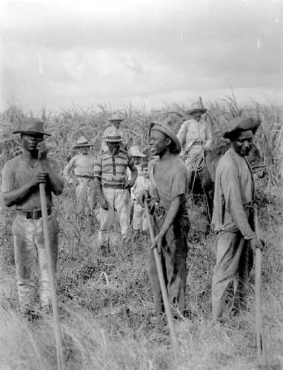
Johnston took these photos in 1908, recording the shift from slavery to free status. Although slavery was abolished in the last half of the nineteenth century, freedom came gradually for the Caribbean region. Most islanders began to own their small farms and begin subsistence farming – growing crops that were enough to feed themselves and their family with any extra produce being sold at the market. Despite ex-slaves having greater control over their free time and labour, there were still limits to their movement and rights to own land. Although people were no longer slaves, the economic benefits were still small.
Workers in a sugar-cane field
in Cuba, 1908-9, Harry Johnston

The legal ending of the trade, despite being partly caused by the sympathy and protest by some of the British public and ruling classes, did not change the attitudes of plantation owners and many individuals. Emancipation did not immediately change ownership of land, power, the harsh conditions which continued on the plantations or the racism and cruelty from many of the European owners.

From 1834 with the abolition of slavery, many people moved to other islands for land and work, especially from the more populated countries, such as Barbados and less populated countries Guyana and Trinidad. Many went to Cuba to work on sugar estates, like the people in the photograph above. Between, the 1880s and 1914 more than 100,000 people left to work on the Panama canal. Many others went to work on the railway and construction sites in Haiti, Honduras, Costa Rica and Nicaragua. The USA and Canada received the largest numbers of West Indians for education, employment and to buy land. Others came to Britain as employees, traders and travellers. In the 1950s the British government encouraged citizens from the Caribbean to come and work in the ‘mother country’ as there was a shortage of labour; and during the same period many west Africans came to Britain to study and work.

