The Arctic Council

GCSE specification links

AQA
3.1.1.4 Climate Change. Climate change is the result of natural and human factors and has a range of effects.

Managing climate change involves both mitigation (reducing causes) and adaptation (responding to change).

Edexcel A
2.2.3b: Global climate is now changing as a result of human activity: Negative effects that climate change is having on the environment and people (changing patterns of crop yield, rising sea levels and retreating glaciers).

Edexcel B
1.1.3: Global climate is now changing as a result of human activity, and there is uncertainty about future climates.

OCR
2.1ci Why is climate change a global issue?

WJEC and Eduqas
5.4.3 How can ecosystems be managed sustainably?

Key terminology
- Permanent Participants – six organisations which represent the Arctic Indigenous Peoples and having full consultation rights within the Arctic Council.
- Peat Soils – soils made from partially decayed organic matter. They are sometimes used as fuel for heat.
- Geopolitics – the study of the interplay of politics and geography and the influence this can have on relations between different places.

Role of the Arctic Council
The Arctic Council was established in 1996 to act as a circumpolar collaboration between the eight Arctic countries and the Permanent Participants representing the indigenous peoples of the region.
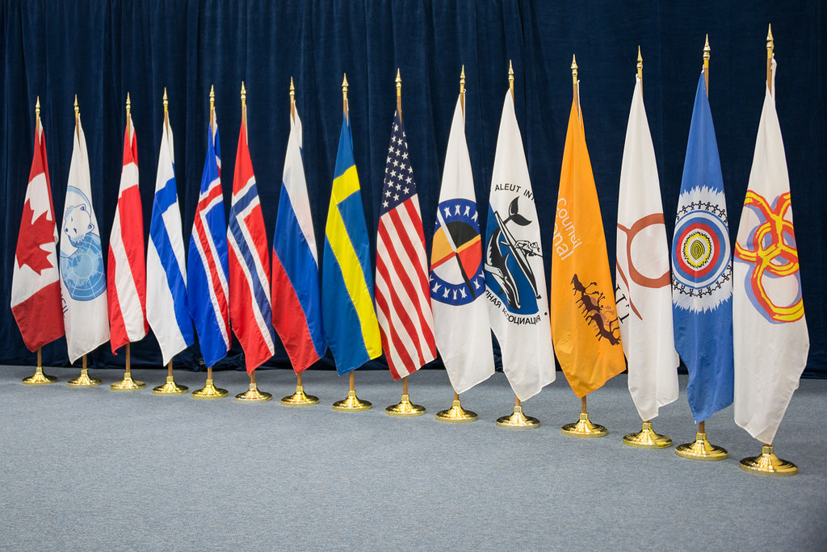
Figure 1: Arctic Council members flags © ACS/Linnea Nordström
The Arctic Council’s main aim is to promote cooperation in the Arctic. Key areas of activity include addressing the impacts of climate change and, in alignment with the Sustainable Development Goals, developing the socioeconomic opportunities in the region.
The Council undergoes a change in leadership and every two years a new chair is selected from one of the eight Arctic countries. In 2023, Norway succeeded the chair from Russia.
The main strategic aims of the Arctic Council for 2021-2030 revolve around their core mission; focusing on climate change and consequent land and sea changes as well as developing the communities of the Arctic in a sustainable way.

- Read this article on how Arctic Indigenous People became part of the Arctic Council. Explain why the role of the Permanent Participants is so important in the Arctic Council.

Arctic Council’s response to climate change

The effects of global warming have had a major impact on the Arctic region and the Arctic Council has been working to monitor and action responses to the threats to the fragile ecosystem.
Under Norway’s administration, the Wildlands Fire Initiative has been launched. Wildland fires (Wildfires) are a natural part of the Arctic ecosystem. However, with the reduction in ice and snow cover due to global warming, the fires have been occurring with increased frequency. Peaty soils in the area if burnt create a black carbon which falls onto the snow as black soot absorbing more solar radiation than that of light surfaces.
The Wildlands Fire Initiative aims to help make research more readily available and support communities by improving their ability to prevent, prepare for, and respond to the increasing threat from wildland fires.
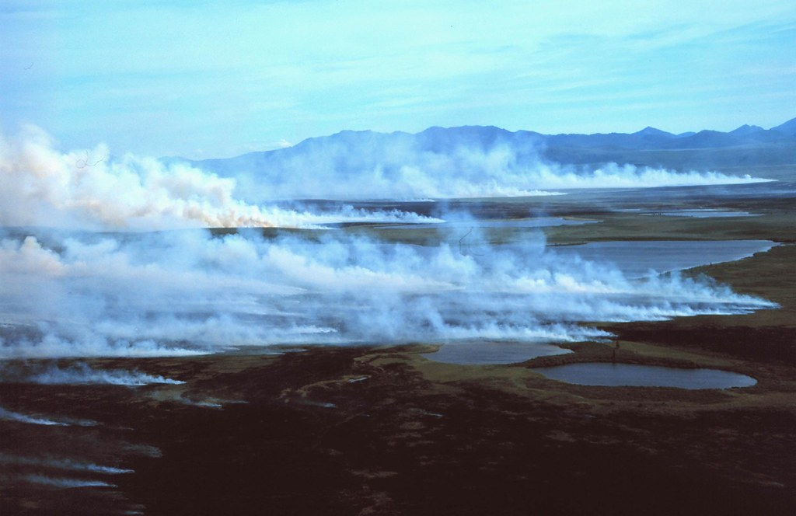
Figure 2: White smoke rising from the tundra in front of the Baird Mountains © NPS photo
The Arctic Council’s Third International Conference (April 2024) will focus on managing marine ecosystems in the warming Arctic seas.
- How could the research conducted by the Arctic Council help tackle the effects of climate change in other parts of the world?

Arctic Council and geopolitics
With Russia having over half of the Arctic’s population and 53% of its coastline it stands as a major influencer in shaping the present and future dynamics of the Arctic. However, this has become more of a challenge in recent years, with Russia’s invasion of Ukraine triggering political sanctions by several member countries within the Arctic Council.

The repercussions of these sanctions have meant that the other seven countries have opted to boycott any meetings involving Russia. Consequently, decisions concerning political collaboration with respect to Arctic territories have been at a standstill since March 2022.

Additionally, with Finland recently joining NATO (2023), there seems to be no respite in the tensions in the region. China also has its sights on mineral extraction of the Arctic having spent $90bn on Russian fossil fuel and mineral projects.

These rising tensions underscore the complexity and impact of geopolitical events on the cooperative efforts within the Arctic Council.

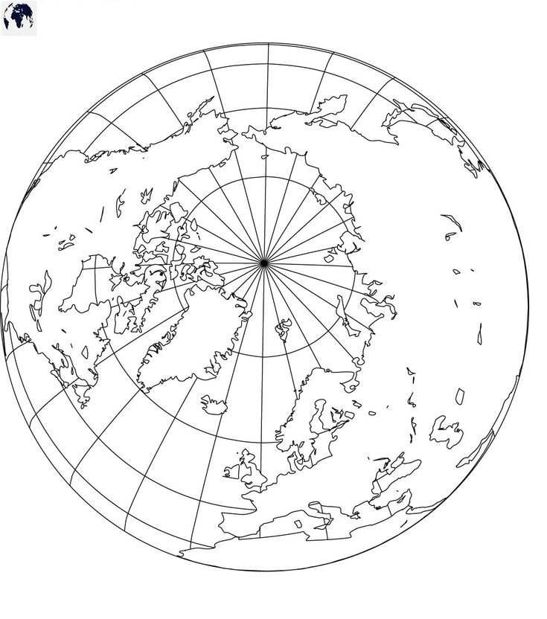

Figure 3. Map of the Arctic with countries. ©blankworldmap.net

Fortunately, the six working parties and scientific research projects remain unaffected due to their operations working on a technical rather than political leadership level. This distinction allows collaborative efforts and studies on the impacts of climate change in the region to proceed for the most part. However, the political decisions resulting from these findings still hang in the balance.

- On the blank map (Figure 3) and using an atlas
  - Label the countries in the Arctic Council
  - Add a dotted line to show where the Arctic circle is located. Label this line.
  - Label the Barents and Bering Seas.
- Using the data below, draw on proportional circles to represent the population in each country.
- Calculate the population density for each country. Is the population density equal to the total number of people?

Challenge: Explain how population density has more of an impact on issues over management of places than total population.

Country | Total Population | Territorial Land in the Arctic (km²) | Population Density
Canada | 150,000 | 3.99 (million)
The Kingdom of Denmark (including Greenland and the Faroe Islands only) | 108,000 | 2.17 (million)
Finland (Lapland) | 180,000 | 113,000
Iceland | 365,000 | 103,000
Norway (Land) | 490,000 | 193,000
Norway (Sea) | 0 | 1.5 (million)
The Russian Federation | 2.5 million | 3.42 (million)
Sweden | 520,000 | 153,000
The United States | 50,000 | 1.48 (million)

Further reading
- The Arctic Council’s article on wildland fires
- The Guardian’s report on Russia in the Arctic, 13th June 2023:
- Financial Times article on China’s involvement in the Arctic.
- BBC News report on wildfires in Siberia 2020.
- Geopolitics and new perspectives on Arctic governance with Dr Ingrid Medby, RGS December 2023 https://soundcloud.com/rgsibg

