A level skills development

Analysing Countryside Survey data

Contents

Introduction 2
The Countryside Survey 2
Understanding the nature of the CS data 3
Viewing Countryside Survey data in ArcGIS online 3
Task 1 4
Selecting and filtering data 5
Adding a data layer 5
To select data to display 5
Task 2 6
Task 3 6
Task 4 8
Task 5 9
Task 6 11
Further development 12
Appendicies 13
Appendix A - Hosted Countryside Survey data layers 13

Introduction
This document uses Countryside Survey data to develop key A level skills, including the ability to manipulate and interpret large datasets using GIS, apply statistical skills, and develop information retrieval skills.
In gaining experience of using GIS in structured exercises, pupils should feel more confident in using this spatial technology and can also explore many aspects of A level course content independently.
In particular, the content of this document provides opportunities to further develop/apply a synoptic understanding of the carbon cycle (all specifications), and Ecosystems under stress (AQA).

The Countryside Survey
The Countryside Survey is an audit of the natural resources of the UK’s countryside that has been carried out at discrete intervals since 1978. Subsequent surveys have been completed in 1984, 1990, 2000, and 2007. It is currently administered by the Centre for Ecology and Hydrology (CEH).
In the early 1970s two ecologists, Bunce and Shaw, were surveying the Lake District National Park, recording species using quadrats, then classifying quadrats into groups based on species present using a multivariate system called Indicator Species Analysis (ISA). They realised the approach could be used to classify land on a larger 1x1km grid using environmental attributes, and in 1975 the Institute of Terrestrial Ecology (ITE) funded the first national ecological survey of Great Britain, which became the Countryside Survey (1978).
Great Britain contains over 240,000 1km squares, so a stratified, random sampling system was needed. The initial approach evolved into the ITE Land Classification system – a stratification system that categorises the land surface of the UK by combining several physical attributes such as altitude, geology, latitude, and precipitation¹. This formed the basis of the field-sampling component of the most recent 2007 Countryside Survey.
Over time, several factors have affected the methodology of the survey, including funding, technology and politics.
During each survey the countryside is sampled and studied using rigorous scientific methods, allowing the results to be compared with those from previous surveys. In this way we can record the quantity and quality of change in our landscapes and detect even the most gradual and subtle changes that occur in the UK’s countryside over time.
A history of the Countryside Survey, including its immediate precursors is available as a Story Map at http://bit.ly/infoceh (Source A).
Information about the sampling strategy used in the Countryside Survey, and how it has changed is available from http://bit.ly/csenvz (supporting documents -CS_sampling_strategy_CIG.pdf) (Source B)
An overview of the different methodologies used to collect data in the field is provided at http://bit.ly/ceharcgis (Source C).

The most recent survey in 2007 is currently being updated as part of the UK-SCAPE project (UK Stats, Change and Projections of the Environment) which seeks to answer key questions:
- Land: How do the main pressures driving land use change interact, historically and into the future?
- Biodiversity: What are the causes of loss and increase in biodiversity, and what is the impact on ecosystems?
- Soil: How do multiple pressures interact to change soil condition and function?
- Air: What drives the fluxes of pollutants and greenhouse gases?
- Water: What are the environmental determinants of water flows and soil moisture?

The UK-SCAPE project is making particular use of mobile devices and GIS, explained by Claire Wood at CEH in this blog post - http://bit.ly/ukceh (Source D). However, due to limited funding it is much smaller in scope than the 2007 survey.

Understanding the nature of the CS data
The CS data does not contain actual field data, but rather statistical estimates generated from field data. In the most recent survey in 2007, fieldwork was completed in 591 1x1km squares (out of over 240,000km2 across Great Britain) within a stratified sampling framework.
These sample squares were dispersed across 45 different land classes (see Land classes document) that are part of the ITE Land Classification system, the stratification system that categorises the land surface of the UK by combining several physical attributes such as altitude, geology, latitude, and precipitation introduced on page 3.
Field data is used to determine the statistical percentage of a given land class that will be comprised of a particular habitat, each different land class having a unique mix of habitats that are characteristic of its physical attributes (geology, precipitation etc.).
As such, the Countryside Survey data layers do not contain individual data for each of the 240,000 square kilometres across Great Britain, but rather categorise each square into a land class, and then apply the same percentage occurrence of a habitat to all squares in which the land class is recorded.

Viewing Countryside Survey data in ArcGIS online
The CEH has hosted a selection of Countryside Survey (CS) data so that it can be viewed in ArcGIS Online. To add CS layers to your ArcGIS map, complete the following steps.
- Login to ArcGIS online, and click on Map to open a blank basemap.
- Click Add, then choose Add layer from Web.
- The CEH data is an ArcGIS Server Web Service – it should be the default type of data selected (if not, choose it from the dropdown list). Copy and paste the respective URL from Appendix A (page 17) into the URL box.
- Click Add Layer
- A green layer will appear and obscure most of your basemap – this shows the extent of the Countryside Survey data and relates to the 1km grid that covers all areas of countryside (i.e. non-urban land) in Great Britain.

Task 1
Read Sources A, B, C and D on page 4, then answer the following questions:
Source A
- What was the main driver for a survey of the natural environment in Shetland in 1974?
- What evidence supported the sampling strategy adopted in the Countryside Survey 1978?
- Watch the video about the Countryside Survey 1990. Which audience is it intended for, and why?
- What were the outcomes of the Countryside Survey 1990 in relation to Hedgerows and Species loss? Were outcomes different in the 2000 survey?
Source B
- What was the accuracy of the new classification scheme introduced in the Countryside Survey 1990 in relation to existing classifications? Does the accuracy matter, and why?
- Read the page Brief History of the ITE Land Classification. Why do you think the number of land classifications and sample squares has increased? Explain the driver behind the need for the changes.
Source C
- What is the name of the research station in Cumbria that has been a base for environmental monitoring since the 1950s? Can you determine the names of two other similar research stations (you’ll need Google).
- How could the Cumbria Marginal Uplands Survey (1978) help us to understand the carbon cycle?
- The Key Habitat Survey (1992-3) evaluated habitats that were perceived to be under threat. Which habitat of the four mapped do you think is most threatened, and why? (You may find it helpful search online for descriptions/images of the habitat types)
- The Countryside Survey (1978-2007) displays an academic paper produced using the survey data. The abstract summarises the content of the paper and lists its authors. Which author is from Estonia?
Source D
- Choose (Citizen science) two apps that would be appropriate for use with young children (7-10-year-olds) and justify your choices. Choose two that would be useful for A level students and justify your choices.
- What is SWEET, and what are the benefits of using it?
- What are the benefits of ArcGIS tools for data collection? What do you think is the most significant, and why?
- What problems might field surveyors encounter using GIS?
- Who is the NERC, and why are they involved?

Selecting and filtering data
We’re going to use an example data layer – the habitat survey layer from 2007.

Adding a data layer
Follow the instructions on page 5 and add the habitat survey (2007) layer using the URL below.

CS habitats (2007): https://services3.arcgis.com/cnh3VyFcFebgkSGa/arcgis/rest/services/CS2007_Broad_Habitat_Stock/FeatureServer

The details tab of My Map will now list CS2007 Broad Habitat Stock as a layer, and the map will be covered with a green/grey data layer which shows the extent of the Countryside Survey data.
You may find it helpful to refer to the document Habitat type information to understand the different data layers available.

To select data to display
- Mouse over CS2007 Broad Habitat Stock in the Details pane and select the Show Table icon (a table with a red cross on it).
- A table will appear below the map. Drag the top of the table upwards to enlarge the table area. This is the mapped data, including the area of each land class, and the statistical percentage of each land class that will contain a specific type of habitat.
NB These percentages do not add to 100% due to the methodology of their calculation.
- Scroll right in the data table to find the Bog column, click on the column header, and choose sort descending. The highest value is 58.17% and the lowest is 0%.
- Clicking on the column header again, and choosing statistics, we can see that there are 45 values – one for each land classification, min/max values that would allow us to calculate range, a standard deviation of 16.7%, and that the average value is 11.01%.
- Mouse over CS2007 Broad Habitat Stock in the Details pane again and select the Filter icon (a funnel).
- Choose the Bog habitat type in the left-hand box, is at least in the middle box, and type 11.01 (representing the average value for the habitat type noted above) in the right-hand box (making sure Value is selected below the input box).
- Click Apply Filter and wait a few seconds for the map to redraw.

- The map now shows areas in which the occurrence of Bracken in a land class is above the average amount across all land classes types (Fig. 1).

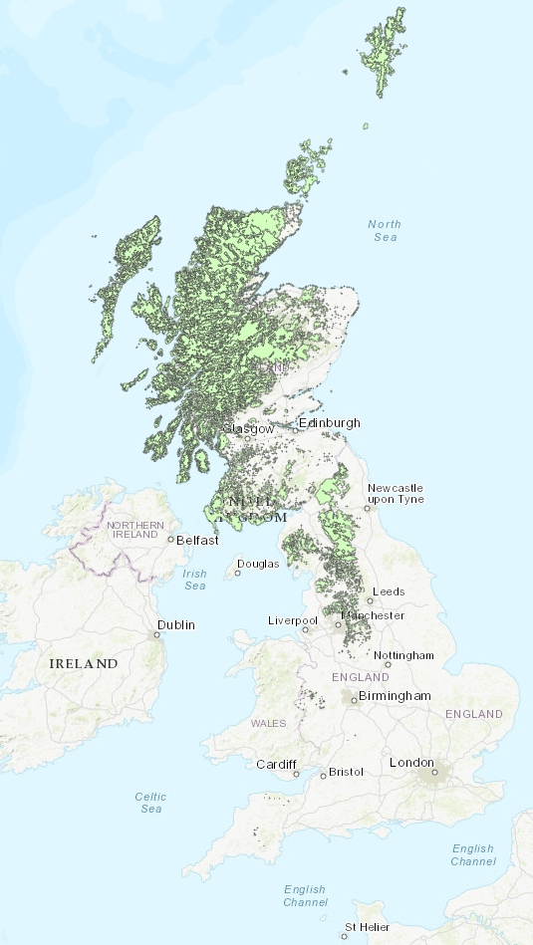
Task 2
Describe the distribution of the Bog habitat mapped.

Can you explain the distribution in terms of topography, climate, or geology?

Bog is an import carbon sink. Are any of the mapped areas likely to be influenced by human activity? If so, how, and where?

Figure 1 ITE Land classes in which the occurrence of the Bog habitat is above average.

Task 3
To complete this task you’ll need to add some data layers to a new map.
- Open a new map in ArcGIS Online.

- Go to https://uk-air.defra.gov.uk/data/wms-services, and find the two layers listed below. For each layer right click on WMS Get Capabilities for the layer, and Copy Link Location. In ArcGIS Online, add each layer to your map by clicking on Add, then Add Layer from Web, choose A WMS OGC Web Service from the dropdown box, paste in the layer you’ve copied (by using Copy Link Location above), and click the Add Layer button.
  - Air quality pollutant emission maps for the UK and Devolved Administrations – Oxides of nitrogen (NO_{x})
  - Air quality pollutant emission maps for the UK and Devolved Administrations – Sulphur dioxide (SO₂)

NB
- You can turn each layer on/off by checking/unchecking the box next to the layer name in the Details tab.
- You may wish to adjust the transparency of the data layers. Do this by hovering your mouse over a data layer name, clicking on the three dots, then selecting Transparency.
- You may wish to change the colour of the CS layer. To do this, hover the mouse over the data layer name, Click on Change Style (a yellow circle, red square, and blue triangle icon), then click Options (for the drawing style), and Click on the word Symbols next to a coloured square.
Part A
Uncheck all data layers except the Bog layer used for Task 3, and the NOx layer. (You may find changing the colour of the Bog layer as described above helps view the data; try white). You may also find the Show legend button useful, just below the Add button.
- What does the map suggest is a principal source of NO_{x} emissions?
- Describe the distribution of areas with low NO_{x} concentration.
- Can you explain the distribution of areas with low NO_{x} concentration?
- Look at the distribution of Bog Vs NO_{x} concentration. (You may find it helpful to click layers on and off or move the transparency slider up and down while studying the map). Is there a correlation between the Bog Habitat and NO_{x} concentration?
- Do you think this is a causal relationship? (i.e. do you think that either Bog affects NO_{x}, or NO_{x} affects Bog). If not, can you suggest a plausible reason for the pattern you observe? (Hint – you may want to consider topography, precipitation, and urbanisation).

Part B
Uncheck the NO_{x} layer and display the SO₂ layer. Format the layers as you feel necessary to answer the following questions.

- How does the distribution of SO₂ concentration differ from NO_{x}? Can you suggest why SO₂ is less pervasive?
- Can you explain several high point-sources of SO₂ around London?
- Look at the distribution of Bog Vs SO₂ concentration. (You may find it helpful to click layers on and off or move the transparency slider up and down while studying the map). Is there a correlation between the Bog Habitat and SO₂ concentration?
- To what extent do you think this is a causal relationship? Do you think the effect of SO₂ on Bog is increasing or decreasing? Why?
- Can you think of a hypothesis that you could test by completing fieldwork in an area of bog habitat that would evaluate a causal relationship?

Task 4
- Open a new blank map and add the CS Habitat (2007) data layer as described on page 8.
CS habitats (2007) https://services3.arcgis.com/cnh3VyFcFebgkSGa/arcgis/rest/services/CS2007_Broad_Habitat_Stock/FeatureServer
- In the Details pane, hover the mouse over the layer name and click on the three dots. Click Copy. Click on the dots again and Rename each layer in turn – Improved Grassland and Arable & horticulture.
- Hover the mouse over the Improved Grassland layer, Click on Show Table, and find the column for Improved grassland. Right click on the column title, click statistics, and write down the mean and standard deviation of the data
- Repeat this process for the second layer but retrieving the mean and standard deviation for Arable & horticulture data.
NB 68% of all data will lie within one standard deviation of the mean, 95% within two standard deviations, and 99.7% within three standard deviations of the mean.
We’re going to filter the top 32% - mean + one standard deviation – to visualise in which land classes improved grassland and arable & horticulture are most prevalent.
- For each layer, add your mean and standard deviation together, then hover the mouse over the layer name, click the Filter icon, choose the appropriate habitat type in the left hand box, is at least in the middle box, then enter the value you have calculated in the right hand box
- Change the colour of improved grassland to red by hovering the mouse over the layer name, clicking on the Change Style icon, Clicking the Options button to Select a drawing style, and Clicking on the word Symbols.

Part 1
- Describe the distribution of the highest concentrations of improved grassland and arable farmland in the UK.
- Does the map suggest topography influences the distribution of these habitats?

Click Add, Search for layers, Choose ArcGIS Online from the dropdown menu, and enter DiGMapGB-625. Add the appropriate layer (it should be the top result). Three layers will appear in the Details pane – make sure only BEDROCK is checked (you can remove the other two layers if you like by hovering the mouse over the layer name, clicking on the three dots, then clicking on remove). You may want to change the layer transparency and/or turn the layer on/off to answer the next question.

Part 2

- Does Bedrock Geology influence the distribution of these two habitat types? Why might this be so? (Hint – you can rearrange the order of the layers by dragging the three vertical dots to the left of the layer name – the layer at the top of the list will draw on top of the other layers. Hint – Clicking on the geology layer will tell you the name of the Bedrock Geology)

Task 5
- Uncheck the layers on your map, then make three further duplicates of the habitat layer.
- Rename the first densest woodland cover. Hover your mouse over the layer name and click on the Filter icon. Remove the existing filters (these were copied with the layer) and apply two expressions (you’ll need to click Add another expression above the standard filter box). The first expression should be Broadleaved, Mixed & Yew Woodland is at least 8.8588, the second should be Coniferous woodland is at least 12.8581. (These numbers correspond to the mean + one standard deviation). Make sure the box above both expressions says Display features in the layer that match any of the following expressions, then click Apply filter. The map will re-draw to show the areas with the land classes in which the top 32% of woodland cover occurs.
- Rename the second layer densest coniferous cover. Repeat the process above, but applying only the filter expression Coniferous woodland is at least 12.8581. Change the visual appearance of the layer by hovering your mouse over the layer name and clicking Change Style, choosing coniferous woodland in box 1, then clicking on the options button for Counts and amounts. Click on the symbols box and choose a blue colour ramp. Move the sliders to the top and bottom of the colour bar and then click OK.
- Rename the third layer densest deciduous cover, and repeat the process above, but now applying only the filter Broadleaved, Mixed & Yew Woodland is at least 8.8588, and changing the colour to a red colour ramp.
Your maps should look like the examples overleaf (Fig. 2).
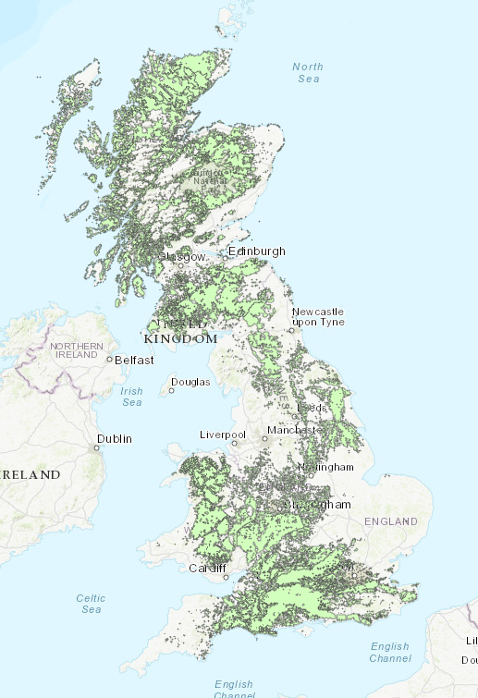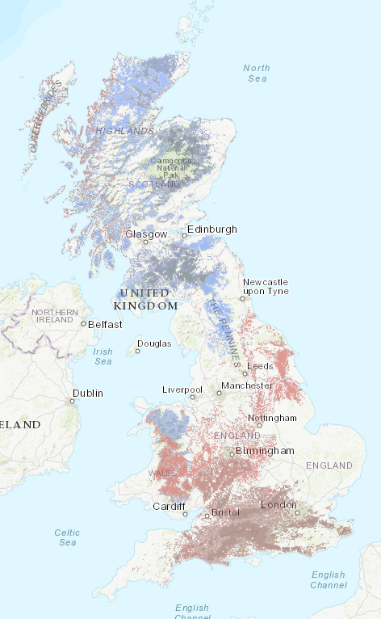
Figure 2 Densest woodland cover (left) and splitting out deciduous (red) and coniferous (blue) cover (right).

- Describe the distribution of the densest tree cover.
- Can you explain this distribution?
- Describe and explain the areas with the densest concentration of coniferous and deciduous tree cover. What physical and human factors might influence this distribution?
- In which areas of the UK is there the greatest potential to increase tree cover, and why?
- Trees are carbon sinks. Which type of tree would be the best for increasing carbon sequestration, and why? Which areas of the UK have the greatest carbon sequestration potential, and why?

Task 6
- Open a new map in ArcGIS Online, and add the hosted layer Linear landscape features (2007) (See Appendix A, page 18).
- Filter the data to display land classes that contain the top 5% of walls (that’s two standard deviations above the mean).
- Your map should look like this:
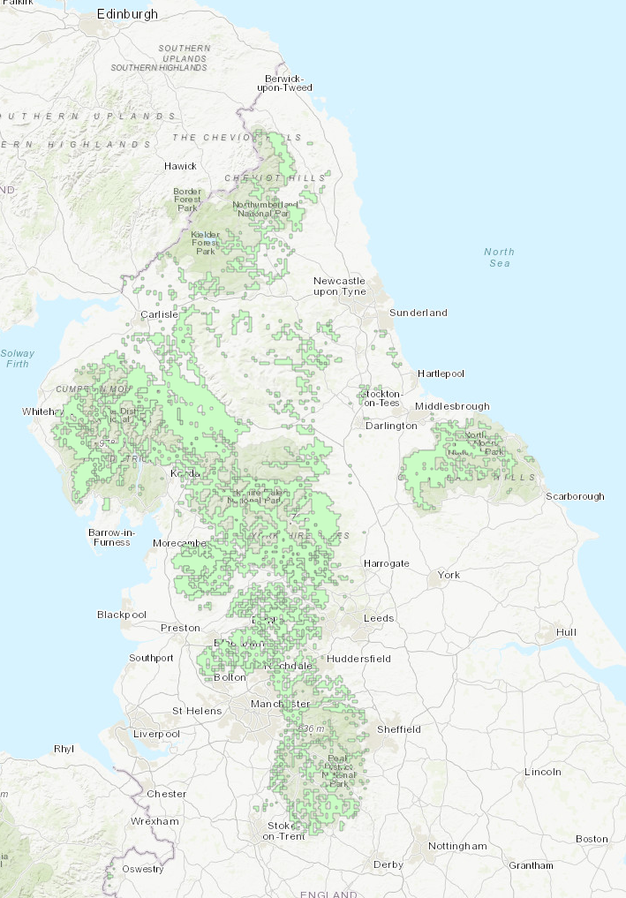
- Describe the distribution of areas with the highest concentration of walls.
- Explain this distribution (remember – these are the land classes that contain the highest 5% of wall concentration).
- Describe and explain one synoptic link to human and physical geography that can be inferred from this map.

Further development

- Although the change in sampling strategy after 1990 prevents us comparing data across all surveys, it is still appropriate to compare 1978-1990, and 2000-2007. This presents opportunities to investigate change over time – of land use classes, of constituent habitat percentages, of habitat extents. Students could also explore whether relationships to other variables – pollution, climate, population density, agricultural production – correlate with or demonstrate causal relationships, and investigate whether these relationships are changing over time.
- The Performing analysis in ArcGIS Online document summarises the spatial Analysis options available to students. The CEH data isn’t suitable for analysis in its current form, however other data that can be imported/hosted are, and can be used in conjunction with CEH data layers. This approach has particular utility for incorporating into NEA investigations and/or when exploring other A level content for which a greater variety of data sets are available, e.g. deprivation.
- The range of habitat types, the range of filtering options, and the time series data available provide many opportunities to practice hypothesising which will support the NEA.

Appendicies

Appendix A - Hosted Countryside Survey data layers

Habitat
(2007, 1998, 1990 are directly comparable. 1978 and 1984 used a different sampling framework so do not map directly).
Broad habitats - 1978
https://services3.arcgis.com/cnh3VyFcFebgkSGa/arcgis/rest/services/Broad_Habitat_1978_Stock/FeatureServer
Broad habitats - 1984
https://services3.arcgis.com/cnh3VyFcFebgkSGa/arcgis/rest/services/Broad_Habitat_Stock_1984/FeatureServer
Broad habitats - 1990
https://services3.arcgis.com/cnh3VyFcFebgkSGa/arcgis/rest/services/CS1990_Broad_Habitat_Stock/FeatureServer
Broad habitats - 1998
https://services3.arcgis.com/cnh3VyFcFebgkSGa/arcgis/rest/services/CS1998_Broad_Habitat_Stock/FeatureServer
Broad habitats - 2007
https://services3.arcgis.com/cnh3VyFcFebgkSGa/arcgis/rest/services/CS2007_Broad_Habitat_Stock/FeatureServer

Landscape

Linear landscape features – 1984
https://services3.arcgis.com/cnh3VyFcFebgkSGa/arcgis/rest/services/CS1984_Linear_Features/FeatureServer
Linear landscape features – 1990
https://services3.arcgis.com/cnh3VyFcFebgkSGa/arcgis/rest/services/CS1990_Linear_Features/FeatureServer
Linear landscape features – 1998
https://services3.arcgis.com/cnh3VyFcFebgkSGa/arcgis/rest/services/CS1998_Linear_Features/FeatureServer
Linear landscape features – 2007
https://services3.arcgis.com/cnh3VyFcFebgkSGa/arcgis/rest/services/CS2007_Linear_Features/FeatureServer

Extracted from http://bit.ly/csenvz – The sampling strategy of the Countryside Survey.
Extracted from https://countrysidesurvey.org.uk/.
Source: https://www.ceh.ac.uk/ukscape

