Case Study: Mineral extraction in the Arctic

GCSE specification links

AQA
3.1.2.4 Development of cold environments creates opportunities and challenges.
Cold environments are at risk from economic development

Edexcel B
1.1.3 Global climate is now changing as a result of human activity, and there is uncertainty about future climates.

OCR
4.3b How are humans seeking a sustainable solution for polar environments?

WJEC and Eduqas
5.4.1 How do people use ecosystems and environments?
5.4.2 How do human activities modify processes and interactions within ecosystems?
5.4.3 How can ecosystems be managed sustainably?

Key terminology
- Antarctic Treaty - an agreement signed by 12 founding signatories in 1959 declaring that the Antarctic should only be used for peaceful purposes. It entered into force in 1961 and outlines how the continent is governed.
- Energy mix – the combination of energy sources to meet a country’s demand.
- Energy security – a country’s ability to access reliable and affordable energy supply.
- EEZ (Exclusive Economic Zone) - an area defined by the UN Law of the Sea Convention within which the sovereign state has the right to exploit and develop available resources.
- Fossil fuel – fuel created by dead organic matter.
- Rare earth materials – a group of 17 metallic elements which are seen as especially useful because of their unusual chemical and physical properties.

Demand in minerals and fossil fuels
The global demand for oil has increased steadily over the 18 years between 2005 and 2023 to just below 102 million barrels per day. This versatile fossil fuel is used across most industries, but the majority is utilised by the transport sector e.g. as fuel, for road building, engine maintenance and much more.

The demand for natural gas has, however, is on track to slow to 1.6% a year between 2022 and 2026 from its previous 2.5% a year between 2017 and 2021 (IEA report, October 2023) this is largely due to the increased use of alternative energy sources including renewable energy in North America, Europe, and the Asia Pacific regions. In addition, the existing natural gas supply to Europe from Russia had to change after Russia’s invasion of Ukraine in February 2022 forcing many northern European markets to change their energy mix to ensure security.

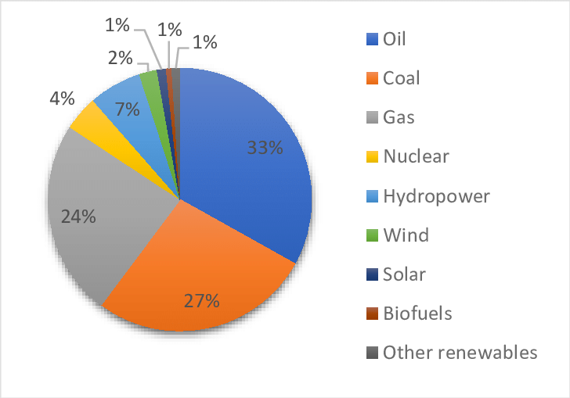

Figure 1. Global energy consumption by source in 2019. Figure was created using data taken from BP.

Most of the increase in natural gas and some of the increased oil demand will come from emerging markets which need it to support the growth of industry and broader social changes. Increased levels of disposable income in these markets will generate a demand for items which rely on oil and gas as part of the production process to function.

Therefore, although the growth of the hydrocarbon market is slowing down, demand remains strong and will continue to be as long as these products underpin development.

- Explain why there has been a recent shift in the global energy mix.

Natural resources in the Arctic
With decreasing availability of natural resources in more traditional locations, there is a growing emphasis on exploring alternative areas, and this is particularly evident in the case of energy security concerns.

It is thought that the Arctic and Antarctic could have a wealth of oil, natural gas and other minerals which could sustain the global population for the foreseeable future. While the Antarctic is safeguarded to a certain extent by the Antarctic Treaty, which restricts exploration and extraction activities in favour of scientific research, the Arctic presents a more complex scenario.

This northern expanse, predominantly sea, surrounded by the political boarders of eight countries - Iceland, Finland, Norway, Canada, USA, Russia, Denmark (through Greenland and the Faroe Islands) and Sweden - is estimated by the USGS to harbour vast reserves, including 90 billion barrels of oil and 44 billion barrels of liquid natural gas. This equates to 22% of undiscovered fuel reserves raising questions of who has rights over the potential extraction of these resources, and whether they should be extracted at all.

In addition, with temperatures rising faster in the Arctic than any other part of the world, new opportunities to extract raw materials become available as the ice melts. For example, the Alaskan $3.2 billion mining industry grew by 5% in just one year in 2021 due to the ability to extract resources from the thawing earth.

Ownership of the Arctic
Navigating the complexities of Arctic ownership involves grappling with international law. According to established norms, an Exclusive Economic Zone (EEZ) can be used by the sovereign state up to 200 nautical miles (370 km) from their coastline for exploration of resources including mineral extraction. With the close proximity of the Arctic nations to each other; there are only 2.4 miles (3.8 km) between the sovereign areas of the US and Russia across the Barents Sea, international agreements are needed to ensure that there is cooperation between the Arctic states. These agreements are crucial to fostering clear cooperation among the Arctic states, ensuring that shared resources are managed responsibly.

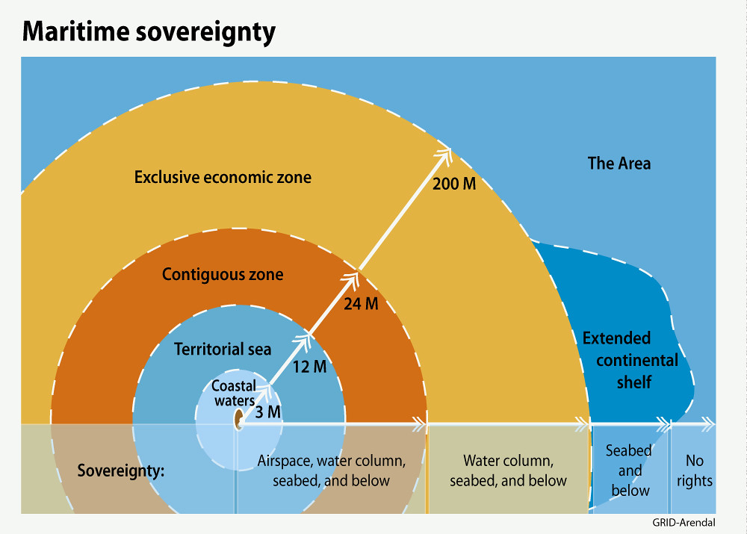
Figure 2. Maritime sovereignty diagram © GRID-Arendal

Countries seek to find advantages over rights to the EEZ by identifying land which belongs to their nation. For example, Greenland is making claims to a ridge of underwater mountains discovered at the North Pole. These volcanoes are thought to be created by subduction of land emanating from Greenland rather than divergence providing Greenland with a basis for extending their claims to the EEZ.

- Explain why claiming land beyond original coastal waters is controversial.

Russia in the Arctic
The Arctic plays a pivotal role in Russia’s economy with 20% of its GDP coming from Arctic territory. To secure further economic gain from the area, Russia has partnered with neighbouring China, which has officially designated itself as a 'near-Arctic state' in a white paper. Together they have built the $27 billion Yamal LNG (Liquid Natural Gas) refinery off the Yamal Peninsula in Siberia, dedicated to the production of liquid natural gas.
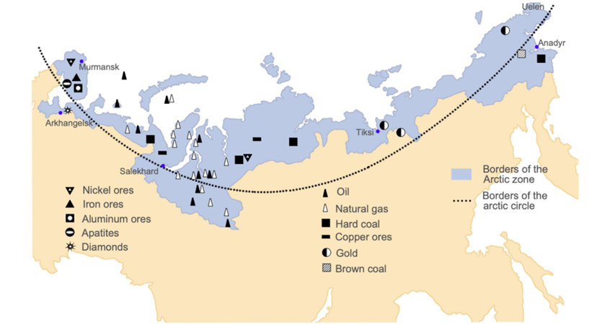
Figure 3. Mineral deposits in the Russian Arctic Migration © ResearchGate

Gas and oil are not the only natural resources found in the Arctic; it is thought that the Russian Arctic could contain an astonishing $2 trillion of rare earth materials which are needed for modern technology. Terbium and dysprosium, for example, are used in radar, missile launching, and laser technology in the US armed forces. Given China’s dominant position in processing and producing approximately 90% of the world’s rare earth materials, there is a keen interest in gaining access to the Arctic's potential reservoirs. Along with faster shipping routes to northern Europe via the Northern Sea Route, China has increased their commitment to collaborative ventures with Russia in the Arctic.

Impacts of mineral extraction in the Arctic
 | Social | Economic | Environmental | Political
Costs | Smoke from wildland fires and dust from mines can have an impact on breathing and exacerbate respiratory diseases such as asthma. In addition, harmful toxins can be released into the water supply creating potential issues with contamination. | Clean-up costs of extraction. In May 2020, over 21,000 tonnes of diesel spilled out from a broken fuel tank contaminating the Ambarnaya river (Russia) and surrounding subsoil. The clean-up cost over $146 million. With the increase in shipping traffic, spills like this could become more frequent. | Increase of CO² from wildland fires. In June 2019 Arctic wildland fires emitted 50 megatons of CO² into the atmosphere which was the equivalent to Sweden’s total emissions in one year. | With increased accessibility to raw materials, tensions could rise between sovereign states over access to the Arctic. For example, Russia has reopened 50 Cold War bases along the Arctic and the US have reinstated Arctic specialist squadrons as a response to the heightening tensions in the region after Russia’s invasion of Ukraine.
Benefits | Communities gain access to facilities and improved infrastructure as the mining industry needs to build roads and ports to export the raw materials. In addition, scientific research stations are established such as the Aurora / China-Iceland Arctic Science Observatory completed in 2018. | Between 2012 and 2017 China’s investments in Greenland reached $2bn - nearly 12% of the country’s GDP. China’s interest in Greenland is largely around mining rights for rare earth mineral extraction. | The Arctic Council is an example of effective collaboration between Arctic nations and representatives to research and recommend solutions in protecting the fragile ecosystem. | Increased access to raw materials means that countries can increase their supply from other sources. For example, in 2022, Norway provided Germany with 33% of its natural gas superseding Russia and providing a more stable trading partner for future energy security.

- Create a cost benefit analysis on the impacts of mineral extraction in the Arctic.

Futures
Despite a cap on Russian oil by the West of $60 per barrel, both China and India paid more than this limit to meet their growing demand for this resource. In 2023, a substantial 70% of Russia’s maritime oil went to India with an additional 20% flowing into China. This shows that emerging economies are willing to navigate sanctions prioritising their energy security and fostering developmental initiatives.

In contrast, the United States faces a potential hurdle as it does not have a reliable independent supply of rare earth materials. This could potentially cause issues in the future to produce new technology which requires these materials.

- Explain how mineral security could pose risks in the future.
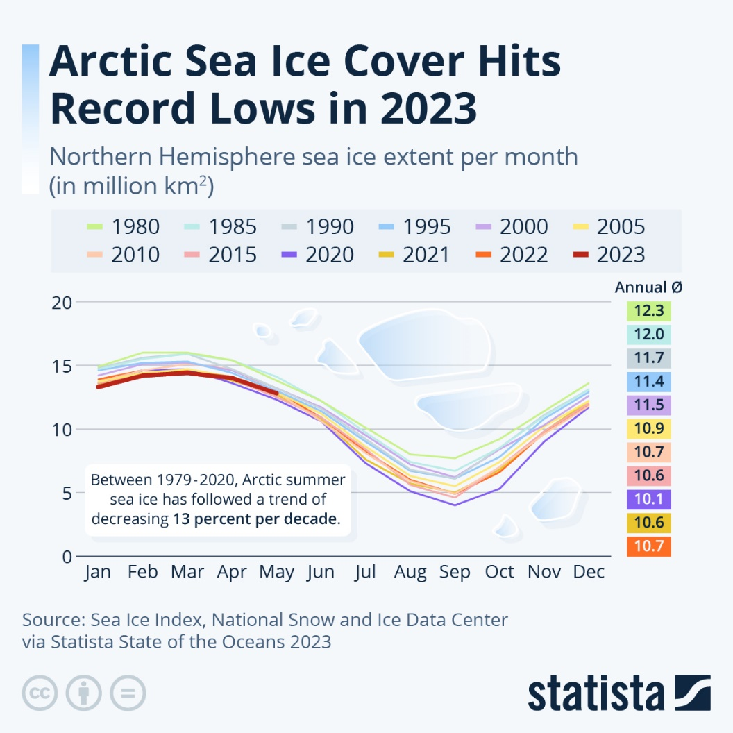

Figure 4. Ice extent in the Arctic © Statista

As Arctic temperatures rise by approximately 13% per decade, there is a growing expectation the region could experience an ice-free summer by 2030. With thinner ice in the Arctic Ocean, the northern shipping routes could become a viable solution to increasing the efficiency of transportation of goods in the near future. This likelihood has spurred substantial initiatives, with Russia spearheading the construction of the largest fleet of icebreaking ships, while China is following suit by developing ice-capable liquid gas carriers, aiming to transport materials to their markets more efficiently.

- Describe the changes in ice extent between 1980 and 2022.

Challenge: Explain the benefits on a national and global scale of an ice-free summer in the Arctic.

Further reading
- BBC Future article on claiming the North Pole mountain range.
- Arctic Institute report on pollution caused by mineral extraction.
- NOAA EEZ explanation

