|  |
| --- |
| California wildfires |

# Introduction

Wildfires are large destructive fires which spread rapidly through woodland and bush. They are mainly a natural event that happens as part of forest rejuvenation; they turn into hazards when they impact human life.

Although a smaller fire started on New Years Eve, Tuesday 7th January saw the first large wildfire of the season, known as the Palisades Fire, break out in Malibu, California. Over the following two days, four additional fires erupted in different areas around Los Angeles: Eaton, Hurst, Lidia, and Kenneth. Each of these areas experienced multiple fires simultaneously, affecting various communities across the region.

# Causes of the California wildfires

The wildfires were triggered by dry conditions caused by hot summer temperatures and failed rains in November, leaving the land void of moisture and very susceptible to fire. Additionally, the Santa Ana winds – dry, potentially hurricane-strength gusts that blow westward through canyons and typically occur between October and March – dried out the little moisture left in the vegetation and fuelled the rapid spread of the flames.

Diagram of the formation of the Santa Ana Winds with the following text: 

High pressure builds in the Great Basin region over the states of Idaho and Utah. The high pressure pushes winds towards areas of low pressure off the southern coast of California. The Mojave desert heats and dries the winds as they move southwards. The Sierra Nevada mountains block these winds, forcing them to move north and south around the range. The winds are funnelled through canyons (including the Santa Ana Canyon which is where the winds got their name) increasing their speed even further. 

*Figure 1: The formation of the Santa Ana winds. Sources: UCLA and San Diego research studies © RGS.*

The steep hills around Los Angeles, where most of the fires raged, are particularly susceptible to fire and pose significant challenges to firefighting. For example, ensuring enough water can be pumped uphill against gravity for the firefighters to effectively keep on top of flames and the strong Santa Ana winds that grounded many helicopters which would otherwise have provided vital aerial firefighting support.

# Effects of the wildfires

At the time of writing, nearly 180,000 people were issued with evacuation orders, at least 27 lives have been lost, and over 40,000 acres of land (approximately 162 km² or the size of about 22,600 football fields) have been scorched. More than 10,000 buildings have been destroyed, with over 60,000 others at risk.

On Friday 11th January as a result of the ongoing fire risk, over 1000 schools were shut, many of which reopened on Monday 13th January. However, eight school campuses were either completely destroyed or severely damaged as a result of the fires.

Initial estimates suggest that the total damage caused could equate to $150bn (£120bn). Many companies do not insure houses in fire-prone areas; the companies that do could face collapse due to the number of claims made.

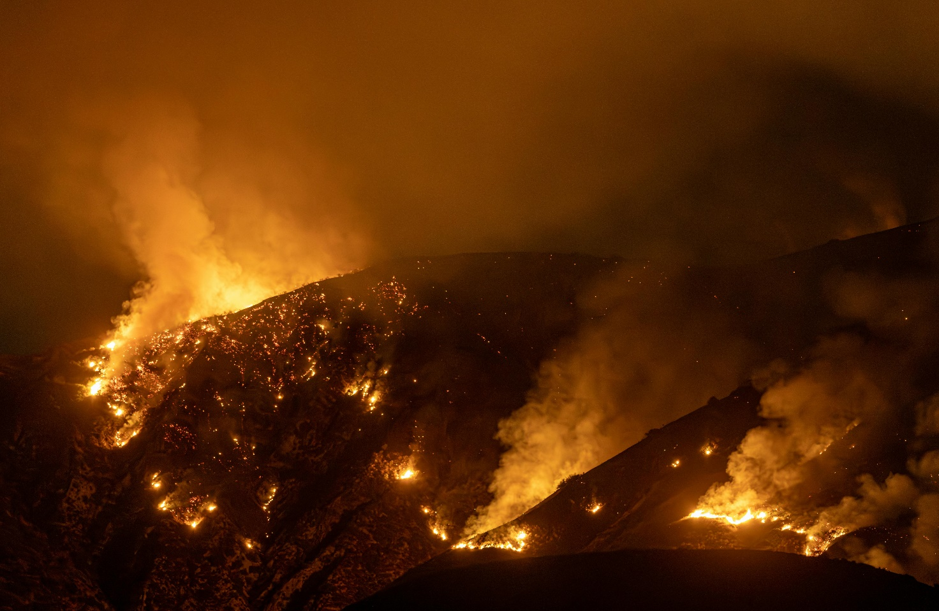

*Figure 2: Impacts of a wildfire © Soly Moses, Pexels*

When the fires have been extinguished, rebuilding has been set as a priority for the Mayor of Los Angeles, Karen Bass. However, many people may choose not to return or not have sufficient funds to rebuild in areas which they once lived. All properties in the state of California are subject to tax, the average is 0.71%[1] of the property’s market value each year. The loss of income from so many destroyed buildings will have an impact on federal funds. If the property tax increases, this may also price certain people out of the area.

The displacement of thousands of people and the loss of amenities through fire damage will, in the long term, have effects on schooling, healthcare and other services as people look for alternative provision. Reconstruction of well-established communities such as the Pacific Palisades and Pasadena areas will take years to complete and will not have the same demographics as before the fires.

# Responses to the wildfires

Thousands of fire fighters in Los Angeles worked solidly to help people get to safety and battle the spread of the flames bringing many of the blazes under some control. Additional firefighters were brought in from nearby states including Origan and Arizona as well as over 70 firefighters and troops from Mexico. To deter the rising concerns over looting of abandoned properties, a curfew was put in place and the National Guard were deployed.

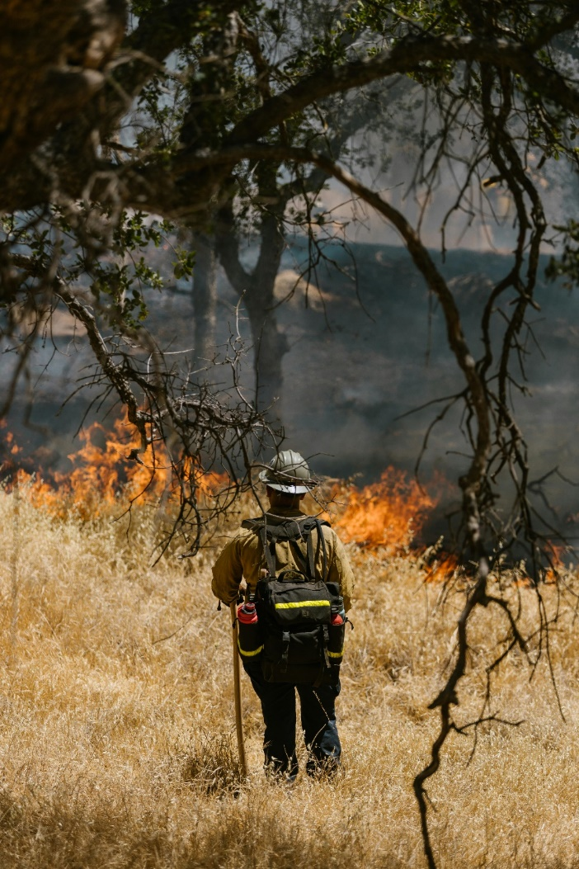

*Figure 3. Firefighter assessing a blaze © RDNE Stock Project, Pexels*

In addition to professional efforts, thousands of volunteers stepped forward, donating funds, clothing, food, and water to assist those who have lost everything to the fires. On 11th January, 939 incarcerated trained volunteers were deployed to fight alongside professional firefighters, providing support in containing the blazes.

Countries such as Canada have donated equipment, and over $2 billion has already been raised to support rebuilding efforts.

# Potential solutions

The U.S. Department for Interior (DOI)[2] has published tips to help people prevent wildfires which includes regularly checking weather conditions, fully extinguishing fires and maintaining trailers to prevent accidental sparks from low lying vehicles.

Regulations for brush clearance is another instrument that could slow down the spread of fire; dry and dead vegetation is cut back and away from infrastructure and buildings to reduce the potential for fires to ‘jump’ between areas. However, in situations like the Californian wildfires, where strong winds intensify the flames, maintaining a sufficiently large gap to make this method effective becomes nearly impossible. Even if achieved, buildings – both residential and commercial – could still act as pathways for fire to spread.

A final option would be to limit the amount of building taking place in areas prone to wildfires. However, as with building on floodplains, authorities must weigh up the risk of a natural disaster with the demand for housing in highly sort after areas.

# Further reading

Esri have produced a map showing live updates on where the fires are located. Click [here](https://www.arcgis.com/apps/instant/basic/index.html?appid=bc0877b75bbd40d5bf7f74fea867ad60) to see the current version.

[Los Angeles Fire Department – Plan, Prepare, Act guide to wildfires](https://lafd.org/wildfire).

[Australian wildfires: Why live in fire prone areas and how do people cope? Dr Christine Eriksen, RGS](https://www.rgs.org/schools/resources-for-schools/australian-wildfires-why-live-in-fire-prone-areas-and-how-do-people-cope)

[Wildfires, RGS](https://www.rgs.org/schools/resources-for-schools/wildfires)

[‘A day not soon forgotten’: the Palisades take stock after blazes rage. The Guardian 9th January 2025](https://www.theguardian.com/us-news/2025/jan/09/palisades-fire-wildfire-damage)

1. [California Property Tax Calculator, SmartAsset](https://smartasset.com/taxes/california-property-tax-calculator#:~:text=Overview%20of%20California%20Taxes,%2C%20which%20sits%20at%200.90%25.)
2. [10 Tips to Prevent Wildfires, DOI, May 2023](https://www.doi.gov/blog/10-tips-prevent-wildfires)