The Northeast Passage

GCSE specification links

AQA
3.1.1.4 managing climate change involves both mitigation and adaption.
3.1.2.4 development of cold environments causes opportunities and challenges. Cold environments are at risk from economic development.

Edexcel A
3.2 the biosphere is a vital system.
6.6 meeting the demands for energy resources can involve interventions by different interest groups.

Edexcel B
1.3 Global climate is now changing because of human activity, and there is uncertainty about future climates.

OCR
2.1c Why is climate change a global issue?
4.3a What is it like in Antarctica and the Arctic?

WJEC and Eduqas
2.4.3 What are the consequences of climate change?
3.2.1 How are ecosystems used by people?
3.2.2 How are ecosystems damaged by human activity?

Key terminology
- Albedo effect – a measure of the extent to which solar radiation is reflected.
- Trade routes – established pathways to move commercial goods from one place to another.
- Thermohaline circulation – a large and slow movement of ocean waters caused by temperature and the salinity (salt content) of the sea.
- Invasive species – a plant or animal not from that environment which has a detrimental effect on the local ecology.
- Exclusive economic zone (EEZ) – an area defined by the UN Law of the Sea Convention within which the sovereign state has the right to exploit and develop available resources.
- Trade embargos – a type of economic sanction on a country or region to restrict trade.

Where is the Northeast Passage?
The Northeast Passage (also known as the Northern Sea Route) is a shipping route ‘over the top’ of the world via the northern shores of Russia connecting the Atlantic and Pacific Oceans. As the majority of the route is within the Arctic Circle, it was until recently impassable for most of the year with only specialist ships that had reinforced hulls being able to pass through the ice at other times. However, the warming of the oceans and consequently more rapid melting of ice in the summer months has opened new possibilities for global shipping and the extraction of raw materials in the region. This is particularly attractive to northern European countries as it is a shorter route to the Pacific than the traditional pathway via the Suez Canal in the Middle East which is currently experiencing its own environmental and political issues.

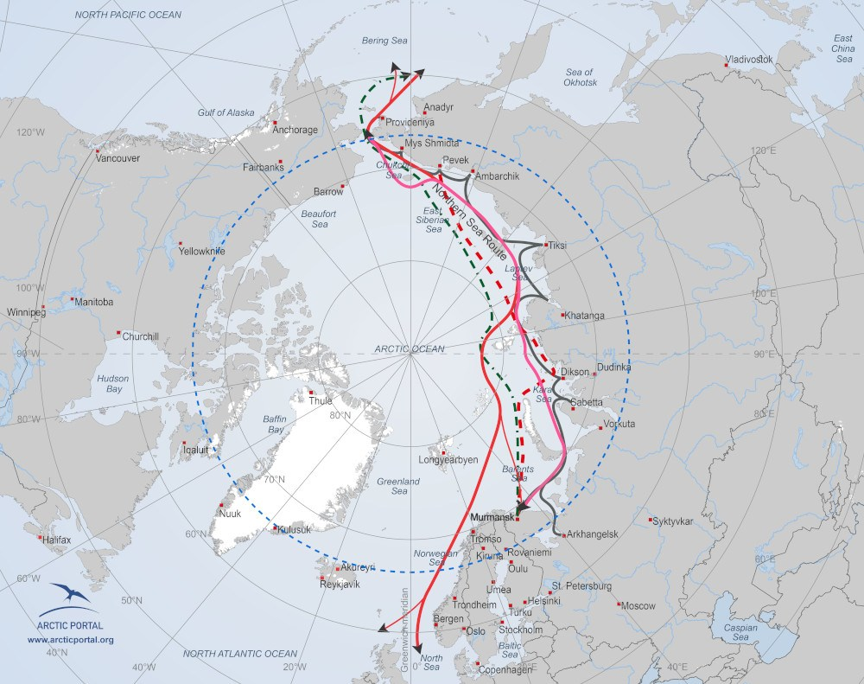
Figure 1: Northeast Passage route ©ArcticPortal.org

Climate change and the Northeast Passage
The heat transferred into the oceans with increasing global temperatures is moved via currents around the world. This ocean warming has an impact on all aspects of ocean life. In the Arctic, both ocean and global temperatures have contributed to a reduction in sea ice. Increased levels of heat energy absorbed by the oceans around the equator have impacted the heat being transferred through the Thermohaline Circulation. As a result, Environment Canada states that the temperatures in the Arctic region have increased by 1.2ºC and ice cover reduced by 32% since the 1960s.

- Watch this animation on global ocean currents courtesy of NASA to gain a better understanding of how the ocean currents interact around the world.

Effects of increased temperatures
There are several potential benefits to increased temperatures in the area along with costs.

Potential Costs | Potential Benefits
Cargo ships which use this route use a specific fuel called advanced diesel. This fuel emits a black soot into the atmosphere which not only acts as a greenhouse gas but leaves a black deposit on the ice. This changes the surface albedo and encourages the ice to melt. | The USGS estimated in 2009 that 25% of the world’s untapped oil and gas reserves are in the Arctic region. With reduced ice cover over longer periods of time, extraction of these resources could be possible, if not desirable.
Ships carry water in their hulls to help keep their boats upright in the water. This is called ballast. The water will come from the ship’s origin waters and therefore can carry alien species into the area. Some of these could be invasive and potentially harm the balance of the Arctic’s fragile ecosystem. | The Northeast passage is approximately 1/3 of the length of the shipping route through the Suez Canal potentially reducing fuel costs and shipping times.
Increased ice-free seasons could encourage longer fishing periods which might alter the quotas currently in place for fishing in that area. | An increase in Arctic tourism where boats can access areas for longer periods of time will be possible. Tourists would have the opportunity to see Arctic wildlife and the Northern Lights, for example. Tourism could bring income to ports serving the ships on the routes through the northeast passage.

- Colour code the contents of the table to identify social, economic, and environmental impacts.
Challenge: are there any other impacts you would add?

Potential issues in the region
The coastline along the Northeast Passage has not been extensively mapped and is notorious for rapidly changing weather including storms and thick fog. Navigation along these waters along with more shipping traffic could increase the potential for shipwrecks. In addition, the sparse population along the coastline could hinder search, rescue, and clean-up efforts.

The Northeast passage has been used by the Russians for decades. As the most navigable waters are near the Russian coastline, they consider this passage to be Russian and therefore control shipping routes. With the lure of faster shipping times, Russia’s ambition would be to compete with the Suez Canal as a transport route from the Atlantic to Pacific oceans. They would benefit economically as they would charge for using the passage (just as Panama and Egypt do for their canals). However, with increased unrest in the region and embargos placed on trade with Russia due to their conflict with Ukraine, shipping companies are discouraged to use this passage. There is also a concern over the safety of transport through these waters at a time of unrest which deters companies from investing in this route rather than a more familiar course.

- List methods which could help improve the safety for people along this route. Explain how they could improve the safety.

Further reading
- Interactive map of shipping routes from Discovering the Arctic
- Future of Arctic shipping article
- Guardian report on changing climate’s impact on the Panama Canal.
- BBC News report on the concern over using the Suez Canal.

