Lesson ideas for geography teachers to share: Our population

Go to
https://blog.ons.gov.uk/2020/03/27/understanding-our-changing-population-statistics-that-count/

Activity
Read the above blog by Liz McKeown, ONS Director of Public Policy Analysis, answer the following questions.

- Why is it important for the ONS to research and publish population statistics?

- What is projected for 2031?

- What exactly do the ONS say we can learn from the past?

Click the last link in the blog titled Our population – Where are we? How did we get here? Where are we going? And go to section 2 Births and Deaths since 1901.

https://www.ons.gov.uk/peoplepopulationandcommunity/populationandmigration/populationestimates/articles/ourpopulationwherearewehowdidwegetherewherearewegoing/2020-03-27

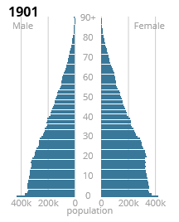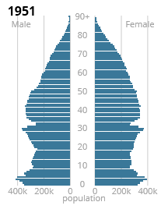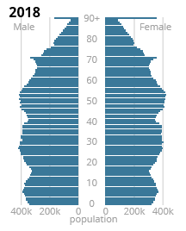

- Write one sentence of description for each of the three UK population pyramids.

- Describe how the UK population has changed over 117 years.

- Click on the green box titled .csv and download the data. Practice drawing a population pyramid for one of these three dates.

- Jump to Figure 5. What has happened to life expectancy in the UK and why?

Go to section 3 Migration.

- What does most migration ‘tend to be’ and what are the reasons listed for it?

- Jump to Figure 8. Describe the long term pattern of international migration, to and from the UK from 1964 to 2018. The slideshow under the graphic is an excellent explanation.

