KS3 lesson Colouring London Local fieldwork and GIS
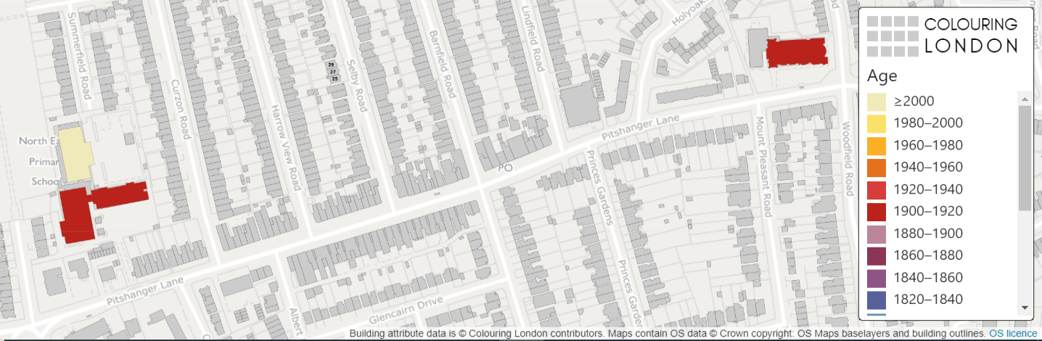

Colouring London aims to collect information on every building in London, to help make the city more sustainable. It provides information about your local area https://colouringlondon.org/

The Colouring London team would like to colour in every building in London and they need your help.
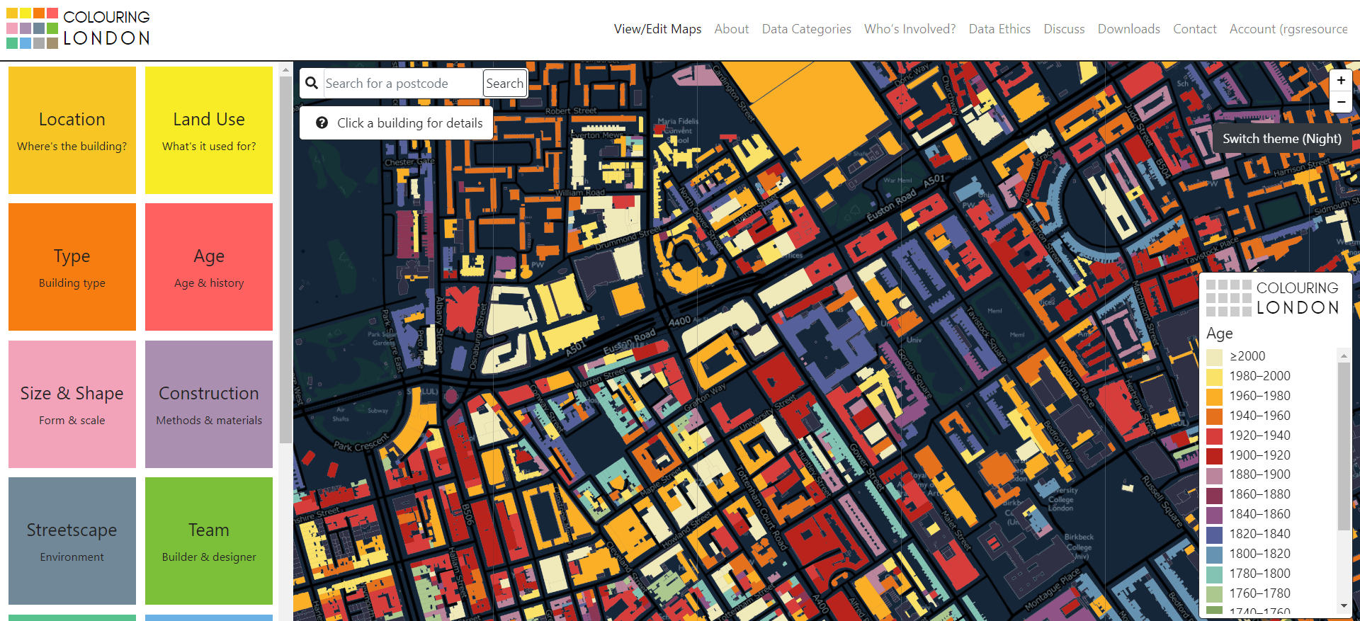

What is GIS?

GIS stands for Geographical Information Systems

It allows us to collect, store, process and display different categories of information linked to places on maps.

GIS can be used to identify patterns and can tell us about what a place is like.

In fact, you have probably used GIS without realising it, such as searching where you live in Google Maps.

You can find out more by visiting https://www.ordnancesurvey.co.uk/mapzone/gis-zone

What information should I collect?

Thinking hats task
Divide into groups of 6 to discuss the following two questions:
- What does sustainability mean?
- What information could you collect about a building that might tell us about how sustainable it is?

Discuss

Write your class ideas into the bubble below.

Review

What information should you collect?

Colouring London would like to collect:
- Location
- Land use
- Type
- Age
- Size & Shape
- Construction
- Streetscape
- Team

Detailed information about how to collect information is available on https://www.pages.colouring.london/buildingcategories

You are the experts in your local area and your aim is to gather information on:
- The age of the buildings
- The type of the buildings
- The height of the buildings

How could you collect this information?

- Primary data
  - Carry out some local fieldwork
  - Colour in your own map
  - Return to school and your teacher can add the data to the Colouring London website
- Secondary data
  - Use Google Earth, Maps and Streetview
  - Use websites such as Historic England or Survey of London

How can GIS be used to map sustainability?
Geographical Information Systems provide a framework for gathering, managing, and analysing data.

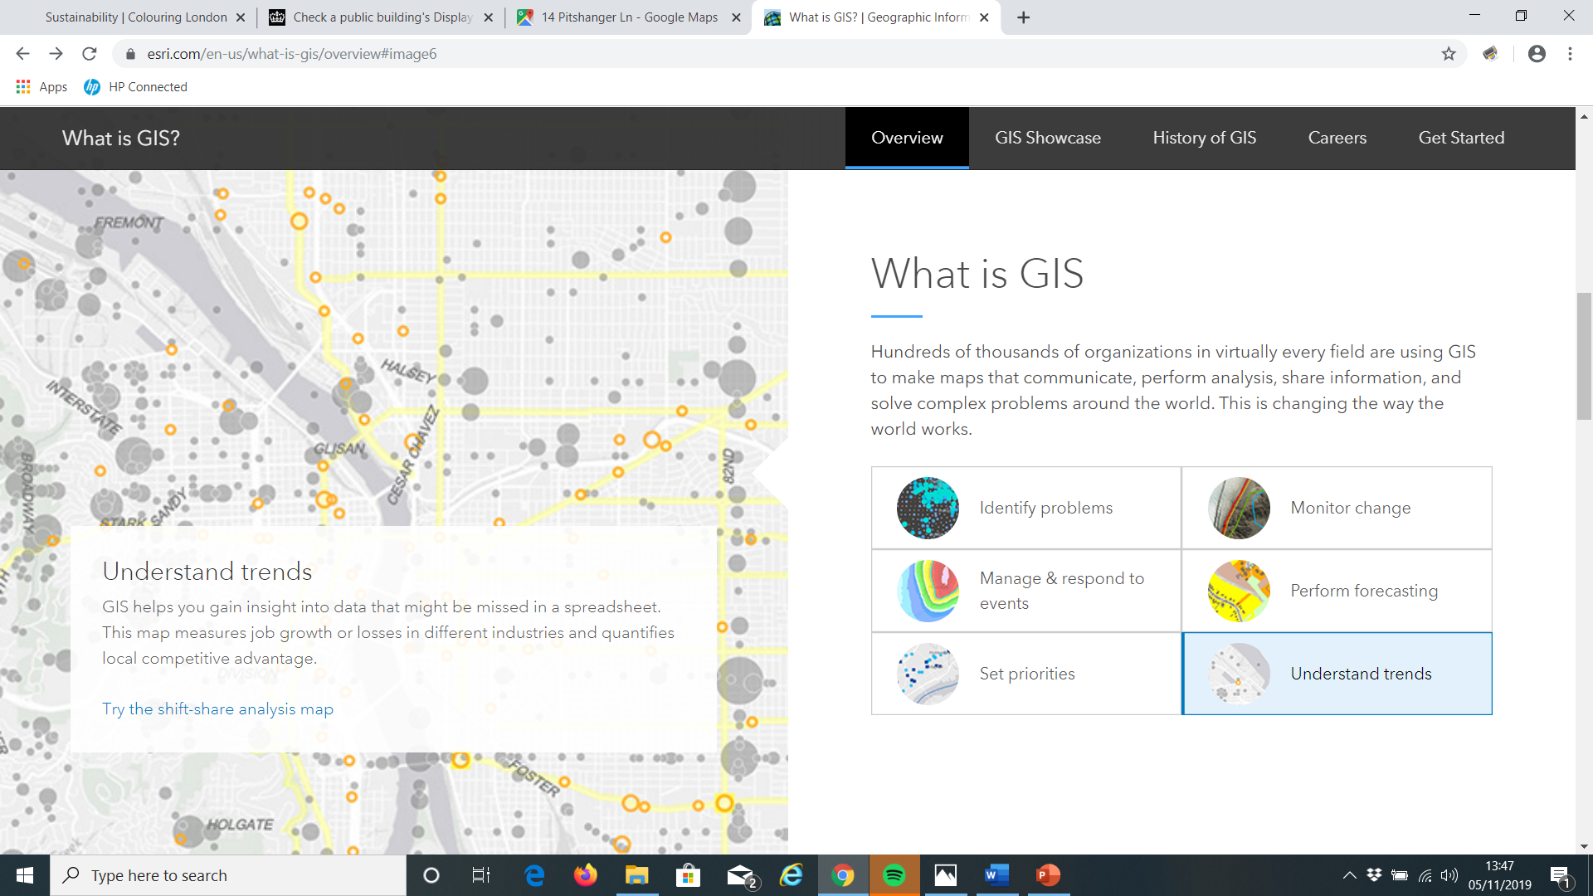

https://www.esri.com/en-us/what-is-gis/overview

Collecting primary and secondary data
- Write 1-3 key questions
- Choose 1-2 streets near school to survey
- Print out a map of your streets (Digimap for schools)
- Design a colour coding system to record on your printed map

Example study - Ealing, London W5

Key questions:
- Are younger buildings more sustainable than older buildings?
- Are high rise buildings more sustainable than low rise buildings?
- Are concrete buildings more sustainable than brick buildings?

For the purposes of this example, building age, type and height along with energy efficiency certificates as the measure for sustainability.

This is following the Route to Enquiry method – further information can be found on https://www.rgs.org/schools/teaching-resources/the-case-for-qualitative-fieldwork/

Example study - Ealing, London

Key questions:
- Do the buildings get older as you get further away from school?
- Does the type of building change as you get further away from school?
- Do buildings get taller (have more storeys) as you get further away from school?

Maps of study area

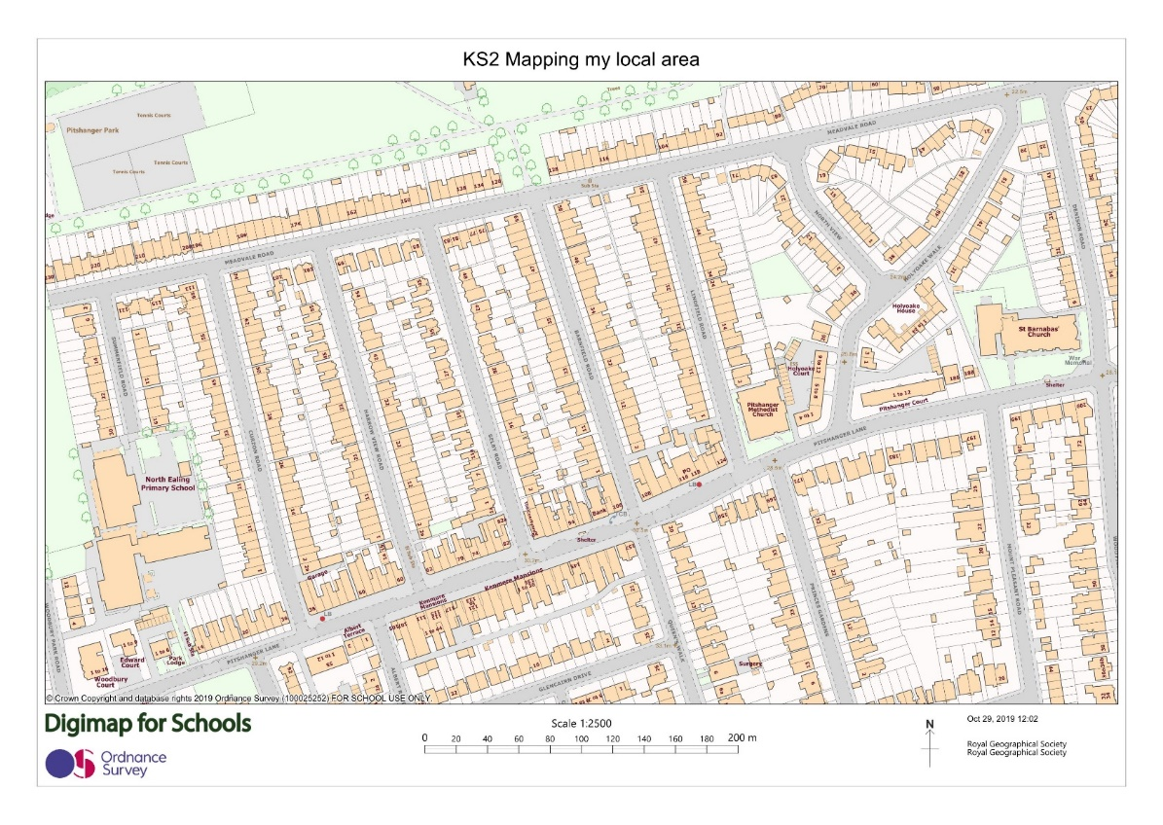

School

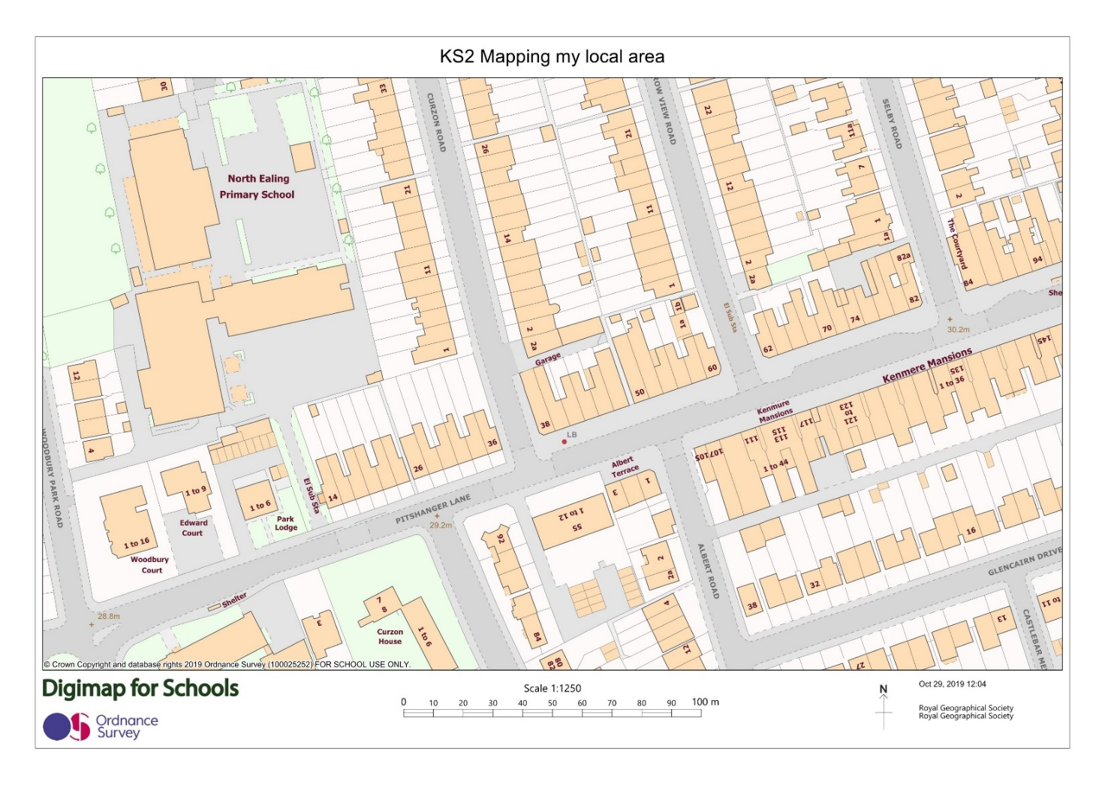

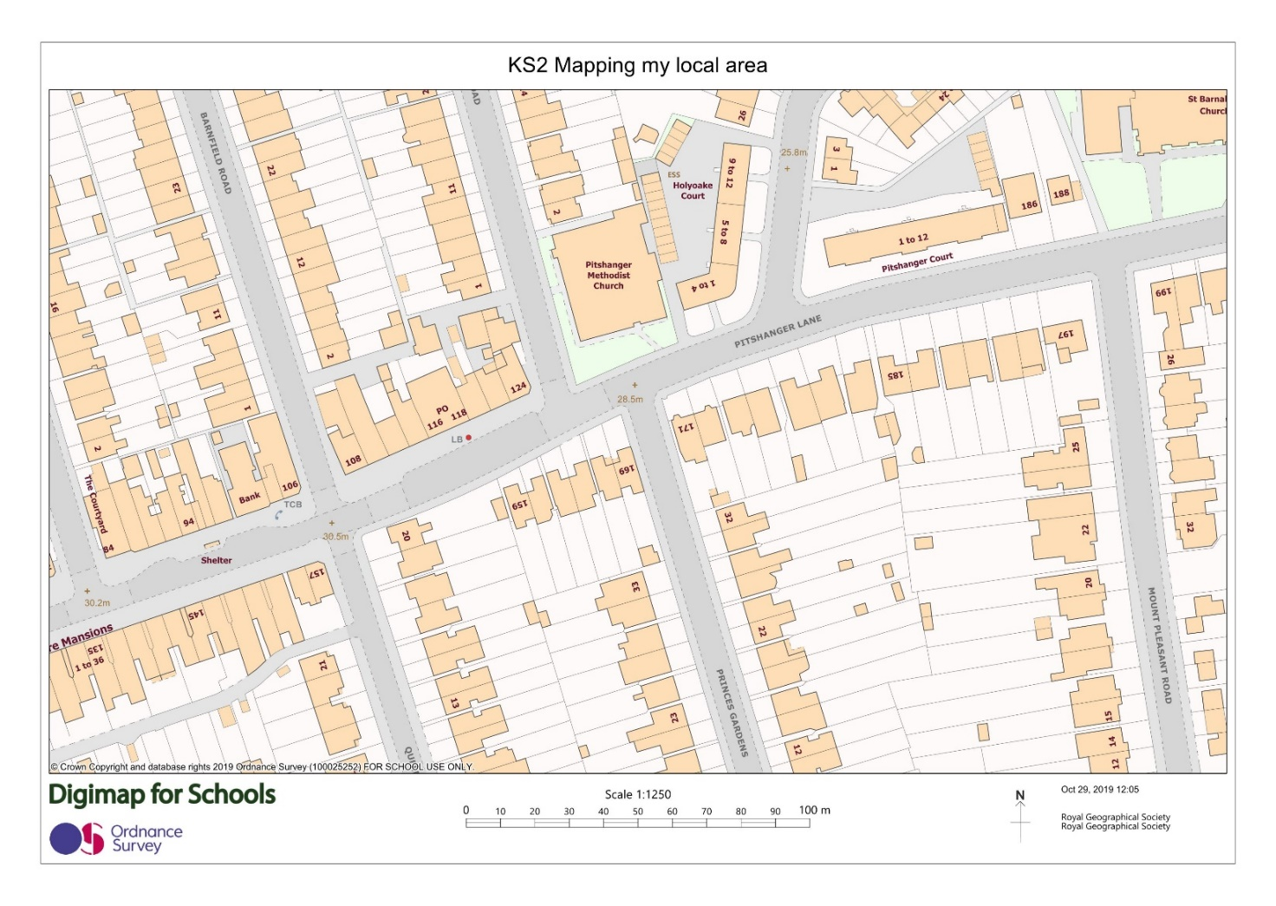

Designing a key

Risk assessment
Before you collect any data, think about your safety and the risks.
Your school will have a clear policy on carrying out a risk assessment before embarking on any fieldwork.
Please refer to this and for further information please visit the RGS-IBG Fieldwork safety and planning pages.
Example of field map coloured in

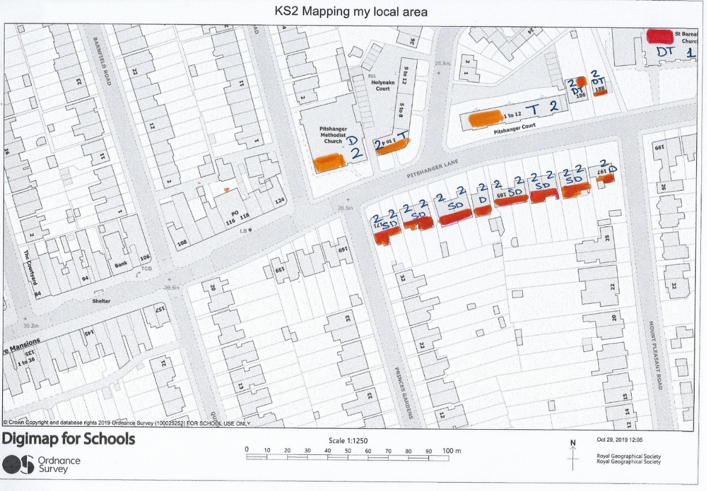

Collecting secondary data

Secondary data is data that has been collected by someone else and made available e.g. government statistics from the Census. In this example we are using Energy Performance Certificates. Any premises sold or rented is required to have an EPC to show how energy efficient it is. Only buildings rate grade E or higher maybe rented. This data is free and available for public use.

EPC data

Obtaining data on energy performance

Using the CDRC database, you can look up EPC data for your local area
https://maps.cdrc.ac.uk/#/metrics/epc_current

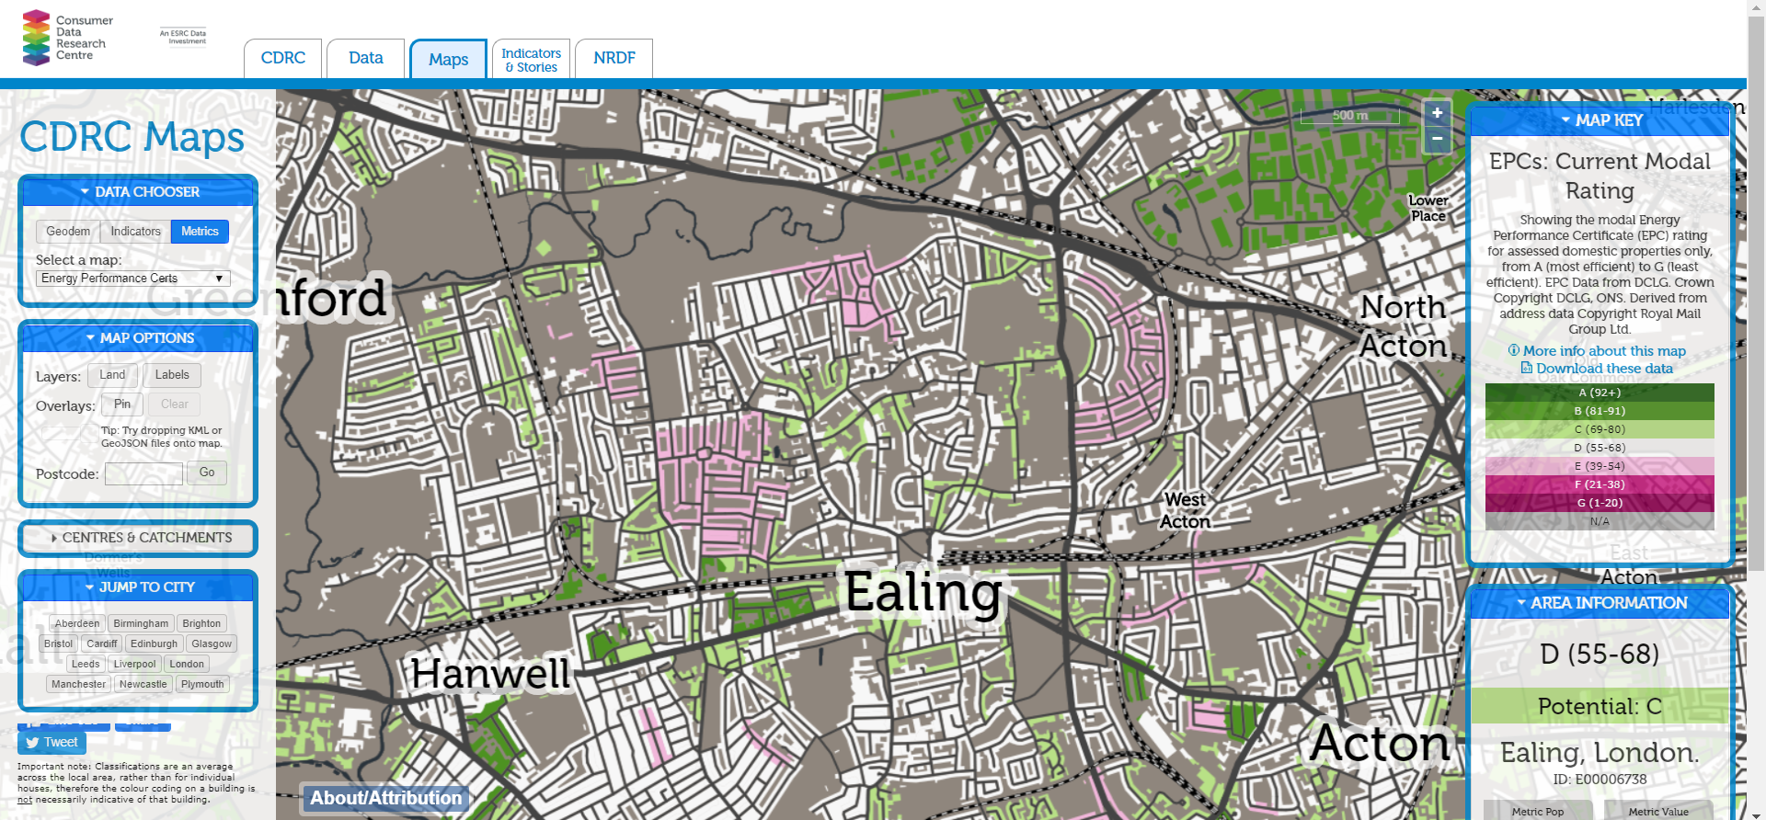

Answering your questions

- Are younger buildings more energy efficient than older buildings?

Buildings constructed between 1910-1930 in Ealing have an average EPC rating E (39-54) which is worse than the built in the 1960’s which have an average EPC rating of C (69-80) suggesting that older buildings are less sustainable than younger buildings.

- Are high rise buildings more sustainable than low rise buildings?

High rise (greater than 4 storeys) buildings in Ealing have an average EPC rating B (81-91) compared with low rise (2 storeys) which have an average EPC rating of D (55-68) suggesting that high rise buildings are more sustainable than low rise buildings.

- Are concrete buildings more sustainable than brick buildings?

Concrete buildings in Ealing have an average EPC rating B (81-91) compared with brick buildings have an average EPC rating of D (55-68) suggesting that concrete buildings are more sustainable than brick buildings.

