FT for schools: California leavin’ activity sheet 4

This resource was written by Stephen Schwab, author, and consultant.

The article
www.ft.com/content/96e78d96-1355-4c36-9d05-efc8e20a4ac5 Opinion Lex, US tech: California leavin’

Specification links
AQA
3.2.2.1. The Nature and Importance of Places. Factors contributing to the character of places: Endogenous: location, topography, physical geography, land use, built environment and infrastructure, demographic and economic characteristics. Exogenous: relationships with other places.

Edexcel
3.3 Globalisation has affected some places and organisations more than others. TNCs are important in globalisation (P: role of TNCs) both contributing to its spread (global production networks, glocalisation and the development of new markets) and taking advantage of economic liberalisation (outsourcing and offshoring).

OCR
1.a. Places are multi-faceted, shaped by shifting flows and connections which change over time. Case studies of two contrasting places.

Eduqas
1.3.3 Changes over time in the economic characteristics of places. External forces and factors influencing economic restructuring including changing technology and lifestyles, government strategy and globalisation.

In the Changing Places section of A level Geography, the concept of place significantly progresses upon GCSE understandings of this term. Professor R. Phillips from the University of Sheffield explains:

At A level, a more complex picture of place emerges. There are two aspects to this. First, place is understood as a geographical nexus of connections and linkages including flows of people, ideas, information, wealth, and things, which come together in and define a geographical location or locality. Since these flows reach from the local to the global, place is not simply a synonym for locality, or the opposite of the global. A Level students study place through at least two localities – one where they live, and one or more contrasting locations. Through these localities, they will have understood how place exists in and through its wider linkages and relationships, which assume economic, political, and other forms.

Context
The USA has various income taxes. Everyone pays federal (whole country) tax at a rate dependant on their income. However, individual states charge registered residents their own taxes on top of this. Figure 1 shows US state individual income tax levels. The high level of tax in California has led to a ‘tech-odus’ from the state towards alternative low-tax jurisdictions, like Texas.

Study the graph making sure you can:

- Name the states with the highest and lowest tax rates
- Identify the tax rate range favoured by most US states
- Identify any patterns reflected in the graph about the geographical distribution of tax rates in the U.S

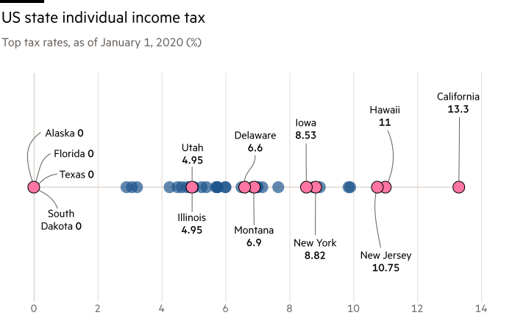Figure 1 © FT

Activity
Complete the following questions using the article and Figure 1 above.
- What do you think the graph adds to the readers understanding of the article?

- What advantages [and disadvantages] would be gained from representing the data differently?

- Identify the reasons for Palantir Technologies leaving California as described in the article and the graph?

- Access and read www.calrev.org/2018/08/03/opinion-the-monoculture-is-silicon-valleys-greatest-threat/?v=79cba1185463 note: in Geography monoculture traditionally has meant ‘the growth in an area of only one crop’. Give reasons why you think Palantir Technologies declared Silicon Valley ‘a monoculture’?

- Do you think’ monoculture’ is a useful appropriation in the FT article? Give reasons for your opinion.

- Other companies are leaving California. Name them and, for each company, identify where they are going and why.

- The FT article uses the term ‘a tech-odus’ meaning ‘the relocation of high growth quaternary industries’. Do you think it is a useful term or not? Give your reasons.
- Read www.theinformation.com/articles/the-informations-techodus-list. The exodus of prominent technology figures from the Bay Area is gathering steam. With the Covid-19 pandemic forcing a shift to remote work, some executives have seized the moment to move elsewhere in California in search of a different lifestyle, or an escape from the region’s charged politics. Others, often citing high taxes, are leaving the state entirely to take up residence in places like Miami and Austin, Texas. A few had already left the region before the pandemic struck.

As the high-profile departures mount, it could become more difficult for the Bay Area to remain the tech industry’s centre of gravity. Workers who once believed a presence in Silicon Valley was essential to their careers now might feel freer to move elsewhere.

According to this extract how is the COVID-19 pandemic affecting Silicon Valley’s ‘centre of gravity’?

- The articles you have now read suggest that Silicon Valley, although changing in value as a place from the viewpoint of some, may still have a vibrant future.

As a Geographer to what extent do you agree or disagree? Give reasons to support your conclusions.

Further reading
- The Guardian California’s immigrants are heading back to Mexico

- American Factory, Netflix film Q&A Royal Geographical Society - Geography resources for teachers (rgs.org)

- The FT The fight for proper protections for gig economy workers

- LA Times The tech-odus from California Op-Ed: Can California stop Big Tech from moving to cheaper spots? - Los Angeles Times (latimes.com)

- Forbes Businesses Are Fleeing California Along With Its Residents, And President Biden Should Pay Attention

- Bloomberg Tesla’s Texas Move Is Latest Sign of California Losing Tech Grip

