Migrants on the Margins
- Let’s investigate, Arunachalam’s story (Colombo)

The Migrants on the Margins research explores four cities: Colombo, Dhaka, Hargeisa and Harare. We explore the lives of four people living in these cities through comics. This quiz will help you to find out more about why each participant has moved and how they find life on the urban margins.
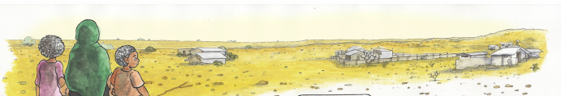

- What year was Arunachalam born on the plantation? _________________

- How many years did Arunachalam spend working in betel shops? _________________

- When Arunachalam returned to the plantation in 1972, which food were his friends still eating? _________________

- In which year did the Black July riots take place? _________________

- What time does Arunachalam open his refreshment stand? _________________

- If you could ask Arunachalam one question about his life and experience what would it be?
__________________________________________________________________________________________________________________________________________________________
_____________________________________________________________________________

