Colouring London
Sense of Place at A Level
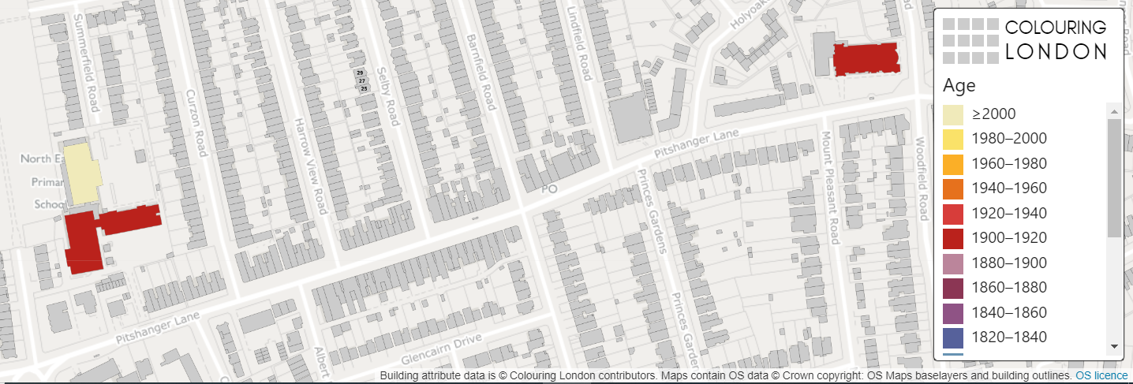

[Start text here]

Colouring London aims to collect information on every building in London, to help make the city more sustainable. It provides information about your local area.
https://colouringlondon.org/

Colouring London would like to collect
- Location
- Land use
- Type
- Age
- Size & Shape
- Construction
- Streetscape
- Team

Detailed information is available on https://www.pages.colouring.london/buildingcategories

Sense of place

There is a wide range of data publicly available that geographers can use to gain an understanding or sense of place from secondary data sources. For example:

- The population characteristics of a ward https://www.nomisweb.co.uk/

- The age of the existing housing stock https://maps.cdrc.ac.uk/#/metrics/dwellingage/default/

- Crime rates https://www.police.uk/ ‘Find your neighbourhood’

How can Colouring London be used?

Colouring London is a free knowledge exchange platform, designed by
University College London to collate, collect, generate, visualise, and make accessible, around fifty categories of statistical data, for every building in London. These can help to gain a sense of place for an area.

Using maps to gain a sense of place
Geo-located data can be used to examine changes through time or can be used to represent place. Mapping the building age, type and its use can offer an immediate sense of place. It can allow a place to be represented.

It could also provide an opportunity for data comparison. For example, asking the question ‘Do the buildings in a local area meet the needs of the local population?’

Mapping the building age, type and use and whether that building is being used as a community asset could be compared with interview/questionnaire data about whether the community feel they are well provided for.

Example – Euston Square, London

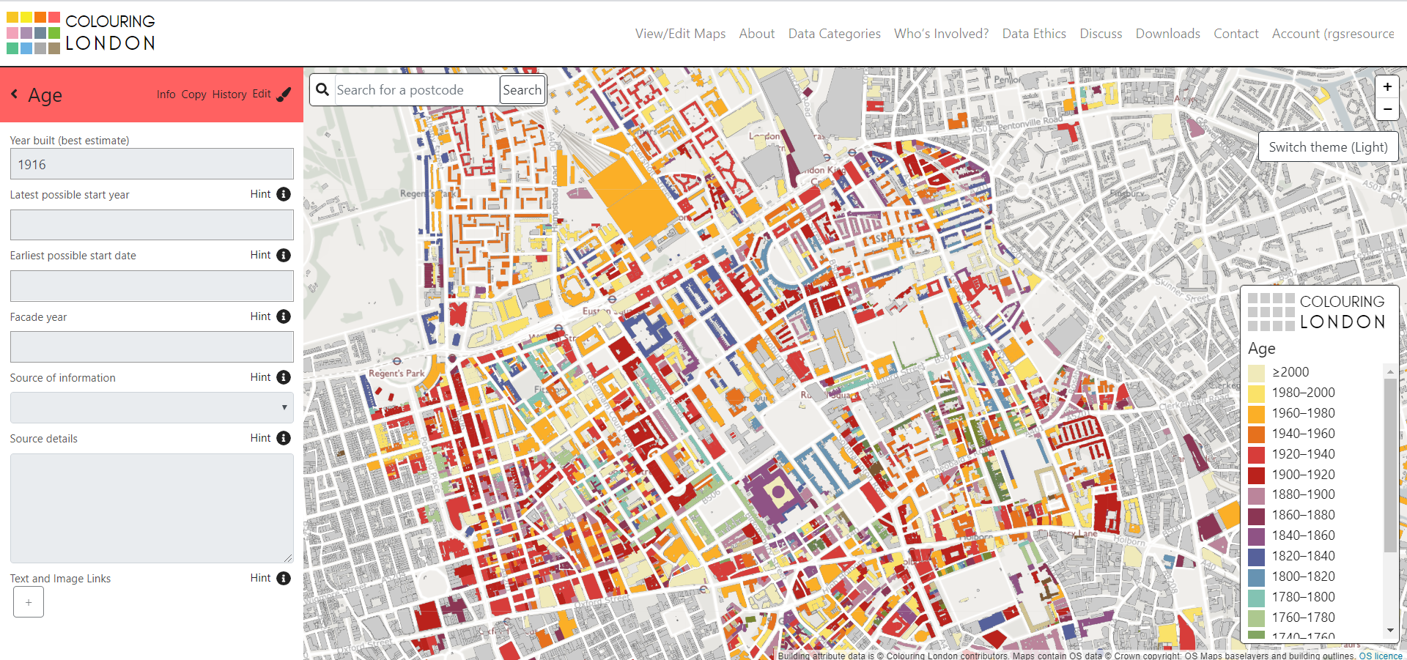

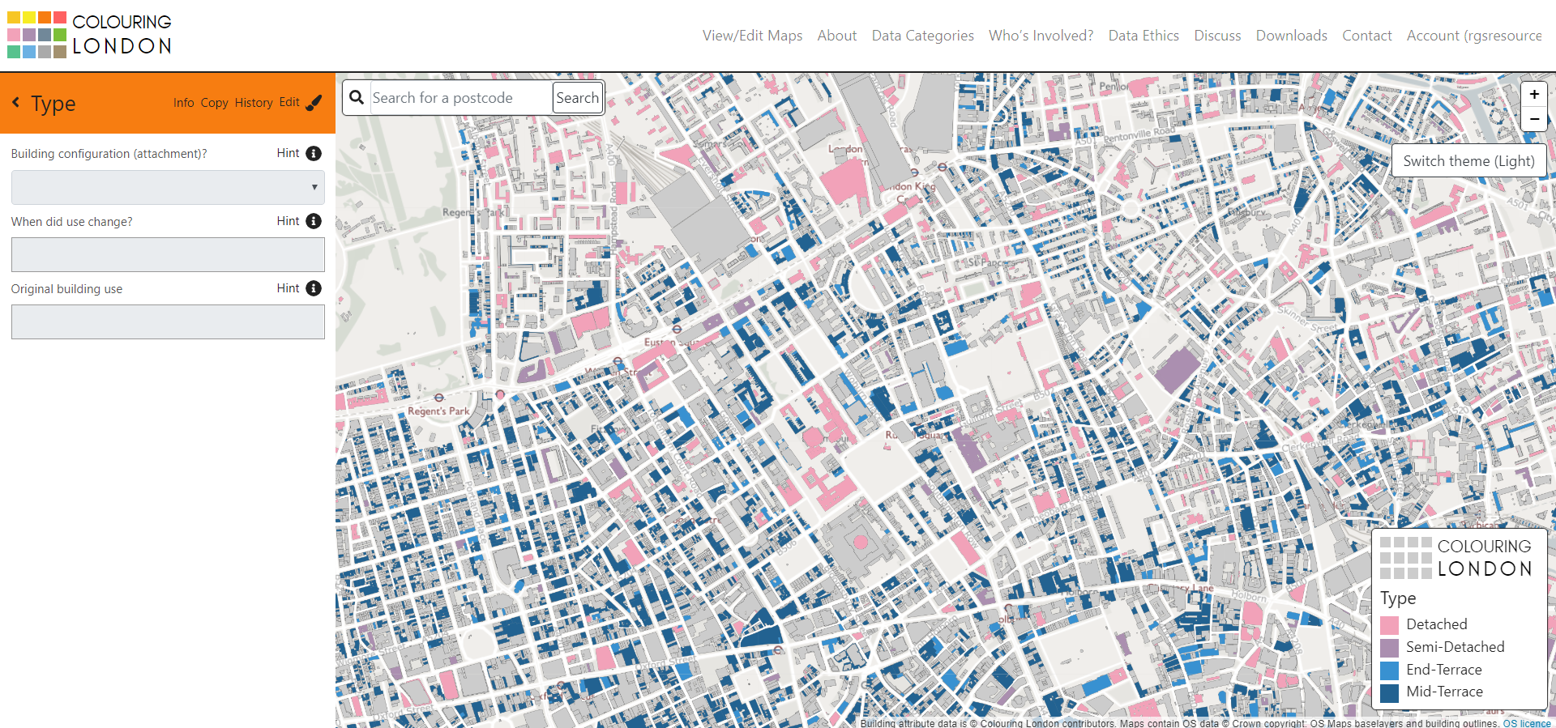
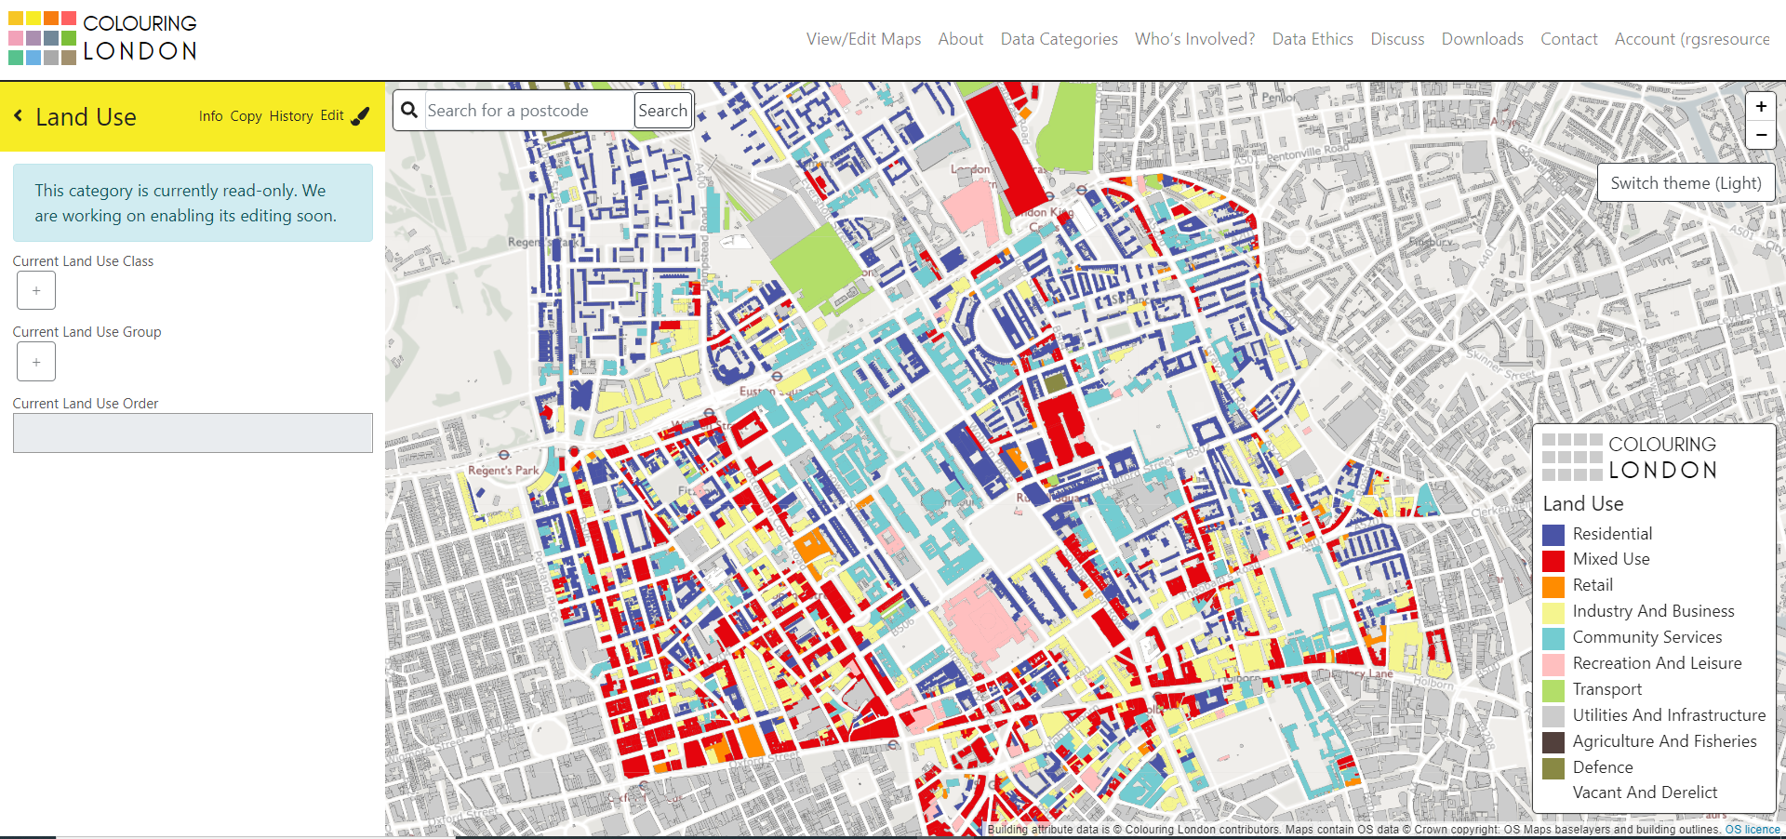

The maps can then be compared with data collected from interviews/questionnaires where semi-structured questions such as ‘How many times have you visited the British Museum in the last year? Never, once or more than once.

Data could be compared with distance travelled to use the community asset. For example, many of the buildings coloured turquoise are University College London buildings and may not be used by the local community.

Census data obtained from https://www.nomisweb.co.uk/ could be used to show how that sense of place has changed over time.

It is also possible to calculate the percentage of buildings being used as community assets by counting the number of buildings.

Observing how a place has changed over time using Colouring London data compared with historical map data.

Map of local area in 1900 https://maps.nls.uk/geo/find

Layer of London (early modern maps) https://www.layersoflondon.org/map

