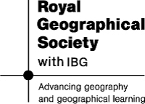

General Skills | Geographical Skills
Being a good communicator with strong presentation skills
Being competent with ICT
Being able to carry out research
Being able to manage your time by juggling commitments, meeting deadlines and managing stress
Being good at combining information from a variety of different sources
Being able to work effectively as part of a team
Being able to take charge in a situation if necessary
Being able to effectively present and report information in a clear manner

