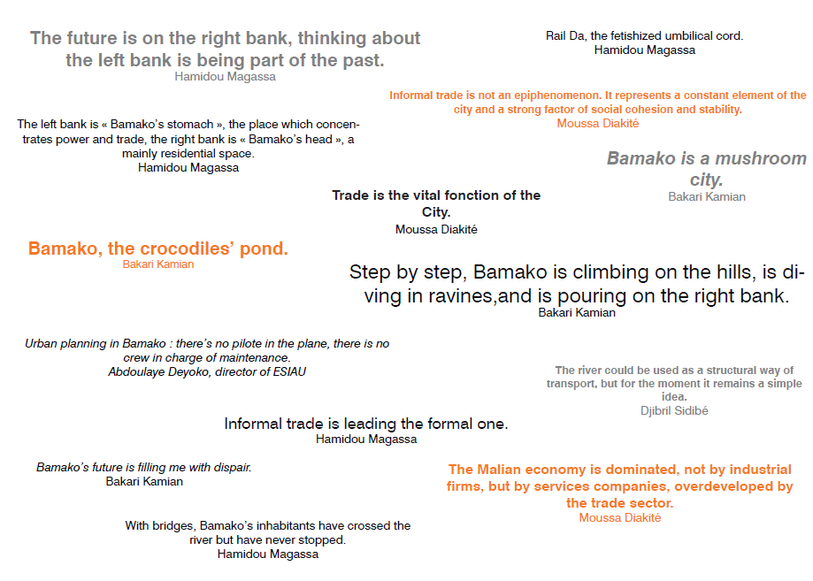
What do these comments tell you about Bamako and its growth?

