Careers with Geographical Information Systems
- Geovisualisation

Discover how geographers bring a unique perspective to presenting data in innovative and understandable ways. https://www.rgs.org/about-us/what-is-geography/geovisualisation

Geography has never been more important in helping us to understand our rapidly changing world.

Geographers bring a critical perspective and approach to interpreting and presenting data. They help make new connections between different types of data by interweaving spatial methods with knowledge about our world and finding innovative and understandable ways to present it.

Using the Society’s Geovisualisation series, students can explore the power of maps and geographical data visualisations that tell stories about our world. The series shows the ways in which connecting data on people, places and environments underpins good decision-making and improves communication and understanding.

Each Geovisualisation has an accompanying interview with the creators, which showcases the skills, data, techniques and tools used to tell the stories, and the insight they can bring.

Using the Geovisualisations with students

There are several ways that teachers can use these Geovisualisations with students, including:

- Embedding as a case study as part of a specific unit of work, for example if discussing supply chains and or / clothing production lines / trade, you might like to look at the Geovisualisation created by Dr Laurie Parsons, Lecturer in Human Geography at Royal Holloway, University of London, and colleagues from The Disaster Trade research project , showing the length and complexity of the supply chains that make the clothes that we use in the UK. https://www.rgs.org/about-us/what-is-geography/geovisualisation/disaster-trade-garment-production.
- Using one example as a plenary activity after teaching about a specific topic, to reinforce the ‘usefulness’ of the skills the students have been learning and showing how those skills and their acquired knowledge can be used in a ‘real world’ scenario.
- Linking these examples across to ‘real’ jobs being advertised, exploring skills needed and salary brackets for people working in those jobs.
- Examples to present to parents at options evenings or careers evenings to show how geographical skills can be applied and demonstrating the use of GIS (and geographical skills) in areas they wouldn’t expect to see them (and thus highlighting the relevance and importance of studying geography).

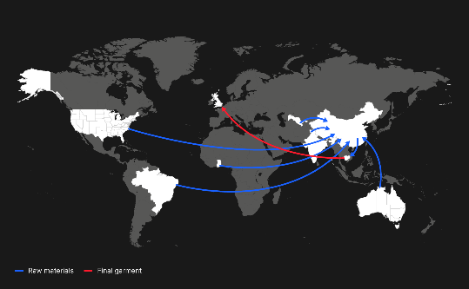 | Visualisation showing the length and complexity of the supply chains that make the clothes that we use in the UK | Disaster trade: garment production https://www.rgs.org/about-us/what-is-geography/geovisualisation/disaster-trade-garment-production
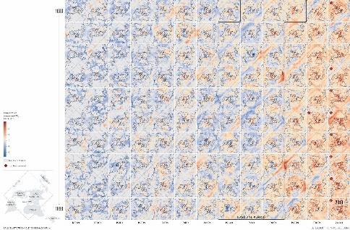 | Visualisation showing the Earth's warming temperature trends from the 1890s to 2020 | Atlas of the Invisible: heat gradient  https://www.rgs.org/about-us/what-is-geography/geovisualisation/atlas-of-the-invisible-heat-gradient/
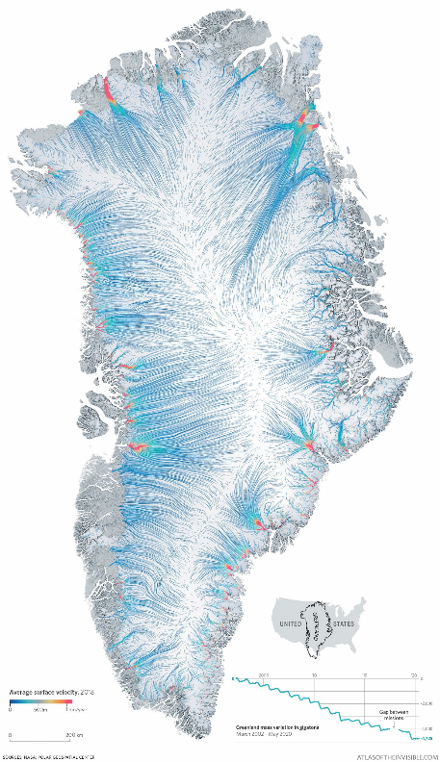 | Visualisation showing the movement of ice on the Greenland ice cap | Atlas of the Invisible: ice flows  https://www.rgs.org/about-us/what-is-geography/geovisualisation/atlas-of-the-invisible-ice-flows/
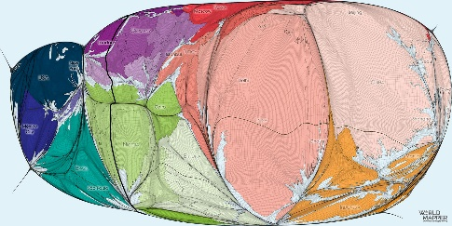 | Visualisation which shows the Earth’s surface resized by its human population | The human planet  https://www.rgs.org/about-us/what-is-geography/geovisualisation/the-human-planet/
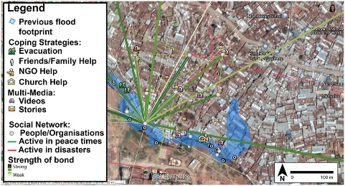 | Visualisation showcasing the less tangible aspects of flood resilience, such as social connections and a sense of place, in low-income communities | Messy maps https://www.rgs.org/about-us/what-is-geography/geovisualisation/messy-maps/
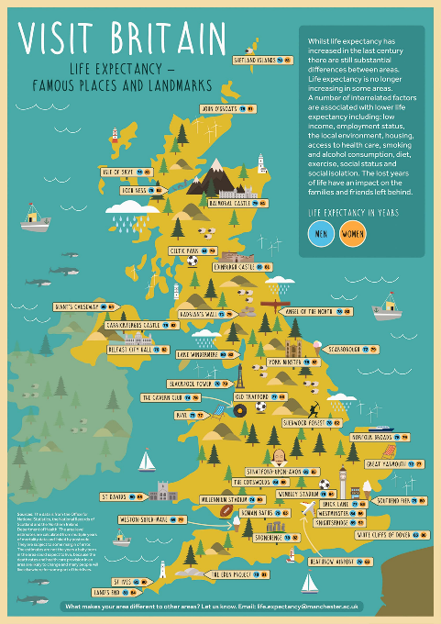 | Visualisation linking life expectancy estimates with some of the most famous places and landmarks in the UK. | Life expectancy in the UK https://www.rgs.org/about-us/what-is-geography/geovisualisation/life-expectancy-in-the-uk/
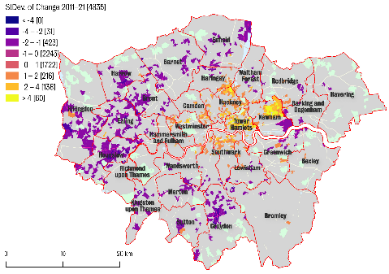 | Visualisation using data science and machine learning methods to predict demographic change throughout London by 2021 | Predicting gentrification in London  https://www.rgs.org/about-us/what-is-geography/geovisualisation/predicting-gentrification-in-london/
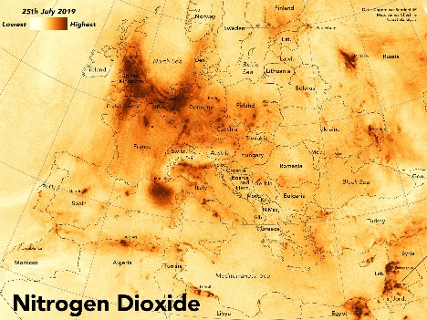 | Visualisation showing the distribution of nitrogen dioxide across Europe on the hottest day of 2019 in the UK | Air pollution in Europe https://www.rgs.org/about-us/what-is-geography/geovisualisation/air-pollution-in-europe/

Further Geovisualisations can be found at https://www.rgs.org/about-us/what-is-geography/geovisualisation

