Food security activity sheet 3

Specification links
AQA 3.2.4 Population and the environment. Global and regional patterns of food production and consumption. Agricultural systems and agricultural productivity. Relationship with key physical environmental variables – climate and soils. Strategies to ensure food security.

OCR Topic 3.4 – Future of Food. 2.a. A number of interrelated factors can influence food security.

Food security
Food is in uneven supply across the world with variations in production and the amount of food people eat (measured as daily calorie intake). Some regions of the world are areas of surplus, and others are in deficit. Food security is when people or a country have access to food which is a) nutritious, b) affordable, and c) reliable. Food insecurity is when people do not have enough food to remain healthy and active.

Food consumption is increasing across the world. This is due to economic development and population growth.

Economic development occurred for many reasons including economic expansion post-WWII, the sudden development of the Asian Tiger and Tiger Cub nations in southeast Asia after the 1960s, and the fall of communism in Eastern Europe in 1989.

World population surged upwards throughout the twentieth century, quadrupling from approximately 1.6 billion to 7.9 billion by 2022. This growth largely stems from rapid population growth in NEEs (Newly Emerging Economies) and LICs (Low Income Countries).

Table 1 below illustrates this increase in global food consumption by showing the number of calories per capita per day from all foods, from 1961 to 2018.

Per capita kilocalorie supply from all foods per day, 1961 to 2018
 | N America | Europe | S America | World | Asia | Africa
1961 | 2,684 | 3,039 | 2,326 | 2,191 | 1,783 | 1,993
1971 | 2,855 | 3,251 | 2,465 | 2,360 | 2,002 | 2,086
1981 | 3,075 | 3,311 | 2,622 | 2,497 | 2,194 | 2,238
1991 | 3,214 | 3,265 | 2,657 | 2,598 | 2,379 | 2,323
2001 | 3,384 | 3,292 | 2,796 | 2,723 | 2,560 | 2,459
2011 | 3,353 | 3,396 | 3,029 | 2,867 | 2,740 | 2,618
2018 | 3,471 | 3,416 | 3,084 | 2,928 | 2,833 | 2,604
Table 1 data extracted from Our World in Data: Food supply

The regions of the world that consume the most calories are not necessarily the countries that produce the most food. Most of our global food originates in Asia, with Asian countries producing the most cereal, wheat, rice, sugar, milk, fish, and meat. South American farms dominate the production of oil crops (such as sunflower and rapeseed). Barley is the main crop grown in Europe, with the continent being the second biggest producers of milk, fish, and pork.

Food security is expected to become more insecure in the coming decades, largely due to climate change. Every decade the global climate warms by around 0.2°C with rainfall increasing in some places and decreasing in others. 9 of the 10 hottest years on record all occurred in the past decade. As a result, drought is likely to affect large swathes of European farmland, particularly under the RCP8.5 scenario between 2068-2100 (with a 4.3°C change in global mean surface temperature).

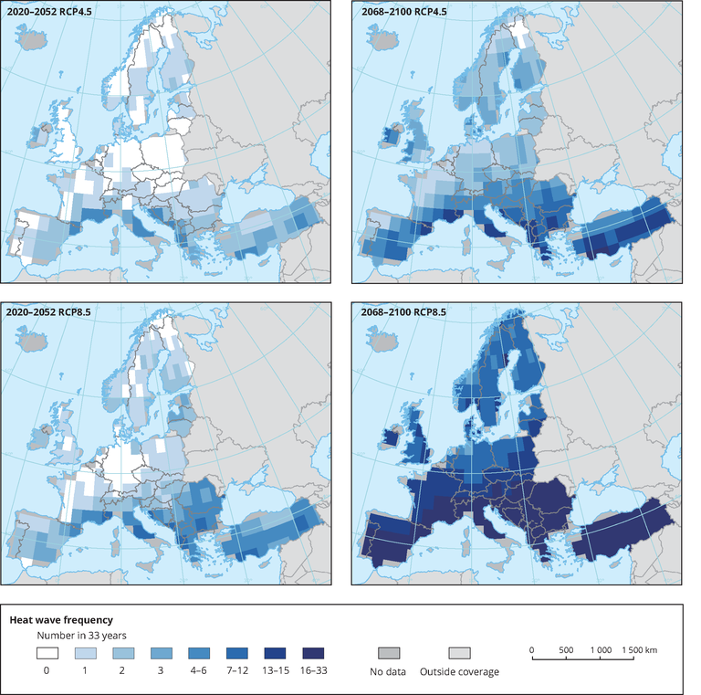
Figure 1 Number of extreme heat waves in future climates under two different climate forcing scenarios © EEA

As the planet warms, water will increasingly be lost through evaporation and surface drying, which will increase drought intensity and duration. Climate models predict that towards the end of the twenty-first century (2081-2100) the equator (particularly the Pacific Ocean area), the Arctic and Antarctica will see substantial increases in precipitation. Whilst reductions will occur in Africa, Western Australia, Chile, Central America, and especially around the Mediterranean.

Figure 2 shows the percentage change in heavy precipitation per °C of warming. Heavy precipitation is defined as the heaviest daily precipitation event of the year for each location. Unlike average annual precipitation, almost the entire world is expected to see an increase in this type of extreme precipitation as it warms.
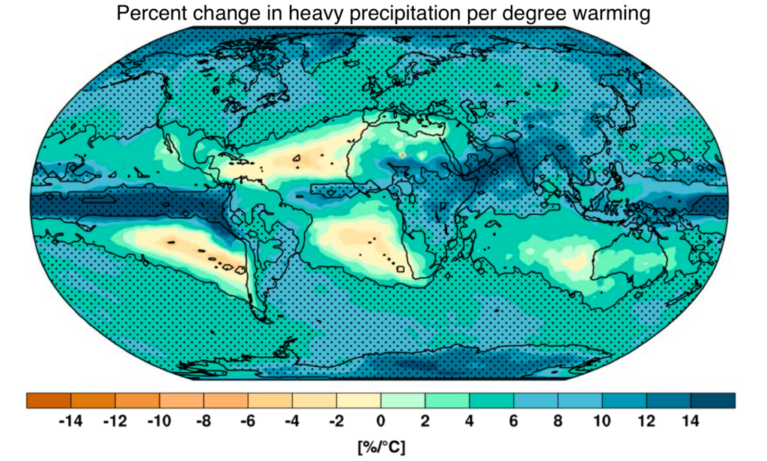
Figure 2 Explainer: What climate models tell us about future rainfall © Carbon Brief

Heavy localised precipitation and flooding have become more frequent in the UK. This is a trend, like heatwave frequency, that is expected to continue. These downpours will severely affect farmers and farmland by:

- Increasing runoff
- Loss of farm infrastructure
- Submerged underwater fields
- An increase in crop disease and pests
- Damage to boundary features like hedgerows

Activity
- Using the data in Table 1 create a horizontal line graph with time along the x axis and calories up the y axis.

- Analyse the pattern of global food calorie intake between 1961 and 2018.

- Go to the National Geographic webpage Where will we find enough food for 9 billion people? Answer this using an example farm in your response.

- Create a horizontal 3-box flow diagram for each of the 5 affects from heavy precipitation, as shown below. Using table 2, match the affect to secondary impact and the overall outcome.

Secondary impact | Overall outcome
Loss of valuable soil and nutrients | Loss of farm profits
Poor crop health | Decline in soil fertility
Livestock forced indoors for longer | Cost of replacement
Livestock damage prohibited areas | Reduced yields
Disruption to business | Environmental stress
Table 2 secondary impacts and overall outcomes

- The UK is not self-sufficient in food production. Read the following articles on Global Food Security and the UK Food Security Report 2021 in the UK. Analyse if food insecurity is an economic risk to the country.

Answers
- Per capita kilocalorie supply from all foods per day is illustrated below in graph 1.

- Overall, calorie intake has increased consistently in this period. North America and Europe have remained largely in step with one another, increasing their average calorie count over time. By 1961 it was over 2500 kcal per day for both regions and continues to grow (bar a brief decline for North America between 2001 and 2011). The fastest increase in calorie supply is across Africa and Asia. However, for some regions, particularly Europe and Africa, there has been a levelling off in calorie intake since 2010. A gap is still clearly visible between the industrialised west (North America and Europe) and the other regions, although in recent decades it has narrowed with South America, Asia, and Africa showing a steep rise in consumption. Since 2011, the gap between Asia and Africa has widened.

- Predictions suggest that there might be 9.6 billion people on the planet by 2050. The continued rise of world population will require a further rise in global food supply during the first half of the twenty-first century. It is hoped that mechanised, large-scale farms in North America will increase farm productivity by using less labour (to cover more ground) and through the use of real-time data (when live data on moisture levels, soil quality and weather conditions are used for limiting crop damage, in harvest planning, and for decision-making). An example is Vulgamore farm in Kansas where combine harvesters can now harvest up to 25 acres of wheat per hour.

- The flow diagram answer is below.

- Food security will be a growing concern for many countries throughout the twenty-first century as the climate continues to change. An example of a climate change impact in the UK is the spread north of the bluetongue virus amongst sheep. The UK presently imports ~46% of total food consumed, which makes the country vulnerable to economic shock, price volatility, and external influences. In 2008 the food price spike had a real impact on consumer purchasing power. Since 2020, food supply chains have become strained due to the multiple impacts from COVID-19. Delivery times have lengthened for some products, with some collapsing altogether. If exacerbated, this could create food insecurity for the country. However, no country provides more than 11% of UK imports which avoids overreliance on any one exporter. Furthermore, the main suppliers of FFD (Food, Feed, and Drink) are reliable European partners with a long history of trade with the UK. For example, in 2020, the largest amount of FFD came from the Netherlands (£5.3bn), Germany (£4.5bn), and Ireland (£4.4bn). In total, 39% of FFD imports by value were despatched from four nearby EU countries (the Netherlands, Ireland, Germany, and France) in 2020. Food insecurity is, therefore, unlikely.

