Plastic Citizen: Shaping the future

The Plastic Citizen Project is part of the wider University of Hull Plastics Collaboratory and is based within the School of Education’s Faculty of Arts, Culture and Education.

Principal Investigator Professor Kevin Burden and his team – Professor Rudi Wurzel, Dr Charlotte Dean and Dr Fiona James have developed the project with the aim of engaging young people in exploring their perceptions of and researching what they feel are the key issues in the plastics circular economy.

The project involves working with groups of young people in schools and youth groups, in and around the city of Hull to encourage them to look at how they and the world around them interacts with single use plastics, what single-use plastic they use themselves, what they are made of, how some can be harmful and some really useful - we really aim to encourage the young people to develop a critical inquiry approach to how plastics are viewed, used and disposed of in our society.

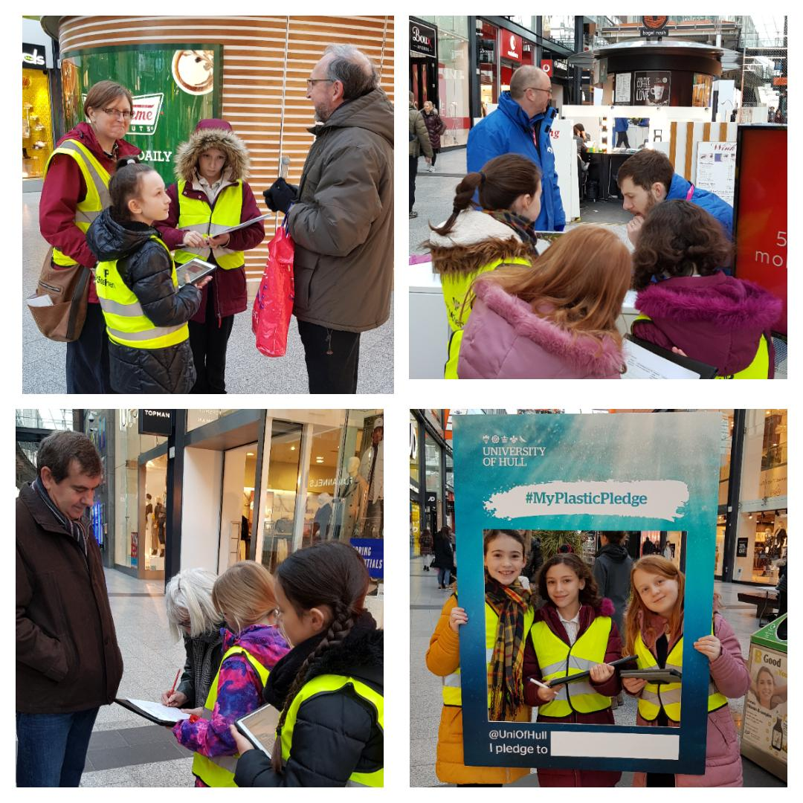
© Dr Charlotte Dean, the University of Hull

We are working with five very different projects, which include an environmental youth work project; a girl guides group; a school for young people who are disengaged from mainstream education and an international council of young people.

The young people are all working on individual research projects which all have the theme of critical inquiry at their core. The groups have been given four criteria around which to design their own research projects. These are that it must:

- Involve carrying out research – may be with other young people, may be local community, school etc.
- Encourage others to use at least one of the 4 Rs – Re-purpose; Reduce, Re-use and Re-cycle single-use plastic.
- Involve digital technology i.e. create an online survey; create an app; use Instagram to log when you have used one of the 4 Rs.

To add an incentive for involvement, we intend to hold a 'Dragon's Den' type event at the university where the young people would present their ideas and potentially win a prize of £500 for their school/youth project. We are also able to provide a sum of funding to the school/youth project in order to pay for any resources/staff time etc. that may be needed in order to remove any barriers to participation as far as possible. (This aspect of the project has been put on hold in light of the current Covid-19 pandemic).

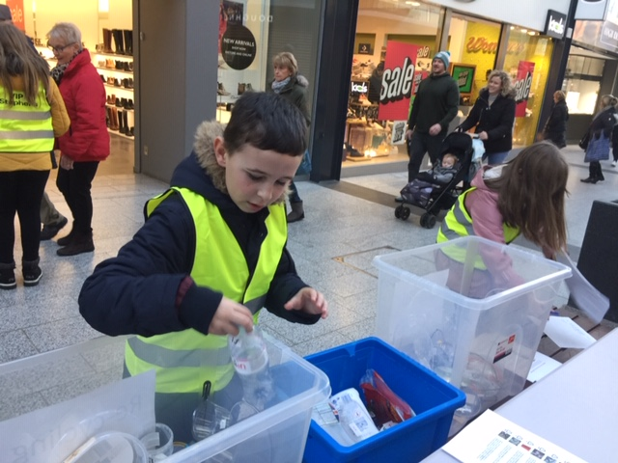
© Dr Charlotte Dean, the University of Hull
The projects that each group are working on are very different - for example, one group are designing an app to educate primary school children about the different types of single use plastics. We have also created a paid work experience opportunity for two students on the BA Digital Design programme to work with the young people to take the app out of the design stage to create a prototype which will be tested across local primary schools through the Universities Teacher Education programme. Another group are carrying out a Citizen Science research project in St Stephens’s shopping centre through asking members of the public to complete their own ‘plastics mission’ created using the nquire Citizen Inquiry software.

An international comparator study has been led by Prof. Rudi Wurzel, whereby, the research team visited schools, the local climate council and universities in Bremerhaven to present findings from the UK project and also trial the nquire Citizen Inquiry software and compare to its use and findings in the UK.

For further information about the project – please contact Charlotte.dean@hull.ac.uk

Twitter: @plastic_citizen
Website: www.plasticsinquiry.com

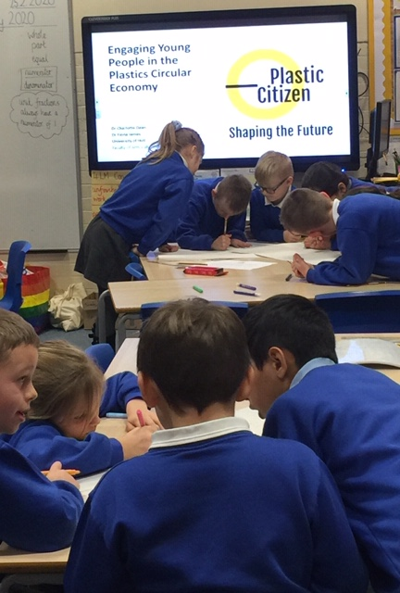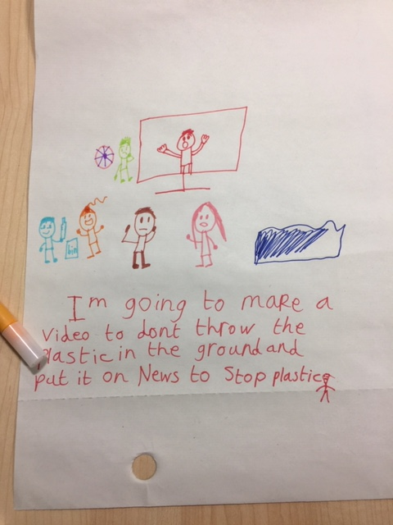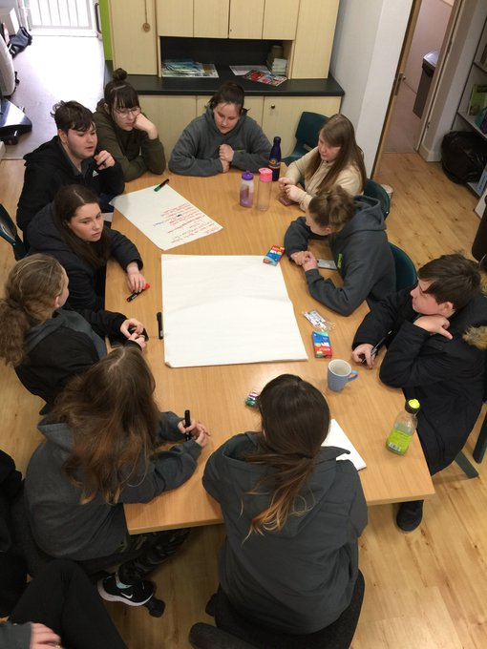
© Dr Charlotte Dean, the University of Hull

Here are some examples of resources created by young people involved in the Plastic Citizen project for facilitating learning around the Circular Plastics Economy. We are currently working on an animated film which aims to educate primary school children (KS1 and 2) about single-use plastic, a vlog, an app, online quizzes, surveys and other resources.

Is Plastic Fantastic or Drastic?
Quiz created by youth environmental activist group Youth in Nature to test and extend young people’s knowledge about single-use plastics:

Click on the link to take part in the quiz Is Plastic Fantastic or Drastic? Quiz

Plastic Citizen – what do people know about the plastic circular economy?
This is an online citizen science inquiry created by the International Pupil Council – a group of 30 young people from various primary schools across the city of Hull.

You can take part in the inquiry here.

This is a really good example of how young people can be involved in the design and creation of a citizen science project. The young people also analyse the findings from the survey on an ongoing basis and draw conclusions and correlations from the resulting analysis.

The Key Stage 2 Plastic Citizen project extension work built on the work already done by the young people to create an app which educates younger children about the 4 R’s (reduce, recycle, re-purpose and re-use). The app was created by the young people with support from digital media students from the University of Hull. Continuation work on the app is ongoing and the following resources were created by the research team when the Covid-19 pandemic required us to send continuation work home for the children to complete:

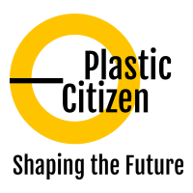

Plastic Citizen Project 1
For the Plastic Citizen Project 1: App Group watch the link of the first iteration of your app development below or copy this link into your web browser https://youtu.be/l_XAAd5tTYg.

Task: Click on the link then tell us what you think about your app so far and what we need to do next to make this better.

- What colours would you use? For example: the X would be red perhaps? or the safe to recycle would be green? In the quiz section would your answer be one colour around the box of the answer and then the correct answer would light up green?

- The buttons Reduce, Reuse, Recycle, Refuse all need information. What would you write for each subheading? Perhaps, write your ideas in your exercise book or on the next page and then upload or record your ideas to seesaw.

- What information would we need to add to the ‘settings’ section of the app? You could include links to webpages/ YouTube clips if you wanted.

Recycling Ranger App
Here is the link to the app that we have been working on with another group of young people (a girl guides group) Recycling Ranger.

This is the 5th iteration of the app that the young people have produced in stages with our digital media students whom we employed as interns on the project. We are currently seeking funding to be able to develop this prototype into a fully-fledged educational app to use in schools/ informal education settings.

Plastic Citizen Project 2
Here are some of your designs we completed in class from the Plastic Citizen Project 2: Recycling Bins.

Task: use an idea above or do a completely new design. Then think about how your recycling bin design could be made really fun to use.

Examples: your bin might be hungry so you need to feed it bits of plastic, your bin can have more than one hole, scoring or counting the number of pieces of recycling it has eaten already? Be creative and use your imagination.

Consider using the internet to find some fun features – Google, Pinterest
https://www.britishbins.co.uk/flatpack-recycling-bins/

Task: How will you help users of your recycling bin to understand what should be put in it?

Look at this link to help you decide what things people should put in the bin.
http://www.hull.gov.uk/bins-and-recycling/recycling/blue-bin

Do you want the bin to be used like Hull City council’s blue bins, or do you have other ideas? Once you have decided, design something that will tell people how to use it – an instruction manual perhaps or a flow chart with pictures and instructions.

Recycling bin design template:

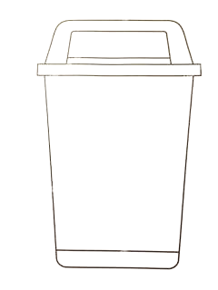

Task: Consider whereabouts in school you would we put this bin?

If lots of these bins were made, where could we put them? Give reasons for your answer.

Plastic Citizen Project 3
Task 1: Grow your own / planter design. Research the vegetables we discussed growing in school. What conditions will they need to grow as best they can? Where abouts in school do you think they would grow best? What time of year do you need to plant them, so they grow well?

Each vegetable should be a new subheading and then write sentences to answer the questions above.

- Think of how the plastic items below could be used as a planter (draw your ideas):

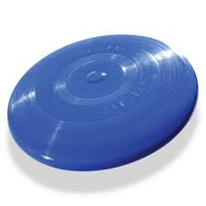
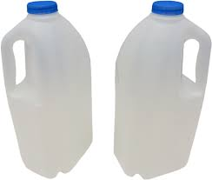
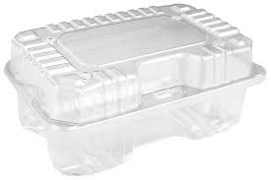
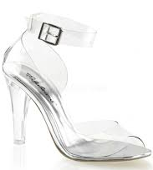

Here are some hints for thinking about planters. Planters need to have drainage holes which can be big or small. They also can be hanging or rest on a surface. Plants need water, sunlight, and soil. This article explains in more detail what a growing plant needs to grow and survive https://www.bbc.co.uk/bitesize/topics/zy66fg8/articles/zcmtk2p.

The next links covers germination, roots and shoots https://www.bbc.co.uk/bitesize/clips/zb4rkqt.

- Make a list of all the materials you will need to germinate your seeds (germination means when the seeds start to grow and put out shoots). Also, how will you look after your new plants? Think about and write down how the class will meet the daily needs of the new plants.

- Research how the group could build greenhouses using recycled materials like plastic bottles. Write down what information you have found and include the names of the websites you got the information from.

