Lagoon ecosystem and sustainable use: flora and fauna factsheet
A list with images of lagoon flora and a list of sources follow the tabulated information
QUESTIONS THAT PARAGRAPHS ANSWER | KEY POINTS | PARAGRAPHS  Compiled by Francesca Colpo, Gaia Schiavon
What types of organisms inhabit the Lagoon of Venice?  Is the biodiversity of the lagoon changing?  Further information on biodiversity change is in the Ecosystem factsheet. | >Biodiversity of the lagoon is changing because of climate change and changes to water quality  >Whether biodiversity increases or decreases in the long run will depend on how the lagoon is managed | In the present day, there are hundreds of species of fish, molluscs, birds and plants in the Venetian lagoon.  Biodiversity has actually increased in the modern era because of the creation of new artificial habitats. For instance, rubble from sea walls has created an artificial reef for crustaceans and breeding fish. Other species have also been attracted by the increasingly warm waters (due to global warming) and the algal blooms. However the process of eutrophication due to nutrient loading into the lagoon poses a threat to biodiversity.  With further warming of the northern Adriatic, it is expected that more species with a Mediterranean distribution will be found in the lagoon.
What types of plants are found in the lagoon?  A list of salt marsh plants found in the Lagoon of Venice (with images and common and Latin names) is included at the end of this factsheet. | >Salt marsh is a major feature of the Lagoon of Venice  >Salt marsh plants display a range of special adaptations, particularly for anchoring themselves in loose sediment and tolerating salty water | Most of the islands are covered by grasses and shrubs, but trees like limes and oleanders are also present.  Common emergent vegetation of the salt marshes include: Salicornia (glasswort), Sea lavender, Puccinellia (salt grass), although with different associations and dominances. While the evolution of vegetation in salt marshes reflects limiting conditions such as salinity, in ‘valli da pesca’ (see below), there are areas best suited to an advancement towards reed beds (Phragmites).  The main associations found in salt marshes are Limonio - Puccinellietum palustris, characterized by Puccinellia festuciformis, Limonium serotinum, and Juncus maritimus.
Which types of animal live in the lagoon?  What is the difference between a ‘resident’ and a ‘seasonal’ species?  Is the lagoon an important habitat for birds? Which areas of the lagoon are important for birds? | >A wide variety of fish and birds have either a permanent or seasonal presence  >The LoVe is an important stopover on bird migration routes  >LIPU (Italian league for bird protection) organises bird watching | Some fish and bird species are ‘resident’, meaning that they always live in the Lagoon of Venice; whereas some are classified as ‘seasonals’ because they regularly come into the lagoon only in some particular periods; usually to lay eggs and to find warmer water.  There are a lot of birds in the lagoon, and the lagoon is a place where a lot of birds nest because of the favourable climate that the lagoon presents - especially near beaches.  An inventory of bird species seen in the Lagoon of Venice can be viewed by following this hyperlink:  http://www.ornitologiaveneziana.eu/guida/bwonve.html  The area of Ca’ Roman, near Chioggia, is an important bird migration route (stopover) where they settle temporarily for a particular period of time. Nowadays, we can count 190 bird species; the most important are the ‘Martin Pescatore’ (kingfisher),the ‘Sparviero’ (sparrowhawk) and different types of seagulls. LIPU (the association that protects these birds) organizes guided walking tours around the island. http://www.lipu.it/oasi-naturale-ca-roman).  Some types of the seasonal birds are protected, since the areas where they nest have become dangerous for the eggs because of people or predators.  Some species of animals are categorized as ‘alien’ because their place of origin isn’t the Venetian lagoon. This is the case with some types of birds and fishes (because of salinity), and some marine mammals like seals or dolphins that occasionally come into the lagoon.
Where and what kind of fish can be found in the Lagoon of Venice? | >Fish must be able to tolerate a range of salinity, as the lagoon is a place where fresh and sea water mix  >Local fish and shellfish can be bought at the open-air fish market in Rialto | An inventory of fish species found in the Lagoon of Venice can be viewed by following this hyperlink: https://it.wikipedia.org/wiki/Pesci_della_Laguna_veneta  Fish are one of the principal resources of the lagoon, and there are traditional fish farms in which it is possible to catch different kinds of fish native to the lagoon such as eel, mullet, bass, and gilt-head bream. All of these species of fish are able to tolerate a massive range of salinity: from 8.0 to 32.0 parts per thousand (the Mediterranean Sea has a salinity average between 38 and 39 ppt). This adaptation is called ‘euryhaline’.  Venice still has an open-air fish market that takes place every day at the Rialto where it is still possible to buy fish and shellfish farmed and caught in the lagoon, as well as fish landed at the many Adriatic fishing harbours and elsewhere.
What are the types of animals that live on islands in the lagoon? | >The lagoon islands contain small mammals, reptiles, amphibians, and non-flying birds | The animals that live on land are mainly small mammals or reptiles. The most common reptile is the lizard, usually around 12cm long. Other types include tortoises, amphibians (like frogs and salamanders) and non-flying birds such as hens and pheasants.  Rats and moles are also common on the islands.

See the next three pages for a list of flora of the Lagoon of Venice

List of flora of the Lagoon of Venice, in alphabetical order with the Latin, English, Italian, and Venetian names
Agropyron pungens | Sea couch grass | Gramigna litoranea | - | 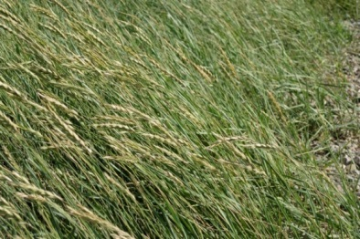  Sea couch grass © Robin Stott, Geography
Artemisia caerulescens | Bluish-leaved wormwood | Assenziolo | Sinsiolo marin | 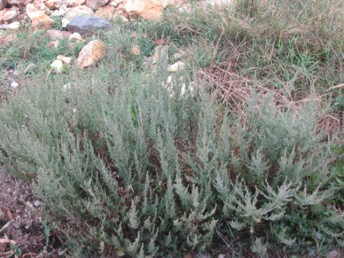  Artemedia caerulescens © Saxifraga-Jasenka Topic
Arthrocnemum fruticosum | Amaranth family | Salicornia fruticosa | Grapeie | 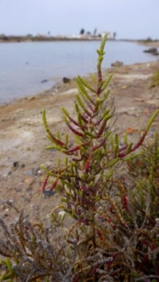  Sarcoconia fruitcosa © Nanosanchez, Wikimedia  Commons
Aster tripolium | Sea aster | Astro | Patano | 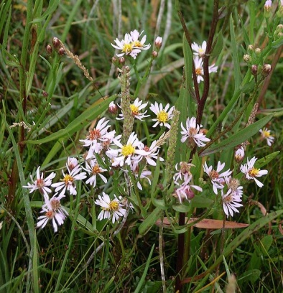  Sea aster © Velela, Wikimedia Commons
Atriplex latifolia | Saltbush | Atriplice | - | 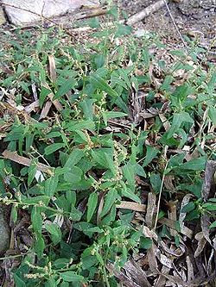  Saltbush © Wikimedia Commons
Beta vulgaris | Sea beet | Bieta | - | 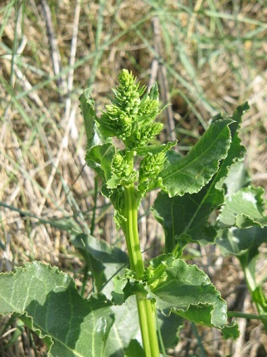  Sea beet © Meneerke Bloem, Wikimedia Commons
Crithmum maritimum | Rock samphire | Finocchio marino | Crètamo | 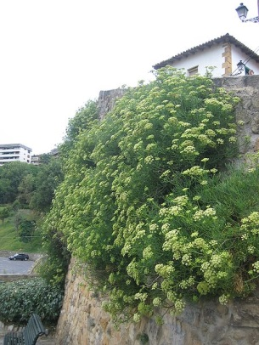  Rock samphire © Jon Peli Oleaga, Wikimedia Commons
Halimione portulacoides | Sea purslane | Campanati | Campanati | 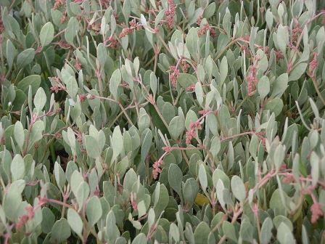  Sea purslane © Velala, Wikimedia Commons
Inula crithmoides L. | Golden samphire | Enula | Salin | 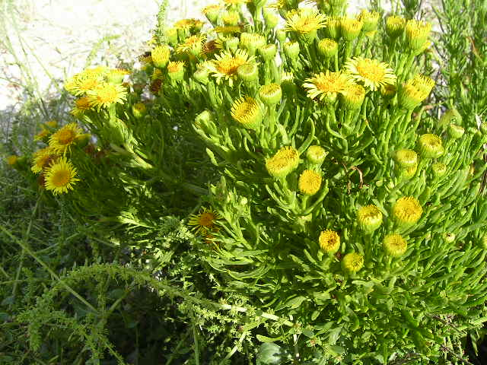  Golden samphire © Chilepine, Wikimedia Commons
Juncus acutus | Spiny rush | Giunco spinoso | Bruo mascio | 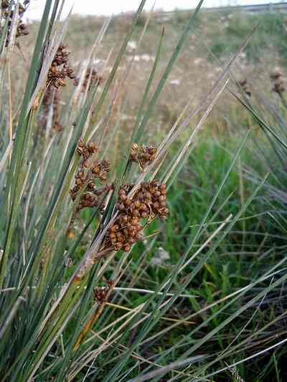  Spiny rush © Esculapio, Wikimedia Commons
Juncus maritimus | Sea rush | Giunco marino | Bruo Femena | 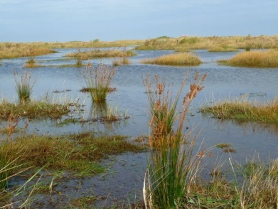  Sea rush © Wikimedia Commons
Limonium serotinum | Sea lavender | Limonio comune | - | 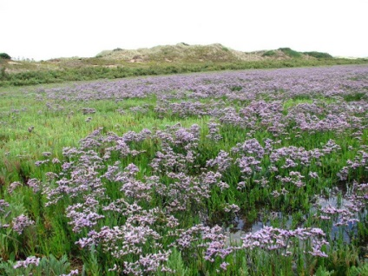  Sea lavender © Evelyn Simak, Geograph
Phragmites australis | Common reed | Canna di valle | Canea | 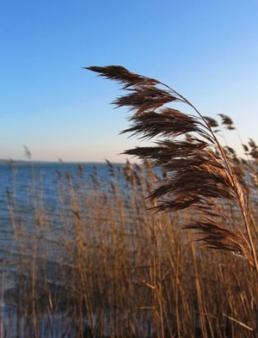  Common reed © Wikimedia Commons
Plantago coronopus | Buck’s-horn plantain | Coronopo | Barba di capuccino | 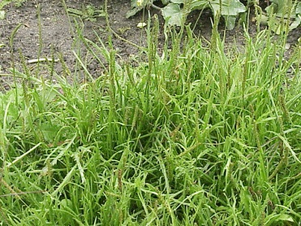  Plantago coronopus © Kurt Stuber, Wikimedia Commons
Puccinellia palustris | Salt grass | Pulcinella | Oii | 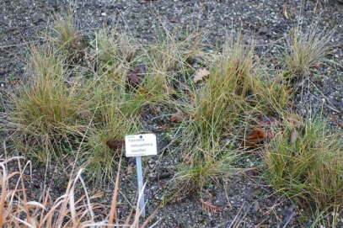  Salt grass © Wikimedia Commons
Salicornia herbacea | Common glasswort | Asparago di mare | Grapeie | 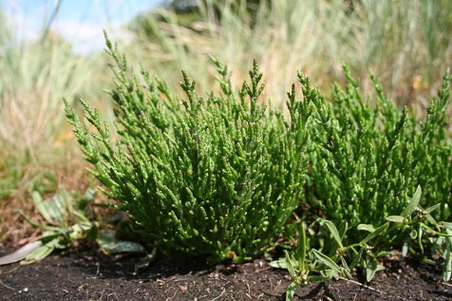  Common glasswort© Marco Schmidt, Wikimedia Commons
Salsola soda | Saltwort | Riscolo | Roscano | 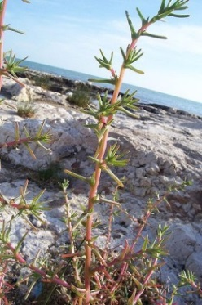  Saltwort © Luigi Rignanese, Wikimedia Commons
Spergularia media | Media sandspurry | Spergolaria media | - | 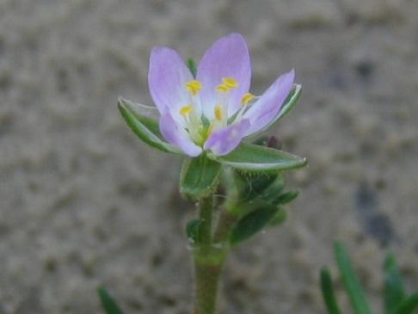  Media sandspurry © Kristian Peters, Wikimedia Commons
Suaeda maritima | Annual seablite | Roscanella | Roscano | 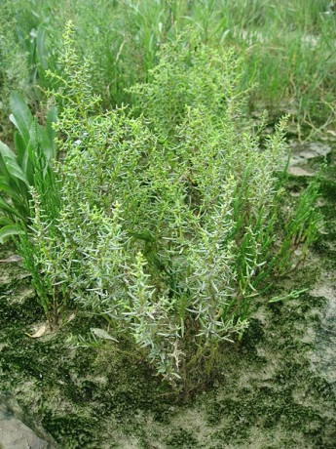  Annual seablite © Wikimedia Commons
Triglochin maritima | Seaside arrowgrass | - | Massacaveo | 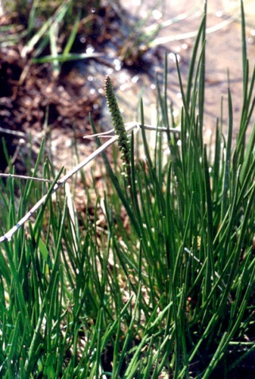  Seaside arrowgrass © Elke Freese, Wikimedia Commons
Zostera marina | Common eelgrass | Alga marina | Alega | 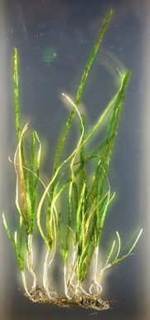  Common eelgrass © Daderot, Wikimedia Commons

Sources
- http://www.lipu.it/oasi-naturale-ca-roman
- http://www.inaturalist.org/taxa/
- https://iris.unive.it/retrieve/handle/10278/21623/20118/Lavoro%20Venezia%2c%20Libro%20Alghe.pdf
- http://www.atlantedellalaguna.it/?q=maps#tema-2-titolo
- https://www.openstarts.units.it/dspace/bitstream/10077/11037/1/Pesci_Book_ita.pdf
- https://it.wikipedia.org/wiki/Pesci_della_Laguna_veneta
- http://www.istitutoveneto.org/venezia/documenti/altri_elaborati/libro_vegetazione.pdf
- http://www.ornitologiaveneziana.eu/guida/bwonve.html

