FT for schools: Draw your own chart activity sheet 9

Introduction
COP26 is an international conference on climate which meets annually in different places around the world. This year it is being held in Glasgow.

It is seen as a pivotal conference as a follow-up to the landmark Paris Agreement of 2015 when 196 parties agreed to limit global warming ‘to well below 2, preferably 1.5°C, compared to preindustrial levels.

This resource was written by Alasdair Monteith, Head of Geography, Gordonstoun school.

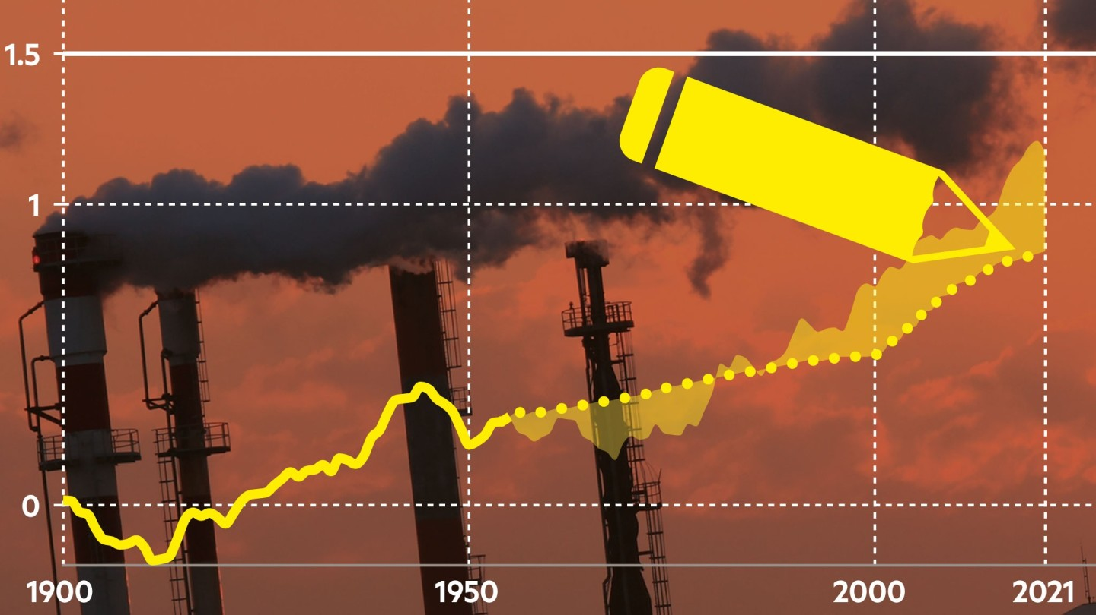
© FT Draw your own chart: test your climate change knowledge

Specification links
AQA A level 3.1.1.4 Water, carbon, climate, and life on Earth. The role of feedbacks within and between cycles and their link to climate change and implications for life on Earth.

Edexcel A level Topic 6: The Carbon Cycle and Energy Security.

7.3.a A number of emerging countries, including Brazil, Russia, India, and China (BRIC) and other G20 members, are considered increasingly important to global economic and political systems, as well as global environment governance (UN Climate Change Conference).

OCR Topic 3.1 – Climate Change. 5. Can an international response to climate change ever work?

WJEC A level 4.5: Weather and Climate. 4.5.7 People, climate, and the future.

The unit could be used in early stages of the A level course, it is suitable as a background evidential example, or it could be used as a taster lesson for students considering A Level geography.

Activity
Chart 1 Temperature

How did your chart compare with other people in your class? Were you more or less pessimistic about current temperature levels?

Do you think the discussion around what data to use for 'preindustrial levels' confuses the message about keeping temperatures below 1.5°C?

Chart 2 Emissions

Was your estimate of China's emissions significantly different than the actual emissions?

Outline how you came to your estimate then visit the climate dashboard here to analyse how emissions from China have changed annually.

To what extent should we take responsibility for some of China's emissions as many of the products that we consume are manufactured there?

Chart 3 Energy mix

It is likely that your guess was probably more optimistic than the current level of energy that comes from renewables!
Read through this article on the recent commitment by world leaders to invest in renewables. And then this article by Tim Harford on the need for a Carbon Tax. Use both these articles to inform your answer to the question below:

To what extent is the commitment agreed by world leaders in Glasgow on clean technology enough to increase the amount of energy coming from renewables in the near future?

Chart 4 Funding

'As the richest country in the world, the USA's contribution to climate related aid should be the highest of the G7 countries'. Discuss.

This article explores the issues around climate financing. Scroll down and find the interactive graph titled ‘The World Bank is the largest provider of multilateral climate-related finance‘. Explore the interactive chart (on the third slide press the play button to watch the graph change from 2009 to 2019).

Further work
- Watch the official COP26 YouTube channel

- Sky News Government gives £210m backing for mini nuclear reactors to hit net zero 'more quickly'

- Visit the Royal Geographical Society webpage 39 Ways to Save the Planet for climate change teaching resources

- Carbon Brief COP26: Key outcomes agreed at the UN climate talks in Glasgow

- France 24 World on 'catastrophic' path to 2.7C warming, warns UN chief

