FT for schools: A student introduction to The Climate Game activity sheet 12

This resource was written by Stephen Schwab, author, and geography consultant.

Specification links
AQA A level 3.1.1 Water and carbon cycles. 3.1.1.4 Water, carbon, climate, and life on Earth.
AQA GCSE 3.1 Living with the physical environment. 3.1.1.4 Climate change.

Edexcel A level Topic 5: The Water Cycle and Water Insecurity. 5.6 Climate change may have significant impacts on the hydrological cycle globally and locally.

Edexcel GCSE Topic 2: Weather hazards and climate change.

OCR A level Topic 3.1 – Climate Change. 2. How and why has the era of industrialisation affected global climate?

OCR GCSE 2.3 Environmental threats to our Planet. 2.3.1 The climate has changed from the start of the Quaternary period.

WJEC A Level 4.5: Weather and Climate. 4.5.6 Impacts of human activities on the atmosphere at local and regional scales.

WJEC GCSE Section A Core Theme 5: Weather, Climate, and Ecosystems. 5.1.2 What are the causes of climate change?

Introduction
Access the online interactive from the Financial Times called The Climate Game. The objective is posed to you in the starting pop up; can you reach net zero by 2050?

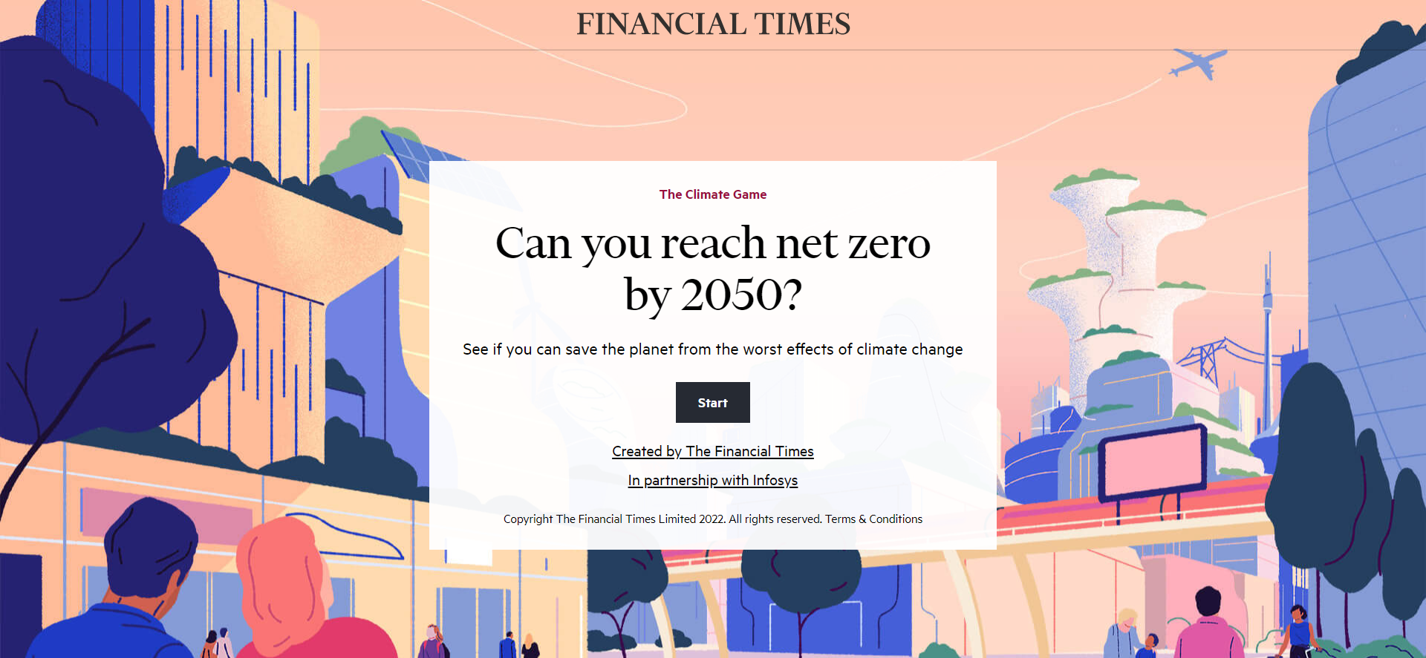

In 2019, David Attenborough wrote in Life on Earth that “no species has ever had such wholesale control over everything on Earth, living or dead, as we now have.” This level of control homo sapiens have cultivated over the natural world brings with it an awesome responsibility. “In our hands now lies not only our own future, but that of all other living creatures with whom we share the Earth.” Play The Climate Game and decide how you will use your wholesale control to mitigate the effects of human-induced climate change.

Working with scientists, modellers and policy experts, the climate crisis has been gamified to see if you can cut emissions to net zero by 2050.

Reaching net zero greenhouse gas emissions by 2050 to keep the planet from further global warming seems a hard task on an individual level.

But what if you had the power to make all the necessary decisions?

KEY OBJECTIVE 1: Can you reach net zero?

The main goal is clear: cut energy-related carbon dioxide emissions from 36bn tonnes a year in 2021 to net zero by 2050.

KEY OBJECTIVE 2: to significantly reduce other greenhouse gases, and to protect people, nature, and jobs, all while ensuring the planet remains habitable.

Good luck. The planet is counting on you.

Activity
- Begin the game by clicking Start. The next pop-up box is a Welcome to the game! You have been appointed “global minister for future generations”. Choose your advisor.

- You have a budget of 100 points, to spend over 3 rounds. Round one is from 2022-2025 and consists of 7 questions on the energy sector.

The energy sector is the source of about three-quarters of global greenhouse gas emissions and holds the key to averting the worst effects of climate change. Answer the 7 questions.

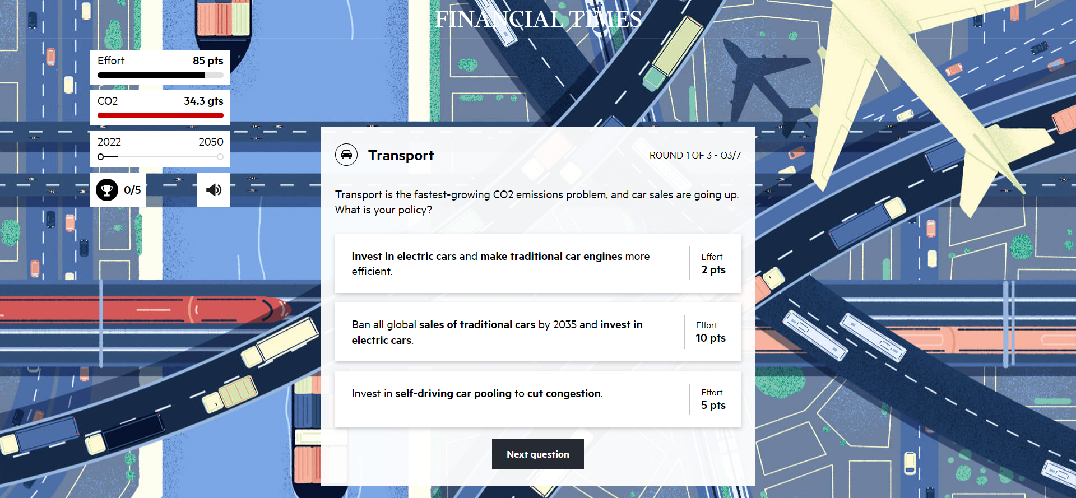

- During the course of round 1 there will be a “Climate Tipping Point” announcement on Antarctica due to continued high levels of carbon dioxide in the atmosphere. Click on the question mark box to find out what the impact will be.

- Each CO₂ related question in the game is tracked to one of three pathways, creating a bespoke version of the net zero chart, based on the choices made by you. This is presented at the end of each round. Click the headings; Electricity, Buildings, Transport, and Industry to receive a comment from your advisor about what would have been a better option.

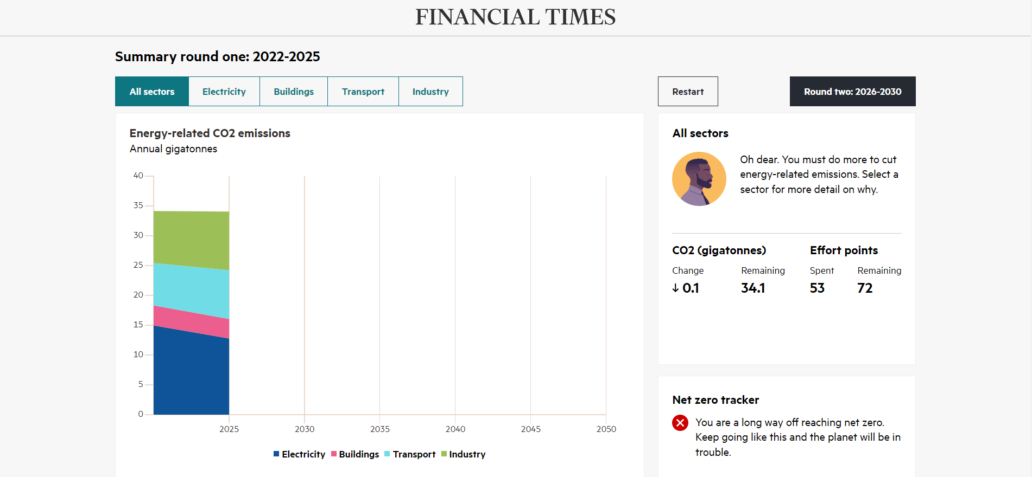

- Click Round two 2026-2030. More tipping points will appear, this time on coral reefs and the Arctic. Click on the question mark boxes to find out what the impacts will be. Try to amend your decision-making in response to these notifications.

- Click Round three 2031-2050. A final tipping point is crossed on Amazonian rainforest dieback. Later in the round thawing permafrost is your last challenge. After this you will have made it to 2050. It is time to see if your hard work has paid off.

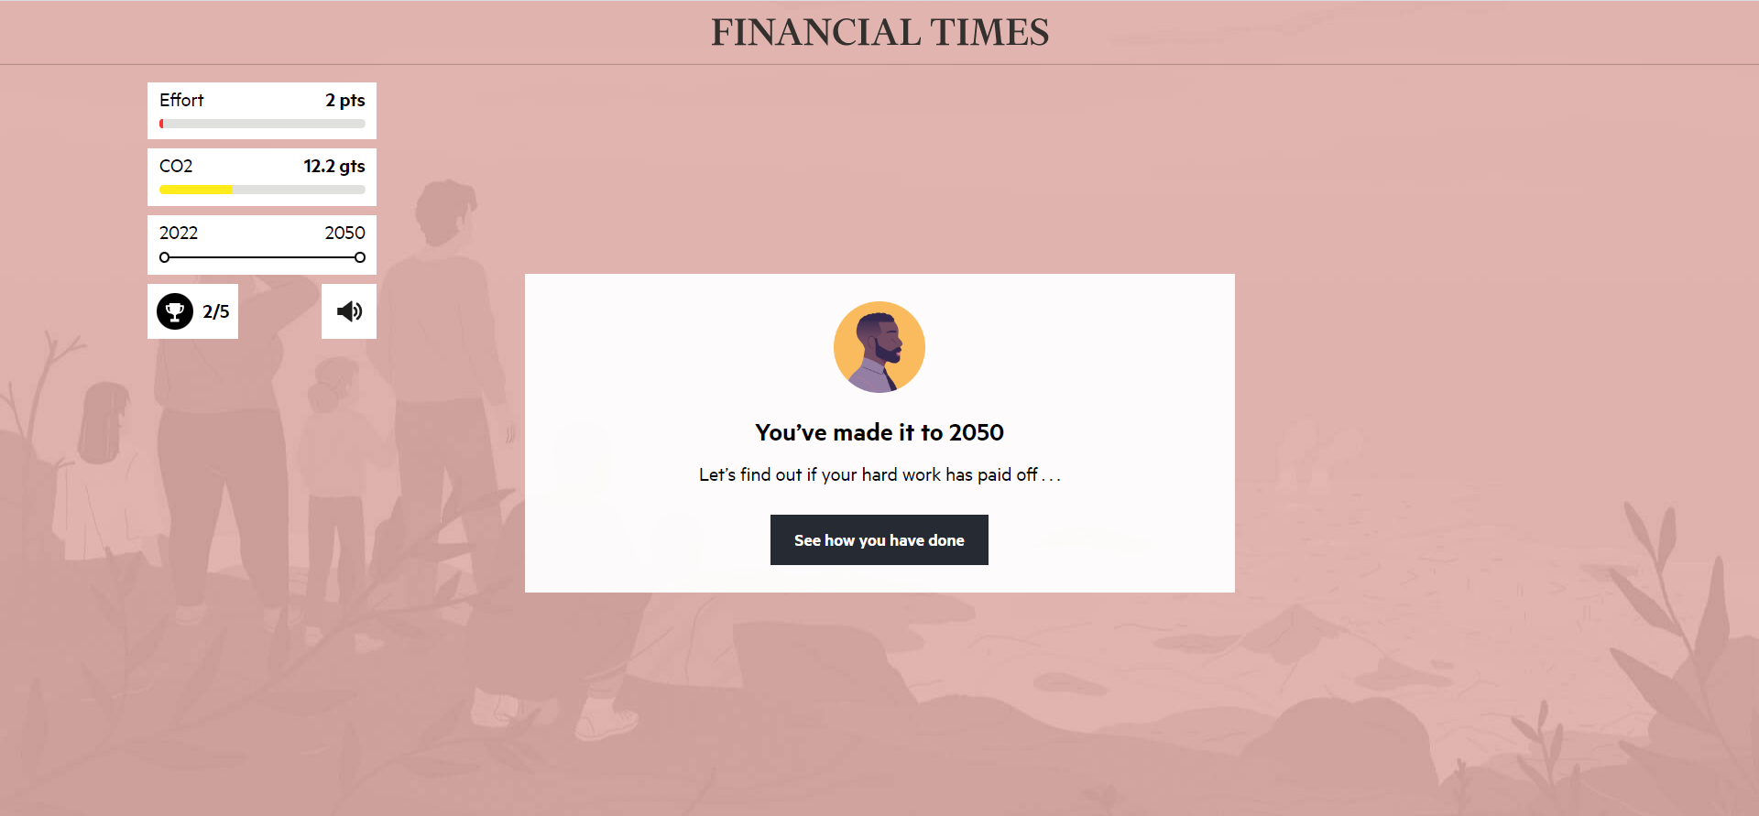

- To finish click on What’s the temperature? for your planet. Then compare it against other degrees of warming.

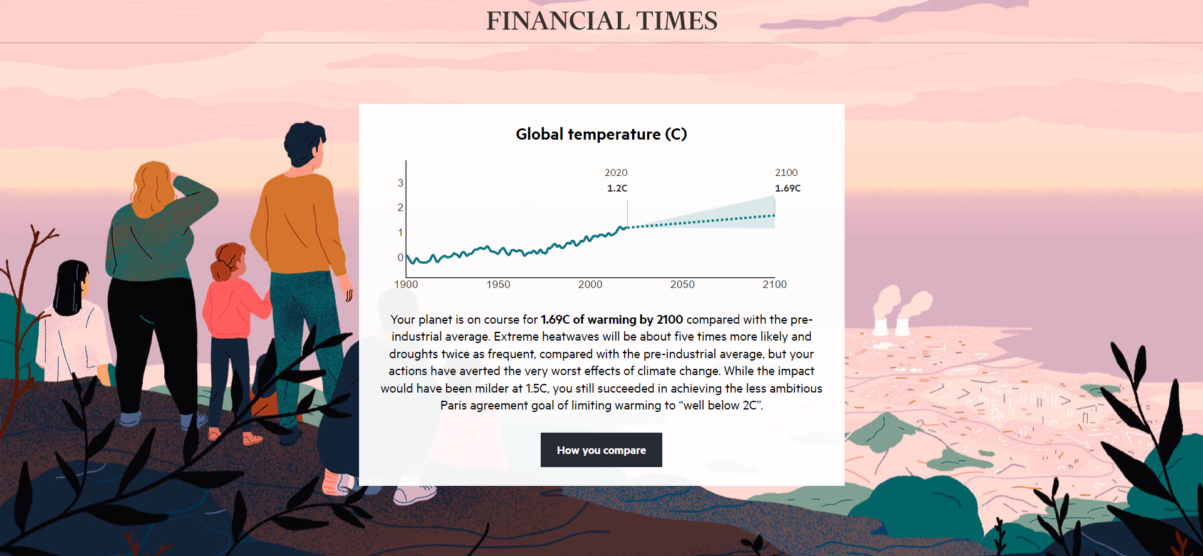

- Review your decisions by clicking How you compare (with other players) and then click Your decisions to see a Final game summary. Compare it against others in the class.

Notes
Your choices do more than just decide the trajectory within a particular sector, such as transport. For example, if you want to build enough high-speed rail to encourage a shift away from aviation, you need a lot of infrastructure. But unless you have decarbonised the whole industry sector, the cement and steel needed to deliver high-speed rail is going to have tonnes of emissions associated with it.

CO₂ might be the principal greenhouse gas contributing to global warming, but it is also necessary to consider other significant pollutants as you play the game. The section in round three on methane is of crucial importance. Methane accounts for about one-third of human-caused warming through emissions from gas leaks, landfills, old coal mines, and beef and dairy. Q3 in round three focuses on reducing meat and dairy in your diet.

As well as cutting emissions you must also focus on other levers crucial to a successful net zero future, such as cooperation, innovation, and adaptation.

Adding effort points serves to emphasise the importance of taking cooperative action sooner rather than later. Answers cost more points as you progress and by round three, when 2050 is looming, things get very expensive if the wrong answers have been selected earlier in the game.

There are many pathways to net zero however it is unlikely to be achieved without bold action. There are parts of the energy system which need innovation to happen now in order to deliver the new technologies we will need at the scale (and cost) in the future.

Advisers are introduced to highlight other pathway factors crucial to a net zero future: behavioural change, new technologies, green business practices and policy change. In game terms, all four advisers earn you 10 points for working hard in their specialist area.

Behavioural change, both in the game and in your daily life, is very important. The author Gaia Vince highlights the importance of decision-making in her new book Nomad Century, when she predicts that a global rise of 3°C would mean “drowned cities, stagnant seas, a crash in biodiversity, intolerable heatwaves, entire countries becoming uninhabitable, [and] widespread hunger”.

Further work
- RGS Key Stage 3 curriculum

- BBC Teach Climate change

- BBC Teach Geography KS3 / GCSE: Climate Change - Ade on the Frontline YouTube

- UN What Is Climate Change?

- GA Support for trainees and NQTs Global warming and climate change

- Teachwire How to Teach Climate Change in Secondary Geography

- RGS Climate 4 Classrooms

- FT Collections Climate change and sustainability

- FT Climate Capital

