[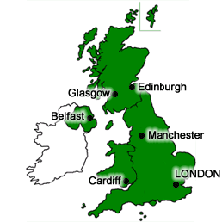](http://www.google.co.uk/url?sa=i&rct=j&q=&esrc=s&frm=1&source=images&cd=&cad=rja&uact=8&ved=0CAcQjRxqFQoTCMf398exlMcCFchq2wodwqwOtQ&url=http://www.ecenglish.com/learnenglish/lessons/what-difference-between-united-kingdom-great-britain-and-england&ei=jEnDVceBBsjV7QbC2bqoCw&bvm=bv.99556055,d.ZGU&psig=AFQjCNGNACM0v5h_LizwCUhFzrrSe4ikXg&ust=1438948081800745)[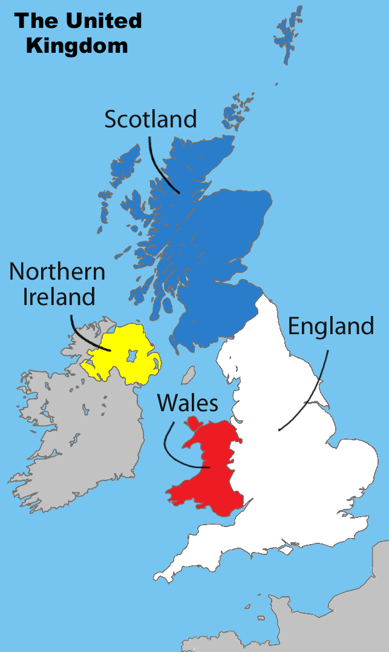](https://www.google.co.uk/url?sa=i&rct=j&q=&esrc=s&frm=1&source=images&cd=&cad=rja&uact=8&ved=0CAcQjRxqFQoTCP7hofmulMcCFUJr2wodrUgFZw&url=https://mciappara.wordpress.com/2015/03/24/the-united-kingdom/&ei=zkbDVf7CDsLW7QatkZW4Bg&bvm=bv.99556055,d.ZGU&psig=AFQjCNG9E6Fz1Z2hGgPdJZMH_MV2Tig4fg&ust=1438947396369581)[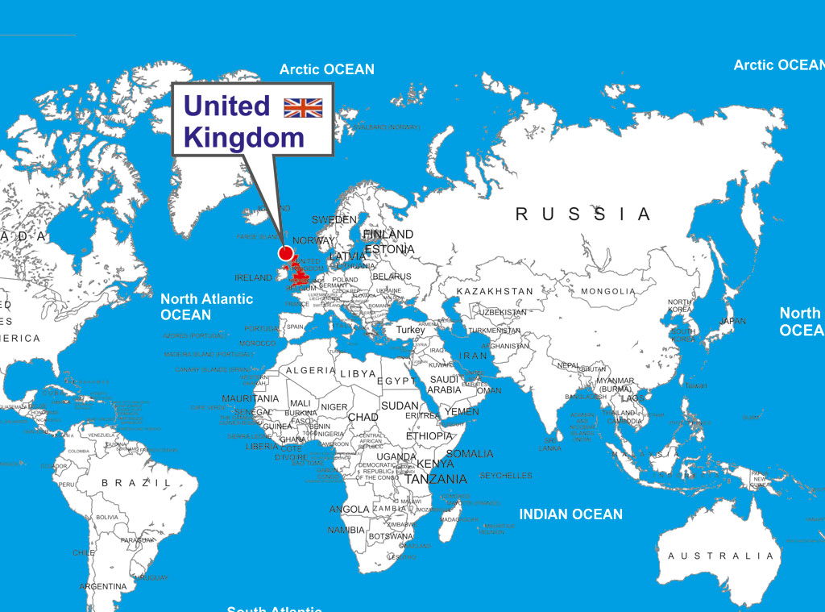](http://www.google.co.uk/url?sa=i&rct=j&q=&esrc=s&frm=1&source=images&cd=&cad=rja&uact=8&ved=0CAcQjRxqFQoTCMq42OrHlMcCFakW2wodN2YNIQ&url=http://www.mapsnworld.com/blog/united-kingdom-location-map/&ei=5mDDVcqtIqmt7Aa3zLWIAg&bvm=bv.99556055,d.ZGU&psig=AFQjCNEKVy9kYzMlAyvrzVqBCcio2ACaYA&ust=1438954080427991)

**Where is the UK?**

The UK is an island nation in Western Europe just off the coast of France. The mainland areas lie between latitudes 49°N and 59°N and longitudes 8°W to 2°E. The UK is bordered by four seas:

* to the South by the English Channel, which separates it from continental Europe
* to the East by the North Sea
* to the West by the Irish Sea and the Atlantic Ocean

Northern Ireland shares a 360 km international land boundary with the Republic of Ireland. The UK has a total area of nearly 245,000 square kilometres.

The **United Kingdom** is composed of: England, Scotland, Wales & Northern Ireland.

**Great Britain:** England, Scotland & Wales

**British Isles:** The UK plus Eire (Southern Ireland)

**Factsheet**

**Lesson One: UK – Building a picture**

**UK Capital Cities:** England (London); Scotland (Edinburgh); Wales (Cardiff) & Northern Ireland (Belfast)

**LESSON ONE: THE UK: BUILDING A PICTURE**