|  |
| --- |
| Dive into the deep Fieldwork Booklet |

# Introduction

This fieldwork booklet has been designed to provide fieldwork ideas to undertake at your local aquarium. It can be adapted to meet the needs of both learning, and the aquarium visited and therefore, sections can be removed or rearranged to suit the learning taking place.

The information gathered for this booklet has been based around a visit to the Sealife Centre in London.

*It is advisable* that the teacher leading the trip visits the aquarium before to identify where best to conduct each activity. Most aquariums offer a free teacher visit if a trip has already been booked. Therefore, it is worth discussing this directly with the aquarium.

Risk assessments, budgeting and other fieldwork administration should be undertaken by the school. This will not be provided in this booklet.

# Developing a sense of place

This is an excellent starter activity to help connect to the ocean. It can also be used at different points within the trip to help pupils compare the place throughout their visit.

There are many ideas available from the [Royal Geographical Society](https://www.rgs.org/schools/resources-for-schools/lake-district/developing-a-sense-of-place-in-the-lake-district). Soundscapes and human camera work particularly well here.

It would be worth completing the sense of place task at the entrance to the aquarium then at a part of the aquarium which replicates open water the most so the sights and sounds reflect how it would feel to be by the ocean.

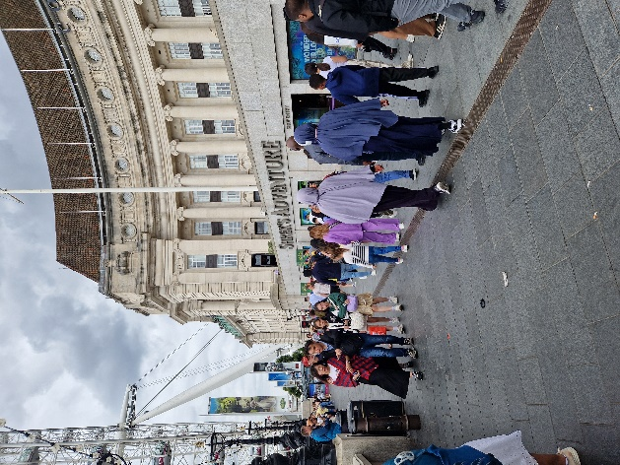

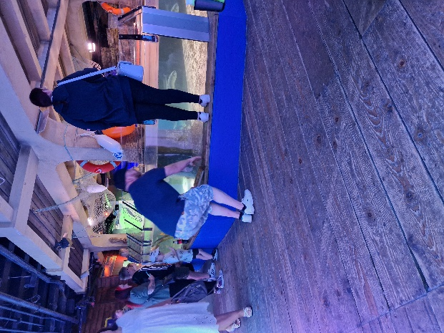

Outside the Sealife Centre, London and the ray tank.

*Figures 1 & 2: Suggested locations at the Sealife Centre in London to conduct the sense of place task © RGS.*

# Species Mapping

This task can be completed throughout the visit as a visual reminder of the diversity of species found in the oceans. Depending upon the information available for the species, pupils could also add information such as conservation level. Use this an opportunity to ask pupils how they feel they are connected to the ocean.

Give pupils some time in each aquarium zone visited to explore the species in the tanks. There are usually information signs near each tank to help identify the species. Pupils then find a species they find interesting and add the name to the map.

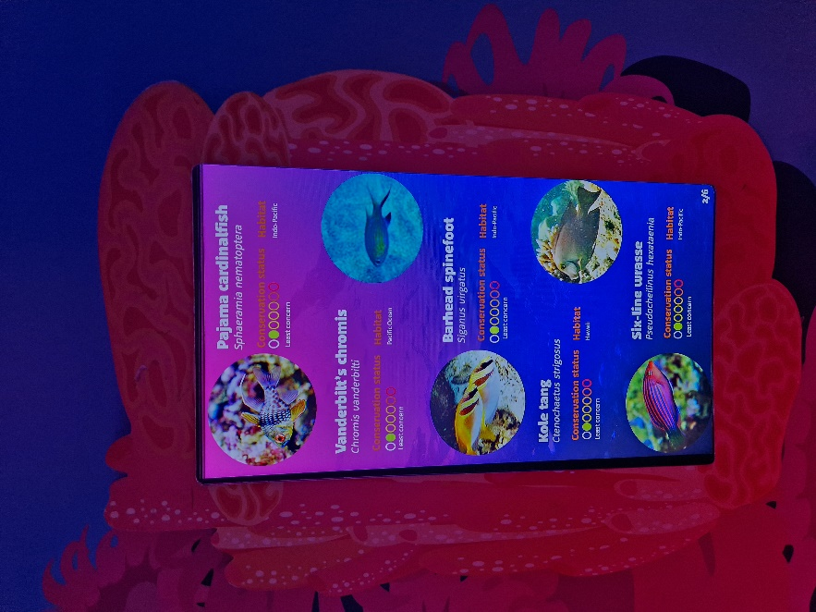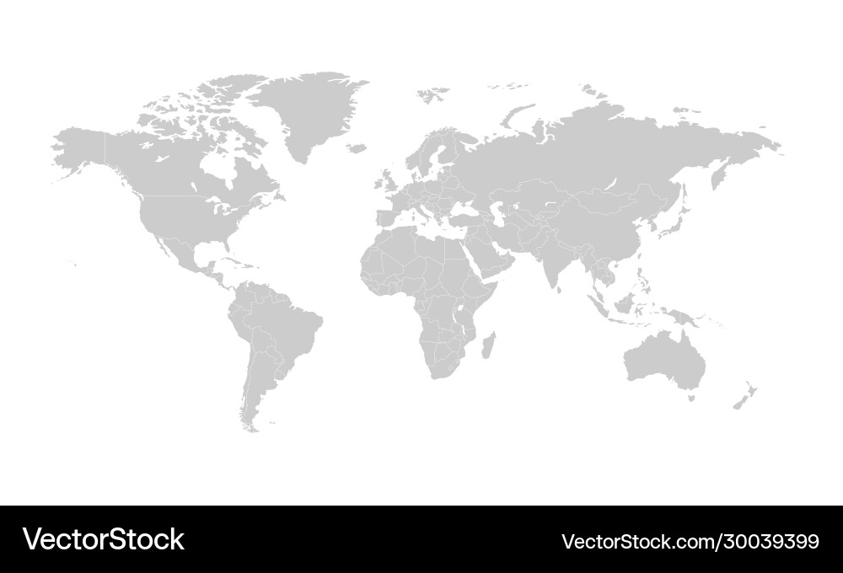

*Figure 4: example of an information board from the Sealife Centre in London © RGS*

Pacific

Antarctic (Southern)

N

Arctic

Indian

Pacific

Atlantic

*Figure 3: Map of the World with the oceans. Designed by Robot (Image #30039399 at VectorStock.com)*

# Fieldsketches

This can take place in one tank of interest or, for a range of fieldsketches, split the class into small groups who are responsible for a specific tank as they go through the aquarium.

Pupils complete a ‘fieldsketch’ on a tank with a range of species in. If there are tanks with producers through to primary consumers (apex predators), use these over others. They should include annotations of the species they find there; this will be found on information boards in the aquarium (see Figure 4). In addition, they should reflect on the tank itself, for example, the light level, features, size, where certain species tend to be located etc to reflect on the unique environment they are looking at. Challenge pupils to think about how this helps them connect to the ocean.

Type of sea: _______________________________

Tank name: _______________________________

# Conservation conservation!

While you visit different zones, take time to find information on the threats as well as ways in which they are being conserved. Then add the information you have found into the zone sections as well as adding ways which you could help towards the conservation.

|  |  |
| --- | --- |
| Zone: _______________________________  Threats: _____________________________  Conservation: ____________________________________________  ________________________________________________________  ________________________________________________________  How could you help? _______________________________________  ________________________________________________________  ________________________________________________________ | Zone: _______________________________  Threats: _____________________________  Conservation: ____________________________________________  ________________________________________________________  ________________________________________________________  How could you help? _______________________________________  ________________________________________________________  ________________________________________________________ |
| Zone: _______________________________  Threats: _____________________________  Conservation: ____________________________________________  ________________________________________________________  ________________________________________________________  How could you help? _______________________________________  ________________________________________________________  ________________________________________________________ | Zone: _______________________________  Threats: _____________________________  Conservation: ____________________________________________  ________________________________________________________  ________________________________________________________  How could you help? _______________________________________  ________________________________________________________  ________________________________________________________ |

# Food chains and webs

This task is a great application of learning from Lesson 2: It’s all part of the system. This works particularly well in smaller tanks (i.e. rockpools, grasses, corals etc) where producers through to consumers can be found. If your visit incorporates a feeding time presentation, then this could be a task after that as pupils will have information about that species to add into the food chain or web.

1. Draw the food chain of your marine zone below:

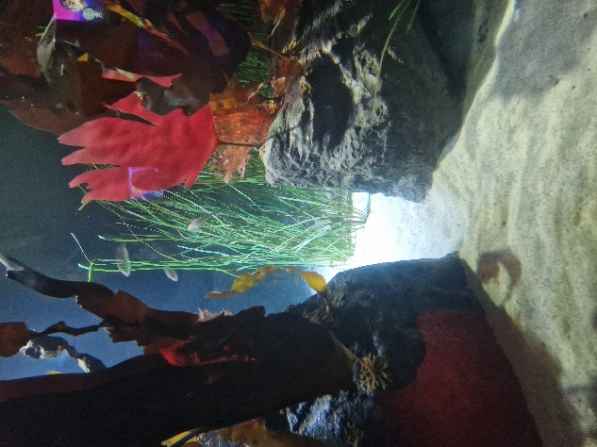 *Figure 5: Food chain example © RGS*

2. Describe what is happening in your food chain.

3. What are the threats to your food chain?

4. How do you think this food chain is different to other parts of the world?

5. How are these systems similar to those found on land?

6. How does this help you feel connected to the ocean?

# Creature feature

Assign a different marine creature to each pupil or group. They can then complete a little fact file on the species to present to the rest of the class or as an extension task written up for homework to add to a large display of the ocean. If the aquarium you are visiting has interactive displays on specific marine creatures, then this would be an excellent opportunity to add information to the fact file.

Species name: _________________________________

|  |  |
| --- | --- |
| 1. Draw a small sketch of the creature you are studying below:  2. Annotate it with specific physical characteristics i.e. their colouring or shape. | 3. What is their main food source?  4. Does it like to eat other things? What are they?  5. Where is their typical habitat? |
| 6. What are their main threats? | 7. If they are being protected, how? |
| 8. One other interesting fact you found out.  *Figure 6: example of an interactive learning station at the Sealife Centre in London © RGS*    9. How do you feel connected to the ocean through this species? | |

# Reflections

The next set of resources can be undertaken while you are still at the aquarium or back at the classroom depending on the time you have.

1. What would it like to be an aquarium keeper for the day? Pupils can write a reflective task on what they think. Encourage them to reflect on how this work helps them to connect to the oceans.

2. Ocean advocates: pupils write a way in which they now feel more connected to the oceans and how they are going to help conserve them.

3. Similarities and differences with the different zones: pupils reflect on the different zones, what made them similar and different as well as how people are connected to them.