Physical environment and flooding in Venice: flooding factsheet
Images, charts, and the sources follow the tabulated information
QUESTIONS THAT PARAGRAPHS ANSWER | KEY POINTS | PARAGRAPHS
How has the frequency of flooding changed in Venice?  What problems is this causing? | >Venice’s worst flooding occurred on 4th November 1966  >smaller floods are a regular occurrence which cause serious inconvenience and structural problems | Compiled by Carlotta Dagnino, Eleonora Baldan, Francesco Barbato, Asia Colmagro, Arianna Semenzato  In recent decades, floods (acqua alta) have become even more frequent and intense due to a simultaneous rise in sea level and drop in land level. Today the lagoon area is more than ever at risk of a catastrophic event such as that of 4 November 1966 when an exceptionally high tide of 194cm completely overwhelmed Venice, Chioggia, towns and villages in the lagoon and the islands. In this event, inundation by sea water severely damaged agriculture on the lagoon islands.  Every year, while not reaching such a high level as 1966, dozens of floods, nevertheless, cause serious inconvenience to citizens and lead to the slow deterioration of buildings and the lagoon ecosystem as a whole.  Of the 10 exceptionally high tides (+140cm from 1897 reference point) recorded in the past hundred years, at least 8 occurred after 1960. Moderately high water (over 80cm above the 1897 reference) is now a much more frequent occurrence. In the early 20th century this typically occurred less than 20 times a year. From the 1990s onwards it has often been 80 to 100 times a year.  The increased frequency of flooding means that the impermeable Istrian stone foundations of canal-side buildings are more often over-topped causing damp to penetrate and corrode masonry.  There is also an economic cost associated with loss of business during times of acqua alta and the cleanup costs afterwards.
What are the causes of more frequent flooding? | >Venice has dropped about 30cm relative to sea level since 1897  >High tides of a given level now flood a greater % of the city than used to be the case | For reasons detailed in the Lagoon environment factsheet, Venice is subsiding and sea level is rising. Since a reference point for mean water level was established in 1897, Venice has dropped about 30cm relative to sea level.  Therefore high tides that in the past wouldn’t have caused widespread flooding, are now able to do so.  An acqua alta (high water flooding) is defined as the tide reaching a level of at least 80cm above the 1897 reference point at Punta della Salute (which is in fact just 50cm above today’s mean water level).  Normal high tide reaches up to 80cm above the Punta della Salute reference. ‘Intense’ high tide reaches up to 110cm above, ‘very intense’ is up to 140cm above, and ‘exceptional’ is over 140cm.  St Mark’s Square and Basilica start to flood when the high tide reaches about 70cm. Very intense high tides (+110cm) flood over 14% Venice and now it is not unusual for this to happen ten times in a year.  About 90% of the city is flooded by an acqua alta that reaches 140cm.
What is the municipality of Venice doing in order to prevent exceptional tides?  How does the MOSE work?  In what ways is the MOSE controversial? | >The MOSE system is a major hard engineering project  >The MOSE is due to be operational by 2018  >The MOSE is not designed to prevent all flood occurrences in Venice. It will only be used to protect against the large events  >The MOSE system has both economic and environmental impacts | Compiled by Carlotta Dagnino, Eleonora Baldan, Francesco Barbato and Flavia Pozza and researched by Pascal Tchen, Max Vaughan, Francesca Drago, Catalina Josanu, Eva Mariotto, Charlie Broad, Alex Carruthers, Francesco Bellati  The MOSE project is a hard engineering, preventative measure. It is a mobile tidal barrier scheme designed to close (to isolate the lagoon from the Adriatic Sea) when high water of 110cm or greater is forecast.  4,000 people are employed directly and indirectly in the construction of MOSE, including about 1,000 in the worksites at the lagoon inlets.  It is made up of 4 mobile barriers and 78 flap gates. It is an integrated system consisting of rows of mobile gates installed at the Lido, Malamocco and Chioggia inlets that are designed to withstand up to a 3 metre high tide. The work has required about 5,500 million euro and they started building it in 2003. It is expected to be completed in 2018, but might be later than this.  The cost in building the MOSE system has been large (around €5.5 billion) and there have been setbacks to its construction. Corruption with the funds provided has also been a problem.  The MOSE scheme should also prevent the erosion of the seashore that faces into the Lagoon of Venice by preventing waves coming from the Adriatic Sea.  The running and maintenance costs of the scheme may exceed 10 million euro a year.  Environmental issues include the physical impact on the lagoon ecosystem of the materials used in the MOSE construction, and (when the gates are closed) prevention of lagoon/sea exchanges which are important for the lagoon ecosystem.  Closure of the MOSE gates interferes with shipping, which is one of the reasons the system will only be used to protect Venice against very intense high tides  With sea level set to continue rising, MOSE will play a role protecting Venice from the worst effects of this. But this does not, by itself, solve the root cause of the problem.
What other potential solutions exist besides MOSE? | >Other solutions exist to mitigate the flood risk, each with various pros cons  >A multi-faceted approach to managing the Lagoon of Venice is necessary  >There are both large scale, and more local scale measures to mitigate flooding | With research by Tom Austen, Laith Belkacem, Marta D’Este, Johnny Wallace, Gaia Schiavon, Francesca Colpo  It has been suggested that billions of gallons of seawater could be pumped into the ground to "inflate" porous sediments under the canal-crossed city, theoretically raising it to offset previous subsidence. This would be technically difficult and very expensive.  Other hard engineering such as sea walls could be constructed to defend certain areas  Forbid access to the lagoon of the largest ships and bring numbers of ships below the current level of 300 p/a. This would reduce bank erosion and the scouring of the lagoon bed, therefore returning the lagoon to something closer to its natural bathymetry, thereby also slowing tidal flows. To achieve this, a shipping terminal could be built on the seaward side of the lagoon and visitors could be shuttled into the lagoon on smaller boats.  The lagoon could also be brought back to a more natural state by replanting saltmarsh vegetation to hold sediment in place (soft engineering).  Managed retreat could occur in mainland areas bordering the lagoon to turn them into flood relief systems, or areas where water can collect to stop the lagoon water level becoming too high; but this would require loss of agricultural land and the resettlement of people.  The ground level of Venice could be raised, but this would impact negatively on the architectural heritage of the city (i.e. raising of floor level causes burial of steps and the base of doorways, thereby damaging the architectural proportions of buildings).  More money for various flood mitigation measures could be raised through a tourist tax (e.g. as exists at Palau).  Continue investment in community preparedness, e.g. flood warnings, and temporary raised walkways (duckboards) of which Venice can install about 4km length of these.

SOURCES
The Science of Saving Venice (Fletcher & Da Mosto)
Acqua in Piazza: water levels in Venice, trends and adaptations (Da Mosto and Mencini)
http://www.venicethefuture.com/schede/uk/358?aliusid=358
https://www.mosevenezia.eu/?lang=en
http://93.62.201.235/maree/DOCUMENTI/D_Alpaos_ICPSM_L_evoluzione_morfologica_della_laguna_di_Venezia_2010.pdf
http://www.silvenezia.it/?q=node/56
GRAPHICS
- Diagram showing the dates and heights of ‘exceptional’ acqua alta (high water at or above 140cm) on the right hand side, and the numbers of ‘very intense’ acqua alta (over 110cm) per decade:
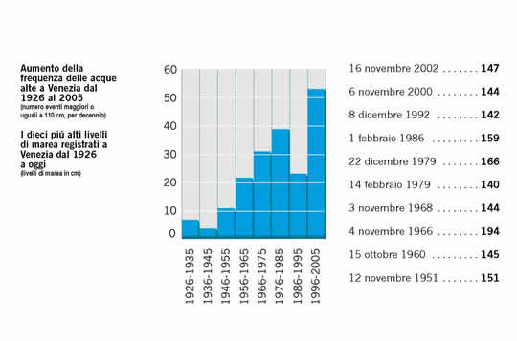
Instances of acqua alta per decade © Venice the Future
http://www.venicethefuture.com/schede/uk/358?aliusid=358

- Chart showing the number of very intense (110cm and above) acqua alta that have occurred from 1872 to 2015 plotted by month:

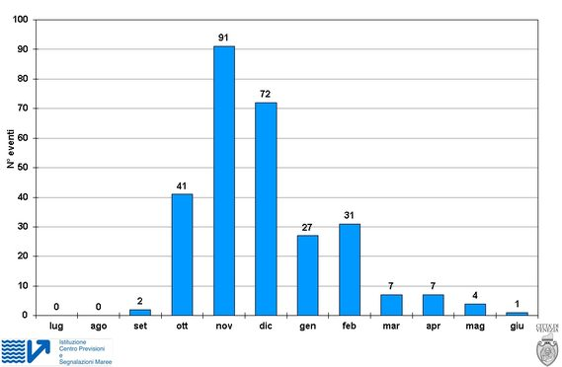
Monthly distribution of high tides © Venezia

http://www.comune.venezia.it/archivio/2973

