Careers with Geographical Information Systems
- GIS in practice – Ordnance Survey
The following materials and activities are sourced from the Ordnance Survey and can be found at https://www.ordnancesurvey.co.uk/education/gis-schools/gis-day-schools

Where to locate a new housing estate

The Ordnance Survey provides a ‘Housing Demo’ which aims to get the class to answer the question ‘Where would you place a new housing estate’? Alongside the demo are a set of teachers’ notes:

View the demo
View the teachers’ notes

Before watching the Housing Demo, children are asked to discuss in groups what geographic considerations there might be for where to place a new housing estate. Some prompts might be needed here (transport, community facilities, ecological considerations etc). After these initial discussions children should be asked to feedback their thoughts on this.

The Housing Demo (which will need to be led by the teacher, clicking through each map layer and focussing on each potential site) then takes students through a number of considerations and shows these on a web map, so the children can consider which location works best for a new housing estate. Teachers may wish to provide students with a blank table to fill in, similar to the one found in the teachers’ notes, so they can compare locations.

Alternatively, if teachers have access to devices or laptops, one location could be allocated to each group for them to scope out and add their information to the table. This could then be fed back to the class, so that the class can then decide which location would be best for the new housing estate. Some guidance on the potential outcome of this is provided in the teachers’ notes.

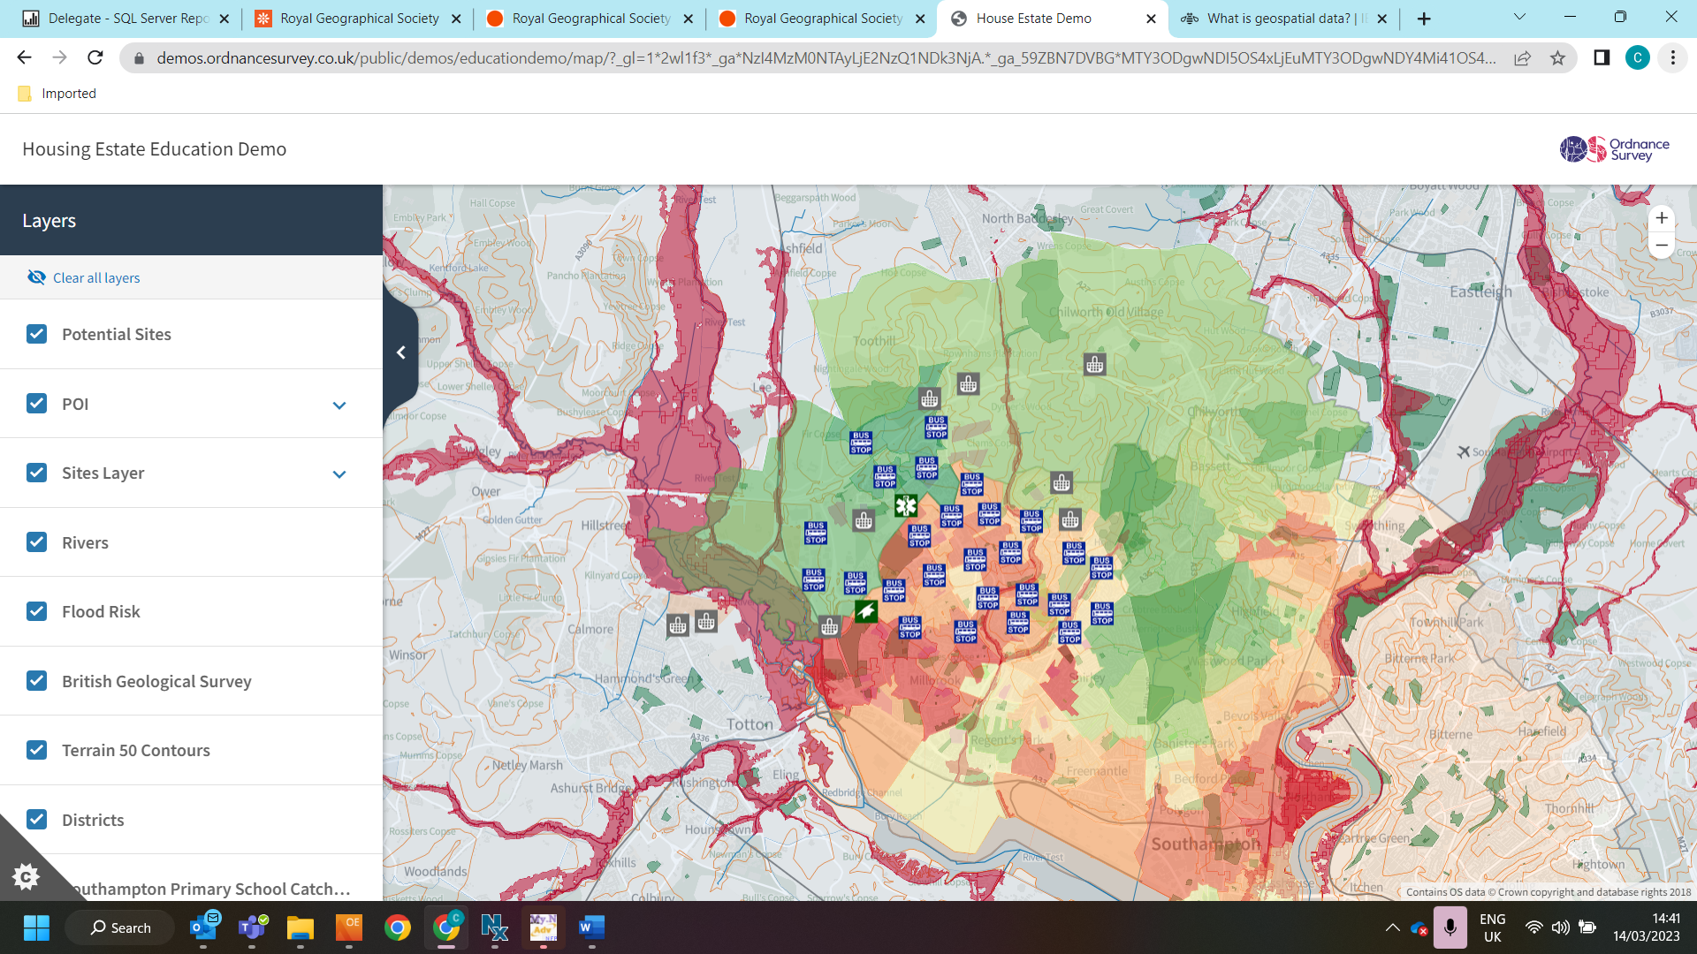

A screenshot of the Ordnance Survey Housing Demo, showing the different map layers selected.

This activity is a great way to show students how GIS and geospatial data can be used in the real world to help with planning and urban development. Teachers should talk to students about the different types of data that would need to be collected to create these map layers (flood risk, terrain, deprivation, transport links etc), and how bringing these pieces of data together and showing them on a map in this way can help show a ‘bigger picture’ and determine where urban development may or may not take place.

Students should be encouraged to consider why being able to do this via a GIS is so useful. Would we be able to identify patterns and potential issues if just surveying an area from the ground? How easy would it be to consider multiple pieces of information if we were not able to layer them in this way?

To take this further, there is a video from OS https://www.youtube.com/watch?v=b1Sare8597E which shows how students can collect their own data (in this case details of street furniture) and upload their data into Digimap for Schools. This activity could give students a flavour of the data collection that was done by professionals at Ordnance Survey to create the map layers seen in the Housing Demo. An important point to stress to students here is that a huge amount of the data used by Ordnance Survey to create maps and map layers is collected by people or equipment in the field.

To support this, teachers might like to look in more detail at a job titles, job descriptions and the skills in demand for GIS professionals – to further highlight to students how work in GIS can be linked to many areas of geography and can help professionals from other career sectors to make decisions that impact people on a daily basis.

Dinosaur Apocalypse

Ordnance Survey have created an activity to show how GIS would be used in an emergency, in this case an alien invader bringing dinosaurs back to life.

The activity can be found at https://www.ordnancesurvey.co.uk/education/gis-schools/gis-day-schools. There is a video and a set of teachers’ notes.

View the video
View the teachers’ notes

The video (11 minutes, but allow time for questions to be answered) can be shown to a class and paused when the questions appear on the screen to give students time to think and answer. The teachers’ notes provide answers to the questions so the teacher is aware of what answers to expect from students at each point throughout the video.

The video is a great way to introduce to students how mapping, GIS and geospatial data can be used in an emergency scenario. Different data layers are added to the map to provide an overall picture of areas at risk / cordon areas / areas that are safe. This can be used in a real-world scenario to determine evacuation areas, dwellings at risk of floods, tracking transport routes around critical incidents, and much, much more.

What does Ordnance Survey do?

There are many other areas of ‘real life’ where GIS mapping and geospatial data can be used to answer questions and solve problems. Ask your students to think about what some of these areas may be.

Ideas could include:
- Local and central government
- Blue light services (Police, Ambulance, Fire)
- Insurance industry
- Utility companies (energy, water etc)
- Critical incidents and accidents, crashes, terrorist incidents etc
- Hazard mapping (floods, gas clouds, volcano evacuation zones)
- Missing people / escaped convicts
- Health related matters such as pandemics
- Spread of disease (Foot and Mouth ect)
- Supermarkets and online shopping (deliveries, stock control, placement of warehouses / new stores)
- Placement of new towns or developments
- Planning new transport routes (HS2 etc)
- Plotting storm pathways, evacuation zones and potential impacts

Ordnance Survey provide a service to many of the sectors listed above. Their service (GIS experts, analysis, production of new mapping) and data can be tailored to show exactly what a client wants and needs to see to make decisions and plan activity.

Several videos are available from Ordnance Survey which provide examples of how they use data to assist other sectors to make decisions:
- What does Ordnance Survey do and who does it provide data to? https://www.youtube.com/watch?v=1R-FrWKzcdE
- Helping the mortgage sector to determine whether houses are at risk from things such as flooding, which may determine how likely a buyer is to get a mortgage on that property https://www.youtube.com/watch?v=weHfZ1ieZCc
- Graduate impressions of working at Ordnance Survey https://www.youtube.com/watch?v=7DRvXbmGPIM

Ordnance Survey also has a list of case studies, highlighting work they have done with a variety of customers. This shows the breath of sectors that reply on GIS and geospatial data (these can be filtered so teachers can find examples linked to particular areas of the curriculum). https://beta.ordnancesurvey.co.uk/customers/case-studies

